Thymeleaf Attributes
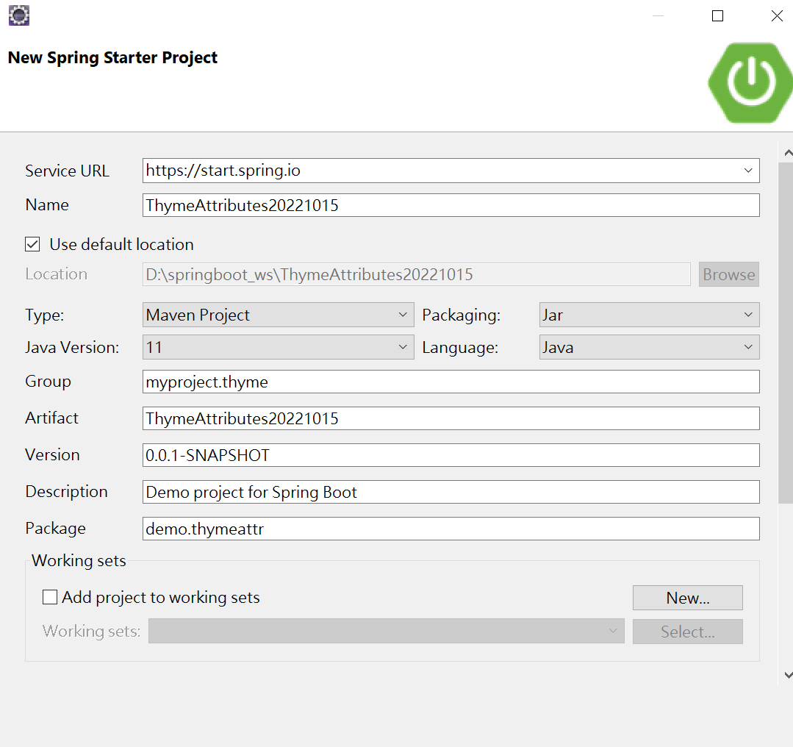
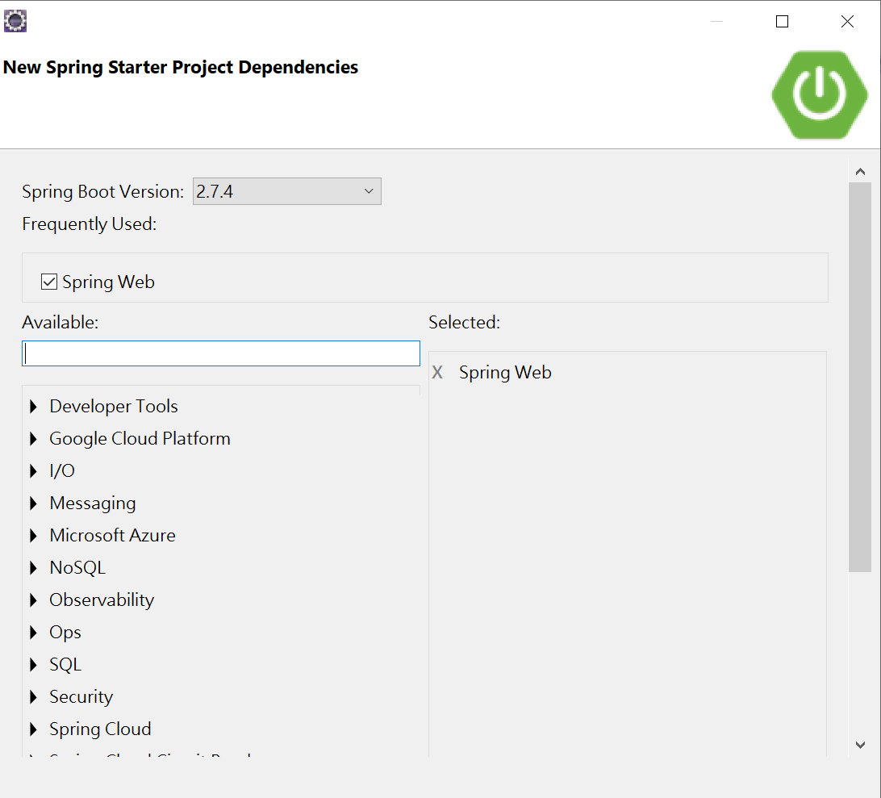

預設SpringBoot 的View 是用 thymeleaf 所以pom必須載入
pom.xml
<dependency>
<groupId>org.springframework.boot</groupId>
<artifactId>spring-boot-starter-thymeleaf</artifactId>
</dependency>

1. Thymeleaf th:text attribute
2. Thymeleaf th:each attribute
3. Thymeleaf th:if and th:unless attribute
4. Thymeleaf th:switch and th:case attribute

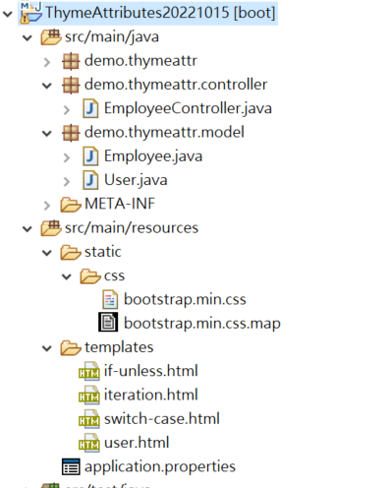
Model:
public class Employee {
private String firstName;
private String lastName;
private String email;

public Employee() {
}
public Employee(String firstName, String lastName, String email) {
this.firstName = firstName;
this.lastName = lastName;
this.email = email;
}
public String getFirstName() {
return firstName;
}
public void setFirstName(String firstName) {
this.firstName = firstName;
}
public String getLastName() {
return lastName;
}
public void setLastName(String lastName) {
this.lastName = lastName;
}
public String getEmail() {
return email;
}
public void setEmail(String email) {
this.email = email;
}
}

public class User {
private String userName;
private String email;
private String role;
private String gender;
public User() {}
public User(String name, String email, String role, String gender) {
this.userName = name;
this.email = email;
this.role = role;
this.gender = gender;
}
public String getUserName() {
return userName;
}
public void setUserName(String name) {
this.userName = name;
}
public String getEmail() {
return email;
}
public void setEmail(String email) {
this.email = email;
}
public String getRole() {
return role;
}
public void setRole(String role) {
this.role = role;
}
public String getGender() {
return gender;
}
public void setGender(String gender) {
this.gender = gender;
}
}

templates/iteration.html

<!DOCTYPE html>
<html xmlns:th="http://www.thymeleaf.org">

<head>
<meta charset="utf-8">
<title>Add Bootstrap CSS Demo</title>

<link th:href="@{/css/bootstrap.min.css}" rel="stylesheet" />
</head>

<body>
<div class="container">
<div class="row">
<h1>Employees</h1>

<table class="table">
<thead>
<tr>
<th>Employee First Name</th>
<th>Employee Last Name</th>
<th>Employee Email</th>
</tr>
</thead>
<tbody>
<tr th:each="employee : ${employees}">
<td th:text="${employee.firstName}"></td>
<td th:text="${employee.lastName}"></td>
<td th:text="${employee.email}"></td>
</tr>
</tbody>
</table>
</div>

</div>
</body>
</html>

EmployeeController:
import org.springframework.stereotype.Controller;
import org.springframework.ui.Model;
import org.springframework.web.bind.annotation.GetMapping;

import demo.thymeattr.model.*;

import java.util.*;
@Controller
public class EmployeeController {
@GetMapping("/iteration")
public String iteration(Model model) {
List<Employee> employees = new ArrayList<>();
employees.add(new Employee("Ramesh", "Fadatare", "ramesh@gmail.com"));
employees.add(new Employee("John", "Cena", "john@gmail.com"));
employees.add(new Employee("Tom", "Cruise", "tom@gmail.com"));
employees.add(new Employee("Tony", "Stark", "tony@gmail.com"));
model.addAttribute("employees", employees);
return "iteration";
}
}

templates/if-unless.html
<!DOCTYPE html>
<html xmlns:th="http://www.thymeleaf.org">

<head>
<meta charset="utf-8">
<title>Add Bootstrap CSS Demo</title>

<link th:href="@{/css/bootstrap.min.css}" rel="stylesheet" />
</head>

<body>
<div class="container">
<div class="row">
<h1>User</h1>
<table class="table">
<thead>
<tr>
<th>User Name</th>
<th>User Email</th>
</tr>
</thead>
<tbody>
<tr th:each="user : ${users}">
<td th:text="${user.userName}"></td>
<td th:text="${user.email}"></td>
<td><a class="btn btn-primary" th:if="${user.role} == 'ADMIN'">Update</a>
<a class="btn btn-danger" th:if="${user.role} == 'ADMIN'">Delete</a>
<a class="btn btn-primary" th:unless="${user.role} == 'ADMIN'">View</a>
</td>
</tr>
</tbody>
</table>
</div>

</div>
</body>
</html>

Controller Method:
@GetMapping("if-unless")
public String ifUnless(Model model){
User ramesh = new User("ramesh","ramesh@gmail.com", "ADMIN", "M");
User admin = new User("admin","admin@gmail.com", "ADMIN", "M");
User meena = new User("meena","meena@gmail.com", "USER", "F");
List<User> users = new ArrayList<>();
users.add(ramesh);
users.add(admin);
users.add(meena);
model.addAttribute("users", users);
return "if-unless";
}
templates/switch-case.html
<!DOCTYPE html>
<html xmlns:th="http://www.thymeleaf.org">

<head>
<meta charset="utf-8">
<title>Add Bootstrap CSS Demo</title>

<link th:href="@{/css/bootstrap.min.css}" rel="stylesheet" />
</head>

<body>
<div class="container">
<h1>Thymeleaf swith case demo</h1>

<h5 th:utext="${user.userName}"></h5>
<p>
<div th:switch="${user.role}">
<p th:case="'ADMIN'">User is an administrator</p>
<p th:case="'MANAGER'">User is a manager</p>
<p th:case="'GUEST'">User is a guest</p>
<!-- * for default case -->
<p th:case="*">User is some other thing</p>
</div>

</div>
</body>
</html>
Controller Method:
@GetMapping("switch-case")
public String user(Model model){
User user = new User("mary","mary@gmail.com", "MANAGER", "M");
model.addAttribute("user", user);
return "switch-case";
}
templates/user.html
<!DOCTYPE html>
<html xmlns:th="http://www.thymeleaf.org">

<head>
<meta charset="utf-8">
<title>Add Bootstrap CSS Demo</title>

<link th:href="@{/css/bootstrap.min.css}" rel="stylesheet" />
</head>

<body>
<div class="container">
<h1>User</h1>
<p> Name: <strong th:text="${user.userName}"></strong></p>
<p> Email: <strong th:text="${user.email}"></strong></p>
<p> Role: <strong th:text="${user.role}"></strong></p>
<p> Gender: <strong th:text="${user.gender}"></strong></p>

</div>
</body>
</html>

Controller Method:

@GetMapping("user")
public String testUser(Model model){

User admin = new User("admin","admin@gmail.com", "ADMIN", "M");
model.addAttribute("user", admin);
return "user";
}

