這份 AngularJS 程式的教學手冊，幫助你了解整體架構與各個功能的運作方式。
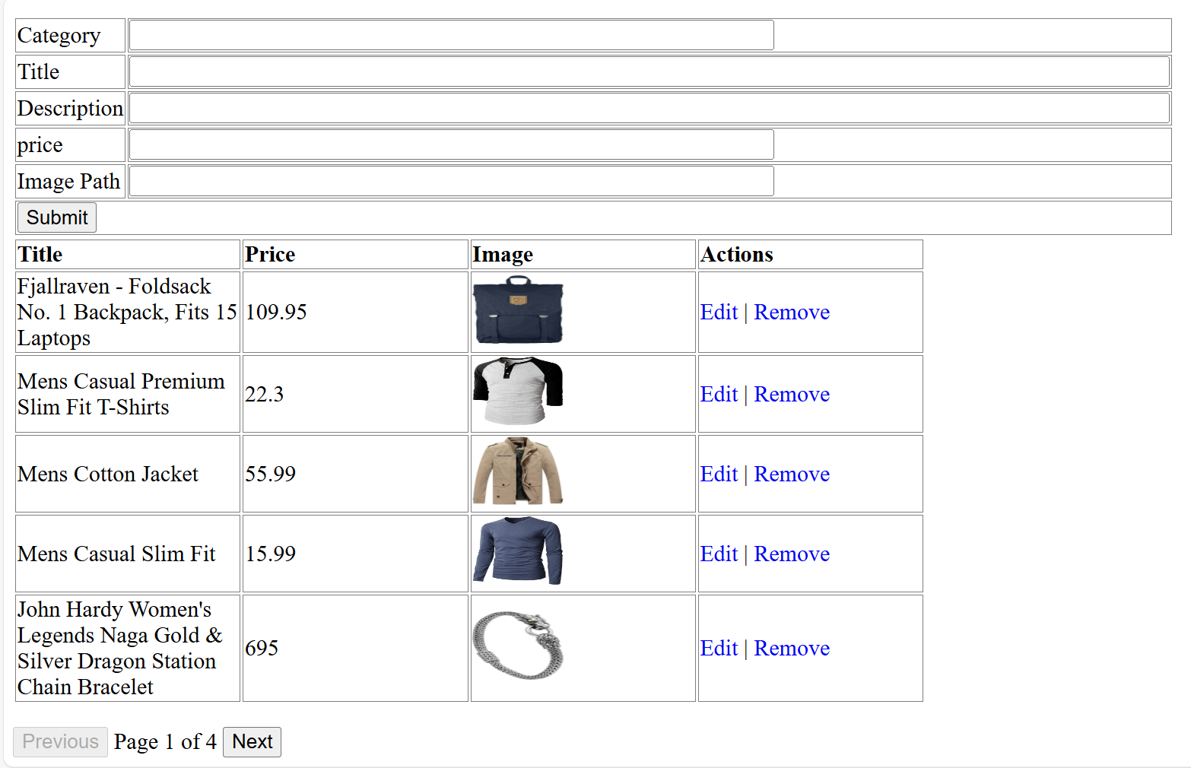

📘 範例名稱：產品管理系統（Product Management）
本教學使用 AngularJS 搭配 RESTful API（Fake Store API）實作基本的「商品管理」功能，包括：
- 讀取產品列表（GET）
- 分頁功能
- 新增產品（POST）
- 編輯產品（PUT）
- 刪除產品（DELETE）

🧠 第一部分：AngularJS App 註冊與 Controller 初始化
var app = angular.module("ProductManagement", []);
app.controller("ProductManagementController", fetchProducts);
- 宣告 AngularJS 模組 ProductManagement
- 註冊 ProductManagementController 並指定邏輯由 fetchProducts 函式處理

🧠 第二部分：Controller 的主體 - fetchProducts
這是整體應用的核心控制邏輯。
function fetchProducts($scope, $http) {
- 使用 $scope 綁定資料與 UI 元素
- 使用 $http 與後端 API 溝通

📌 初始化設定
$scope.products = [];
$scope.currentPage = 0;
$scope.pageSize = 5;
- products: 所有商品資料
- currentPage: 分頁當前頁碼
- pageSize: 每頁顯示幾筆資料
$scope.form = {
id: -1,
category: "",
description: "",
price: "",
images: "",
title: "",
rating: {}
};
- form: 用於新增/編輯產品的表單
- 當 id = -1 表示為新增操作

📘 分頁功能
顯示目前頁的產品：
$scope.pagedProducts = function () {
var start = $scope.currentPage * $scope.pageSize;
return $scope.products.slice(start, start + $scope.pageSize);
};
計算總頁數：
$scope.numberOfPages = function () {
return Math.ceil($scope.products.length / $scope.pageSize);
};
上一頁 / 下一頁控制：
$scope.prevPage = function () {
if ($scope.currentPage > 0) {
$scope.currentPage--;
}
};

$scope.nextPage = function () {
if ($scope.currentPage < $scope.numberOfPages() - 1) {
$scope.currentPage++;
}
};

📘 新增/編輯產品（POST/PUT）
$scope.submitProduct = function () {
var method = "";
var url = "";

if ($scope.form.id == -1) {
method = "POST";
url = 'https://fakestoreapi.com/products';
} else {
method = "PUT";
url = 'https://fakestoreapi.com/products/' + $scope.form.id;
}

$http({
method: method,
url: url,
data: angular.toJson($scope.form),
headers: {
'Content-Type': 'application/json'
}
}).then(_success, _error);
};
- 若為新增則呼叫 POST API
- 若為修改則呼叫 PUT API（需提供 ID）

🧹 刪除產品（DELETE）
$scope.removeProduct = function (product) {
$http({
method: 'DELETE',
url: 'https://fakestoreapi.com/products/' + product.id
}).then(_success, _error);
};
- 根據 product.id 呼叫 DELETE API

✏️ 編輯產品（表單填入現有資料）
$scope.editProduct = function (product) {
$scope.form.category = product.category;
$scope.form.title = product.title;
$scope.form.description = product.description;
$scope.form.price = product.price;
$scope.form.rating = product.rating;
$scope.form.image = product.image;
$scope.form.id = product.id;
};
- 將選取的產品內容填入 $scope.form，以供修改

🔄 重新讀取資料
function _refreshPageData() {
$http({
method: 'GET',
url: 'https://fakestoreapi.com/products'
}).then(function successCallback(response) {
$scope.products = response.data;
}, function errorCallback(response) {
console.log(response.statusText);
});
}
- 呼叫 FakeStore API 取得所有產品並存入 $scope.products

✅ 成功與錯誤處理函式
function _success(response) {
_refreshPageData();
_clearForm();
}

function _error(response) {
console.log(response.statusText);
}
- _success: 資料更新成功後重新載入 + 清除表單
- _error: 錯誤時輸出訊息至 console

🧽 清空表單資料
function _clearForm() {
$scope.form.category = "";
$scope.form.title = "";
$scope.form.description = "";
$scope.form.price = "";
$scope.form.rating = "";
$scope.form.image = "";
$scope.form.id = -1;
};

✅ 教學總結：
功能 | 方法 | API 路徑
查詢全部產品 | GET | /products
新增產品 | POST | /products
編輯產品 | PUT | /products/{id}
刪除產品 | DELETE | /products/{id}

這個 HTML 搭配 AngularJS 的前端畫面設計，和你提供的 main.js 控制器程式碼（fetchProducts）是完整搭配的。以下是這份 HTML 頁面的詳細教學手冊式解說，幫助你（或學生）清楚了解整體架構與各部分功能：

📄 檔案名稱：index.html

🎯 頁面目標：
- 顯示產品列表（含分頁）
- 提供新增/修改/刪除產品的表單
- 使用 AngularJS 的 $http 呼叫 Fake Store API

📦 主要引入的資源
<script src="http://ajax.googleapis.com/ajax/libs/angularjs/1.8.2/angular.min.js"></script>
<script src="./js/main.js"></script>
- AngularJS v1.8.2：負責雙向綁定、MVC 結構等
- main.js：你自定的 AngularJS 控制器邏輯，包含讀取/新增/編輯/刪除資料的功能

🎨 基本樣式設定（CSS）
.button { cursor: pointer; color: blue; }
td, th { border: 1px solid gray; width: 25%; text-align: left; }
table { width: 800px; }
簡單的按鈕風格與表格樣式設定。

📌 AngularJS 應用與控制器啟用
<body ng-app="ProductManagement" ng-controller="ProductManagementController">
- ng-app：宣告 AngularJS 應用模組名稱為 ProductManagement
- ng-controller：將此區塊的資料與邏輯交由 ProductManagementController 控制

🧾 商品輸入表單（新增/編輯）
<form ng-submit="submitProduct()">
當按下「Submit」按鈕時，會觸發 submitProduct() 方法（位於 main.js 裡面）。

表單欄位綁定
每個欄位都有對應 ng-model 綁定 $scope.form 物件：
欄位名稱 | ng-model 綁定
Category | form.category
Title | form.title
Description | form.description
Price | form.price
Image Path | form.image

📋 顯示產品清單（含圖片與操作）
<tr ng-repeat="product in pagedProducts()">
- pagedProducts()：來自 Controller，用來處理目前頁面要顯示的商品（有分頁機制）

顯示欄位：
欄位 | 資料來源
Title | {{ product.title }}
Price | {{ product.price }}
Image | <img src="{{product.image}}" />
Actions | Edit / Remove

操作按鈕：
<a ng-click="editProduct(product)">Edit</a>
<a ng-click="removeProduct(product)">Remove</a>

🔢 分頁控制區
<button ng-click="prevPage()" ng-disabled="currentPage == 0">Previous</button>
Page {{currentPage + 1}} of {{numberOfPages()}}
<button ng-click="nextPage()" ng-disabled="currentPage >= numberOfPages() - 1">Next</button>
- 透過 prevPage() / nextPage() 切換頁面
- 顯示當前頁碼與總頁數

✅ 總結：整體流程圖
表單輸入 → submitProduct()
↳ 新增：POST
↳ 編輯：PUT
↳ 成功後刷新資料

清單顯示 → GET 資料（pagedProducts + ng-repeat）

刪除按鈕 → removeProduct(product) → DELETE

編輯按鈕 → editProduct(product) → 將資料填入 form

分頁 → prevPage() / nextPage()

main.js

function fetchProducts($scope, $http) {
//Initialize page with default data which is blank in this example
$scope.products = [];
$scope.currentPage = 0;
$scope.pageSize = 5;
$scope.form = {
id: -1,
category: "",
description: "",
price: "",
images: "",
price: "",
title: "",
rating: {}
};
//Now load the data from server
_refreshPageData();

$scope.pagedProducts = function () {
var start = $scope.currentPage * $scope.pageSize;
return $scope.products.slice(start, start + $scope.pageSize);
};

$scope.numberOfPages = function () {
return Math.ceil($scope.products.length / $scope.pageSize);
};

$scope.prevPage = function () {
if ($scope.currentPage > 0) {
$scope.currentPage--;
}
};

$scope.nextPage = function () {
if ($scope.currentPage < $scope.numberOfPages() - 1) {
$scope.currentPage++;
}
};

//HTTP POST/PUT methods for add/edit employee
$scope.submitProduct = function () {

var method = "";
var url = "";
if ($scope.form.id == -1) {
//Id is absent so add employee - POST operation
method = "POST";
url = 'https://fakestoreapi.com/products';
} else {
//If Id is present, it's edit operation - PUT operation
method = "PUT";
url = 'https://fakestoreapi.com/products/' + $scope.form.id;
}

$http({
method: method,
url: url,
data: angular.toJson($scope.form),
headers: {
'Content-Type': 'application/json'
}
}).then(_success, _error);
};

//HTTP DELETE- delete employee by Id
$scope.removeProduct = function (product) {
$http({
method: 'DELETE',
url: 'https://fakestoreapi.com/products/' + product.id
}).then(_success, _error);
};

//In case of edit employee, populate form with employee data
$scope.editProduct = function (product) {
$scope.form.category = product.category;
$scope.form.title = product.title;
$scope.form.description = product.description;
$scope.form.price = product.price;
$scope.form.rating = product.rating;
$scope.form.image = product.image;
$scope.form.id = product.id;
};

/* Private Methods */
//HTTP GET- get all employees collection
function _refreshPageData() {
$http({
method: 'GET',
url: 'https://fakestoreapi.com/products'
}).then(function successCallback(response) {
$scope.products = response.data;
}, function errorCallback(response) {
console.log(response.statusText);
});
}

function _success(response) {
_refreshPageData();
_clearForm();
}

function _error(response) {
console.log(response.statusText);

}

//Clear the form
function _clearForm() {
$scope.form.category = "";
$scope.form.title = "";
$scope.form.description = "";
$scope.form.price = "";
$scope.form.rating = "";
$scope.form.image = "";
$scope.form.id = -1;
};
}

var app = angular.module("ProductManagement", []);
//Controller Part
app.controller("ProductManagementController", fetchProducts);

fakeproducts.html

<!doctype html>
<html>

<head>
<meta charset="utf-8" />
<title>
AngularJS - fake product Demo using $http service
</title>
<script src="http://ajax.googleapis.com/ajax/libs/angularjs/1.8.2/angular.min.js"></script>
<!-- Load AngularJS -->
<script src="./js/main.js"></script>
<style>
.button {
cursor: pointer;
color: blue;
}

td,
th {
border: 1px solid gray;
width: 25%;
text-align: left;
}

table {
width: 800px;
}
</style>

<head>

<body ng-app="ProductManagement" ng-controller="ProductManagementController">
<h1>
AngularJS - Use $http to invoke Product APIs
</h1>
<h2>Add/Edit Product</h2>
<form ng-submit="submitProduct()">
<table>
<tr>
<td>Category</td>
<td><input type="text" ng-model="form.category" size="60" /></td>
</tr>
<tr>
<td>Title</td>
<td><input type="text" ng-model="form.title" size="100" /></td>
</tr>
<tr>
<td>Description</td>
<td><input type="text" ng-model="form.description" size="100" /></td>
</tr>
<tr>
<td>price</td>
<td><input type="text" ng-model="form.price" size="60" /></td>
</tr>
<tr>
<td>Image Path</td>
<td><input type="text" ng-model="form.image" size="60" /></td>
</tr>
<tr>
<td colspan="2"><input type="submit" value="Submit" /></td>
</tr>
</table>
</form>
<table>
<tr>
<th>Title</th>
<th>Price</th>
<th>Image</th>
<th>Actions</th>
</tr>

<tr ng-repeat="product in pagedProducts()">
<td>{{ product.title }}</td>
<td>{{ product.price }}</td>
<td><img src="{{product.image}}" width="80px" height="60px" /></td>
<td><a ng-click="editProduct( product )" class="button">Edit</a> | <a ng-click="removeProduct( product )"
class="button">Remove</a></td>
</tr>
</table>
<div style="margin-top: 20px;">
<button ng-click="prevPage()" ng-disabled="currentPage == 0">Previous</button>
Page {{currentPage + 1}} of {{numberOfPages()}}
<button ng-click="nextPage()" ng-disabled="currentPage >= numberOfPages() - 1">Next</button>
</div>
</body>
</html>

