已知JSON資料將之儲存於資料庫
JSON 資料
{
"id": 1,
"title": "Fjallraven - Foldsack No. 1 Backpack, Fits 15 Laptops",
"price": 109.95,
"description": "Your perfect pack for everyday use and walks in the forest. Stash your laptop (up to 15 inches) in the padded sleeve, your everyday",
"category": "men's clothing",
"image": "https://fakestoreapi.com/img/81fPKd-2AYL._AC_SL1500_.jpg",
"rating": {
"rate": 3.9,
"count": 120
}
},

建立Spring Boot Data JPA專案:
pom.xml
<dependency>
<groupId>org.springframework.boot</groupId>
<artifactId>spring-boot-starter-data-jpa</artifactId>
</dependency>
<dependency>
<groupId>org.springframework.boot</groupId>
<artifactId>spring-boot-starter-web</artifactId>
</dependency>
<dependency>
<groupId>com.mysql</groupId>
<artifactId>mysql-connector-j</artifactId>
<scope>runtime</scope>
</dependency>

application.properties:

spring.datasource.url=jdbc:mysql://localhost/mydb
spring.datasource.username=root
spring.datasource.password=1234
spring.datasource.driver-class-name=com.mysql.cj.jdbc.Driver

spring.jpa.show-sql=true
spring.jpa.properties.hibernate.format_sql=true

# update create-drop validate
spring.jpa.properties.hibernate.hbm2ddl.auto=create-drop

Rating.java
import jakarta.persistence.*;
@Entity
public class Rating {
@Id
@GeneratedValue(strategy = GenerationType.IDENTITY)
Integer id;
double rate;
int count;
public Rating() {
}
public Rating(double rating, int count) {
this.rate = rating;
this.count = count;
}
public Integer getId() {
return id;
}
public void setId(Integer id) {
this.id = id;
}
public double getRate() {
return rating;
}
public void setRate(double rating) {
this.rate = rating;
}
public int getCount() {
return count;
}
public void setCount(int count) {
this.count = count;
}
@Override
public String toString() {
return "Rating [id=" + id + ", rating=" + rate + ", count=" + count + "]";
}
}
Product.java

import jakarta.persistence.*;
@Entity
@Table(name="jsonproducts")
public class Product {
@Id
Integer id;
String title;
String description;
String category;

@OneToOne(cascade = CascadeType.ALL)
@JoinColumn(name = "rating_id", referencedColumnName = "id")
Rating rating;
double price;
String image;

public Product() {
}

public Product(Integer id, String title, String description, String category, Rating rating, double price,
String image) {
this.id = id;
this.title = title;
this.description = description;
this.category = category;
this.rating = rating;
this.price = price;
this.image = image;
}

public Integer getId() {
return id;
}

public void setId(Integer id) {
this.id = id;
}
public String getTitle() {
return title;
}
public void setTitle(String title) {
this.title = title;
}
public String getDescription() {
return description;
}
public void setDescription(String description) {
this.description = description;
}
public String getCategory() {
return category;
}
public void setCategory(String category) {
this.category = category;
}
public Rating getRating() {
return rating;
}
public void setRating(Rating rating) {
this.rating = rating;
}
public double getPrice() {
return price;
}

public void setPrice(double price) {
this.price = price;
}
public String getImage() {
return image;
}
public void setImage(String image) {
this.image = image;
}
@Override
public String toString() {
return "Product [id=" + id + ", title=" + title + ", description=" + description + ", category=" + category
+ ", rating=" + rating + ", price=" + price + ", image=" + image + "]";
}
}

ProductDAO.java
import org.springframework.data.jpa.repository.JpaRepository;

public interface ProductDAO extends JpaRepository<Product,Integer> {

}
ProductController.java
import org.springframework.beans.factory.annotation.Autowired;
import org.springframework.web.bind.annotation.PostMapping;
import org.springframework.web.bind.annotation.RequestBody;
import org.springframework.web.bind.annotation.RestController;

import com.example.jsondb.model.*;

@RestController
public class ProductController {

@Autowired
ProductDAO dao;

@PostMapping("/products")
public Product saveProduct(@RequestBody Product product) {
dao.save(product);
return product;
}
}
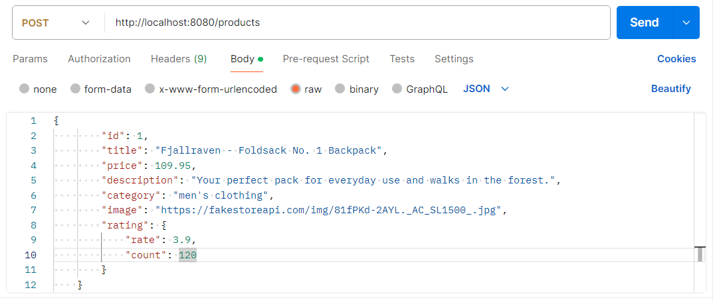

{
"id": 1,
"title": "Fjallraven - Foldsack No. 1 Backpack",
"price": 109.95,
"description": "Your perfect pack for everyday use and walks in the forest.",
"category": "men's clothing",
"image": "https://fakestoreapi.com/img/81fPKd-2AYL._AC_SL1500_.jpg",
"rating": {
"rate": 3.9,
"count": 120
}
}

