JAX-RS JPA jQuery範例
在這個範例中，我們使用jQuery來使用RESTful Web服務。

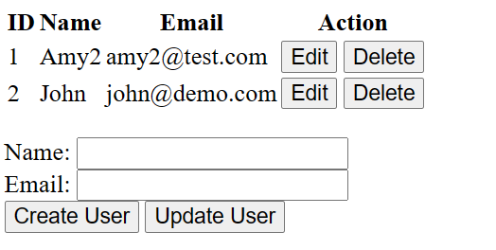

前端jQuery程式:

<!DOCTYPE html>
<html>
<head>
<title>CRUD Example</title>
<script src="https://code.jquery.com/jquery-3.6.0.min.js"></script>
</head>
<body>
<table>
<thead>
<tr>
<th>ID</th>
<th>Name</th>
<th>Email</th>
<th>Action</th>
</tr>
</thead>
<tbody id="users-table-body">
</tbody>
</table>
<p>
<form>
<input type="hidden" id="user-id">
<label for="user-name">Name:</label>
<input type="text" id="user-name"><br/>
<label for="user-email">Email:</label>
<input type="text" id="user-email"><br/>
<button type="button" id="create-user">Create User</button>
<button type="button" id="update-user">Update User</button>
</form>
<script>
var apiUrl = 'http://localhost:8080/RSJpa20230506/api/users';

$(document).ready(function() {
// Load initial users data
loadUsers();

// Create new user
$('#create-user').click(function() {
var name = $('#user-name').val();
var email = $('#user-email').val();
var user = {name: name, email: email};
createUser(user);
});

// Update existing user
$('#update-user').click(function() {
var id = $('#user-id').val();
var name = $('#user-name').val();
var email = $('#user-email').val();
var user = {id: id, name: name, email: email};
updateUser(user);
});

// Load users data
function loadUsers() {
$.get(apiUrl)
.done(function(data) {
$('#users-table-body').empty();
$.each(data, function(i, user) {
var row = '<tr>' +
'<td>' + user.id + '</td>' +
'<td>' + user.name + '</td>' +
'<td>' + user.email + '</td>' +
'<td><button type="button" class="edit-user" data-id="' + user.id + '">Edit</button> ' +
'<button type="button" class="delete-user" data-id="' + user.id + '">Delete</button></td>' +
'</tr>';
$('#users-table-body').append(row);
});
});
}

// Create user
function createUser(user) {
$.ajax({
url: apiUrl,
type: 'POST',
contentType: 'application/json',
data: JSON.stringify(user)
})
.done(function() {
clearForm();
loadUsers();
})
.fail(function(jqXHR, textStatus, errorThrown) {
alert('Failed to create user: ' + errorThrown);
});
}

// Update user
function updateUser(user) {
$.ajax({
url: apiUrl + '/' + user.id,
type: 'PUT',
contentType: 'application/json',
data: JSON.stringify(user)
})
.done(function() {
clearForm();
loadUsers();
})
.fail(function(jqXHR, textStatus, errorThrown) {
alert('Failed to update user: ' + errorThrown);
});
}

// Delete user
$('#users-table-body').on('click', '.delete-user', function() {
var id = $(this).data('id')
$.ajax({
url: apiUrl + '/' + id,
type: 'DELETE'
})
.done(function() {
loadUsers();
})
.fail(function(jqXHR, textStatus, errorThrown) {
alert('Failed to delete user: ' + errorThrown);
});
});

// Edit user
$('#users-table-body').on('click', '.edit-user', function() {
var id = $(this).data('id');
$.get(apiUrl + '/' + id)
.done(function(user) {
$('#user-id').val(user.id);
$('#user-name').val(user.name);
$('#user-email').val(user.email);
})
.fail(function(jqXHR, textStatus, errorThrown) {
alert('Failed to load user: ' + errorThrown);
});
});

// Clear form
function clearForm() {
$('#user-id').val('');
$('#user-name').val('');
$('#user-email').val('');
}
});
</script>

