應用程式 Spring Boot, Thymeleaf, Spring Data JPA, Hibernate, 及MySQL
在本課程中我們將學習如何使用Spring Boot, Thymeleaf, Spring Data JPA, Hibernate和MySQL資料庫開發Spring Boot CRUD Web應用程式。

專案要求
以下是為員工管理系統創建 Web 應用程式的高級專案要求。用戶應該能夠：
- 取得所有員工資料
- 添加新員工資料
- 更新員工資料
- 刪除員工資料

我們將建構什麼？
我們將為員工管理系統建立一個Spring MVC Web應用程式 以實現上述功能。

下面的截圖總結了我們將在本練習中開發的 CRUD 操作。
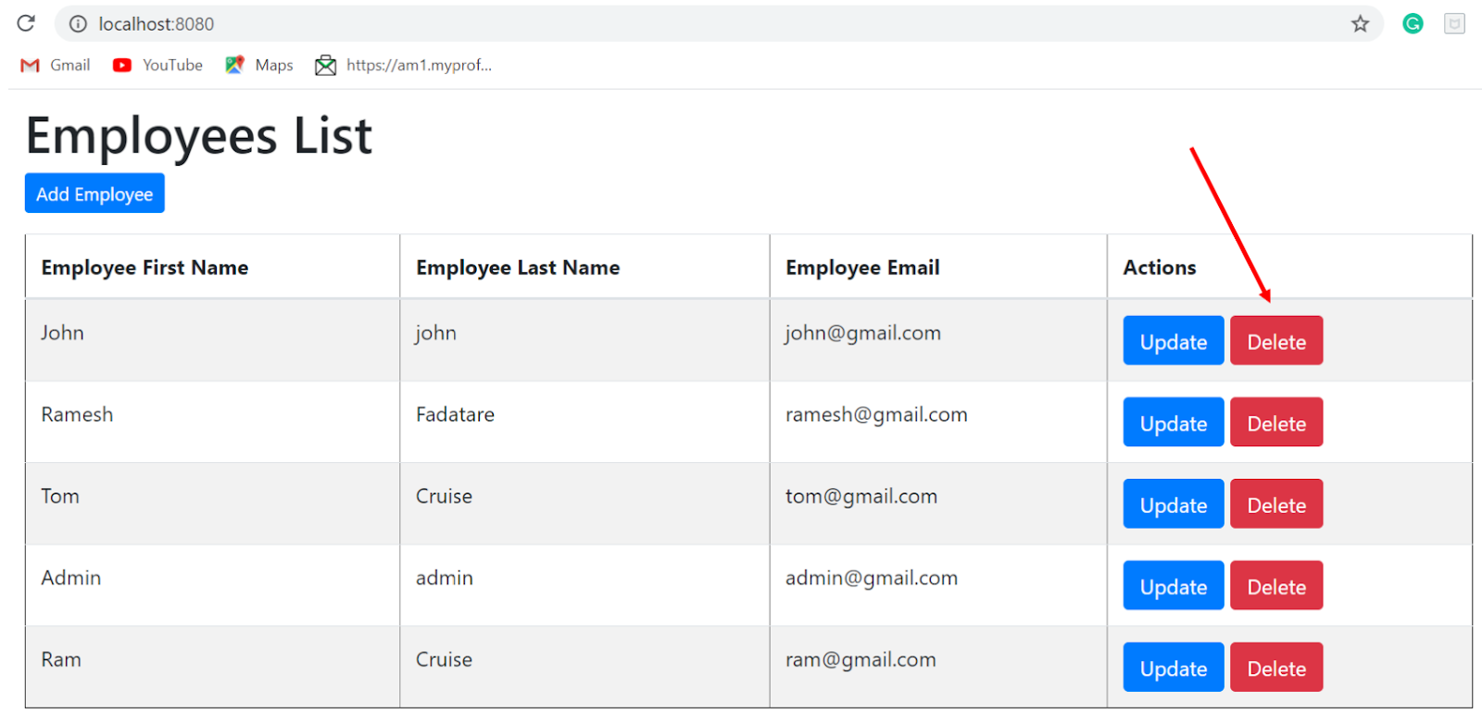
開發流程
下圖顯示了我們的Spring Boot MVC Web應用程式與Thymeleaf的應用程式流程：
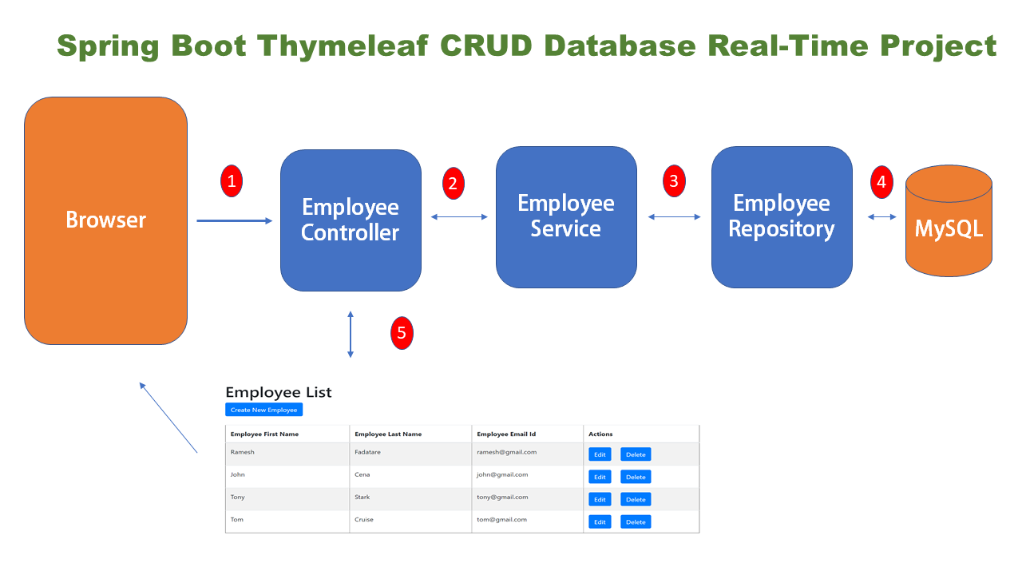
使用的工具和技術
- IDE - Eclipse / STS
- Spring Boot 2.2.6+
- Spring Framework 5.2.5+
- Maven 3.2 +
- Java 8
- Spring Data JPA ( Hibernate)
- Thymeleaf

1. 建立Spring Boot專案
有許多方法可以建立SpringBoot應用程式。

2. Maven依賴關係
<?xml version="1.0" encoding="UTF-8"?>
<project
xmlns="http://maven.apache.org/POM/4.0.0"
xmlns:xsi="http://www.w3.org/2001/XMLSchema-instance"
xsi:schemaLocation="http://maven.apache.org/POM/4.0.0 https://maven.apache.org/xsd/maven-4.0.0.xsd">
<modelVersion>4.0.0</modelVersion>
<parent>
<groupId>org.springframework.boot</groupId>
<artifactId>spring-boot-starter-parent</artifactId>
<version>2.2.7.RELEASE</version>
<relativePath/>
<!-- lookup parent from repository -->
</parent>
<groupId>net.javaguides</groupId>
<artifactId>springboot-thymeleaf-crud-web-app</artifactId>
<version>0.0.1-SNAPSHOT</version>
<name>springboot-thymeleaf-crud-web-app</name>
<description>Demo project for Spring Boot and thymeleaf</description>
<properties>
<java.version>1.8</java.version>
</properties>
<dependencies>
<dependency>
<groupId>org.springframework.boot</groupId>
<artifactId>spring-boot-starter-data-jpa</artifactId>
</dependency>
<dependency>
<groupId>org.springframework.boot</groupId>
<artifactId>spring-boot-starter-thymeleaf</artifactId>
</dependency>
<dependency>
<groupId>org.springframework.boot</groupId>
<artifactId>spring-boot-starter-web</artifactId>
</dependency>
<dependency>
<groupId>org.springframework.boot</groupId>
<artifactId>spring-boot-devtools</artifactId>
<scope>runtime</scope>
<optional>true</optional>
</dependency>
<dependency>
<groupId>mysql</groupId>
<artifactId>mysql-connector-java</artifactId>
<scope>runtime</scope>
</dependency>
<dependency>
<groupId>org.springframework.boot</groupId>
<artifactId>spring-boot-starter-test</artifactId>
<scope>test</scope>
<exclusions>
<exclusion>
<groupId>org.junit.vintage</groupId>
<artifactId>junit-vintage-engine</artifactId>
</exclusion>
</exclusions>
</dependency>
</dependencies>
<build>
<plugins>
<plugin>
<groupId>org.springframework.boot</groupId>
<artifactId>spring-boot-maven-plugin</artifactId>
</plugin>
</plugins>
</build>
</project>
3. 專案架構
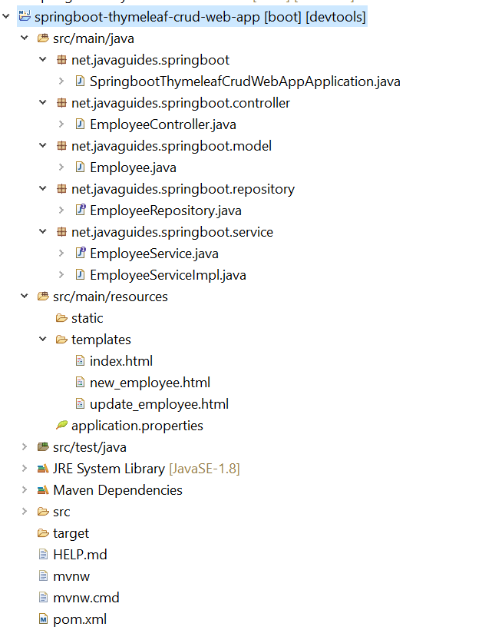
4. 配置和設置我的 SQL 資料庫
在MySQL資料庫伺服器中建立一個名為「demo」的資料庫。
我們需要配置MySQL資料庫URL，使用者名和密碼，以便Spring可以在啟動時與資料庫建立連接。
開啟應用程式屬性並新增以下 MySQL 資料庫設定：
# DATASOURCE (DataSourceAutoConfiguration & DataSourceProperties)
spring.datasource.url=jdbc:mysql://localhost:3306/demo?useSSL=false&serverTimezone=UTC&useLegacyDatetimeCode=false
spring.datasource.username=root
spring.datasource.password=1234

# Hibernate
# The SQL dialect makes Hibernate generate better SQL for the chosen database
spring.jpa.properties.hibernate.dialect = org.hibernate.dialect.MySQL5InnoDBDialect

# Hibernate ddl auto (create, create-drop, validate, update)
spring.jpa.hibernate.ddl-auto = update

logging.level.org.hibernate.SQL=DEBUG
logging.level.org.hibernate.type=TRACE

確保根據MySQL安裝時更改spring.datasource.username 和 spring.datasource.password 屬性spring.jpa.hibernate.ddl-auto = update屬性可確保應用程式中的資料庫表保持同步。每當您更改模型時，Hibernate都會在您重新啟動應用程式時自動更新資料庫中的映射表。
我們還為hibernate指定了日誌，以便我們可以hibernate執行的 SQL 查詢進行除錯。
5. 模型層 - JPA Entity - Employee.java
讓我們在其中加入以下內容：
package net.springboot.model;

import javax.persistence.Column;
import javax.persistence.Entity;
import javax.persistence.GeneratedValue;
import javax.persistence.GenerationType;
import javax.persistence.Id;
import javax.persistence.Table;

@Entity
@Table(name = "employees")
public class Employee {

@Id
@GeneratedValue(strategy = GenerationType.IDENTITY)
private long id;

@Column(name = "first_name")
private String firstName;

@Column(name = "last_name")
private String lastName;

@Column(name = "email")
private String email;
public long getId() {
return id;
}
public void setId(long id) {
this.id = id;
}
public String getFirstName() {
return firstName;
}
public void setFirstName(String firstName) {
this.firstName = firstName;
}
public String getLastName() {
return lastName;
}
public void setLastName(String lastName) {
this.lastName = lastName;
}
public String getEmail() {
return email;
}
public void setEmail(String email) {
this.email = email;
}
}
6. Repository Layer - EmployeeRepository.java
在「Repository」套件下建立一個員工存儲庫介面，並向其中加入以下內容：

package net.springboot.repository;

import org.springframework.data.jpa.repository.JpaRepository;
import org.springframework.stereotype.Repository;

import net.javaguides.springboot.model.Employee;

@Repository
public interface EmployeeRepository extends JpaRepository<Employee, Long>{

}
7. 服務層
7.1 EmployeeService.java介面

package net.springboot.service;
import java.util.List;
import net.springboot.model.Employee;

public interface EmployeeService {
List < Employee > getAllEmployees();
void saveEmployee(Employee employee);
Employee getEmployeeById(long id);
void deleteEmployeeById(long id);
}
7.2. EmployeeServiceImpl類別

package net.springboot.service;
import java.util.List;
import java.util.Optional;

import org.springframework.beans.factory.annotation.Autowired;
import org.springframework.stereotype.Service;

import net.javaguides.springboot.model.Employee;
import net.springboot.repository.EmployeeRepository;

@Service
public class EmployeeServiceImpl implements EmployeeService {

@Autowired
private EmployeeRepository employeeRepository;

@Override
public List < Employee > getAllEmployees() {
return employeeRepository.findAll();
}

@Override
public void saveEmployee(Employee employee) {
this.employeeRepository.save(employee);
}

@Override
public Employee getEmployeeById(long id) {
Optional < Employee > optional = employeeRepository.findById(id);
Employee employee = null;
if (optional.isPresent()) {
employee = optional.get();
} else {
throw new RuntimeException(" Employee not found for id :: " + id);
}
return employee;
}

@Override
public void deleteEmployeeById(long id) {
this.employeeRepository.deleteById(id);
}
}
8. 控制器層 - EmployeeController.java

package net.springboot.controller;
import org.springframework.beans.factory.annotation.Autowired;
import org.springframework.stereotype.Controller;
import org.springframework.ui.Model;
import org.springframework.web.bind.annotation.GetMapping;
import org.springframework.web.bind.annotation.ModelAttribute;
import org.springframework.web.bind.annotation.PathVariable;
import org.springframework.web.bind.annotation.PostMapping;

import net.springboot.model.Employee;
import net.springboot.service.EmployeeService;

@Controller
public class EmployeeController {

@Autowired
private EmployeeService employeeService;

// display list of employees
@GetMapping("/")
public String viewHomePage(Model model) {
model.addAttribute("listEmployees", employeeService.getAllEmployees());
return "index";
}

@GetMapping("/showNewEmployeeForm")
public String showNewEmployeeForm(Model model) {
// create model attribute to bind form data
Employee employee = new Employee();
model.addAttribute("employee", employee);
return "new_employee";
}

@PostMapping("/saveEmployee")
public String saveEmployee(@ModelAttribute("employee") Employee employee) {
// save employee to database
employeeService.saveEmployee(employee);
return "redirect:/";
}

@GetMapping("/showFormForUpdate/{id}")
public String showFormForUpdate(@PathVariable(value = "id") long id, Model model) {

// get employee from the service
Employee employee = employeeService.getEmployeeById(id);

// set employee as a model attribute to pre-populate the form
model.addAttribute("employee", employee);
return "update_employee";
}

@GetMapping("/deleteEmployee/{id}")
public String deleteEmployee(@PathVariable(value = "id") long id) {

// call delete employee method
this.employeeService.deleteEmployeeById(id);
return "redirect:/";
}
}
9. 檢視層
9.1 index.html
在 「resources/templates」資料夾下建立新的index.html檔，並向其中加入以下內容：
<!DOCTYPE html>
<html xmlns:th="http://www.thymeleaf.org">

<head>
<meta charset="UTF-8">
<title>Employee Management System</title>

<link rel="stylesheet" href="https://stackpath.bootstrapcdn.com/bootstrap/4.1.3/css/bootstrap.min.css" integrity="sha384-MCw98/SFnGE8fJT3GXwEOngsV7Zt27NXFoaoApmYm81iuXoPkFOJwJ8ERdknLPMO" crossorigin="anonymous">

</head>

<body>

<div class="container my-2">
<h1>Employees List</h1>

<a th:href="@{/showNewEmployeeForm}" class="btn btn-primary btn-sm mb-3"> Add Employee </a>

<table border="1" class="table table-striped table-responsive-md">
<thead>
<tr>
<th>Employee First Name</th>
<th>Employee Last Name</th>
<th>Employee Email</th>
<th> Actions </th>
</tr>
</thead>
<tbody>
<tr th:each="employee : ${listEmployees}">
<td th:text="${employee.firstName}"></td>
<td th:text="${employee.lastName}"></td>
<td th:text="${employee.email}"></td>
<td> <a th:href="@{/showFormForUpdate/{id}(id=${employee.id})}" class="btn btn-primary">Update</a>
<a th:href="@{/deleteEmployee/{id}(id=${employee.id})}" class="btn btn-danger">Delete</a>
</td>
</tr>
</tbody>
</table>
</div>
</body>

</html>
9.2 new_employee.html
在「resources/templates」資料夾下建立新的new_employee.html檔，並向其中加入以下內容：
<!DOCTYPE html>
<html xmlns:th="http://www.thymeleaf.org">

<head>
<meta charset="UTF-8">
<title>Employee Management System</title>
<link rel="stylesheet" href="https://stackpath.bootstrapcdn.com/bootstrap/4.1.3/css/bootstrap.min.css" integrity="sha384-MCw98/SFnGE8fJT3GXwEOngsV7Zt27NXFoaoApmYm81iuXoPkFOJwJ8ERdknLPMO" crossorigin="anonymous">
</head>

<body>
<div class="container">
<h1>Employee Management System</h1>
<hr>
<h2>Save Employee</h2>

<form action="#" th:action="@{/saveEmployee}" th:object="${employee}" method="POST">
<input type="text" th:field="*{firstName}" placeholder="Employee First Name" class="form-control mb-4 col-4">

<input type="text" th:field="*{lastName}" placeholder="Employee Last Name" class="form-control mb-4 col-4">

<input type="text" th:field="*{email}" placeholder="Employee Email" class="form-control mb-4 col-4">

<button type="submit" class="btn btn-info col-2"> Save Employee</button>
</form>

<hr>

<a th:href="@{/}"> Back to Employee List</a>
</div>
</body>

</html>
9.3 update_employee.html
在「resources/templates」資料夾下建立update_employee.html檔，並向其中加入以下內容：
<!DOCTYPE html>
<html xmlns:th="http://www.thymeleaf.org">

<head>
<meta charset="UTF-8">
<title>Employee Management System</title>

<link rel="stylesheet" href="https://stackpath.bootstrapcdn.com/bootstrap/4.1.3/css/bootstrap.min.css" integrity="sha384-MCw98/SFnGE8fJT3GXwEOngsV7Zt27NXFoaoApmYm81iuXoPkFOJwJ8ERdknLPMO" crossorigin="anonymous">
</head>

<body>
<div class="container">
<h1>Employee Management System</h1>
<hr>
<h2>Update Employee</h2>

<form action="#" th:action="@{/saveEmployee}" th:object="${employee}" method="POST">

<!-- Add hidden form field to handle update -->
<input type="hidden" th:field="*{id}" />

<input type="text" th:field="*{firstName}" class="form-control mb-4 col-4">

<input type="text" th:field="*{lastName}" class="form-control mb-4 col-4">

<input type="text" th:field="*{email}" class="form-control mb-4 col-4">

<button type="submit" class="btn btn-info col-2"> Update Employee</button>
</form>

<hr>

<a th:href="@{/}"> Back to Employee List</a>
</div>
</body>

</html>
10. 執行SpringBoot應用程式

列出員工「頁面」。

更新員工頁面
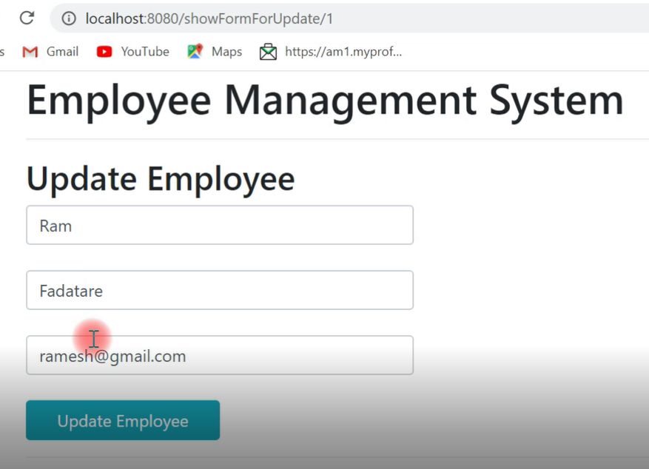
添加員工頁面

