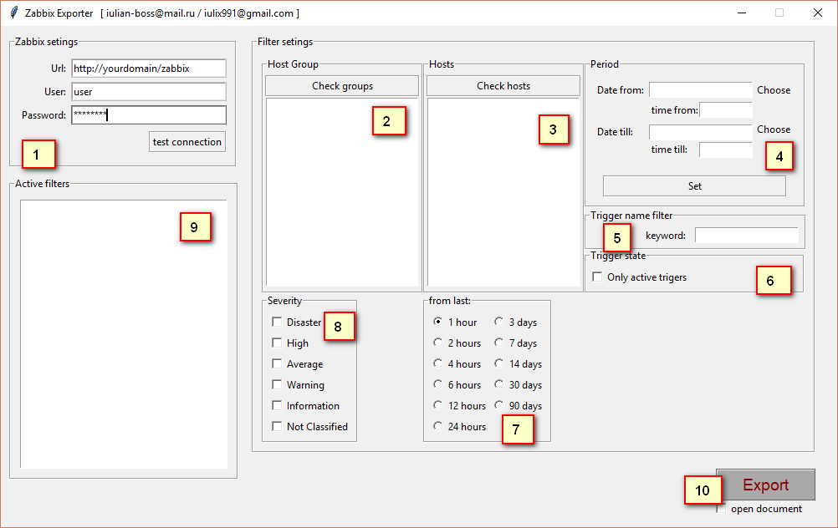

1. Set your credentials:

<url> [example: <http://yourdomain/zabbix>]

<user> [zabbix user]

<password> [zabbix password]

You can push [test connection] button to test your connection with server

1. You can check groups to set whose group you need to filter

<duble click to set filter>

<select and right click to view group hosts>

1. You can filter some hosts, by default all hosts

<duble click> to set host filter

1. You can set period from->till to view trigger of specific interval
2. Keyword filter, extract trigger with specific frase in name

<press enter to set>

<example> trigger name: free disk space is less than 20% <keyword> -> disk

1. If you active checkbox will extract only triggers with status “problem”
2. Set from which time ago {do not stack with point 7}
3. Set severity triggers {by default all}
4. List of all seted filters
5. Export button, [start export]

Checkbox open document will open document after export finish

Result file will look like:

