Program logic:  
1. With trigger.get we obtain all triggers on the specified period of time  
2. For every trigger we obtain the eventids for the specified period  
3. For every eventid we get eventid full data (object name, tag, value (event_state), severity, clock,

recovery_eventid and so on)  
3.1. If event have recovery event we make another request to obtain r_event time and with those data

we calculate the duration of the problem  
4. Write data to Excel file with a preformated template.

The name of the excel file is [HH_mm] YYYY-MM- DD.xlsx  
  
Notes:  
1. If in the excel file trigger will have only one row with the status of the trigger Resolved and without duration, this mean that problem was started before the specified period of time, and we can't calculate the duration  
2. If in the excel file for a trigger the first row had the status Resolved, the next row under this trigger will show when the problem was started with the status also: Resolved. This is a little incovenience, but that is.  
3. The program have the feature to be started under the command-line, the parameters are:   
--url     :set the URL of zabbix server: <http://IP/zabbix>  
--user  :set the user to connect to zabbix server  
--pass  :set the password to connect to zabbix server  
--autorun  1  :will start the program in minimized mode and run by default a report for 1 hour and

export the data (in this case don't need to specify --hour)  
--hour 1  :will set the time from --hours ago (the parameter autostart need to be indicated to

automatically export the data) - must be an integer value  
--quit 1 : :will close the program after export

--utc: :{ex: +1,-2} will set automatically timezone in main filter list

--opendoc :{1 -> open, other-> nothing} will open automatically document after finish

--host : will set automatically indicated host to main filter, if host is written wrong( do not exists)

then will export triggers like this host filter do not exists

--group :will set automatically indicated group to main filter, if group is written wrong

( do not exists) then program will ignore this filter

--onlyactive 1 :will set to filer only active trigers  
  
The parameters short version: --user = -u; --pass = -p; --hour = -h; --quit = -q, --group = -g  
  
to run python version  
1. install python3.0+(don't forget to check to add to PATH)  
2. in command-line: pip install  
3. in command-line: pip install requests  
4. in command-line: pip install pypiwin32  
5. in command-line: pip install xlsxwriter

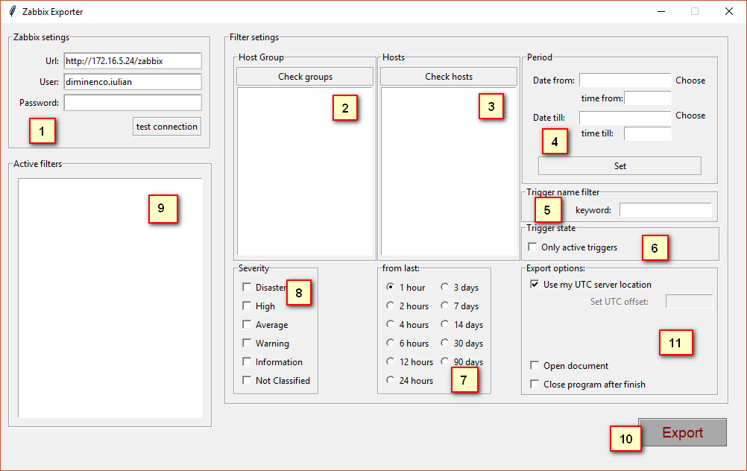

1. Set your credentials:

<url> [example: <http://yourdomain/zabbix>]

<user> [zabbix user]

<password> [zabbix password]

You can push [test connection] button to test your connection with server

1. You can check groups to set whose group you need to filter

<double click to set filter>

<select and right click to view group hosts>

1. You can filter some hosts, by default all hosts

<double click> add host to filter

1. You can set period from->till to view trigger of specific interval

You can select <choose> or click on <date from:> or <date till:> to select date

<time from> <time till> set the time of <date from> or <date till> , do not use without <date_from>,<date_till>

! do not forget click <set> to add timestamps to main filter

1. Keyword filter, extract trigger with specific phrase in name

<press enter to set>

{example} [trigger name: free disk space is less than 20% ] <keyword> -> disk

1. If you checked checkbox <only active triggers> will extract only problems with status “problem”
2. Set from which time ago {do not stack with point [4]}
3. Set severity triggers {by default all}
4. List of all indicated filters
5. Export button, [start export]
6. Export Options

<Checkbox use my UTC server location> If your zabbix server is in other timezone you can indicate this with uncheck checkbox and indicate server timezone (example [+2][-2])

<Checkbox open document> after finish exporting will open excel document automatically

<Checkbox open program after finish> will close program after exporting

Result file will look like:

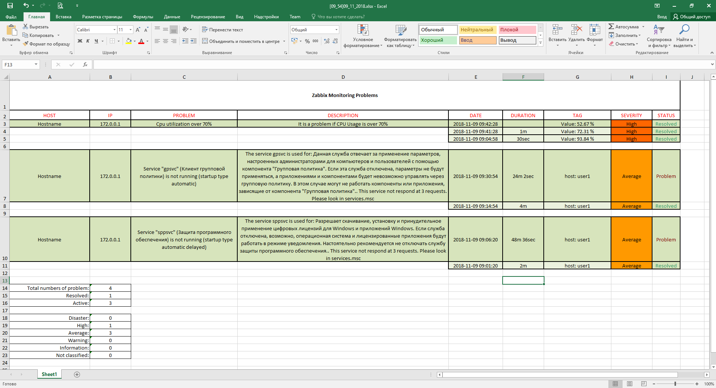

Main Rows: (a bit darker) [row 3,7,10]

Every row will show information about trigger ( hostname, host ip, which problem, description,)

If row have problem resolved, Date will show you when problem have closed, with which tag,

problem severity and actual state

Sub Rows: (a bit lighter)

Every subrow will show statistic about when the trigger was in problem state

<Date> then started problem

<Duration> How long was in problem state

<Severity> problem severity

<Status> subrows shows you when problem was in problem state so considering that

the problem is already resolved so the status will always [Resolved]