Hello Every one if do you want extract ( download ) graphs from zabbix-server you can use my program:

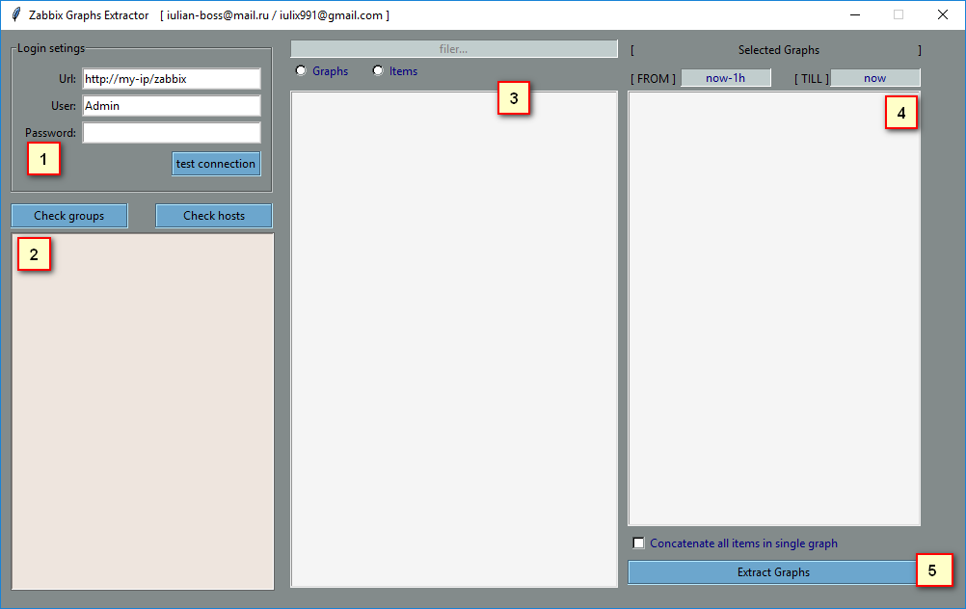

Usage is very simple just set your credentials in login settings and navigate, select graphs from hosts or hostgroups and exctract it

Program parts:

1. Login settings set in url field your zabbix server url ,for example { <http://172.0.0.1/zabbix> or <http://youtdomain/zabbix> }

In user and password field set your credentials like in zabbix

You can push [test connection] if do you want verify if connection exists

1. In second part do you can click [check groups] or [check hosts] to see bottom all hosts or all host-groups

Clicking one host group you will see to the right all graphs for this group

Clicking a right mouse button you will see all hosts from this group

Clicking one host you will see all his graph and items

1. In this part you can see all the graph from selected host/group, if you selected host you can change between graphs and items, [double-click] to select graph or item to download image

Also in filter field you can search items/graphs with specific name

Few right at radio-buttons you will see name of the selected host/group

1. In this part you will see all selected items/graphs , on top – select graphs interval, its can be:

[now-1d],[now-1h],[now-3600s] or datestamp format [YYYY-MM-dd HH:mm:ss]

In list you will see selected graphs with blue and items with orange, the items can possibility to concatenate in one graph, for this check the checkbox [concatenate all items in single graph]

or double click on items to set specific

[Extract Graphs] button will download all selected graphs in png format and place it in dd_MM_YYYY folder, where the program was opened

For bags and sugestions you can write email: [Iulian-boss@mail.ru](mailto:Iulian-boss@mail.ru) / [iulix991@gmail.com](mailto:iulix991@gmail.com)