DYNAMIC DISTILLATION / COMPLETED RUN

C3C4_QR_xB_C3_control_continue2400s_QR65_Qc65_20260717
Continue_40min_to_bottoms_C3_target_with_QR65_Qc65
RUN VALIDITY  USABLE | DYNAMIC GATE  PASS | FINAL SCORE  0.380 | SIM / WALL  0.188

Run Identity
Item | Value
Run ID | 20260717_111627
Started | 2026-07-17 11:16:27
Completed | 2026-07-17 14:49:26
Run type | Continuation from native checkpoint
Input workbook | C:\Users\Thomas Zvolensky\Documents\Python Scripts\Dynamic_DistillationII\logs\c3c4_initializer_residual_vapor_state_stage2_20260706.xlsx
Input checkpoint | C:\Users\Thomas Zvolensky\Documents\Python Scripts\Dynamic_DistillationII\logs\c3c4_QR_xB_C3_control_300s_Qc65_dwsim_20260716\c3c4_initializer_residual_vapor_state_stage2_20260706__checkpoint_20260716_165553.npz
Summary data | C:\Users\Thomas Zvolensky\Documents\Python Scripts\Dynamic_DistillationII\logs\c3c4_QR_xB_C3_control_continue2400s_QR65_Qc65_20260717\column_summary_20260717_111627.csv
Tray-profile data | C:\Users\Thomas Zvolensky\Documents\Python Scripts\Dynamic_DistillationII\logs\c3c4_QR_xB_C3_control_continue2400s_QR65_Qc65_20260717\column_profile_20260717_111627.csv

Operating Snapshot
Parameter | Start | End | Units
Feed | 7,142.98 | 7,142.98 | lbmol/h
Distillate | 2,386.93 | 2,983.79 | lbmol/h
Bottoms | 4,761.98 | 4,692.97 | lbmol/h
Reflux | Not reported | 5,967.32 | lbmol/h
Top pressure | 222.619 | 223.112 | psia
Bottom pressure | 311.523 | 232.184 | psia
Distillate temperature | 113.43 | 113.43 | deg F
Bottoms temperature | 211.76 | 214.47 | deg F
Condenser duty | Not reported | -53.598 | MMBtu/h
Reboiler duty | Not reported | 57.797 | MMBtu/h
Distillate drum level | Not reported | 51.98 | %
Bottoms sump level | Not reported | 48.99 | %
Steady-state score | Not reported | 0.3804 | -

Product Composition
Component | Distillate start | Distillate end | Bottoms start | Bottoms end
n-Butane | 6.368% | 7.028% | 72.286% | 78.143%
n-Pentane | 0.006% | 0.004% | 15.158% | 16.726%
n-Propane | 93.626% | 92.968% | 12.556% | 5.132%
source | Not reported | Not reported | Not reported | Not reported

Dynamic Trends
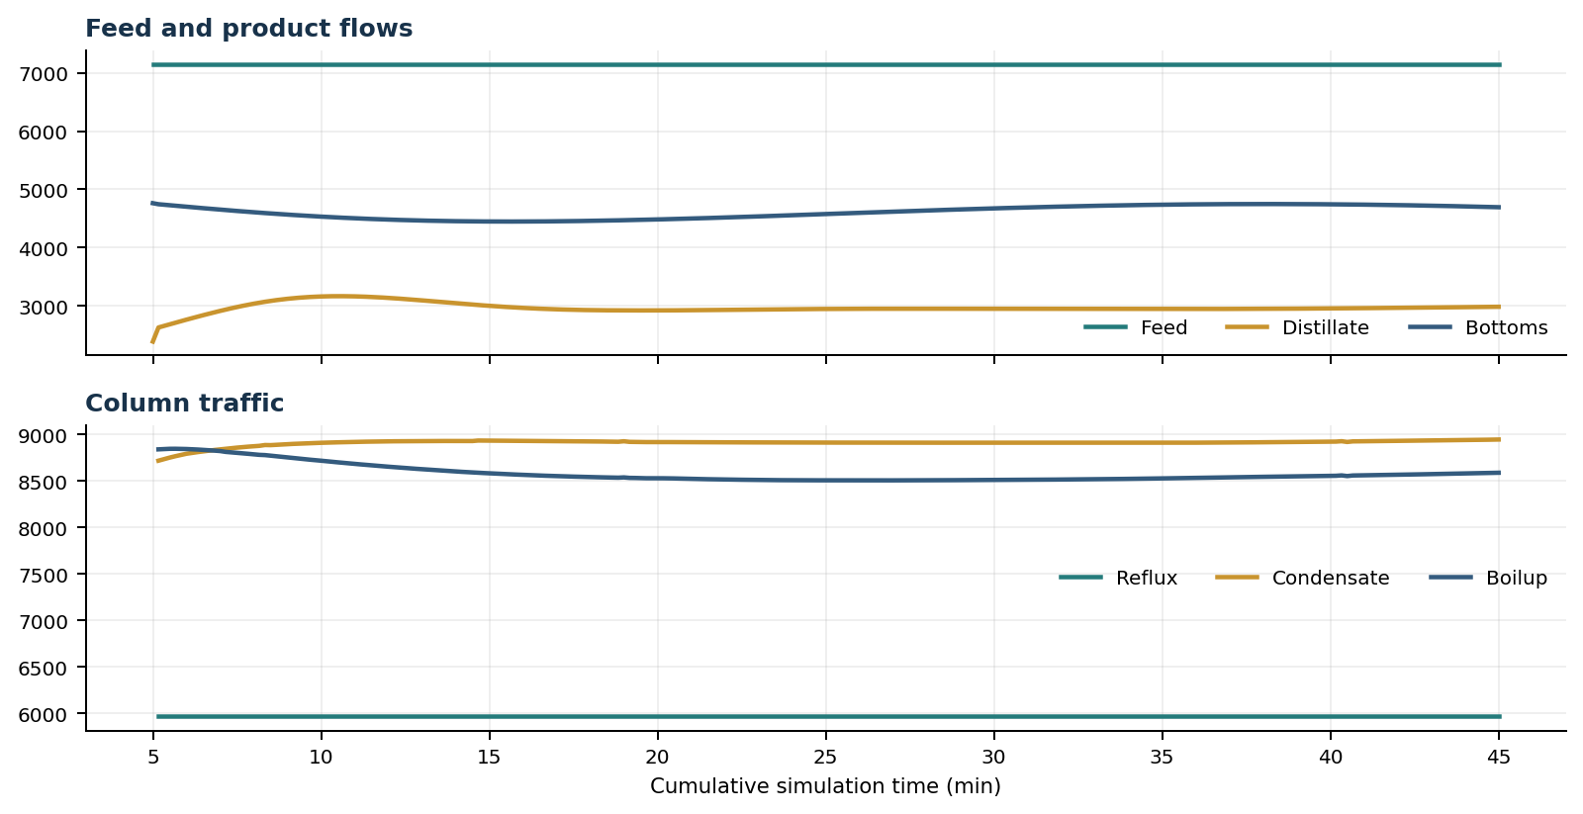
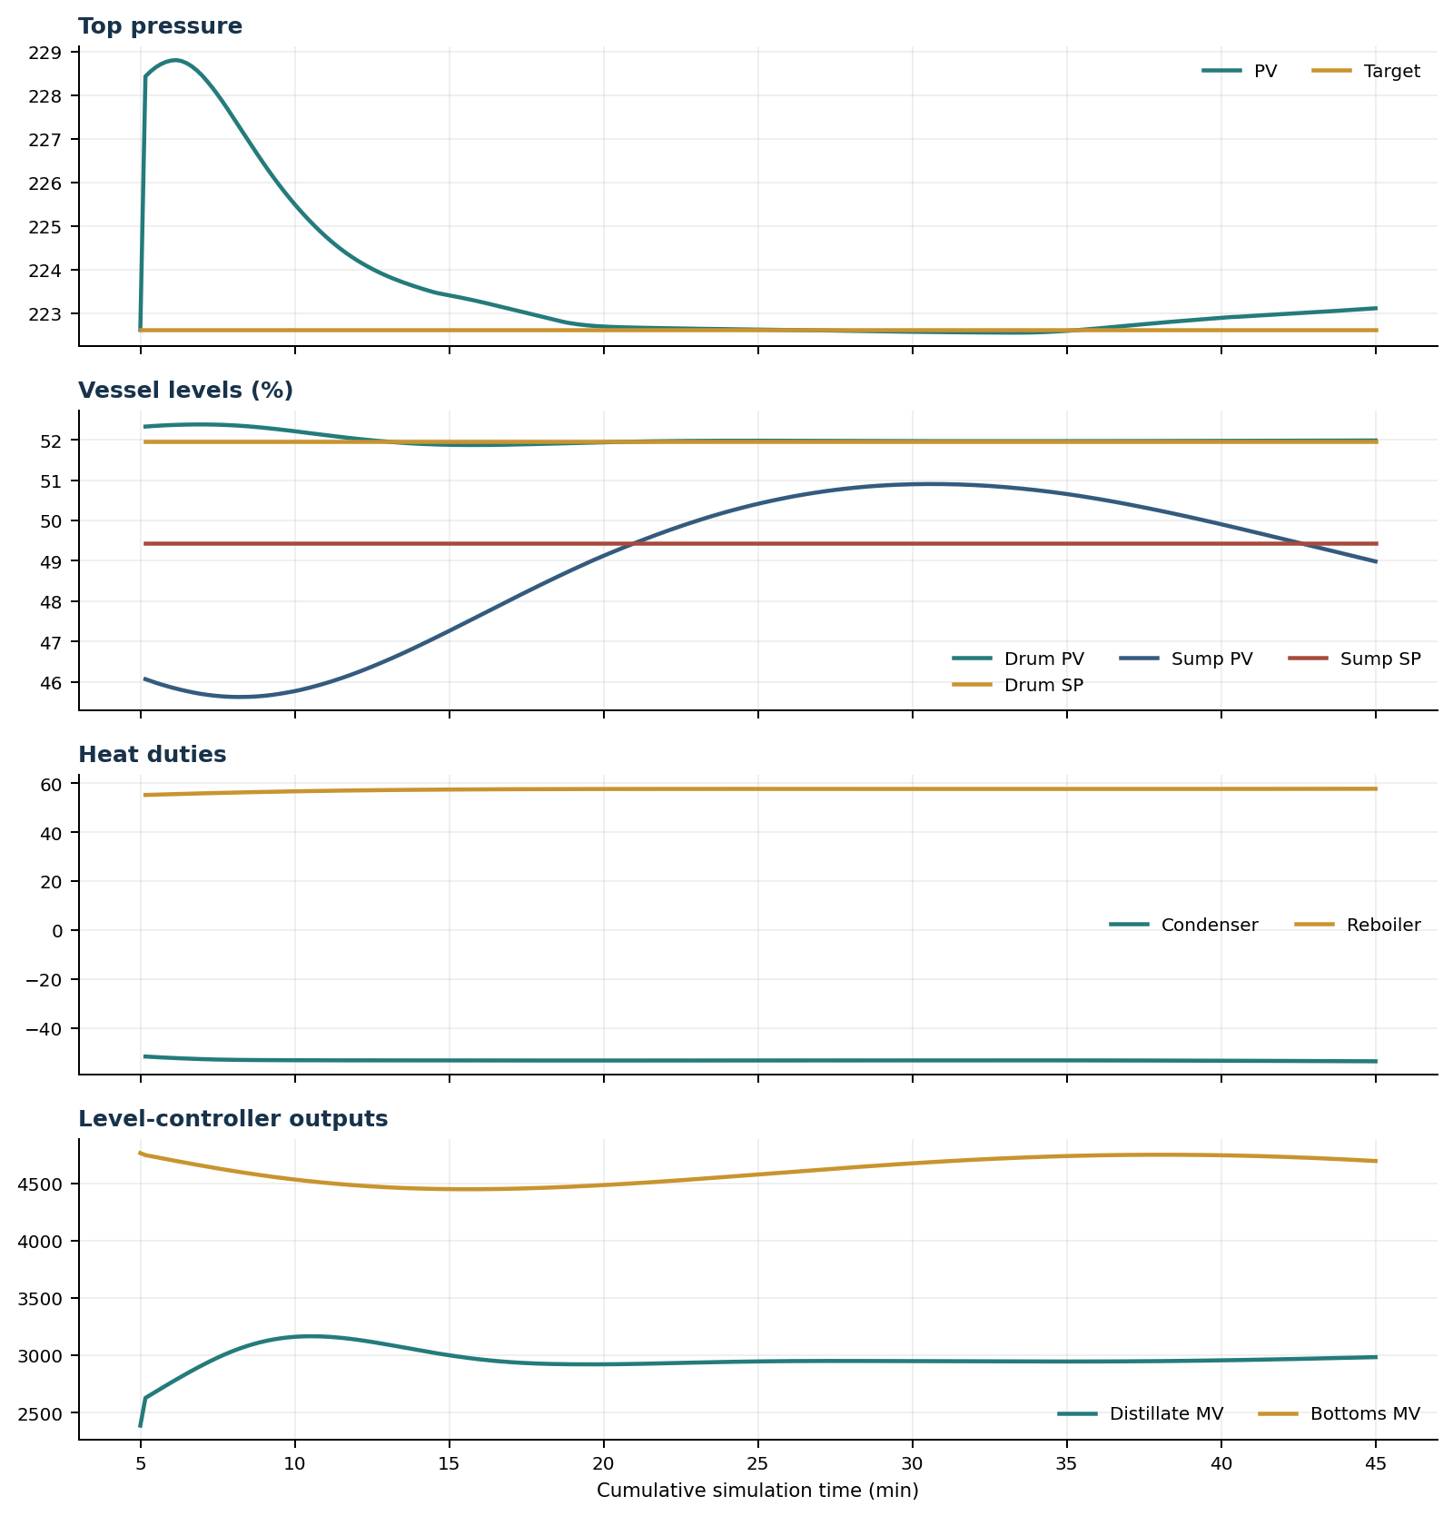

Final Tray Profiles
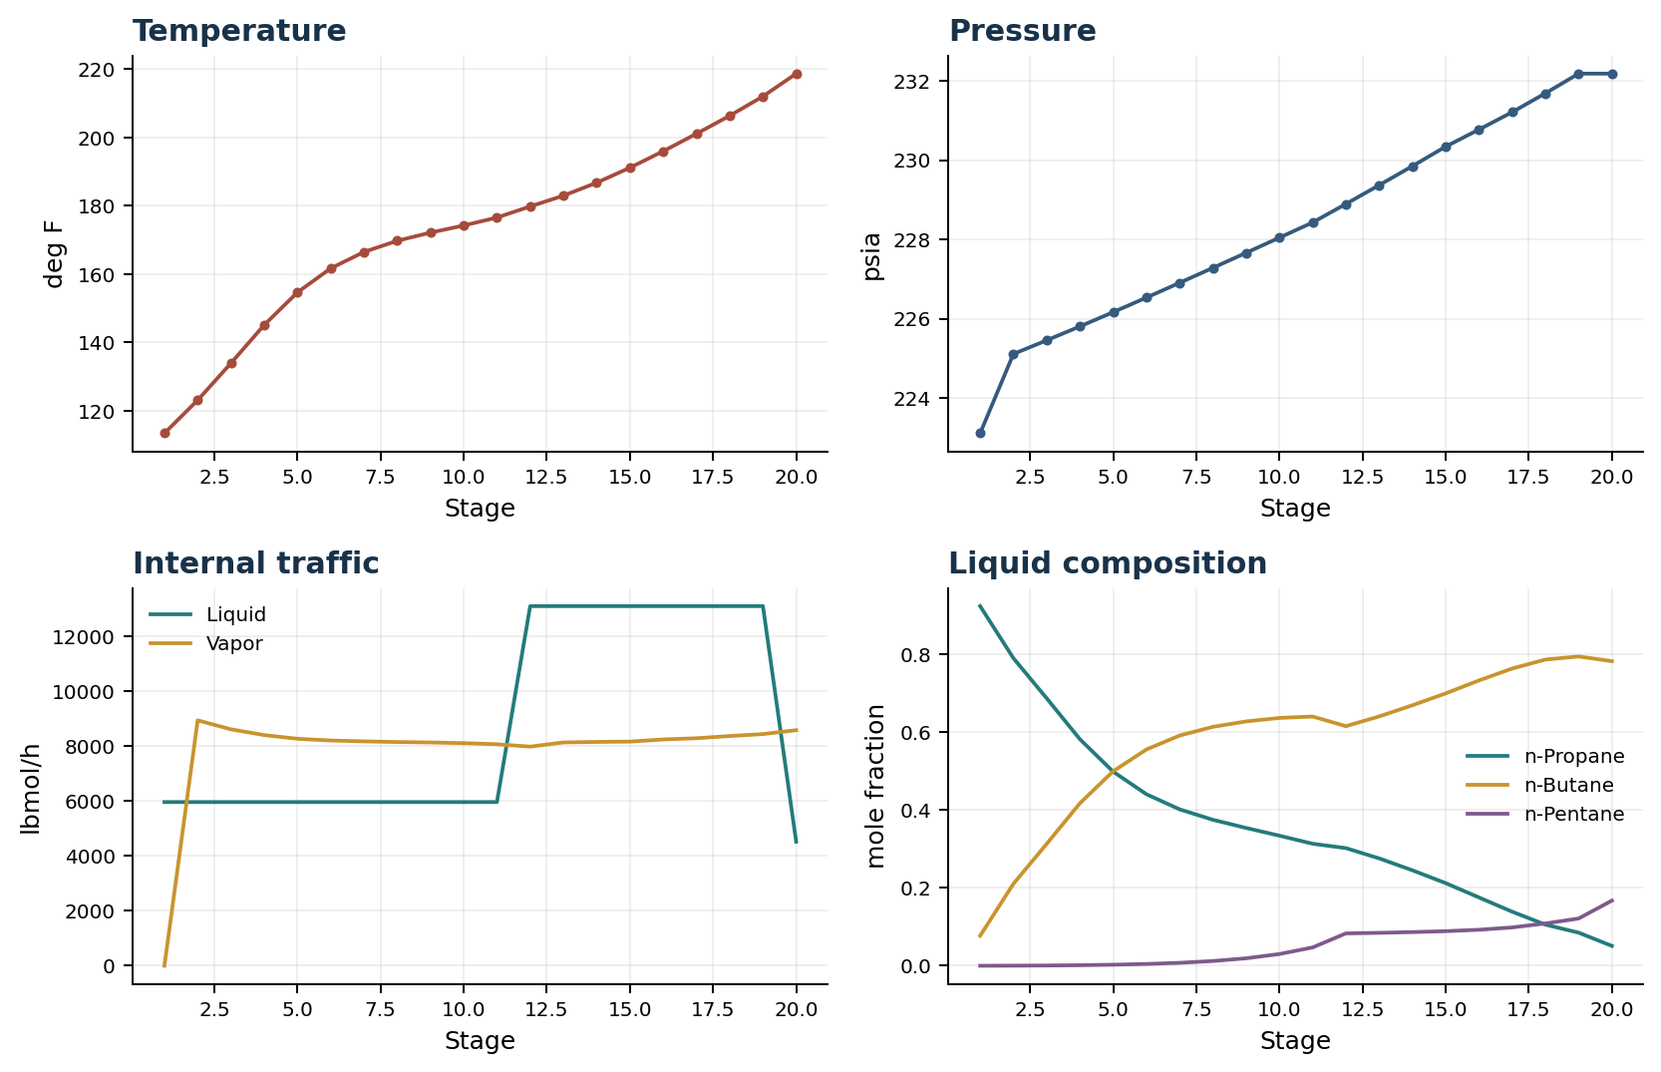

Final Tray Profile Table
Stage | T (deg F) | P (psia) | L (lbmol/h) | V (lbmol/h) | x n-Propane | x n-Butane | x n-Pentane | y n-Propane | y n-Butane | y n-Pentane
1 | 113.43 | 223.112 | 5,967.3 | 0.0 | 0.9229 | 0.0770 | 0.0001 | 0.0000 | 0.0000 | 0.0000
2 | 123.13 | 225.112 | 5,967.3 | 8,947.6 | 0.7893 | 0.2104 | 0.0003 | 0.9229 | 0.0770 | 0.0001
3 | 133.94 | 225.457 | 5,967.3 | 8,619.5 | 0.6865 | 0.3128 | 0.0007 | 0.8243 | 0.1754 | 0.0003
4 | 145.12 | 225.807 | 5,967.3 | 8,410.1 | 0.5814 | 0.4171 | 0.0015 | 0.7506 | 0.2489 | 0.0006
5 | 154.66 | 226.167 | 5,967.3 | 8,275.7 | 0.4982 | 0.4991 | 0.0027 | 0.6746 | 0.3242 | 0.0011
6 | 161.69 | 226.534 | 5,967.3 | 8,212.7 | 0.4403 | 0.5551 | 0.0047 | 0.6143 | 0.3836 | 0.0021
7 | 166.49 | 226.907 | 5,967.3 | 8,180.1 | 0.4015 | 0.5909 | 0.0076 | 0.5723 | 0.4241 | 0.0036
8 | 169.76 | 227.284 | 5,967.3 | 8,157.4 | 0.3747 | 0.6131 | 0.0122 | 0.5442 | 0.4499 | 0.0059
9 | 172.16 | 227.664 | 5,967.3 | 8,140.0 | 0.3537 | 0.6271 | 0.0192 | 0.5250 | 0.4657 | 0.0093
10 | 174.24 | 228.046 | 5,967.3 | 8,116.0 | 0.3339 | 0.6360 | 0.0301 | 0.5098 | 0.4756 | 0.0146
11 | 176.57 | 228.429 | 5,967.3 | 8,075.8 | 0.3132 | 0.6397 | 0.0471 | 0.4952 | 0.4820 | 0.0228
12 | 179.82 | 228.897 | 13,110.3 | 7,989.2 | 0.3020 | 0.6149 | 0.0831 | 0.4798 | 0.4848 | 0.0354
13 | 182.97 | 229.370 | 13,110.3 | 8,141.9 | 0.2756 | 0.6398 | 0.0846 | 0.4440 | 0.5188 | 0.0373
14 | 186.77 | 229.851 | 13,110.3 | 8,160.8 | 0.2450 | 0.6685 | 0.0864 | 0.4014 | 0.5590 | 0.0396
15 | 191.16 | 230.343 | 13,110.3 | 8,171.9 | 0.2122 | 0.6990 | 0.0888 | 0.3523 | 0.6050 | 0.0427
16 | 195.99 | 230.773 | 13,110.3 | 8,250.5 | 0.1754 | 0.7322 | 0.0924 | 0.3001 | 0.6534 | 0.0464
17 | 201.09 | 231.212 | 13,110.3 | 8,295.1 | 0.1388 | 0.7627 | 0.0984 | 0.2421 | 0.7056 | 0.0523
18 | 206.36 | 231.688 | 13,110.3 | 8,375.1 | 0.1056 | 0.7858 | 0.1086 | 0.1850 | 0.7532 | 0.0618
19 | 212.04 | 232.184 | 13,110.3 | 8,446.2 | 0.0850 | 0.7937 | 0.1213 | 0.1337 | 0.7885 | 0.0778
20 | 218.70 | 232.184 | 4,522.1 | 8,588.2 | 0.0510 | 0.7817 | 0.1672 | 0.1029 | 0.8000 | 0.0971

Simulation Configuration
Parameter | Value
Runtime Mode | hydraulic
Thermo Mode | dwsim
Dwsim Property Package | pr
Integrator | explicit-euler
N Steps | 12000
Dt Sec | 0.2
Log Every N Steps | 50
Thermo Every N Steps | 1
Include Energy | True
Enable Equilibrium Relaxation | True
Equilibrium Relaxation Mode | composition-exponential
Equilibrium Tau Sec | 0.5
Flash Feed At Stage Conditions | True
Enable Liquid Hydraulic Override | True
Liquid Hydraulic Model | francis
Liquid Hydraulic Override Alpha | 0.25
Enable Level Control | True
Top Level Pv Mode | true-level
Top Level Kc | 20.0
Top Level Ti Sec | 120.0
Bottom Level Pv Mode | true-level
Bottom Level Kc | 3.0
Bottom Level Ti Sec | 300.0
Enable Pressure Control | True
Pressure Control Mv | condenser-duty
Top Pressure Sp Psia | 222.6194497041178
Top Pressure Kc | -300000.0
Top Pressure Ti Sec | 180.0
Top Pressure Pv Filter Tau Sec | 5.0
Top Pressure Mv Slew Limit Per S | 25000.0
Condenser Duty Mode | specified
Condenser Duty Btu Per H | -51600000.0
Condenser Duty Min Btu Per H | -65000000.0
Condenser Duty Max Btu Per H | -46000000.0
Reboiler Duty Btu Per H | 49340000.0
Vapor Holdup Relaxation Sec | 0.0
Vapor Flow Relaxation Sec | 0.0
Vapor Flow Zero Temperature Target | True
Dynamic Vflow Nominal Hi Ratio | 1.05
Steady State Window Sec | 30.0
Steady State Min Time Sec | 60.0
Steady State Rel State Rate Tol Per S | 0.003
Steady State Temp Rate Tol F Per S | 0.15
Steady State Sp Error Tol | 0.02
Steady State Require Sp | False

Exact Launch Command
"C:\Users\Thomas Zvolensky\anaconda3\python.exe" -m dynamic_distillation.dynamic_run_scaffold_v1 --excel logs\c3c4_initializer_residual_vapor_state_stage2_20260706.xlsx --init-from-checkpoint "C:\Users\Thomas Zvolensky\Documents\Python Scripts\Dynamic_DistillationII\logs\c3c4_QR_xB_C3_control_300s_Qc65_dwsim_20260716\c3c4_initializer_residual_vapor_state_stage2_20260706__checkpoint_20260716_165553.npz" --run-name C3C4_QR_xB_C3_control_continue2400s_QR65_Qc65_20260717 --run-description Continue_40min_to_bottoms_C3_target_with_QR65_Qc65 --runtime-mode hydraulic --thermo dwsim --dwsim-property-package pr --include-energy --equilibrium-relaxation-mode composition-exponential --equilibrium-tau-sec 0.5 --flash-feed-at-stage-conditions --enable-liquid-hydraulic-override --liquid-hydraulic-model francis --liquid-hydraulic-override-alpha 0.25 --enable-level-control --ignore-workbook-level-pv-mode --top-level-pv-mode true-level --bottom-level-pv-mode true-level --top-level-kc 20 --top-level-ti 120 --bottom-level-kc 3 --bottom-level-ti 300 --enable-pressure-control --pressure-control-mv condenser-duty --top-pressure-sp 222.6194497041178 --top-pressure-kc -300000 --top-pressure-ti 180 --top-pressure-pv-filter-tau-sec 5 --top-pressure-mv-slew-limit-per-s 25000 --condenser-duty-mode specified --condenser-duty-btuph -51600000 --condenser-duty-min-btuph -65000000 --condenser-duty-max-btuph -46000000 --enable-top-drum-resident-condensation --top-drum-resident-condensation-tau-sec 30 --top-drum-resident-condensation-max-frac-per-step 0.10 --reflux 5967.322711692588 --vapor-holdup-relaxation-sec 0 --vapor-flow-relaxation-sec 0 --vapor-flow-zero-temperature-target --use-excel-vapor-holdup --dynamic-vflow-nominal-hi-ratio 1.05 --disable-startup-thermo-conditioning --disable-restart-reentry-settling --enable-bottoms-composition-control --bottoms-comp-component C3 --bottoms-comp-sp 0.04717 --bottoms-comp-kc 50000000 --bottoms-comp-ti 600 --bottoms-comp-mv reboiler-duty --reboiler-duty-btuph 49340000 --reboiler-duty-cmd-min-btuph 45000000 --reboiler-duty-cmd-max-btuph 65000000 --n-steps 12000 --dt 0.2 --log-every 50 --logs-dir logs\c3c4_QR_xB_C3_control_continue2400s_QR65_Qc65_20260717 --allow-repeat-command

