DYNAMIC DISTILLATION / COMPLETED RUN

C3C4_QR_xB_C3_control_continue2700s_QR65_20260716
Continue_bottoms_C3_control_45min_with_QR_limit_65MMBtuhr
RUN VALIDITY  REVIEW | DYNAMIC GATE  PASS | FINAL SCORE  0.913 | SIM / WALL  0.180
AUTOMATED ASSESSMENT Top pressure is 2.32 psi from its logged target, so the rate gate does not establish acceptable pressure control.

Run Identity
Item | Value
Run ID | 20260716_095832
Started | 2026-07-16 09:58:32
Completed | 2026-07-16 14:07:56
Run type | Continuation from native checkpoint
Input workbook | C:\Users\Thomas Zvolensky\Documents\Python Scripts\Dynamic_DistillationII\logs\c3c4_initializer_residual_vapor_state_stage2_20260706.xlsx
Input checkpoint | C:\Users\Thomas Zvolensky\Documents\Python Scripts\Dynamic_DistillationII\logs\c3c4_QR_xB_C3_control_continue300s_20260716\c3c4_initializer_residual_vapor_state_stage2_20260706__checkpoint_20260716_092914.npz
Summary data | C:\Users\Thomas Zvolensky\Documents\Python Scripts\Dynamic_DistillationII\logs\c3c4_QR_xB_C3_control_continue2700s_QR65_20260716\column_summary_20260716_095832.csv
Tray-profile data | C:\Users\Thomas Zvolensky\Documents\Python Scripts\Dynamic_DistillationII\logs\c3c4_QR_xB_C3_control_continue2700s_QR65_20260716\column_profile_20260716_095832.csv

Operating Snapshot
Parameter | Start | End | Units
Feed | 7,142.98 | 7,142.98 | lbmol/h
Distillate | 2,386.93 | 3,128.20 | lbmol/h
Bottoms | 4,761.98 | 4,434.96 | lbmol/h
Reflux | Not reported | 5,967.32 | lbmol/h
Top pressure | 222.619 | 224.939 | psia
Bottom pressure | 314.167 | 232.263 | psia
Distillate temperature | 113.43 | 113.43 | deg F
Bottoms temperature | 208.01 | 213.65 | deg F
Condenser duty | Not reported | -55.000 | MMBtu/h
Reboiler duty | Not reported | 58.250 | MMBtu/h
Distillate drum level | Not reported | 52.04 | %
Bottoms sump level | Not reported | 47.01 | %
Steady-state score | Not reported | 0.9127 | -

Product Composition
Component | Distillate start | Distillate end | Bottoms start | Bottoms end
n-Butane | 6.379% | 8.427% | 72.356% | 77.765%
n-Pentane | 0.005% | 0.015% | 15.796% | 16.713%
n-Propane | 93.616% | 91.559% | 11.848% | 5.522%
source | Not reported | Not reported | Not reported | Not reported

Dynamic Trends
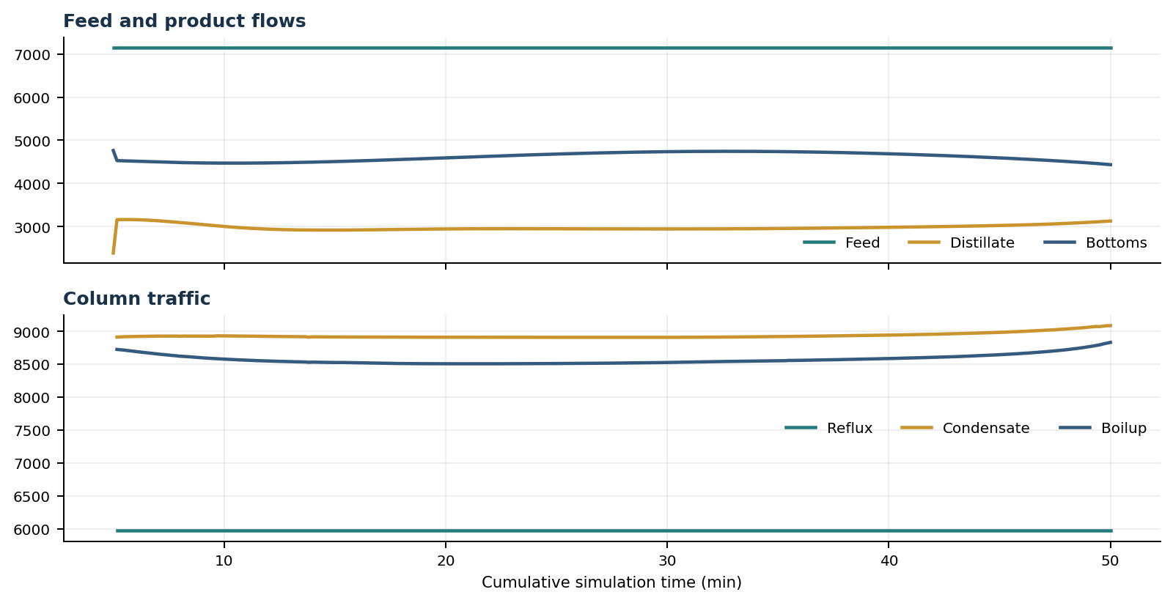
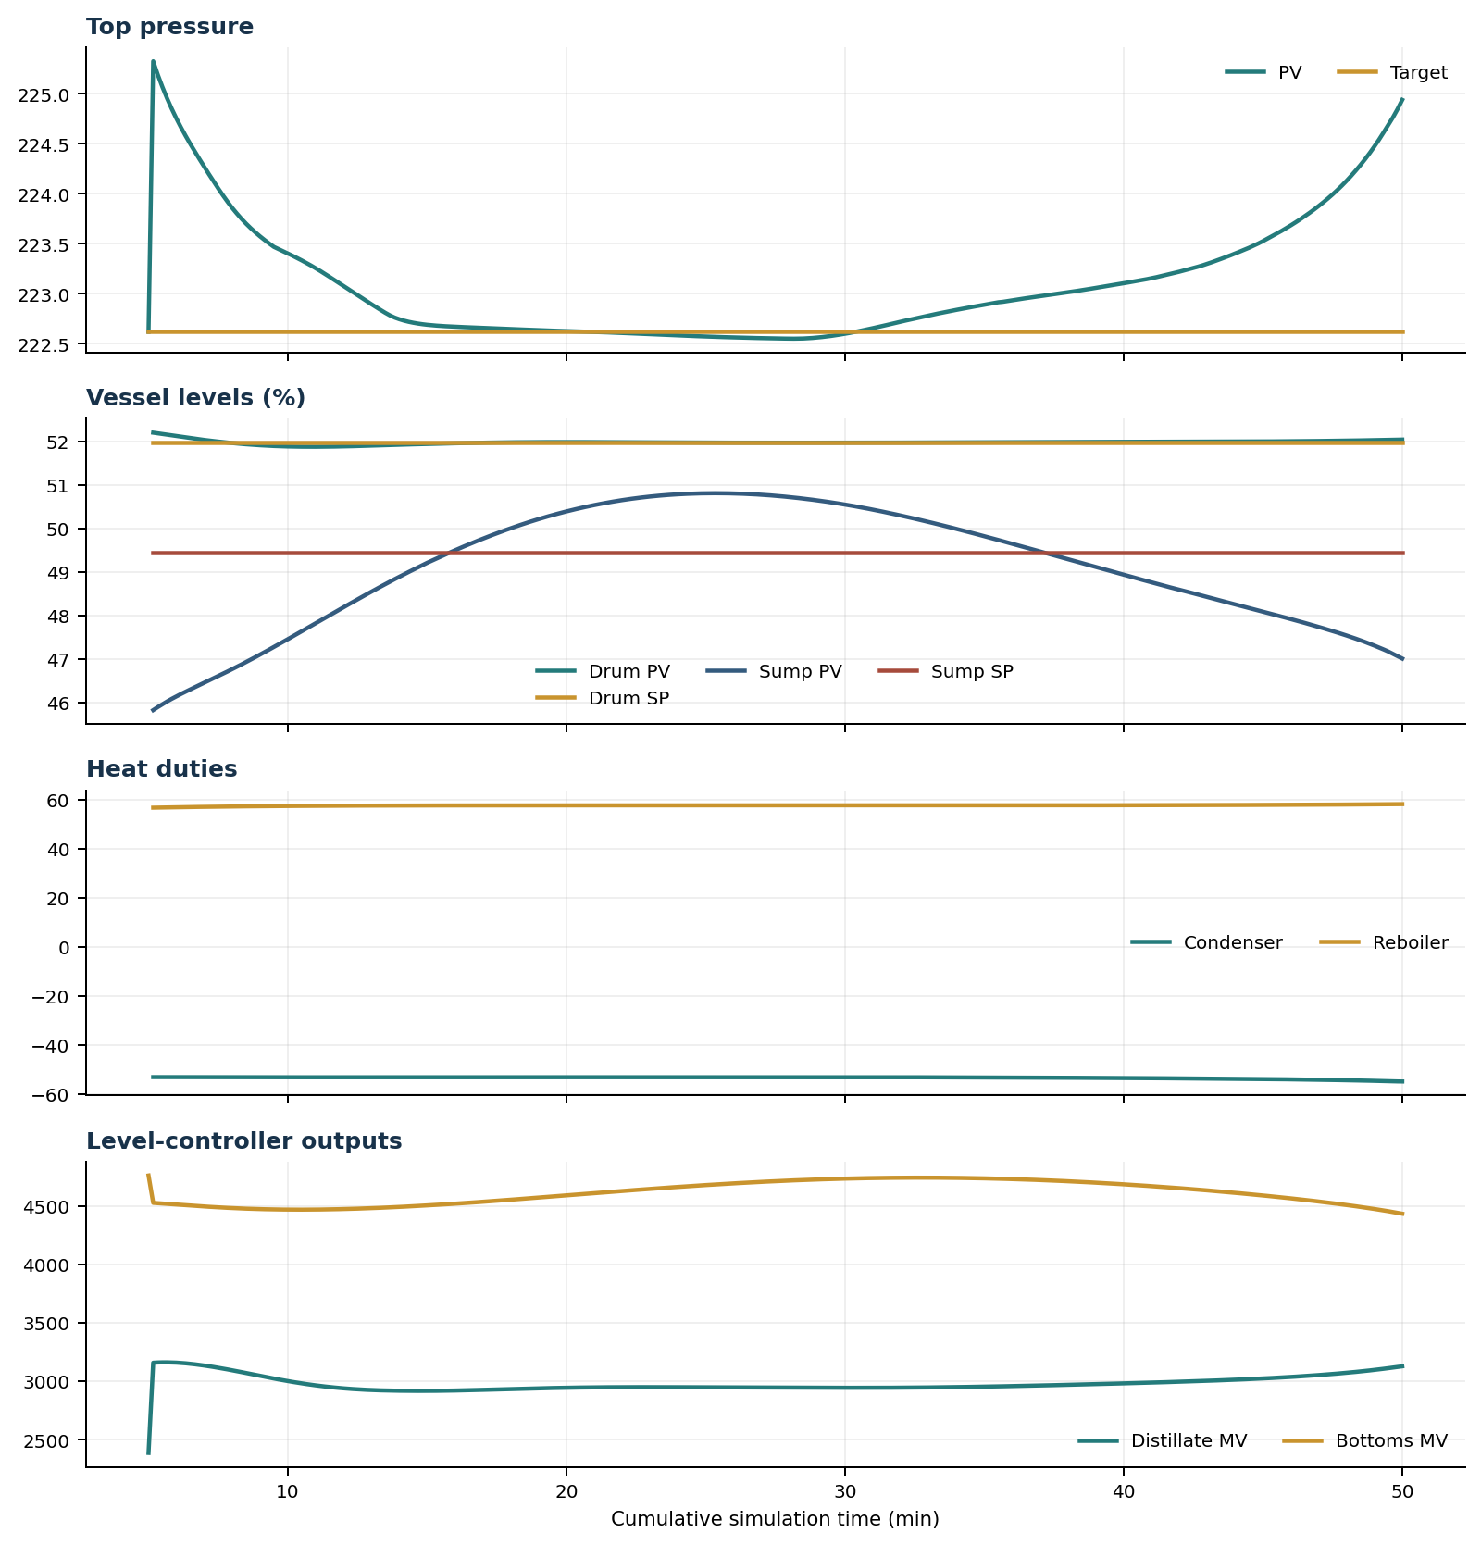

Final Tray Profiles
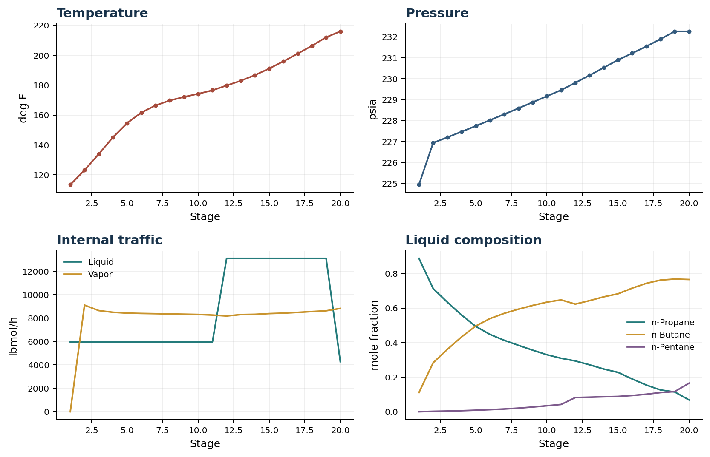

Final Tray Profile Table
Stage | T (deg F) | P (psia) | L (lbmol/h) | V (lbmol/h) | x n-Propane | x n-Butane | x n-Pentane | y n-Propane | y n-Butane | y n-Pentane
1 | 113.43 | 224.939 | 5,967.3 | 0.0 | 0.8877 | 0.1117 | 0.0006 | 0.0000 | 0.0000 | 0.0000
2 | 123.14 | 226.939 | 5,967.3 | 9,116.4 | 0.7131 | 0.2839 | 0.0030 | 0.8877 | 0.1117 | 0.0006
3 | 133.94 | 227.204 | 5,967.3 | 8,647.7 | 0.6340 | 0.3615 | 0.0045 | 0.7375 | 0.2592 | 0.0033
4 | 145.12 | 227.473 | 5,967.3 | 8,502.2 | 0.5597 | 0.4337 | 0.0066 | 0.6754 | 0.3194 | 0.0052
5 | 154.66 | 227.746 | 5,967.3 | 8,429.7 | 0.4941 | 0.4966 | 0.0094 | 0.6183 | 0.3739 | 0.0078
6 | 161.69 | 228.024 | 5,967.3 | 8,402.6 | 0.4477 | 0.5397 | 0.0126 | 0.5695 | 0.4195 | 0.0110
7 | 166.49 | 228.306 | 5,967.3 | 8,383.0 | 0.4138 | 0.5697 | 0.0165 | 0.5347 | 0.4507 | 0.0146
8 | 169.76 | 228.591 | 5,967.3 | 8,358.7 | 0.3846 | 0.5939 | 0.0215 | 0.5089 | 0.4724 | 0.0187
9 | 172.16 | 228.878 | 5,967.3 | 8,337.4 | 0.3567 | 0.6155 | 0.0278 | 0.4862 | 0.4903 | 0.0234
10 | 174.24 | 229.167 | 5,967.3 | 8,314.4 | 0.3304 | 0.6344 | 0.0352 | 0.4643 | 0.5068 | 0.0289
11 | 176.57 | 229.458 | 5,967.3 | 8,263.5 | 0.3098 | 0.6476 | 0.0427 | 0.4447 | 0.5209 | 0.0344
12 | 179.82 | 229.809 | 13,110.3 | 8,184.8 | 0.2943 | 0.6232 | 0.0826 | 0.4311 | 0.5301 | 0.0388
13 | 182.97 | 230.165 | 13,110.3 | 8,306.2 | 0.2721 | 0.6432 | 0.0847 | 0.3860 | 0.5714 | 0.0427
14 | 186.77 | 230.528 | 13,110.3 | 8,327.0 | 0.2477 | 0.6652 | 0.0871 | 0.3525 | 0.6017 | 0.0457
15 | 191.16 | 230.897 | 13,110.3 | 8,391.0 | 0.2284 | 0.6826 | 0.0890 | 0.3165 | 0.6341 | 0.0494
16 | 195.99 | 231.218 | 13,110.3 | 8,428.3 | 0.1903 | 0.7154 | 0.0944 | 0.2910 | 0.6569 | 0.0521
17 | 201.09 | 231.546 | 13,110.3 | 8,491.9 | 0.1548 | 0.7433 | 0.1019 | 0.2366 | 0.7031 | 0.0602
18 | 206.36 | 231.898 | 13,110.3 | 8,564.8 | 0.1265 | 0.7621 | 0.1114 | 0.1865 | 0.7416 | 0.0719
19 | 212.04 | 232.263 | 13,110.3 | 8,629.0 | 0.1149 | 0.7679 | 0.1172 | 0.1486 | 0.7652 | 0.0862
20 | 216.00 | 232.263 | 4,277.1 | 8,833.2 | 0.0689 | 0.7655 | 0.1656 | 0.1372 | 0.7691 | 0.0937

Simulation Configuration
Parameter | Value
Runtime Mode | hydraulic
Thermo Mode | dwsim
Dwsim Property Package | pr
Integrator | explicit-euler
N Steps | 13500
Dt Sec | 0.2
Log Every N Steps | 50
Thermo Every N Steps | 1
Include Energy | True
Enable Equilibrium Relaxation | True
Equilibrium Relaxation Mode | composition-exponential
Equilibrium Tau Sec | 0.5
Flash Feed At Stage Conditions | True
Enable Liquid Hydraulic Override | True
Liquid Hydraulic Model | francis
Liquid Hydraulic Override Alpha | 0.25
Enable Level Control | True
Top Level Pv Mode | true-level
Top Level Kc | 20.0
Top Level Ti Sec | 120.0
Bottom Level Pv Mode | true-level
Bottom Level Kc | 3.0
Bottom Level Ti Sec | 300.0
Enable Pressure Control | True
Pressure Control Mv | condenser-duty
Top Pressure Sp Psia | 222.6194497041178
Top Pressure Kc | -300000.0
Top Pressure Ti Sec | 180.0
Top Pressure Pv Filter Tau Sec | 5.0
Top Pressure Mv Slew Limit Per S | 25000.0
Condenser Duty Mode | specified
Condenser Duty Btu Per H | -51600000.0
Condenser Duty Min Btu Per H | -55000000.0
Condenser Duty Max Btu Per H | -46000000.0
Reboiler Duty Btu Per H | 49340000.0
Vapor Holdup Relaxation Sec | 0.0
Vapor Flow Relaxation Sec | 0.0
Vapor Flow Zero Temperature Target | True
Dynamic Vflow Nominal Hi Ratio | 1.05
Steady State Window Sec | 30.0
Steady State Min Time Sec | 60.0
Steady State Rel State Rate Tol Per S | 0.003
Steady State Temp Rate Tol F Per S | 0.15
Steady State Sp Error Tol | 0.02
Steady State Require Sp | False

Exact Launch Command
"C:\Users\Thomas Zvolensky\anaconda3\python.exe" -m dynamic_distillation.dynamic_run_scaffold_v1 --excel logs\c3c4_initializer_residual_vapor_state_stage2_20260706.xlsx --init-from-checkpoint "C:\Users\Thomas Zvolensky\Documents\Python Scripts\Dynamic_DistillationII\logs\c3c4_QR_xB_C3_control_continue300s_20260716\c3c4_initializer_residual_vapor_state_stage2_20260706__checkpoint_20260716_092914.npz" --run-name C3C4_QR_xB_C3_control_continue2700s_QR65_20260716 --run-description Continue_bottoms_C3_control_45min_with_QR_limit_65MMBtuhr --runtime-mode hydraulic --thermo dwsim --dwsim-property-package pr --include-energy --equilibrium-relaxation-mode composition-exponential --equilibrium-tau-sec 0.5 --flash-feed-at-stage-conditions --enable-liquid-hydraulic-override --liquid-hydraulic-model francis --liquid-hydraulic-override-alpha 0.25 --enable-level-control --ignore-workbook-level-pv-mode --top-level-pv-mode true-level --bottom-level-pv-mode true-level --top-level-kc 20 --top-level-ti 120 --bottom-level-kc 3 --bottom-level-ti 300 --enable-pressure-control --pressure-control-mv condenser-duty --top-pressure-sp 222.6194497041178 --top-pressure-kc -300000 --top-pressure-ti 180 --top-pressure-pv-filter-tau-sec 5 --top-pressure-mv-slew-limit-per-s 25000 --condenser-duty-mode specified --condenser-duty-btuph -51600000 --condenser-duty-min-btuph -55000000 --condenser-duty-max-btuph -46000000 --enable-top-drum-resident-condensation --top-drum-resident-condensation-tau-sec 30 --top-drum-resident-condensation-max-frac-per-step 0.10 --reflux 5967.322711692588 --vapor-holdup-relaxation-sec 0 --vapor-flow-relaxation-sec 0 --vapor-flow-zero-temperature-target --use-excel-vapor-holdup --dynamic-vflow-nominal-hi-ratio 1.05 --disable-startup-thermo-conditioning --disable-restart-reentry-settling --enable-bottoms-composition-control --bottoms-comp-component C3 --bottoms-comp-sp 0.04717 --bottoms-comp-kc 50000000 --bottoms-comp-ti 600 --bottoms-comp-mv reboiler-duty --reboiler-duty-btuph 49340000 --reboiler-duty-cmd-min-btuph 45000000 --reboiler-duty-cmd-max-btuph 65000000 --n-steps 13500 --dt 0.2 --log-every 50 --logs-dir logs\c3c4_QR_xB_C3_control_continue2700s_QR65_20260716 --no-word-report --allow-repeat-command

