DYNAMIC DISTILLATION / COMPLETED RUN

C3C4_fixed_Q46_authority_probe
300s_fixed_minus46_MMBtuh_condenser_duty_without_pressure_PI
RUN VALIDITY  REVIEW | DYNAMIC GATE  PASS | FINAL SCORE  0.515 | SIM / WALL  0.247
AUTOMATED ASSESSMENT At least one geometry-based vessel level remains more than five percentage points from setpoint.

Run Identity
Item | Value
Run ID | 20260710_174923
Started | 2026-07-10 17:49:23
Completed | 2026-07-10 18:09:40
Run type | Continuation from native checkpoint
Input workbook | C:\Users\Thomas Zvolensky\Documents\Python Scripts\Dynamic_DistillationII\logs\c3c4_initializer_residual_vapor_state_stage2_20260706.xlsx
Input checkpoint | C:\Users\Thomas Zvolensky\Documents\Python Scripts\Dynamic_DistillationII\logs\c3c4_checkpoint900_bottomTi300_continue_900s_r2_20260710\c3c4_initializer_residual_vapor_state_stage2_20260706__checkpoint_20260710_113142.npz
Summary data | C:\Users\Thomas Zvolensky\Documents\Python Scripts\Dynamic_DistillationII\logs\c3c4_checkpoint1800_fixedQ46_continue_300s_20260710\column_summary_20260710_174923.csv
Tray-profile data | C:\Users\Thomas Zvolensky\Documents\Python Scripts\Dynamic_DistillationII\logs\c3c4_checkpoint1800_fixedQ46_continue_300s_20260710\column_profile_20260710_174923.csv

Operating Snapshot
Parameter | Start | End | Units
Feed | 7,142.98 | 7,142.98 | lbmol/h
Distillate | 2,386.93 | 1,849.93 | lbmol/h
Bottoms | 4,761.98 | 3,812.19 | lbmol/h
Reflux | Not reported | 5,967.32 | lbmol/h
Top pressure | 222.619 | 222.957 | psia
Bottom pressure | 316.632 | 232.177 | psia
Distillate temperature | 113.43 | 113.43 | deg F
Bottoms temperature | 248.11 | 253.39 | deg F
Condenser duty | Not reported | -46.000 | MMBtu/h
Reboiler duty | Not reported | 54.844 | MMBtu/h
Distillate drum controller PV | Not reported | 44.97 | lbmol
Bottoms sump controller PV | Not reported | 46.49 | lbmol
Steady-state score | Not reported | 0.5155 | -

Product Composition
Component | Distillate start | Distillate end | Bottoms start | Bottoms end
n-Butane | 15.210% | 19.581% | 65.447% | 63.654%
n-Pentane | 0.686% | 1.259% | 13.971% | 13.711%
n-Propane | 84.104% | 79.160% | 20.582% | 22.635%
source | Not reported | Not reported | Not reported | Not reported

Dynamic Trends
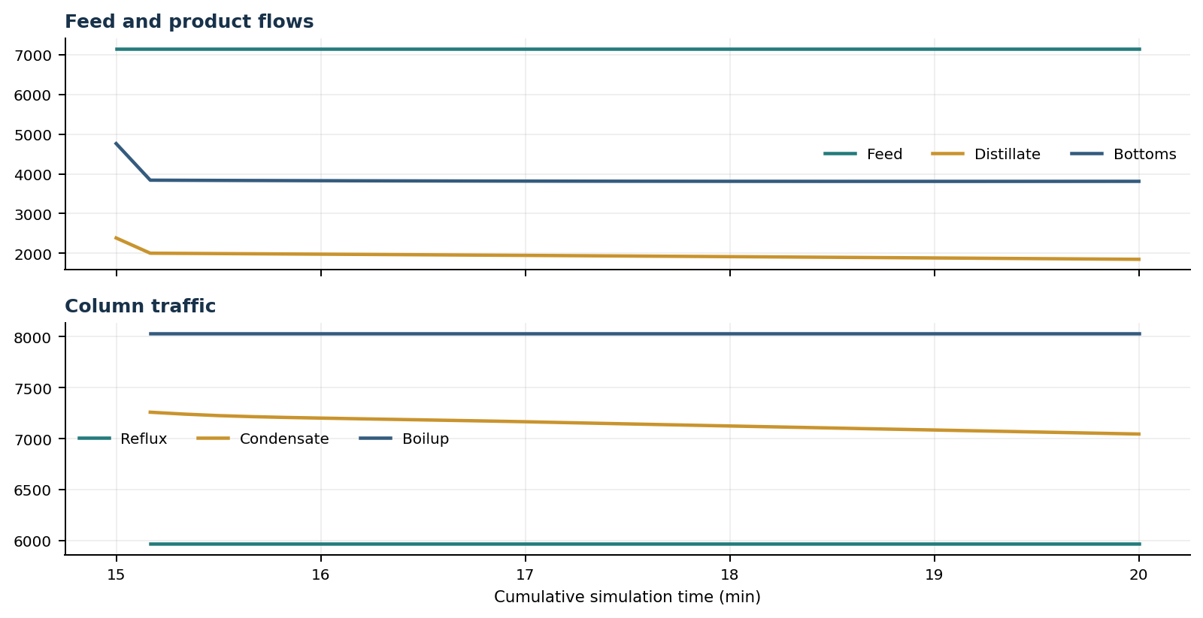
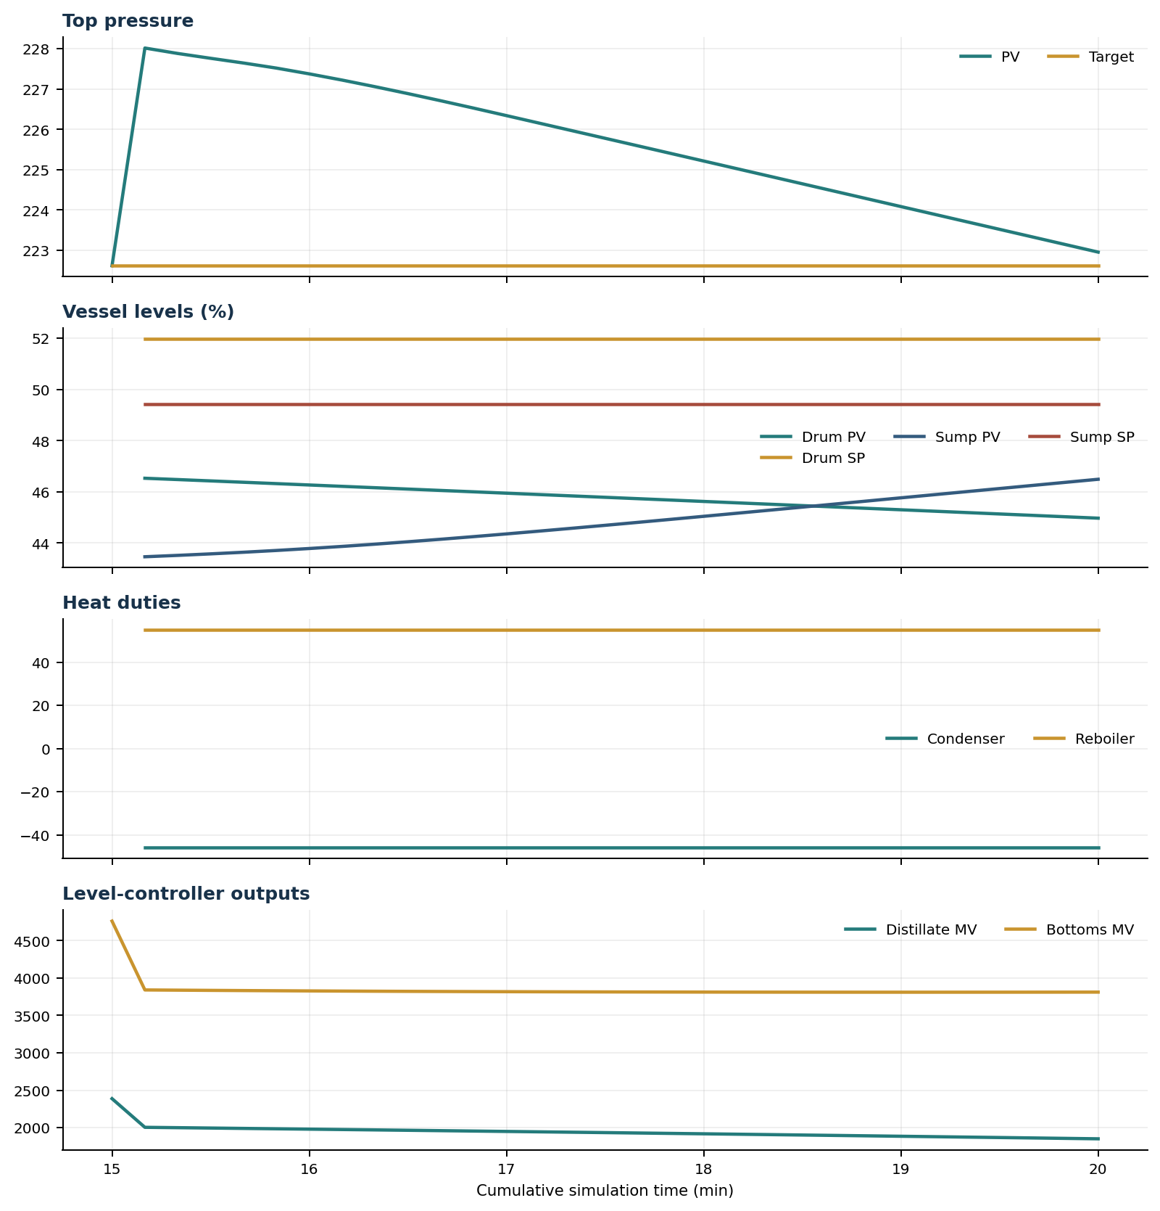

Final Tray Profiles
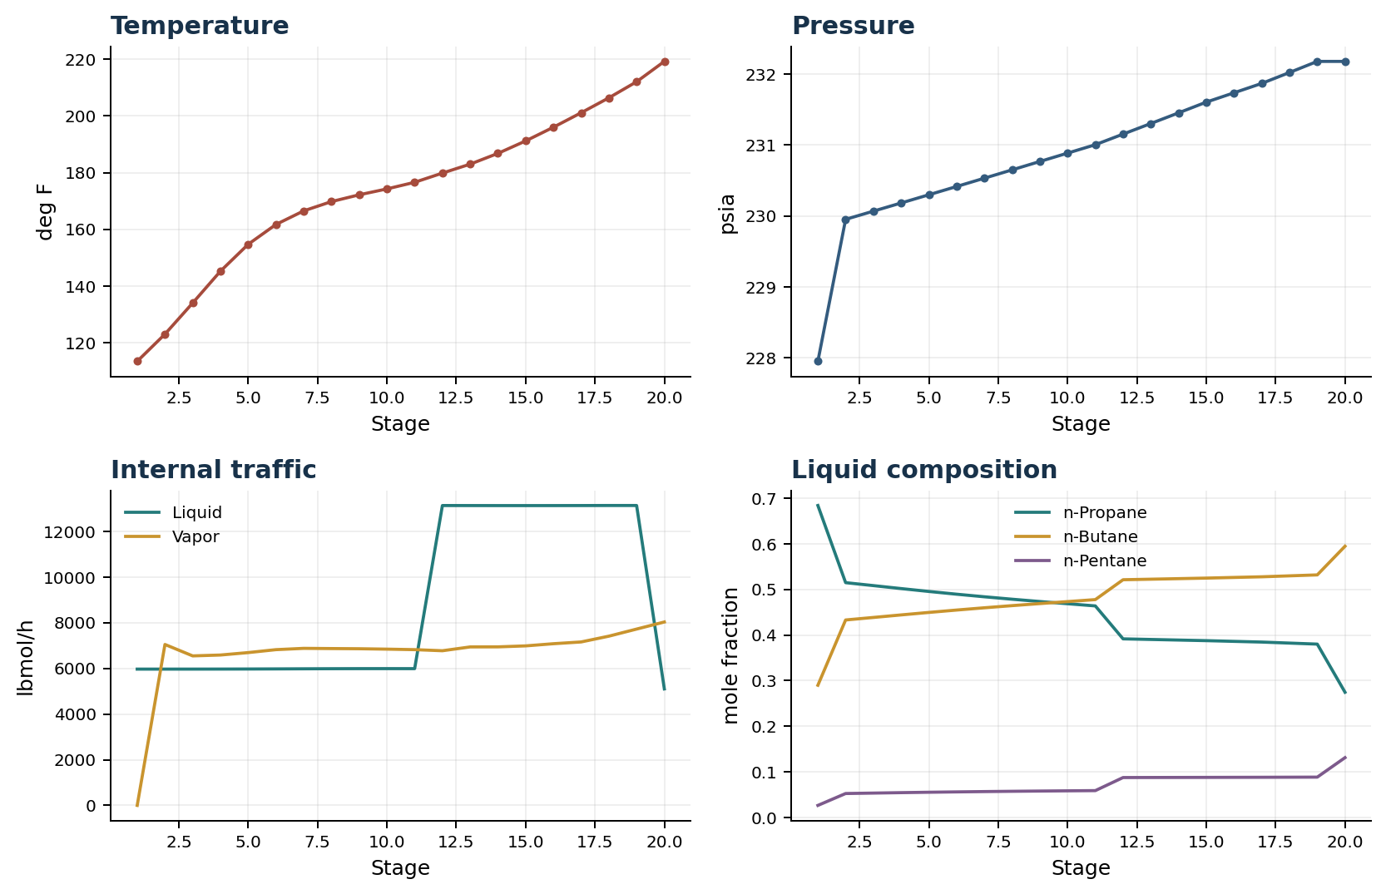

Final Tray Profile Table
Stage | T (deg F) | P (psia) | L (lbmol/h) | V (lbmol/h) | x n-Propane | x n-Butane | x n-Pentane | y n-Propane | y n-Butane | y n-Pentane
1 | 113.43 | 227.952 | 5,967.3 | 0.0 | 0.6841 | 0.2898 | 0.0262 | 0.0000 | 0.0000 | 0.0000
2 | 123.02 | 229.952 | 5,967.4 | 7,045.9 | 0.5148 | 0.4330 | 0.0522 | 0.6841 | 0.2898 | 0.0262
3 | 134.00 | 230.067 | 5,967.8 | 6,545.7 | 0.5083 | 0.4385 | 0.0532 | 0.4313 | 0.5064 | 0.0624
4 | 145.22 | 230.182 | 5,969.2 | 6,584.0 | 0.5018 | 0.4440 | 0.0541 | 0.4324 | 0.5054 | 0.0622
5 | 154.70 | 230.298 | 5,971.9 | 6,690.6 | 0.4955 | 0.4495 | 0.0550 | 0.4335 | 0.5044 | 0.0621
6 | 161.69 | 230.414 | 5,976.0 | 6,818.9 | 0.4895 | 0.4547 | 0.0558 | 0.4345 | 0.5035 | 0.0620
7 | 166.49 | 230.531 | 5,980.8 | 6,875.8 | 0.4838 | 0.4597 | 0.0565 | 0.4355 | 0.5026 | 0.0619
8 | 169.76 | 230.649 | 5,985.1 | 6,866.8 | 0.4785 | 0.4644 | 0.0571 | 0.4364 | 0.5017 | 0.0619
9 | 172.16 | 230.767 | 5,987.8 | 6,859.1 | 0.4734 | 0.4689 | 0.0577 | 0.4374 | 0.5009 | 0.0618
10 | 174.24 | 230.885 | 5,988.4 | 6,841.3 | 0.4686 | 0.4733 | 0.0582 | 0.4383 | 0.5000 | 0.0617
11 | 176.57 | 231.003 | 5,987.4 | 6,819.2 | 0.4638 | 0.4776 | 0.0586 | 0.4392 | 0.4992 | 0.0616
12 | 179.82 | 231.152 | 13,128.9 | 6,771.3 | 0.3915 | 0.5212 | 0.0873 | 0.4401 | 0.4984 | 0.0615
13 | 182.97 | 231.302 | 13,127.4 | 6,938.4 | 0.3902 | 0.5224 | 0.0874 | 0.4410 | 0.4975 | 0.0615
14 | 186.77 | 231.452 | 13,126.3 | 6,940.8 | 0.3889 | 0.5236 | 0.0875 | 0.4419 | 0.4967 | 0.0614
15 | 191.16 | 231.603 | 13,125.9 | 6,983.6 | 0.3876 | 0.5248 | 0.0876 | 0.4427 | 0.4959 | 0.0614
16 | 195.99 | 231.735 | 13,126.5 | 7,078.8 | 0.3860 | 0.5262 | 0.0877 | 0.4436 | 0.4951 | 0.0613
17 | 201.09 | 231.867 | 13,128.0 | 7,156.3 | 0.3845 | 0.5277 | 0.0879 | 0.4445 | 0.4943 | 0.0612
18 | 206.36 | 232.020 | 13,130.5 | 7,409.4 | 0.3822 | 0.5297 | 0.0880 | 0.4454 | 0.4934 | 0.0612
19 | 212.04 | 232.177 | 13,130.3 | 7,720.2 | 0.3800 | 0.5318 | 0.0882 | 0.4463 | 0.4926 | 0.0611
20 | 219.21 | 232.177 | 5,100.2 | 8,030.0 | 0.2744 | 0.5947 | 0.1309 | 0.4471 | 0.4919 | 0.0610

Simulation Configuration
Parameter | Value
Runtime Mode | hydraulic
Thermo Mode | dwsim
Dwsim Property Package | pr
Integrator | explicit-euler
N Steps | 1500
Dt Sec | 0.2
Log Every N Steps | 50
Thermo Every N Steps | 1
Include Energy | True
Enable Equilibrium Relaxation | True
Equilibrium Relaxation Mode | composition-only
Equilibrium Tau Sec | 0.5
Flash Feed At Stage Conditions | True
Enable Liquid Hydraulic Override | True
Liquid Hydraulic Model | francis
Liquid Hydraulic Override Alpha | 0.25
Enable Level Control | True
Top Level Pv Mode | true-level
Top Level Kc | 1.0
Top Level Ti Sec | 600.0
Bottom Level Pv Mode | true-level
Bottom Level Kc | 1.0
Bottom Level Ti Sec | 300.0
Enable Pressure Control | False
Pressure Control Mv | auto
Condenser Duty Mode | specified
Condenser Duty Btu Per H | -46000000.0
Vapor Holdup Relaxation Sec | 0.0
Vapor Flow Relaxation Sec | 0.0
Vapor Flow Zero Temperature Target | True
Dynamic Vflow Nominal Hi Ratio | 1.05
Steady State Window Sec | 30.0
Steady State Min Time Sec | 60.0
Steady State Rel State Rate Tol Per S | 0.003
Steady State Temp Rate Tol F Per S | 0.15
Steady State Sp Error Tol | 0.02
Steady State Require Sp | False

Exact Launch Command
"C:\Users\Thomas Zvolensky\anaconda3\python.exe" -m dynamic_distillation.dynamic_run_scaffold_v1 --excel logs\c3c4_initializer_residual_vapor_state_stage2_20260706.xlsx --init-from-checkpoint logs\c3c4_checkpoint900_bottomTi300_continue_900s_r2_20260710\c3c4_initializer_residual_vapor_state_stage2_20260706__checkpoint_20260710_113142.npz --run-name C3C4_fixed_Q46_authority_probe --run-description 300s_fixed_minus46_MMBtuh_condenser_duty_without_pressure_PI --runtime-mode hydraulic --thermo dwsim --dwsim-property-package pr --include-energy --equilibrium-relaxation-mode composition-only --equilibrium-tau-sec 0.5 --equilibrium-component-transfer-max-cancel-multiplier 1.0 --flash-feed-at-stage-conditions --enable-liquid-hydraulic-override --liquid-hydraulic-model francis --liquid-hydraulic-override-alpha 0.25 --enable-level-control --ignore-workbook-level-pv-mode --top-level-pv-mode true-level --bottom-level-pv-mode true-level --top-level-kc 1 --top-level-ti 600 --bottom-level-kc 1 --bottom-level-ti 300 --vapor-holdup-relaxation-sec 0 --vapor-flow-relaxation-sec 0 --vapor-flow-zero-temperature-target --use-excel-vapor-holdup --condenser-duty-mode specified --condenser-duty-btuph -46000000 --dynamic-vflow-nominal-hi-ratio 1.05 --disable-startup-thermo-conditioning --disable-restart-reentry-settling --n-steps 1500 --dt 0.2 --log-every 50 --logs-dir logs\c3c4_checkpoint1800_fixedQ46_continue_300s_20260710 --allow-repeat-command

