DYNAMIC DISTILLATION / COMPLETED RUN

C3C4_pressure_control_continuation
guarded_300s_condenser_duty_pressure_PI
RUN VALIDITY  REVIEW | DYNAMIC GATE  NOT PASSED | FINAL SCORE  1,675.448 | SIM / WALL  1.377
AUTOMATED ASSESSMENT The dynamic acceptance gate did not pass (final score 1,675.448). The final tray snapshot reports 20 failed thermo flashes; interpret operating results as invalid until the thermo path is restored. The top level loop reported molar holdup rather than a geometry-based level fraction. The bottom level loop reported molar holdup rather than a geometry-based level fraction.

Run Identity
Item | Value
Run ID | 20260710_160527
Started | 2026-07-10 16:05:27
Completed | 2026-07-10 16:09:05
Run type | Continuation from native checkpoint
Input workbook | C:\Users\Thomas Zvolensky\Documents\Python Scripts\Dynamic_DistillationII\logs\c3c4_initializer_residual_vapor_state_stage2_20260706.xlsx
Input checkpoint | C:\Users\Thomas Zvolensky\Documents\Python Scripts\Dynamic_DistillationII\logs\c3c4_checkpoint900_bottomTi300_continue_900s_r2_20260710\c3c4_initializer_residual_vapor_state_stage2_20260706__checkpoint_20260710_113142.npz
Summary data | C:\Users\Thomas Zvolensky\Documents\Python Scripts\Dynamic_DistillationII\logs\c3c4_checkpoint1800_pressurePI_continue_300s_20260710\column_summary_20260710_160527.csv
Tray-profile data | C:\Users\Thomas Zvolensky\Documents\Python Scripts\Dynamic_DistillationII\logs\c3c4_checkpoint1800_pressurePI_continue_300s_20260710\column_profile_20260710_160527.csv

Operating Snapshot
Parameter | Start | End | Units
Feed | 7,142.98 | 7,142.98 | lbmol/h
Distillate | 2,386.93 | 3,866.95 | lbmol/h
Bottoms | 4,761.98 | 3,874.09 | lbmol/h
Reflux | Not reported | 5,967.32 | lbmol/h
Top pressure | 222.619 | 483.184 | psia
Bottom pressure | 316.632 | 485.184 | psia
Distillate temperature | 113.43 | 113.43 | deg F
Bottoms temperature | 248.11 | 241.66 | deg F
Condenser duty | Not reported | -50.000 | MMBtu/h
Reboiler duty | Not reported | 54.844 | MMBtu/h
Distillate drum controller PV | Not reported | 2,693.58 | lbmol
Bottoms sump controller PV | Not reported | 891.76 | lbmol
Steady-state score | Not reported | 1,675.4481 | -

Product Composition
Component | Distillate start | Distillate end | Bottoms start | Bottoms end
n-Butane | 15.210% | 30.279% | 65.447% | 63.987%
n-Pentane | 0.686% | 3.050% | 13.971% | 13.914%
n-Propane | 84.104% | 66.671% | 20.582% | 22.099%
source | Not reported | Not reported | Not reported | Not reported

Dynamic Trends
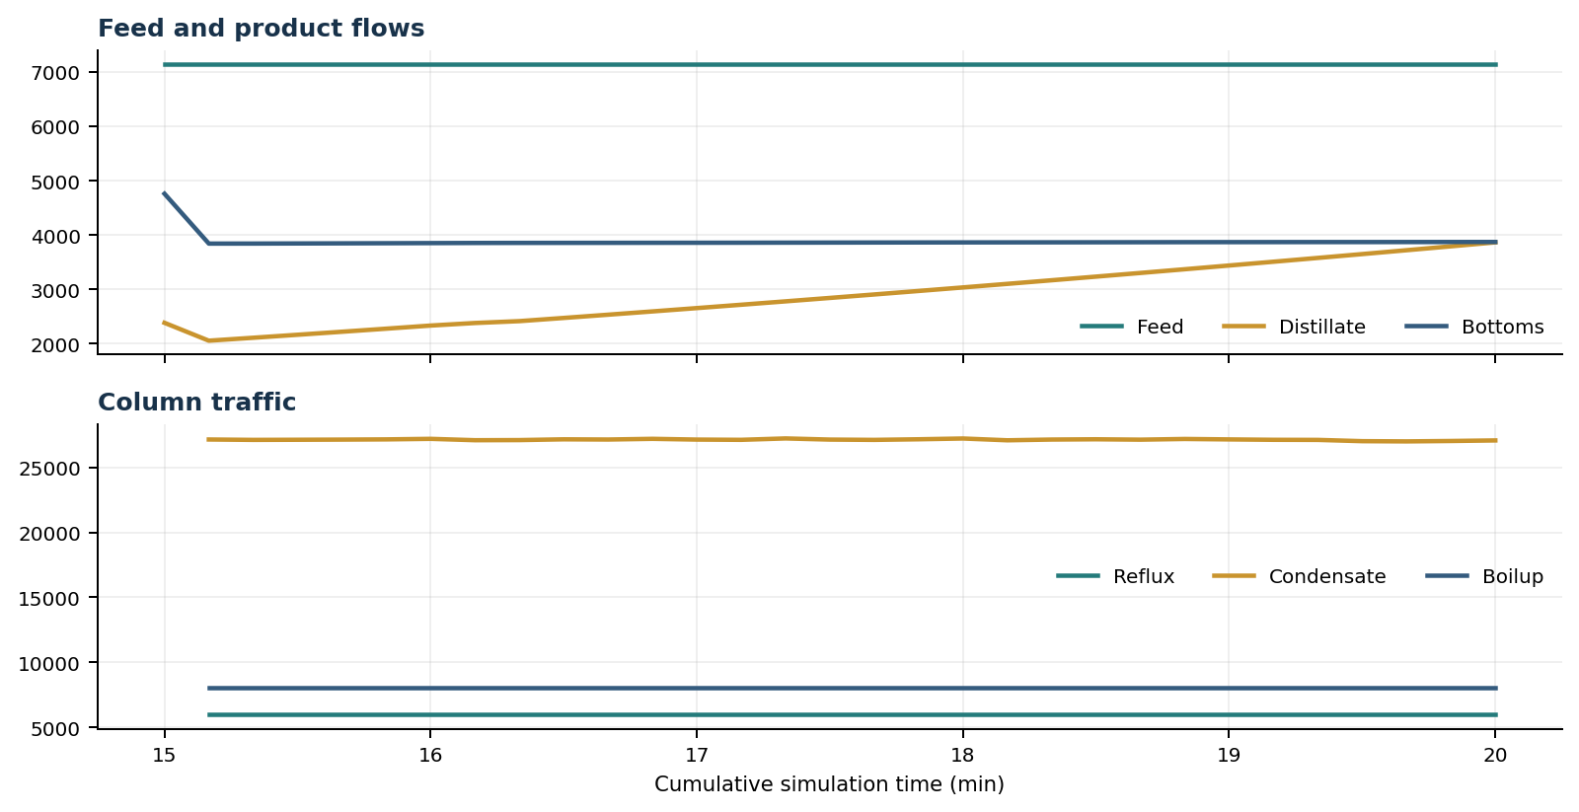
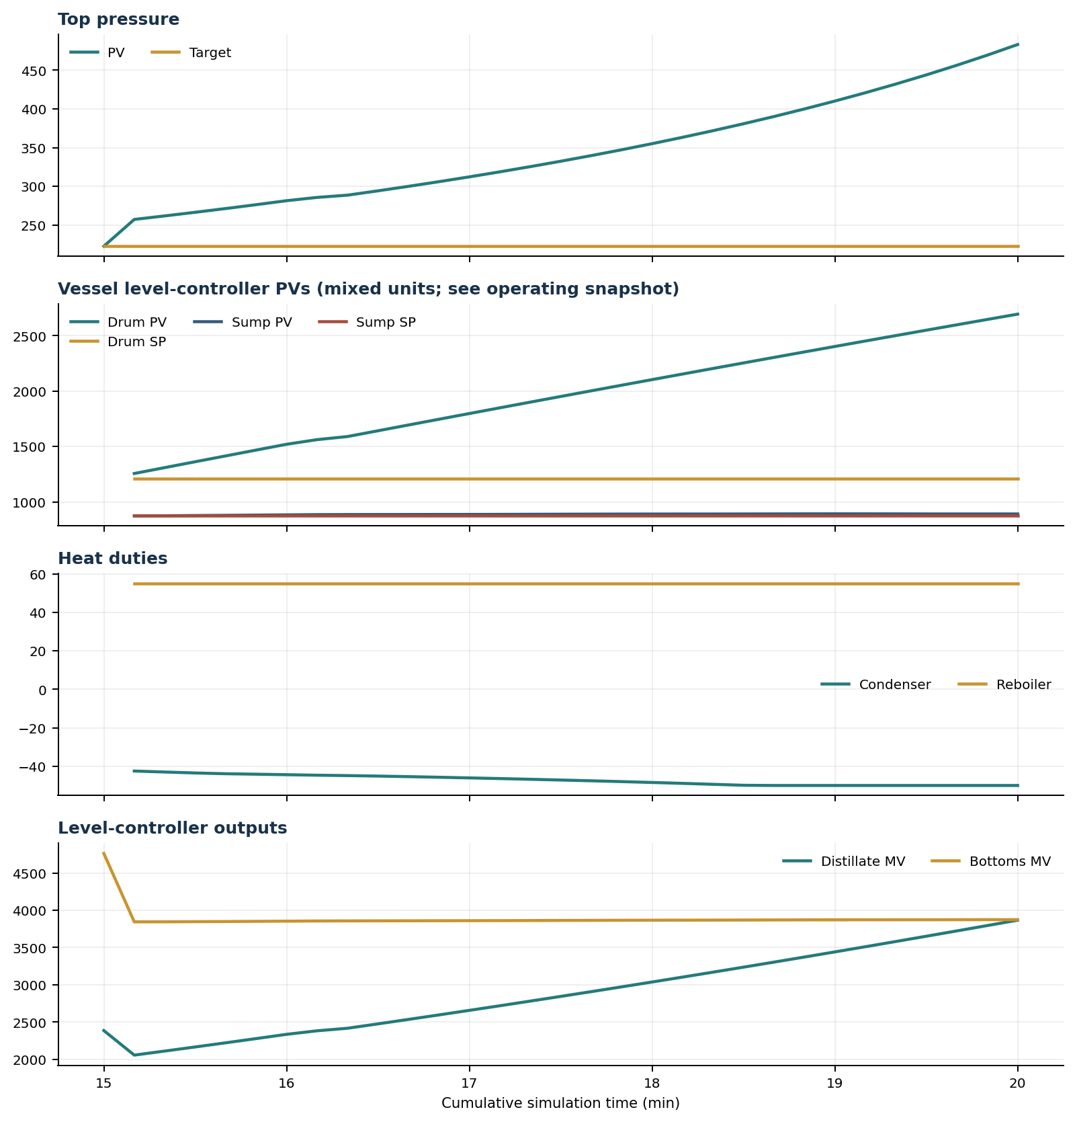

Final Tray Profiles
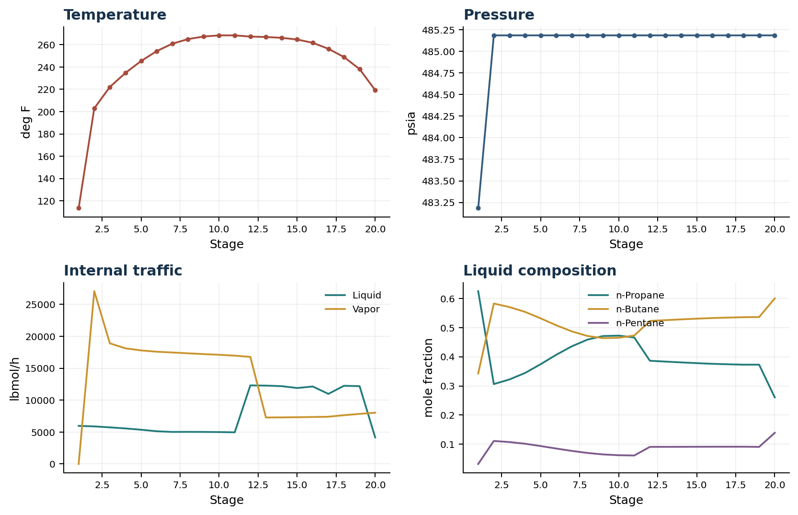

Final Tray Profile Table
Stage | T (deg F) | P (psia) | L (lbmol/h) | V (lbmol/h) | x n-Propane | x n-Butane | x n-Pentane | y n-Propane | y n-Butane | y n-Pentane
1 | 113.43 | 483.184 | 5,967.3 | 0.0 | 0.6254 | 0.3428 | 0.0317 | 0.0000 | 0.0000 | 0.0000
2 | 202.95 | 485.184 | 5,885.0 | 27,067.6 | 0.3062 | 0.5830 | 0.1107 | 0.6254 | 0.3428 | 0.0317
3 | 222.10 | 485.184 | 5,733.4 | 18,893.0 | 0.3221 | 0.5709 | 0.1070 | 0.0000 | 0.8824 | 0.1176
4 | 234.71 | 485.184 | 5,567.3 | 18,118.0 | 0.3443 | 0.5544 | 0.1013 | 1.0000 | 0.0000 | 0.0000
5 | 245.35 | 485.184 | 5,363.8 | 17,788.5 | 0.3746 | 0.5321 | 0.0933 | 0.0000 | 0.8824 | 0.1176
6 | 254.24 | 485.184 | 5,125.3 | 17,587.3 | 0.4069 | 0.5084 | 0.0847 | 1.0000 | 0.0000 | 0.0000
7 | 260.88 | 485.184 | 5,018.4 | 17,466.0 | 0.4361 | 0.4873 | 0.0766 | 0.0000 | 0.8824 | 0.1176
8 | 265.00 | 485.184 | 5,027.9 | 17,334.6 | 0.4590 | 0.4715 | 0.0695 | 1.0000 | 0.0000 | 0.0000
9 | 267.30 | 485.184 | 5,019.6 | 17,214.0 | 0.4714 | 0.4641 | 0.0645 | 0.0000 | 0.8824 | 0.1176
10 | 268.36 | 485.184 | 4,996.3 | 17,103.5 | 0.4728 | 0.4654 | 0.0618 | 1.0000 | 0.0000 | 0.0000
11 | 268.35 | 485.184 | 4,958.7 | 16,968.9 | 0.4662 | 0.4730 | 0.0608 | 0.0000 | 0.8824 | 0.1176
12 | 267.28 | 485.184 | 12,311.4 | 16,773.3 | 0.3864 | 0.5232 | 0.0904 | 1.0000 | 0.0000 | 0.0000
13 | 266.90 | 485.184 | 12,275.8 | 7,278.8 | 0.3835 | 0.5260 | 0.0905 | 0.0000 | 0.8824 | 0.1176
14 | 266.17 | 485.184 | 12,192.6 | 7,296.8 | 0.3807 | 0.5286 | 0.0906 | 0.9161 | 0.0740 | 0.0099
15 | 264.64 | 485.184 | 11,898.5 | 7,322.2 | 0.3782 | 0.5310 | 0.0908 | 0.0000 | 0.8824 | 0.1176
16 | 261.68 | 485.184 | 12,135.5 | 7,357.9 | 0.3759 | 0.5332 | 0.0909 | 0.4250 | 0.5073 | 0.0676
17 | 256.33 | 485.184 | 10,980.8 | 7,402.3 | 0.3743 | 0.5347 | 0.0910 | 0.4250 | 0.5073 | 0.0677
18 | 248.91 | 485.184 | 12,247.6 | 7,638.7 | 0.3730 | 0.5361 | 0.0910 | 0.4250 | 0.5073 | 0.0677
19 | 238.10 | 485.184 | 12,189.4 | 7,843.4 | 0.3729 | 0.5367 | 0.0904 | 0.4250 | 0.5073 | 0.0677
20 | 219.21 | 485.184 | 4,159.3 | 8,030.0 | 0.2606 | 0.6007 | 0.1387 | 0.4306 | 0.5038 | 0.0656

Simulation Configuration
Parameter | Value
Runtime Mode | hydraulic
Thermo Mode | dwsim
Dwsim Property Package | pr
Integrator | explicit-euler
N Steps | 1500
Dt Sec | 0.2
Include Energy | True
Enable Equilibrium Relaxation | True
Equilibrium Relaxation Mode | composition-only
Equilibrium Tau Sec | 0.5
Flash Feed At Stage Conditions | True
Enable Liquid Hydraulic Override | True
Liquid Hydraulic Model | francis
Liquid Hydraulic Override Alpha | 0.25
Enable Level Control | True
Top Level Pv Mode | true-level
Top Level Kc | 1.0
Top Level Ti Sec | 600.0
Bottom Level Pv Mode | true-level
Bottom Level Kc | 1.0
Bottom Level Ti Sec | 300.0
Enable Pressure Control | True
Pressure Control Mv | condenser-duty
Top Pressure Sp Psia | 222.6194497041178
Top Pressure Kc | -150000.0
Top Pressure Ti Sec | 300.0
Condenser Duty Mode | specified
Condenser Duty Btu Per H | -42000000.0
Condenser Duty Max Btu Per H | -34000000.0
Condenser Duty Min Btu Per H | -50000000.0
Top Pressure Mv Slew Limit Per S | 50000.0
Top Pressure Pv Filter Tau Sec | 5.0

Exact Launch Command
python -m dynamic_distillation.dynamic_run_scaffold_v1 --excel logs\c3c4_initializer_residual_vapor_state_stage2_20260706.xlsx --init-from-checkpoint logs\c3c4_checkpoint900_bottomTi300_continue_900s_r2_20260710\c3c4_initializer_residual_vapor_state_stage2_20260706__checkpoint_20260710_113142.npz --run-name C3C4_pressure_control_continuation --run-description guarded_300s_condenser_duty_pressure_PI --runtime-mode hydraulic --thermo dwsim --dwsim-property-package pr --include-energy --equilibrium-relaxation-mode composition-only --equilibrium-tau-sec 0.5 --equilibrium-component-transfer-max-cancel-multiplier 1.0 --flash-feed-at-stage-conditions --enable-liquid-hydraulic-override --liquid-hydraulic-model francis --liquid-hydraulic-override-alpha 0.25 --enable-level-control --ignore-workbook-level-pv-mode --top-level-pv-mode true-level --bottom-level-pv-mode true-level --top-level-kc 1 --top-level-ti 600 --bottom-level-kc 1 --bottom-level-ti 300 --vapor-holdup-relaxation-sec 0 --vapor-flow-relaxation-sec 0 --vapor-flow-zero-temperature-target --use-excel-vapor-holdup --condenser-duty-mode specified --condenser-duty-btuph -42000000 --enable-pressure-control --pressure-control-mv condenser-duty --top-pressure-sp 222.6194497041178 --top-pressure-kc -150000 --top-pressure-ti 300 --top-pressure-pv-filter-tau-sec 5 --top-pressure-mv-slew-limit-per-s 50000 --condenser-duty-min-btuph -50000000 --condenser-duty-max-btuph -34000000 --dynamic-vflow-nominal-hi-ratio 1.05 --disable-startup-thermo-conditioning --disable-restart-reentry-settling --n-steps 1500 --dt 0.2 --log-every 50 --logs-dir logs\c3c4_checkpoint1800_pressurePI_continue_300s_20260710 --allow-repeat-command

