DYNAMIC DISTILLATION / COMPLETED RUN

C3C4_pressure_control_continuation_r2
guarded_300s_condenser_duty_pressure_PI_with_live_DWSIM_PR
RUN VALIDITY  REVIEW | DYNAMIC GATE  PASS | FINAL SCORE  0.545 | SIM / WALL  0.366
AUTOMATED ASSESSMENT Top pressure is 12.99 psi from its logged target, so the rate gate does not establish acceptable pressure control. At least one geometry-based vessel level remains more than five percentage points from setpoint.

Run Identity
Item | Value
Run ID | 20260710_162340
Started | 2026-07-10 16:23:40
Completed | 2026-07-10 16:37:21
Run type | Continuation from native checkpoint
Input workbook | C:\Users\Thomas Zvolensky\Documents\Python Scripts\Dynamic_DistillationII\logs\c3c4_initializer_residual_vapor_state_stage2_20260706.xlsx
Input checkpoint | C:\Users\Thomas Zvolensky\Documents\Python Scripts\Dynamic_DistillationII\logs\c3c4_checkpoint900_bottomTi300_continue_900s_r2_20260710\c3c4_initializer_residual_vapor_state_stage2_20260706__checkpoint_20260710_113142.npz
Summary data | C:\Users\Thomas Zvolensky\Documents\Python Scripts\Dynamic_DistillationII\logs\c3c4_checkpoint1800_pressurePI_continue_300s_r2_20260710\column_summary_20260710_162340.csv
Tray-profile data | C:\Users\Thomas Zvolensky\Documents\Python Scripts\Dynamic_DistillationII\logs\c3c4_checkpoint1800_pressurePI_continue_300s_r2_20260710\column_profile_20260710_162340.csv

Operating Snapshot
Parameter | Start | End | Units
Feed | 7,142.98 | 7,142.98 | lbmol/h
Distillate | 2,386.93 | 1,836.21 | lbmol/h
Bottoms | 4,761.98 | 3,811.84 | lbmol/h
Reflux | Not reported | 5,967.32 | lbmol/h
Top pressure | 222.619 | 235.610 | psia
Bottom pressure | 316.632 | 237.610 | psia
Distillate temperature | 113.43 | 113.43 | deg F
Bottoms temperature | 248.11 | 253.39 | deg F
Condenser duty | Not reported | -45.075 | MMBtu/h
Reboiler duty | Not reported | 54.844 | MMBtu/h
Distillate drum controller PV | Not reported | 44.66 | lbmol
Bottoms sump controller PV | Not reported | 46.48 | lbmol
Steady-state score | Not reported | 0.5452 | -

Product Composition
Component | Distillate start | Distillate end | Bottoms start | Bottoms end
n-Butane | 15.210% | 19.934% | 65.447% | 63.654%
n-Pentane | 0.686% | 1.319% | 13.971% | 13.711%
n-Propane | 84.104% | 78.747% | 20.582% | 22.636%
source | Not reported | Not reported | Not reported | Not reported

Dynamic Trends
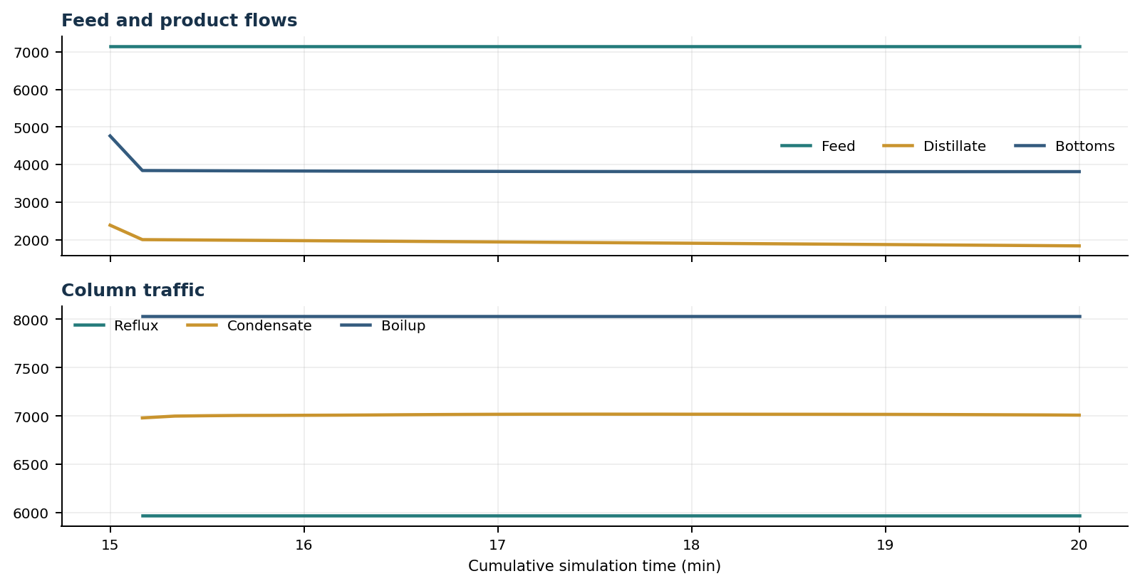
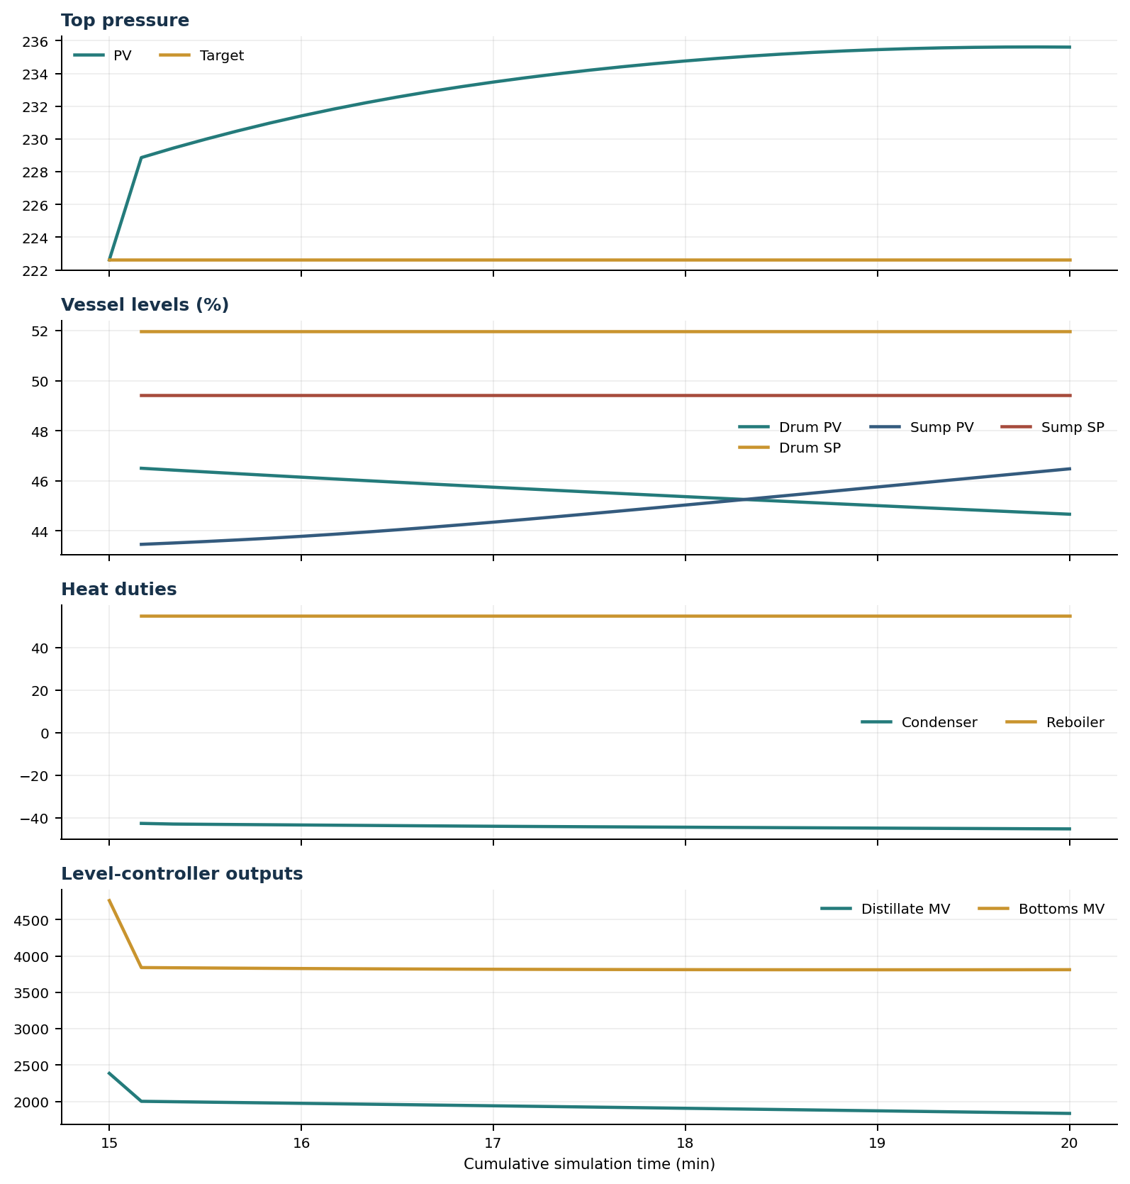

Final Tray Profiles
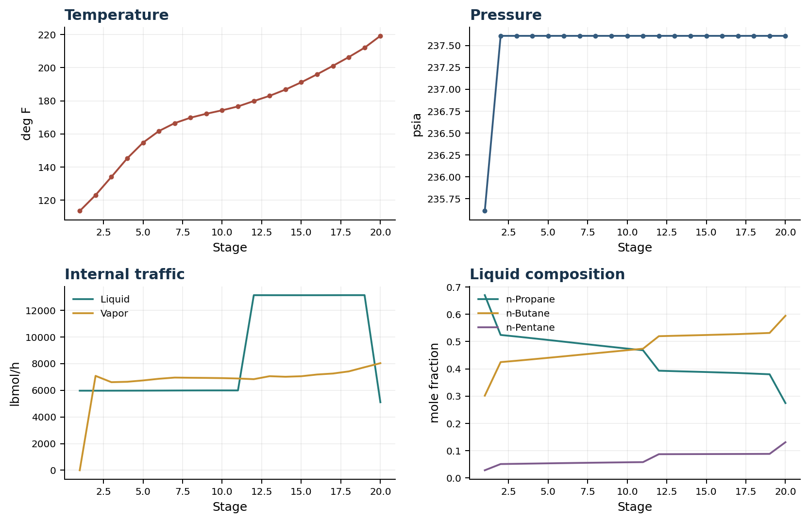

Final Tray Profile Table
Stage | T (deg F) | P (psia) | L (lbmol/h) | V (lbmol/h) | x n-Propane | x n-Butane | x n-Pentane | y n-Propane | y n-Butane | y n-Pentane
1 | 113.43 | 235.610 | 5,967.3 | 0.0 | 0.6703 | 0.3016 | 0.0281 | 0.0000 | 0.0000 | 0.0000
2 | 123.02 | 237.610 | 5,967.4 | 7,078.3 | 0.5243 | 0.4248 | 0.0509 | 0.6703 | 0.3016 | 0.0281
3 | 134.00 | 237.610 | 5,967.8 | 6,605.1 | 0.5185 | 0.4297 | 0.0518 | 0.4315 | 0.5061 | 0.0623
4 | 145.22 | 237.610 | 5,969.2 | 6,634.6 | 0.5123 | 0.4350 | 0.0527 | 0.4327 | 0.5051 | 0.0622
5 | 154.70 | 237.610 | 5,971.9 | 6,735.7 | 0.5060 | 0.4405 | 0.0535 | 0.4337 | 0.5042 | 0.0621
6 | 161.69 | 237.610 | 5,976.0 | 6,860.3 | 0.4996 | 0.4460 | 0.0544 | 0.4347 | 0.5032 | 0.0620
7 | 166.49 | 237.610 | 5,980.8 | 6,950.8 | 0.4932 | 0.4516 | 0.0552 | 0.4357 | 0.5024 | 0.0619
8 | 169.76 | 237.610 | 5,985.1 | 6,936.5 | 0.4868 | 0.4572 | 0.0559 | 0.4366 | 0.5015 | 0.0618
9 | 172.16 | 237.610 | 5,987.8 | 6,925.9 | 0.4805 | 0.4628 | 0.0567 | 0.4376 | 0.5007 | 0.0618
10 | 174.24 | 237.610 | 5,988.4 | 6,909.9 | 0.4743 | 0.4684 | 0.0573 | 0.4385 | 0.4999 | 0.0617
11 | 176.57 | 237.610 | 5,987.4 | 6,880.7 | 0.4681 | 0.4739 | 0.0580 | 0.4394 | 0.4990 | 0.0616
12 | 179.82 | 237.610 | 13,128.9 | 6,830.3 | 0.3931 | 0.5198 | 0.0871 | 0.4403 | 0.4982 | 0.0615
13 | 182.97 | 237.610 | 13,127.4 | 7,054.1 | 0.3915 | 0.5213 | 0.0872 | 0.4411 | 0.4974 | 0.0615
14 | 186.77 | 237.610 | 13,126.3 | 7,011.7 | 0.3899 | 0.5227 | 0.0874 | 0.4420 | 0.4966 | 0.0614
15 | 191.16 | 237.610 | 13,125.9 | 7,051.0 | 0.3884 | 0.5241 | 0.0875 | 0.4429 | 0.4958 | 0.0613
16 | 195.99 | 237.610 | 13,126.5 | 7,180.2 | 0.3866 | 0.5258 | 0.0877 | 0.4437 | 0.4950 | 0.0613
17 | 201.09 | 237.610 | 13,128.0 | 7,254.0 | 0.3849 | 0.5273 | 0.0878 | 0.4446 | 0.4942 | 0.0612
18 | 206.36 | 237.610 | 13,130.5 | 7,413.2 | 0.3825 | 0.5295 | 0.0880 | 0.4455 | 0.4933 | 0.0611
19 | 212.04 | 237.610 | 13,130.2 | 7,725.2 | 0.3801 | 0.5317 | 0.0882 | 0.4464 | 0.4925 | 0.0611
20 | 219.21 | 237.610 | 5,100.2 | 8,030.0 | 0.2745 | 0.5946 | 0.1309 | 0.4472 | 0.4918 | 0.0610

Simulation Configuration
Parameter | Value
Runtime Mode | hydraulic
Thermo Mode | dwsim
Dwsim Property Package | pr
Integrator | explicit-euler
N Steps | 1500
Dt Sec | 0.2
Log Every N Steps | 50
Thermo Every N Steps | 1
Include Energy | True
Enable Equilibrium Relaxation | True
Equilibrium Relaxation Mode | composition-only
Equilibrium Tau Sec | 0.5
Flash Feed At Stage Conditions | True
Enable Liquid Hydraulic Override | True
Liquid Hydraulic Model | francis
Liquid Hydraulic Override Alpha | 0.25
Enable Level Control | True
Top Level Pv Mode | true-level
Top Level Kc | 1.0
Top Level Ti Sec | 600.0
Bottom Level Pv Mode | true-level
Bottom Level Kc | 1.0
Bottom Level Ti Sec | 300.0
Enable Pressure Control | True
Pressure Control Mv | condenser-duty
Top Pressure Sp Psia | 222.6194497041178
Top Pressure Kc | -150000.0
Top Pressure Ti Sec | 300.0
Top Pressure Pv Filter Tau Sec | 5.0
Top Pressure Mv Slew Limit Per S | 50000.0
Condenser Duty Mode | specified
Condenser Duty Btu Per H | -42000000.0
Condenser Duty Min Btu Per H | -50000000.0
Condenser Duty Max Btu Per H | -34000000.0
Vapor Holdup Relaxation Sec | 0.0
Vapor Flow Relaxation Sec | 0.0
Vapor Flow Zero Temperature Target | True
Dynamic Vflow Nominal Hi Ratio | 1.05
Steady State Window Sec | 30.0
Steady State Min Time Sec | 60.0
Steady State Rel State Rate Tol Per S | 0.003
Steady State Temp Rate Tol F Per S | 0.15
Steady State Sp Error Tol | 0.02
Steady State Require Sp | False

Exact Launch Command
"C:\Users\Thomas Zvolensky\anaconda3\python.exe" -m dynamic_distillation.dynamic_run_scaffold_v1 --excel logs\c3c4_initializer_residual_vapor_state_stage2_20260706.xlsx --init-from-checkpoint logs\c3c4_checkpoint900_bottomTi300_continue_900s_r2_20260710\c3c4_initializer_residual_vapor_state_stage2_20260706__checkpoint_20260710_113142.npz --run-name C3C4_pressure_control_continuation_r2 --run-description guarded_300s_condenser_duty_pressure_PI_with_live_DWSIM_PR --runtime-mode hydraulic --thermo dwsim --dwsim-property-package pr --include-energy --equilibrium-relaxation-mode composition-only --equilibrium-tau-sec 0.5 --equilibrium-component-transfer-max-cancel-multiplier 1.0 --flash-feed-at-stage-conditions --enable-liquid-hydraulic-override --liquid-hydraulic-model francis --liquid-hydraulic-override-alpha 0.25 --enable-level-control --ignore-workbook-level-pv-mode --top-level-pv-mode true-level --bottom-level-pv-mode true-level --top-level-kc 1 --top-level-ti 600 --bottom-level-kc 1 --bottom-level-ti 300 --vapor-holdup-relaxation-sec 0 --vapor-flow-relaxation-sec 0 --vapor-flow-zero-temperature-target --use-excel-vapor-holdup --condenser-duty-mode specified --condenser-duty-btuph -42000000 --enable-pressure-control --pressure-control-mv condenser-duty --top-pressure-sp 222.6194497041178 --top-pressure-kc -150000 --top-pressure-ti 300 --top-pressure-pv-filter-tau-sec 5 --top-pressure-mv-slew-limit-per-s 50000 --condenser-duty-min-btuph -50000000 --condenser-duty-max-btuph -34000000 --dynamic-vflow-nominal-hi-ratio 1.05 --disable-startup-thermo-conditioning --disable-restart-reentry-settling --n-steps 1500 --dt 0.2 --log-every 50 --logs-dir logs\c3c4_checkpoint1800_pressurePI_continue_300s_r2_20260710 --allow-repeat-command

