DYNAMIC DISTILLATION / COMPLETED RUN

C3C4_DD047_chemsep_duty_control_isolation_180s_r2
ChemSep_centered_condenser_duty_pressure_and_inventory_control_isolation
RUN VALIDITY  USABLE | DYNAMIC GATE  PASS | FINAL SCORE  0.549 | SIM / WALL  0.494

Run Identity
Item | Value
Run ID | 20260711_163320
Started | 2026-07-11 16:33:20
Completed | 2026-07-11 16:39:24
Run type | Continuation from native checkpoint
Input workbook | C:\Users\Thomas Zvolensky\Documents\Python Scripts\Dynamic_DistillationII\logs\c3c4_initializer_residual_vapor_state_stage2_20260706.xlsx
Input checkpoint | C:\Users\Thomas Zvolensky\Documents\Python Scripts\Dynamic_DistillationII\logs\c3c4_dd046_inventory_coordination_continue300s_20260711\c3c4_initializer_residual_vapor_state_stage2_20260706__checkpoint_20260711_160221.npz
Summary data | C:\Users\Thomas Zvolensky\Documents\Python Scripts\Dynamic_DistillationII\logs\c3c4_dd047_chemsep_duty_control_isolation_180s_r2_20260711\column_summary_20260711_163320.csv
Tray-profile data | C:\Users\Thomas Zvolensky\Documents\Python Scripts\Dynamic_DistillationII\logs\c3c4_dd047_chemsep_duty_control_isolation_180s_r2_20260711\column_profile_20260711_163320.csv

Operating Snapshot
Parameter | Start | End | Units
Feed | 7,142.98 | 7,142.98 | lbmol/h
Distillate | 2,386.93 | 3,623.58 | lbmol/h
Bottoms | 4,761.98 | 8,176.58 | lbmol/h
Reflux | Not reported | 4,900.00 | lbmol/h
Top pressure | 222.619 | 224.680 | psia
Bottom pressure | 316.632 | 231.631 | psia
Distillate temperature | 113.43 | 113.43 | deg F
Bottoms temperature | 209.72 | 190.58 | deg F
Condenser duty | Not reported | -51.629 | MMBtu/h
Reboiler duty | Not reported | 54.844 | MMBtu/h
Distillate drum controller PV | Not reported | 52.10 | lbmol
Bottoms sump controller PV | Not reported | 47.66 | lbmol
Steady-state score | Not reported | 0.5491 | -

Product Composition
Component | Distillate start | Distillate end | Bottoms start | Bottoms end
n-Butane | 7.514% | 7.207% | 69.910% | 70.673%
n-Pentane | 0.164% | 0.129% | 15.571% | 15.609%
n-Propane | 92.322% | 92.664% | 14.519% | 13.719%
source | Not reported | Not reported | Not reported | Not reported

Dynamic Trends
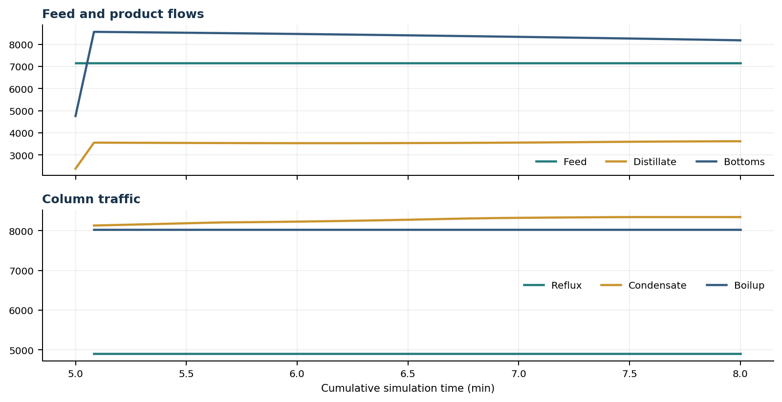
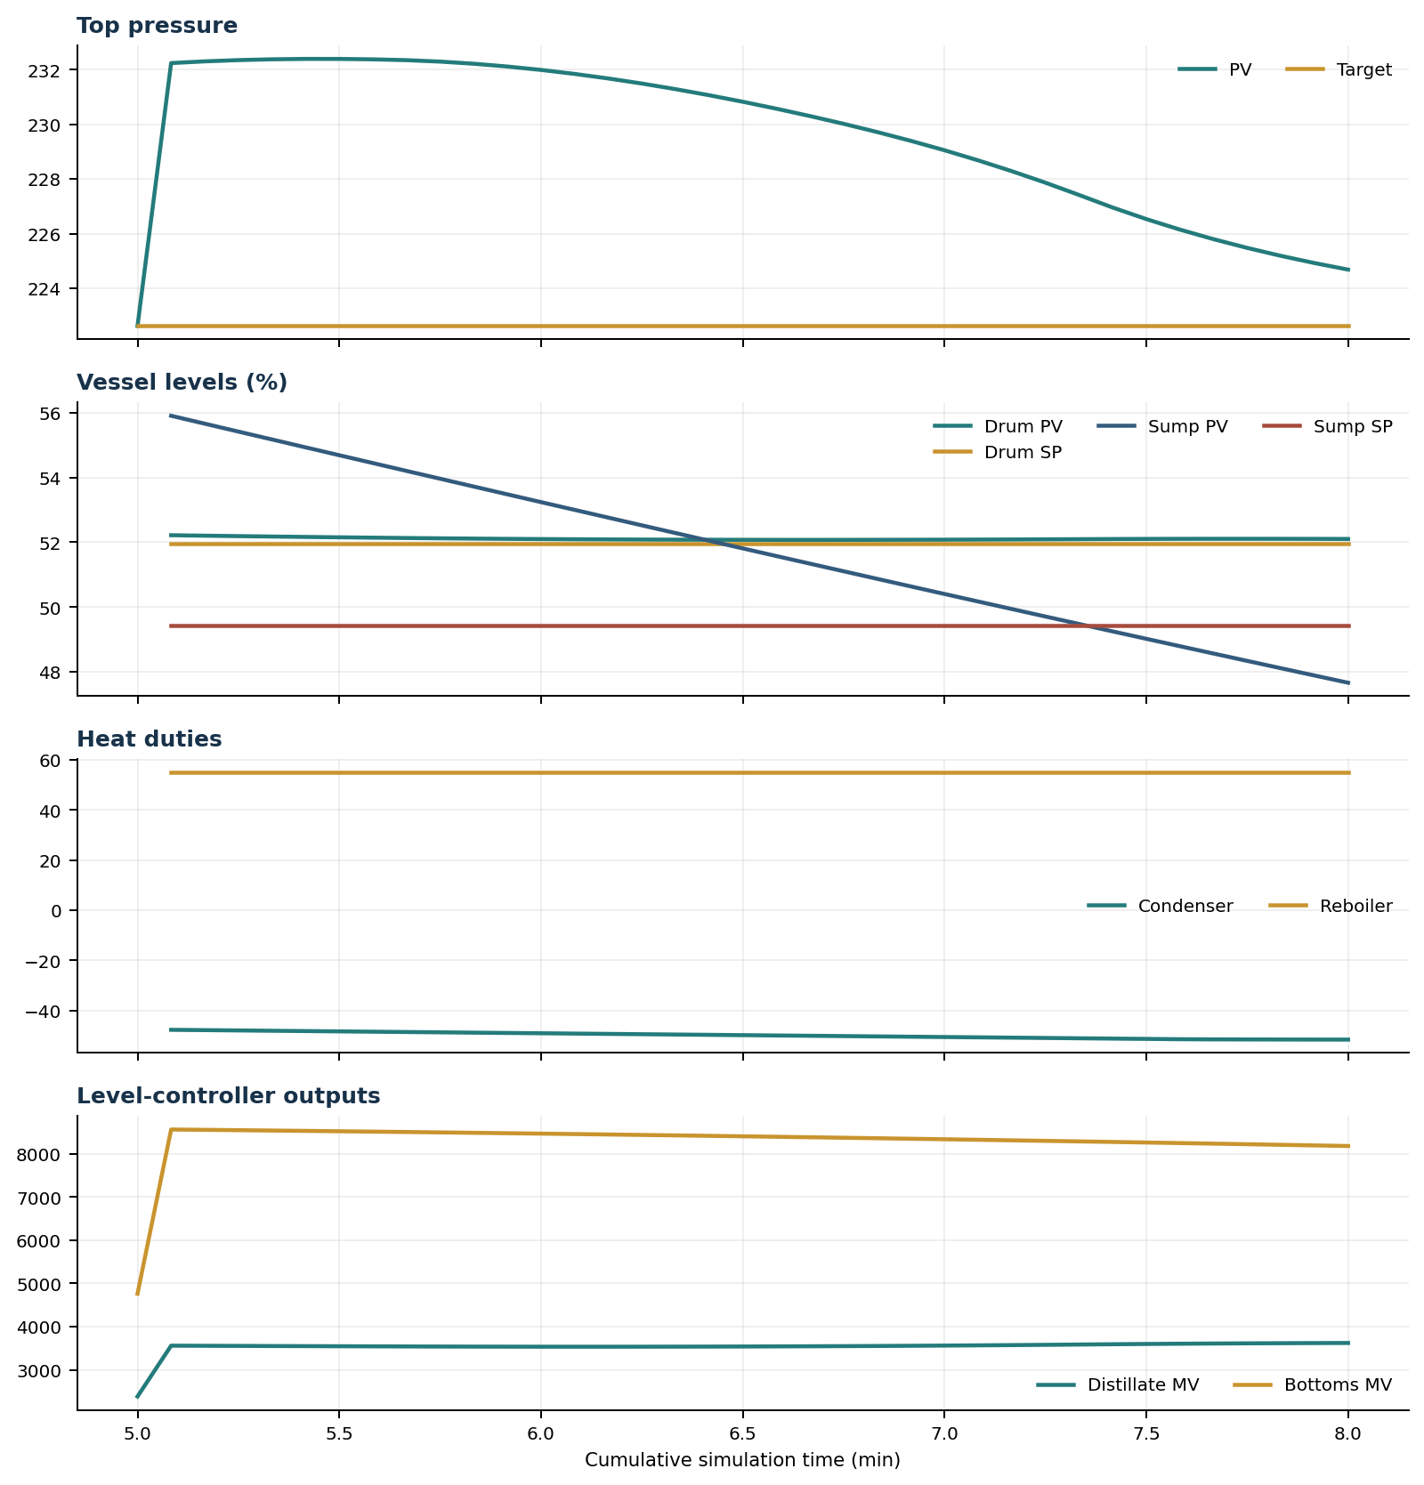

Final Tray Profiles
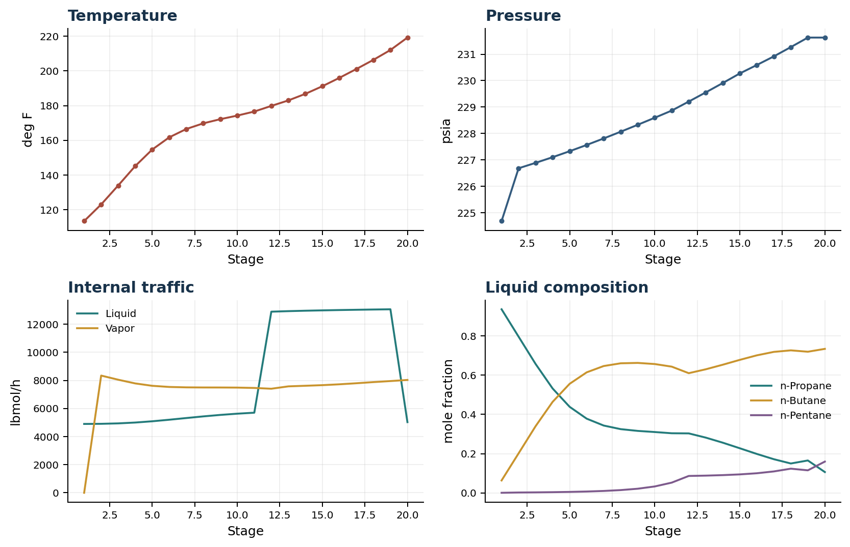

Final Tray Profile Table
Stage | T (deg F) | P (psia) | L (lbmol/h) | V (lbmol/h) | x n-Propane | x n-Butane | x n-Pentane | y n-Propane | y n-Butane | y n-Pentane
1 | 113.43 | 224.680 | 4,900.0 | 0.0 | 0.9365 | 0.0633 | 0.0003 | 0.0000 | 0.0000 | 0.0000
2 | 123.02 | 226.680 | 4,908.8 | 8,341.8 | 0.7967 | 0.2015 | 0.0018 | 0.9377 | 0.0621 | 0.0002
3 | 133.94 | 226.885 | 4,939.4 | 8,047.4 | 0.6574 | 0.3402 | 0.0024 | 0.8587 | 0.1408 | 0.0005
4 | 145.12 | 227.100 | 4,999.5 | 7,783.4 | 0.5323 | 0.4643 | 0.0034 | 0.7706 | 0.2285 | 0.0008
5 | 154.66 | 227.326 | 5,089.0 | 7,613.8 | 0.4389 | 0.5563 | 0.0048 | 0.6885 | 0.3102 | 0.0013
6 | 161.69 | 227.563 | 5,199.5 | 7,532.5 | 0.3785 | 0.6147 | 0.0068 | 0.6239 | 0.3740 | 0.0021
7 | 166.49 | 227.810 | 5,319.5 | 7,503.0 | 0.3434 | 0.6469 | 0.0097 | 0.5787 | 0.4181 | 0.0032
8 | 169.76 | 228.065 | 5,436.8 | 7,495.0 | 0.3250 | 0.6609 | 0.0141 | 0.5484 | 0.4466 | 0.0050
9 | 172.16 | 228.327 | 5,541.9 | 7,493.2 | 0.3160 | 0.6629 | 0.0210 | 0.5281 | 0.4640 | 0.0079
10 | 174.24 | 228.594 | 5,629.9 | 7,486.5 | 0.3103 | 0.6572 | 0.0325 | 0.5137 | 0.4735 | 0.0128
11 | 176.57 | 228.865 | 5,699.9 | 7,461.2 | 0.3040 | 0.6439 | 0.0521 | 0.5016 | 0.4772 | 0.0213
12 | 179.82 | 229.207 | 12,889.1 | 7,405.7 | 0.3033 | 0.6105 | 0.0862 | 0.4896 | 0.4740 | 0.0364
13 | 182.97 | 229.554 | 12,926.6 | 7,573.8 | 0.2818 | 0.6304 | 0.0879 | 0.4570 | 0.5043 | 0.0387
14 | 186.77 | 229.909 | 12,957.0 | 7,616.6 | 0.2559 | 0.6537 | 0.0904 | 0.4170 | 0.5412 | 0.0418
15 | 191.16 | 230.272 | 12,982.1 | 7,659.8 | 0.2275 | 0.6784 | 0.0941 | 0.3702 | 0.5836 | 0.0462
16 | 195.99 | 230.591 | 13,005.2 | 7,720.8 | 0.1985 | 0.7015 | 0.0999 | 0.3195 | 0.6280 | 0.0525
17 | 201.09 | 230.918 | 13,024.5 | 7,795.7 | 0.1716 | 0.7191 | 0.1092 | 0.2682 | 0.6696 | 0.0622
18 | 206.36 | 231.270 | 13,042.6 | 7,877.4 | 0.1497 | 0.7269 | 0.1233 | 0.2209 | 0.7018 | 0.0773
19 | 212.04 | 231.631 | 13,058.9 | 7,951.2 | 0.1652 | 0.7200 | 0.1149 | 0.1818 | 0.7182 | 0.1000
20 | 219.21 | 231.631 | 5,028.8 | 8,030.0 | 0.1060 | 0.7345 | 0.1594 | 0.2022 | 0.7109 | 0.0870

Simulation Configuration
Parameter | Value
Runtime Mode | hydraulic
Thermo Mode | dwsim
Dwsim Property Package | pr
Integrator | explicit-euler
N Steps | 900
Dt Sec | 0.2
Log Every N Steps | 25
Thermo Every N Steps | 1
Include Energy | True
Enable Equilibrium Relaxation | True
Equilibrium Relaxation Mode | composition-exponential
Equilibrium Tau Sec | 0.5
Flash Feed At Stage Conditions | True
Enable Liquid Hydraulic Override | True
Liquid Hydraulic Model | francis
Liquid Hydraulic Override Alpha | 0.25
Enable Level Control | True
Top Level Pv Mode | true-level
Top Level Kc | 20.0
Top Level Ti Sec | 120.0
Bottom Level Pv Mode | true-level
Bottom Level Kc | 3.0
Bottom Level Ti Sec | 300.0
Enable Pressure Control | True
Pressure Control Mv | condenser-duty
Top Pressure Sp Psia | 222.6194497041178
Top Pressure Kc | -150000.0
Top Pressure Ti Sec | 300.0
Top Pressure Pv Filter Tau Sec | 5.0
Top Pressure Mv Slew Limit Per S | 25000.0
Condenser Duty Mode | specified
Condenser Duty Btu Per H | -49500000.0
Condenser Duty Min Btu Per H | -52000000.0
Condenser Duty Max Btu Per H | -46000000.0
Vapor Holdup Relaxation Sec | 0.0
Vapor Flow Relaxation Sec | 0.0
Vapor Flow Zero Temperature Target | True
Dynamic Vflow Nominal Hi Ratio | 1.05
Steady State Window Sec | 30.0
Steady State Min Time Sec | 60.0
Steady State Rel State Rate Tol Per S | 0.003
Steady State Temp Rate Tol F Per S | 0.15
Steady State Sp Error Tol | 0.02
Steady State Require Sp | False

Exact Launch Command
"C:\Users\Thomas Zvolensky\anaconda3\python.exe" -m dynamic_distillation.dynamic_run_scaffold_v1 --excel logs\c3c4_initializer_residual_vapor_state_stage2_20260706.xlsx --init-from-checkpoint .\logs\c3c4_dd046_inventory_coordination_continue300s_20260711\c3c4_initializer_residual_vapor_state_stage2_20260706__checkpoint_20260711_160221.npz --run-name C3C4_DD047_chemsep_duty_control_isolation_180s_r2 --run-description ChemSep_centered_condenser_duty_pressure_and_inventory_control_isolation --runtime-mode hydraulic --thermo dwsim --dwsim-property-package pr --include-energy --equilibrium-relaxation-mode composition-exponential --equilibrium-tau-sec 0.5 --equilibrium-component-transfer-max-cancel-multiplier 1.0 --flash-feed-at-stage-conditions --enable-liquid-hydraulic-override --liquid-hydraulic-model francis --liquid-hydraulic-override-alpha 0.25 --enable-level-control --ignore-workbook-level-pv-mode --top-level-pv-mode true-level --bottom-level-pv-mode true-level --top-level-kc 20 --top-level-ti 120 --bottom-level-kc 3 --bottom-level-ti 300 --enable-pressure-control --pressure-control-mv condenser-duty --top-pressure-sp 222.6194497041178 --top-pressure-kc -150000 --top-pressure-ti 300 --top-pressure-pv-filter-tau-sec 5 --top-pressure-mv-slew-limit-per-s 25000 --condenser-duty-mode specified --condenser-duty-btuph -49500000 --condenser-duty-min-btuph -52000000 --condenser-duty-max-btuph -46000000 --enable-top-drum-resident-condensation --top-drum-resident-condensation-tau-sec 30 --top-drum-resident-condensation-max-frac-per-step 0.10 --reflux 4900 --vapor-holdup-relaxation-sec 0 --vapor-flow-relaxation-sec 0 --vapor-flow-zero-temperature-target --use-excel-vapor-holdup --dynamic-vflow-nominal-hi-ratio 1.05 --disable-startup-thermo-conditioning --disable-restart-reentry-settling --n-steps 900 --dt 0.2 --log-every 25 --logs-dir logs\c3c4_dd047_chemsep_duty_control_isolation_180s_r2_20260711 --allow-repeat-command --no-word-report

