DYNAMIC DISTILLATION / COMPLETED RUN

C3C4_DD048_selective_integral_rebase_180s_r2
Corrected_live_validation_of_selective_pressure_and_bottom_level_PI_integral_rebase
RUN VALIDITY  USABLE | DYNAMIC GATE  PASS | FINAL SCORE  0.817 | SIM / WALL  0.514

Run Identity
Item | Value
Run ID | 20260711_170234
Started | 2026-07-11 17:02:34
Completed | 2026-07-11 17:08:24
Run type | Continuation from native checkpoint
Input workbook | C:\Users\Thomas Zvolensky\Documents\Python Scripts\Dynamic_DistillationII\logs\c3c4_initializer_residual_vapor_state_stage2_20260706.xlsx
Input checkpoint | C:\Users\Thomas Zvolensky\Documents\Python Scripts\Dynamic_DistillationII\logs\c3c4_dd047_chemsep_duty_control_isolation_180s_r2_20260711\c3c4_initializer_residual_vapor_state_stage2_20260706__checkpoint_20260711_163320.npz
Summary data | C:\Users\Thomas Zvolensky\Documents\Python Scripts\Dynamic_DistillationII\logs\c3c4_dd048_selective_integral_rebase_180s_r2_20260711\column_summary_20260711_170234.csv
Tray-profile data | C:\Users\Thomas Zvolensky\Documents\Python Scripts\Dynamic_DistillationII\logs\c3c4_dd048_selective_integral_rebase_180s_r2_20260711\column_profile_20260711_170234.csv

Operating Snapshot
Parameter | Start | End | Units
Feed | 7,142.98 | 7,142.98 | lbmol/h
Distillate | 2,386.93 | 3,523.80 | lbmol/h
Bottoms | 4,761.98 | 4,720.23 | lbmol/h
Reflux | Not reported | 4,900.00 | lbmol/h
Top pressure | 222.619 | 223.213 | psia
Bottom pressure | 316.632 | 232.234 | psia
Distillate temperature | 113.43 | 113.43 | deg F
Bottoms temperature | 190.58 | 199.75 | deg F
Condenser duty | Not reported | -49.640 | MMBtu/h
Reboiler duty | Not reported | 54.844 | MMBtu/h
Distillate drum controller PV | Not reported | 51.91 | lbmol
Bottoms sump controller PV | Not reported | 49.24 | lbmol
Steady-state score | Not reported | 0.8171 | -

Product Composition
Component | Distillate start | Distillate end | Bottoms start | Bottoms end
n-Butane | 7.207% | 6.958% | 70.673% | 71.514%
n-Pentane | 0.129% | 0.101% | 15.609% | 15.810%
n-Propane | 92.664% | 92.941% | 13.719% | 12.676%
source | Not reported | Not reported | Not reported | Not reported

Dynamic Trends
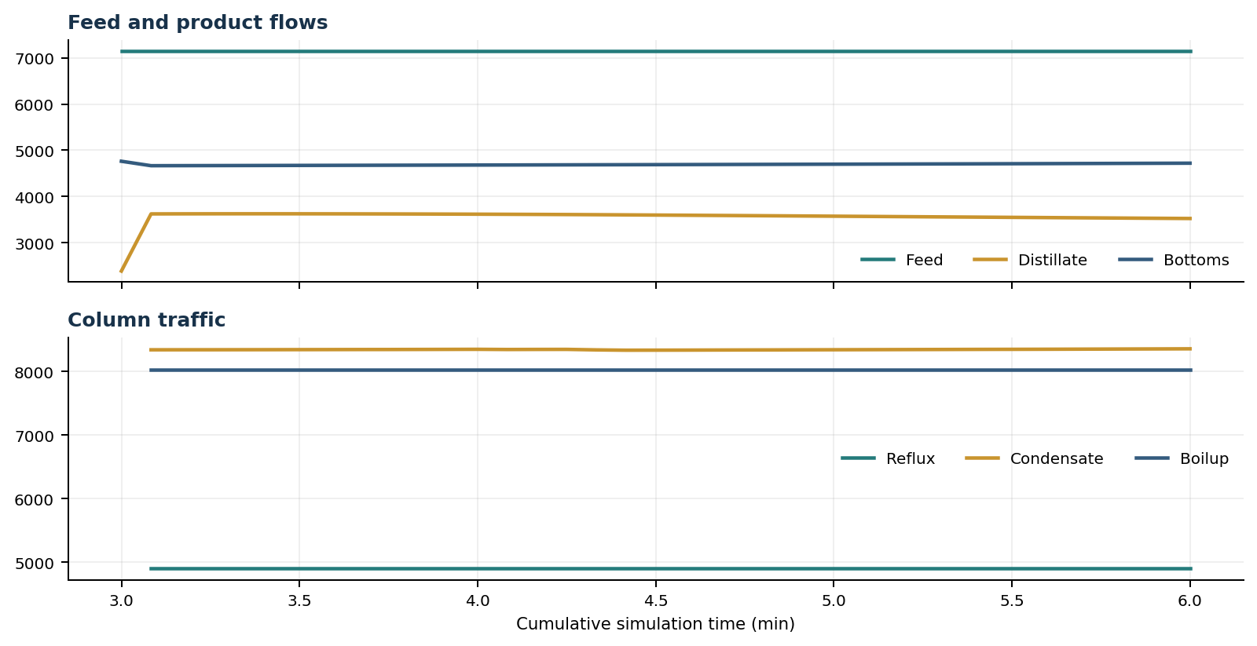
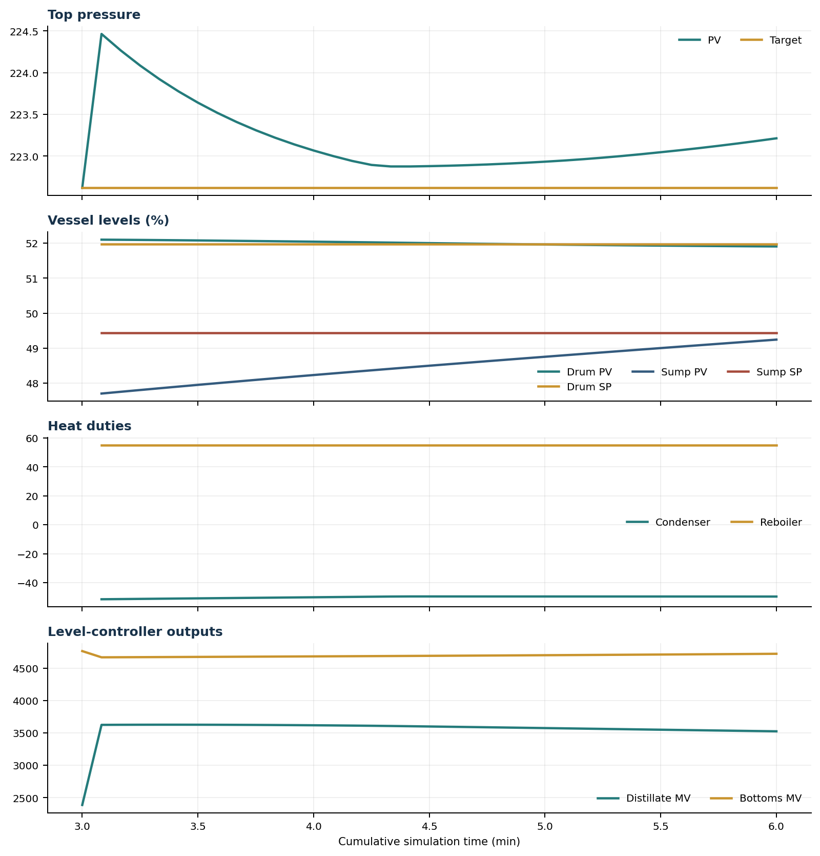

Final Tray Profiles
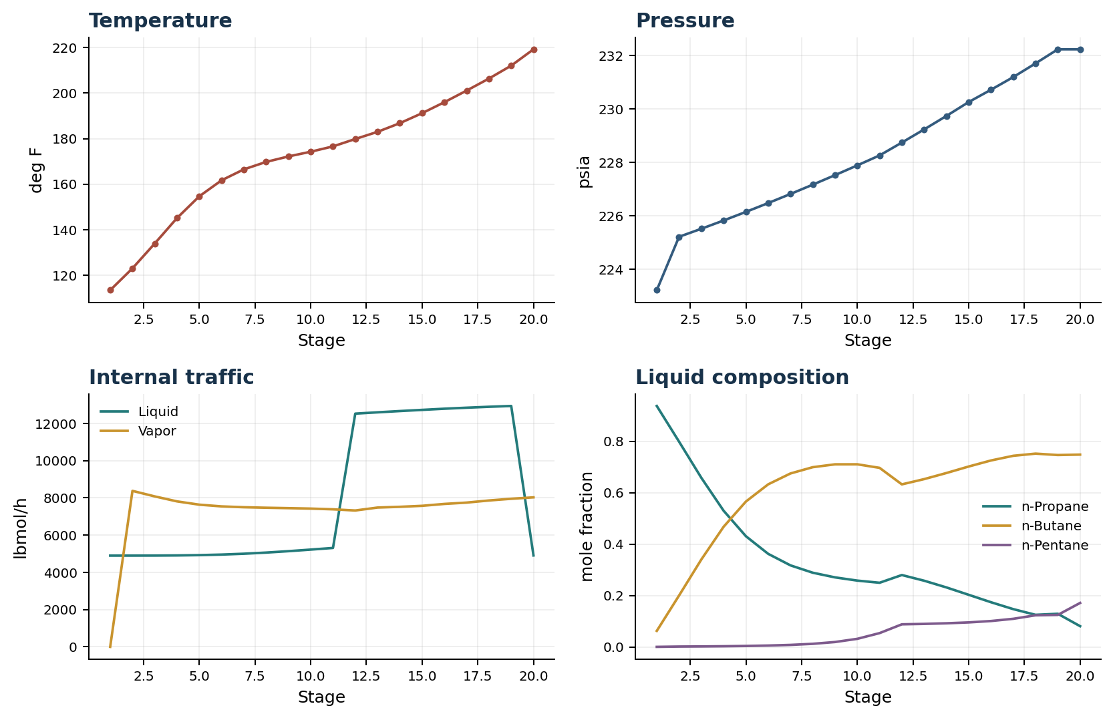

Final Tray Profile Table
Stage | T (deg F) | P (psia) | L (lbmol/h) | V (lbmol/h) | x n-Propane | x n-Butane | x n-Pentane | y n-Propane | y n-Butane | y n-Pentane
1 | 113.43 | 223.213 | 4,900.0 | 0.0 | 0.9376 | 0.0622 | 0.0002 | 0.0000 | 0.0000 | 0.0000
2 | 123.02 | 225.213 | 4,900.4 | 8,378.3 | 0.7987 | 0.1999 | 0.0014 | 0.9376 | 0.0622 | 0.0002
3 | 133.94 | 225.513 | 4,902.9 | 8,080.8 | 0.6580 | 0.3401 | 0.0018 | 0.8584 | 0.1412 | 0.0004
4 | 145.12 | 225.824 | 4,910.3 | 7,813.1 | 0.5299 | 0.4676 | 0.0026 | 0.7702 | 0.2292 | 0.0006
5 | 154.66 | 226.145 | 4,926.7 | 7,636.9 | 0.4307 | 0.5656 | 0.0036 | 0.6878 | 0.3112 | 0.0010
6 | 161.69 | 226.476 | 4,956.3 | 7,544.3 | 0.3622 | 0.6326 | 0.0052 | 0.6230 | 0.3754 | 0.0016
7 | 166.49 | 226.816 | 5,001.7 | 7,498.9 | 0.3173 | 0.6749 | 0.0078 | 0.5774 | 0.4202 | 0.0024
8 | 169.76 | 227.165 | 5,063.4 | 7,472.1 | 0.2887 | 0.6993 | 0.0119 | 0.5466 | 0.4495 | 0.0039
9 | 172.16 | 227.522 | 5,138.9 | 7,450.8 | 0.2705 | 0.7105 | 0.0190 | 0.5256 | 0.4680 | 0.0064
10 | 174.24 | 227.887 | 5,223.8 | 7,426.1 | 0.2580 | 0.7106 | 0.0314 | 0.5105 | 0.4787 | 0.0108
11 | 176.57 | 228.260 | 5,312.7 | 7,386.8 | 0.2496 | 0.6968 | 0.0536 | 0.4979 | 0.4831 | 0.0190
12 | 179.82 | 228.742 | 12,526.7 | 7,323.7 | 0.2797 | 0.6325 | 0.0878 | 0.4870 | 0.4783 | 0.0347
13 | 182.97 | 229.234 | 12,597.3 | 7,482.1 | 0.2576 | 0.6529 | 0.0895 | 0.4539 | 0.5093 | 0.0368
14 | 186.77 | 229.738 | 12,665.2 | 7,521.5 | 0.2315 | 0.6767 | 0.0919 | 0.4134 | 0.5470 | 0.0396
15 | 191.16 | 230.259 | 12,728.4 | 7,575.3 | 0.2027 | 0.7020 | 0.0953 | 0.3658 | 0.5908 | 0.0434
16 | 195.99 | 230.720 | 12,791.2 | 7,677.0 | 0.1739 | 0.7255 | 0.1007 | 0.3137 | 0.6374 | 0.0489
17 | 201.09 | 231.194 | 12,845.3 | 7,748.4 | 0.1470 | 0.7437 | 0.1093 | 0.2602 | 0.6826 | 0.0573
18 | 206.36 | 231.706 | 12,895.2 | 7,861.9 | 0.1249 | 0.7521 | 0.1230 | 0.2098 | 0.7196 | 0.0705
19 | 212.04 | 232.234 | 12,938.3 | 7,953.5 | 0.1289 | 0.7466 | 0.1245 | 0.1656 | 0.7430 | 0.0914
20 | 219.21 | 232.234 | 4,908.3 | 8,030.0 | 0.0807 | 0.7483 | 0.1710 | 0.1583 | 0.7456 | 0.0960

Simulation Configuration
Parameter | Value
Runtime Mode | hydraulic
Thermo Mode | dwsim
Dwsim Property Package | pr
Integrator | explicit-euler
N Steps | 900
Dt Sec | 0.2
Log Every N Steps | 25
Thermo Every N Steps | 1
Include Energy | True
Enable Equilibrium Relaxation | True
Equilibrium Relaxation Mode | composition-exponential
Equilibrium Tau Sec | 0.5
Flash Feed At Stage Conditions | True
Enable Liquid Hydraulic Override | True
Liquid Hydraulic Model | francis
Liquid Hydraulic Override Alpha | 0.25
Enable Level Control | True
Top Level Pv Mode | true-level
Top Level Kc | 20.0
Top Level Ti Sec | 120.0
Bottom Level Pv Mode | true-level
Bottom Level Kc | 3.0
Bottom Level Ti Sec | 300.0
Enable Pressure Control | True
Pressure Control Mv | condenser-duty
Top Pressure Sp Psia | 222.6194497041178
Top Pressure Kc | -150000.0
Top Pressure Ti Sec | 300.0
Top Pressure Pv Filter Tau Sec | 5.0
Top Pressure Mv Slew Limit Per S | 25000.0
Condenser Duty Mode | specified
Condenser Duty Btu Per H | -49500000.0
Condenser Duty Min Btu Per H | -52000000.0
Condenser Duty Max Btu Per H | -46000000.0
Vapor Holdup Relaxation Sec | 0.0
Vapor Flow Relaxation Sec | 0.0
Vapor Flow Zero Temperature Target | True
Dynamic Vflow Nominal Hi Ratio | 1.05
Steady State Window Sec | 30.0
Steady State Min Time Sec | 60.0
Steady State Rel State Rate Tol Per S | 0.003
Steady State Temp Rate Tol F Per S | 0.15
Steady State Sp Error Tol | 0.02
Steady State Require Sp | False

Exact Launch Command
"C:\Users\Thomas Zvolensky\anaconda3\python.exe" -m dynamic_distillation.dynamic_run_scaffold_v1 --excel logs\c3c4_initializer_residual_vapor_state_stage2_20260706.xlsx --init-from-checkpoint .\logs\c3c4_dd047_chemsep_duty_control_isolation_180s_r2_20260711\c3c4_initializer_residual_vapor_state_stage2_20260706__checkpoint_20260711_163320.npz --rebase-controller-integral top-pressure --rebase-controller-integral bottom-level --run-name C3C4_DD048_selective_integral_rebase_180s_r2 --run-description Corrected_live_validation_of_selective_pressure_and_bottom_level_PI_integral_rebase --runtime-mode hydraulic --thermo dwsim --dwsim-property-package pr --include-energy --equilibrium-relaxation-mode composition-exponential --equilibrium-tau-sec 0.5 --equilibrium-component-transfer-max-cancel-multiplier 1.0 --flash-feed-at-stage-conditions --enable-liquid-hydraulic-override --liquid-hydraulic-model francis --liquid-hydraulic-override-alpha 0.25 --enable-level-control --ignore-workbook-level-pv-mode --top-level-pv-mode true-level --bottom-level-pv-mode true-level --top-level-kc 20 --top-level-ti 120 --bottom-level-kc 3 --bottom-level-ti 300 --enable-pressure-control --pressure-control-mv condenser-duty --top-pressure-sp 222.6194497041178 --top-pressure-kc -150000 --top-pressure-ti 300 --top-pressure-pv-filter-tau-sec 5 --top-pressure-mv-slew-limit-per-s 25000 --condenser-duty-mode specified --condenser-duty-btuph -49500000 --condenser-duty-min-btuph -52000000 --condenser-duty-max-btuph -46000000 --enable-top-drum-resident-condensation --top-drum-resident-condensation-tau-sec 30 --top-drum-resident-condensation-max-frac-per-step 0.10 --reflux 4900 --vapor-holdup-relaxation-sec 0 --vapor-flow-relaxation-sec 0 --vapor-flow-zero-temperature-target --use-excel-vapor-holdup --dynamic-vflow-nominal-hi-ratio 1.05 --disable-startup-thermo-conditioning --disable-restart-reentry-settling --n-steps 900 --dt 0.2 --log-every 25 --logs-dir logs\c3c4_dd048_selective_integral_rebase_180s_r2_20260711 --allow-repeat-command

