DYNAMIC DISTILLATION / COMPLETED RUN

C3C4_DD051_pressure_resident_margin_120s
Faster_pressure_PI_with_temporary_resident_condensation_margin
RUN VALIDITY  USABLE | DYNAMIC GATE  PASS | FINAL SCORE  0.464 | SIM / WALL  0.447

Run Identity
Item | Value
Run ID | 20260712_085323
Started | 2026-07-12 08:53:23
Completed | 2026-07-12 08:57:52
Run type | Continuation from native checkpoint
Input workbook | C:\Users\Thomas Zvolensky\Documents\Python Scripts\Dynamic_DistillationII\logs\c3c4_initializer_residual_vapor_state_stage2_20260706.xlsx
Input checkpoint | C:\Users\Thomas Zvolensky\Documents\Python Scripts\Dynamic_DistillationII\logs\c3c4_dd050_pressure_duty_55cap_120s_20260712\c3c4_initializer_residual_vapor_state_stage2_20260706__checkpoint_20260712_084602.npz
Summary data | C:\Users\Thomas Zvolensky\Documents\Python Scripts\Dynamic_DistillationII\logs\c3c4_dd051_pressure_resident_margin_120s_20260712\column_summary_20260712_085323.csv
Tray-profile data | C:\Users\Thomas Zvolensky\Documents\Python Scripts\Dynamic_DistillationII\logs\c3c4_dd051_pressure_resident_margin_120s_20260712\column_profile_20260712_085323.csv

Operating Snapshot
Parameter | Start | End | Units
Feed | 7,142.98 | 7,142.98 | lbmol/h
Distillate | 2,386.93 | 2,832.45 | lbmol/h
Bottoms | 4,761.98 | 4,921.14 | lbmol/h
Reflux | Not reported | 5,967.32 | lbmol/h
Top pressure | 222.619 | 223.397 | psia
Bottom pressure | 316.632 | 231.964 | psia
Distillate temperature | 113.43 | 113.43 | deg F
Bottoms temperature | 206.22 | 205.60 | deg F
Condenser duty | Not reported | -52.251 | MMBtu/h
Reboiler duty | Not reported | 54.844 | MMBtu/h
Distillate drum controller PV | Not reported | 52.29 | lbmol
Bottoms sump controller PV | Not reported | 51.25 | lbmol
Steady-state score | Not reported | 0.4636 | -

Product Composition
Component | Distillate start | Distillate end | Bottoms start | Bottoms end
n-Butane | 6.674% | 6.615% | 73.674% | 74.673%
n-Pentane | 0.068% | 0.058% | 16.734% | 17.028%
n-Propane | 93.258% | 93.327% | 9.592% | 8.300%
source | Not reported | Not reported | Not reported | Not reported

Dynamic Trends
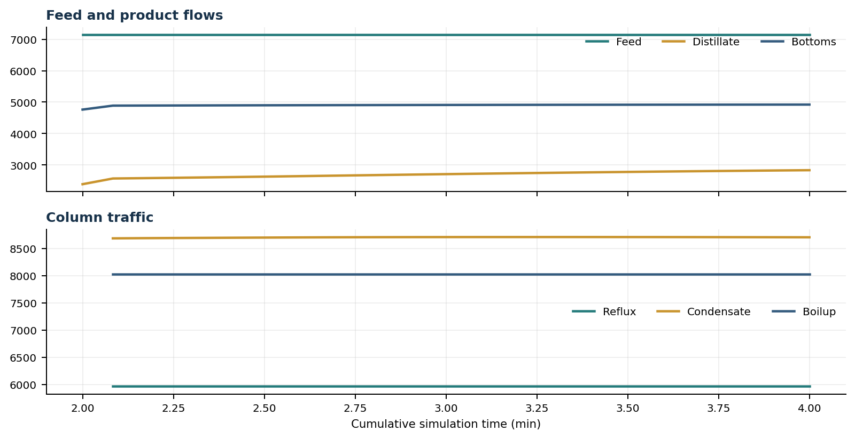
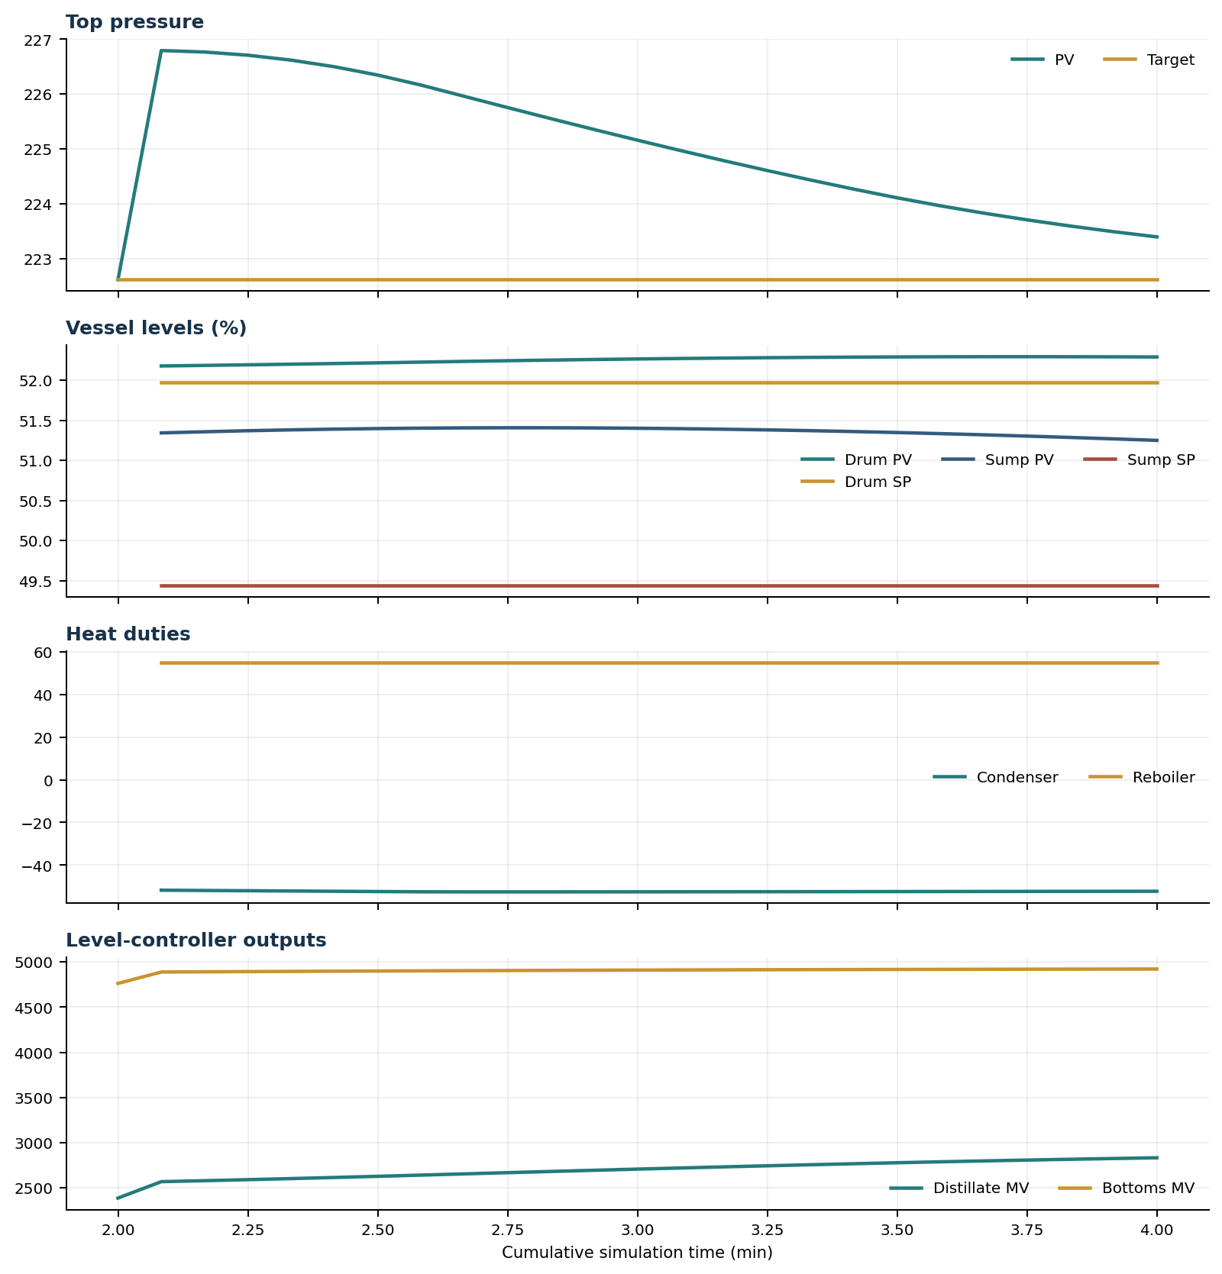

Final Tray Profiles
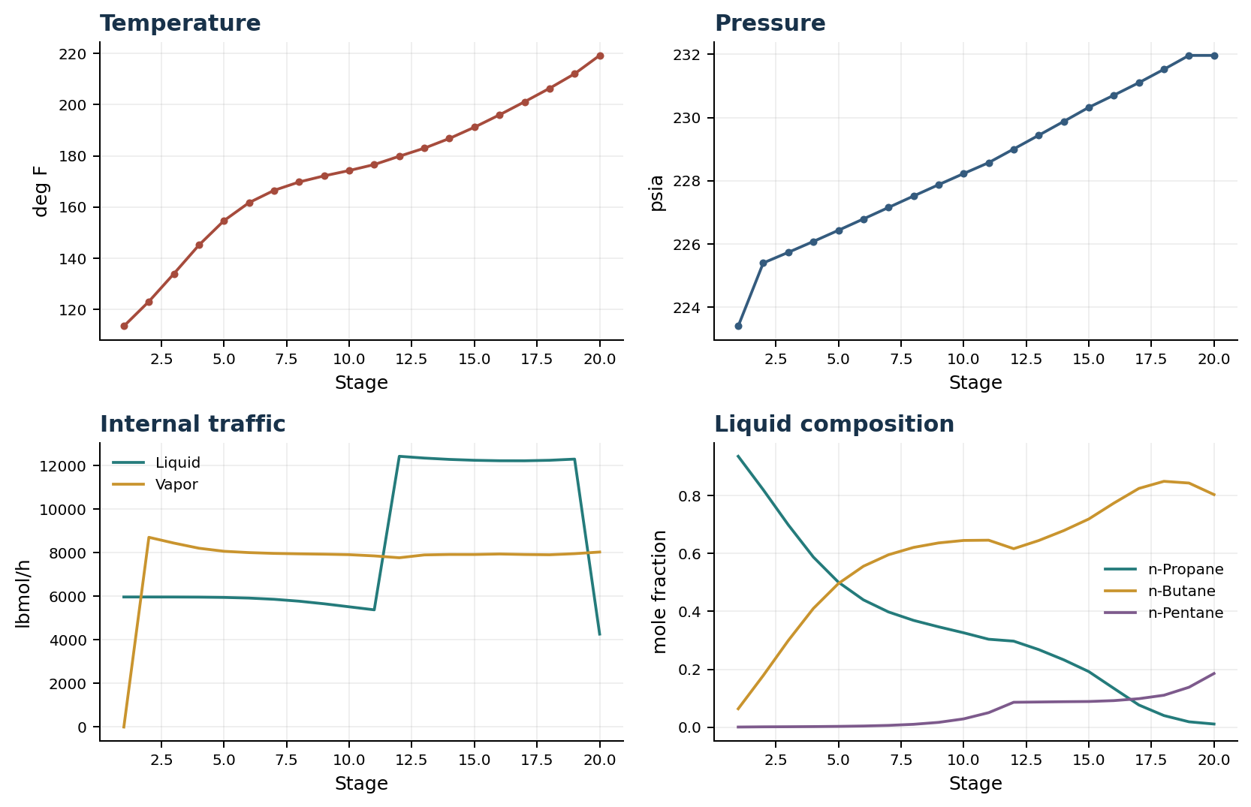

Final Tray Profile Table
Stage | T (deg F) | P (psia) | L (lbmol/h) | V (lbmol/h) | x n-Propane | x n-Butane | x n-Pentane | y n-Propane | y n-Butane | y n-Pentane
1 | 113.43 | 223.397 | 5,967.3 | 0.0 | 0.9366 | 0.0632 | 0.0001 | 0.0000 | 0.0000 | 0.0000
2 | 123.07 | 225.397 | 5,967.2 | 8,705.4 | 0.8209 | 0.1783 | 0.0008 | 0.9370 | 0.0628 | 0.0001
3 | 133.94 | 225.732 | 5,966.0 | 8,440.5 | 0.6995 | 0.2994 | 0.0011 | 0.8576 | 0.1421 | 0.0003
4 | 145.12 | 226.077 | 5,961.2 | 8,204.4 | 0.5881 | 0.4102 | 0.0016 | 0.7694 | 0.2301 | 0.0005
5 | 154.66 | 226.430 | 5,947.6 | 8,064.6 | 0.5012 | 0.4964 | 0.0024 | 0.6871 | 0.3121 | 0.0008
6 | 161.69 | 226.789 | 5,917.3 | 8,003.9 | 0.4400 | 0.5564 | 0.0037 | 0.6224 | 0.3762 | 0.0014
7 | 166.49 | 227.152 | 5,861.6 | 7,967.3 | 0.3982 | 0.5960 | 0.0058 | 0.5770 | 0.4207 | 0.0023
8 | 169.76 | 227.514 | 5,773.7 | 7,947.2 | 0.3691 | 0.6214 | 0.0096 | 0.5465 | 0.4495 | 0.0040
9 | 172.16 | 227.872 | 5,654.7 | 7,931.3 | 0.3468 | 0.6370 | 0.0163 | 0.5262 | 0.4670 | 0.0068
10 | 174.24 | 228.225 | 5,516.2 | 7,908.7 | 0.3262 | 0.6455 | 0.0283 | 0.5120 | 0.4762 | 0.0118
11 | 176.57 | 228.570 | 5,377.8 | 7,852.4 | 0.3038 | 0.6464 | 0.0498 | 0.5001 | 0.4794 | 0.0205
12 | 179.82 | 229.002 | 12,422.8 | 7,767.4 | 0.2972 | 0.6170 | 0.0857 | 0.4880 | 0.4764 | 0.0356
13 | 182.97 | 229.437 | 12,341.4 | 7,897.2 | 0.2680 | 0.6452 | 0.0867 | 0.4535 | 0.5098 | 0.0368
14 | 186.77 | 229.875 | 12,280.2 | 7,918.1 | 0.2326 | 0.6796 | 0.0877 | 0.4105 | 0.5515 | 0.0380
15 | 191.16 | 230.321 | 12,240.0 | 7,917.0 | 0.1918 | 0.7197 | 0.0884 | 0.3583 | 0.6026 | 0.0392
16 | 195.99 | 230.705 | 12,219.0 | 7,939.7 | 0.1339 | 0.7746 | 0.0915 | 0.2976 | 0.6627 | 0.0396
17 | 201.09 | 231.101 | 12,217.3 | 7,916.5 | 0.0764 | 0.8255 | 0.0982 | 0.2078 | 0.7485 | 0.0437
18 | 206.36 | 231.524 | 12,240.1 | 7,904.3 | 0.0398 | 0.8501 | 0.1101 | 0.1161 | 0.8305 | 0.0534
19 | 212.04 | 231.964 | 12,293.8 | 7,954.3 | 0.0182 | 0.8441 | 0.1377 | 0.0571 | 0.8719 | 0.0711
20 | 219.21 | 231.964 | 4,263.8 | 8,030.0 | 0.0105 | 0.8042 | 0.1853 | 0.0223 | 0.8653 | 0.1124

Simulation Configuration
Parameter | Value
Runtime Mode | hydraulic
Thermo Mode | dwsim
Dwsim Property Package | pr
Integrator | explicit-euler
N Steps | 600
Dt Sec | 0.2
Log Every N Steps | 25
Thermo Every N Steps | 1
Include Energy | True
Enable Equilibrium Relaxation | True
Equilibrium Relaxation Mode | composition-exponential
Equilibrium Tau Sec | 0.5
Flash Feed At Stage Conditions | True
Enable Liquid Hydraulic Override | True
Liquid Hydraulic Model | francis
Liquid Hydraulic Override Alpha | 0.25
Enable Level Control | True
Top Level Pv Mode | true-level
Top Level Kc | 20.0
Top Level Ti Sec | 120.0
Bottom Level Pv Mode | true-level
Bottom Level Kc | 3.0
Bottom Level Ti Sec | 300.0
Enable Pressure Control | True
Pressure Control Mv | condenser-duty
Top Pressure Sp Psia | 222.6194497041178
Top Pressure Kc | -300000.0
Top Pressure Ti Sec | 180.0
Top Pressure Pv Filter Tau Sec | 5.0
Top Pressure Mv Slew Limit Per S | 25000.0
Condenser Duty Mode | specified
Condenser Duty Btu Per H | -51600000.0
Condenser Duty Min Btu Per H | -55000000.0
Condenser Duty Max Btu Per H | -46000000.0
Vapor Holdup Relaxation Sec | 0.0
Vapor Flow Relaxation Sec | 0.0
Vapor Flow Zero Temperature Target | True
Dynamic Vflow Nominal Hi Ratio | 1.05
Steady State Window Sec | 30.0
Steady State Min Time Sec | 60.0
Steady State Rel State Rate Tol Per S | 0.003
Steady State Temp Rate Tol F Per S | 0.15
Steady State Sp Error Tol | 0.02
Steady State Require Sp | False

Exact Launch Command
"C:\Users\Thomas Zvolensky\anaconda3\python.exe" -m dynamic_distillation.dynamic_run_scaffold_v1 --excel logs\c3c4_initializer_residual_vapor_state_stage2_20260706.xlsx --init-from-checkpoint .\logs\c3c4_dd050_pressure_duty_55cap_120s_20260712\c3c4_initializer_residual_vapor_state_stage2_20260706__checkpoint_20260712_084602.npz --rebase-controller-integral top-pressure --run-name C3C4_DD051_pressure_resident_margin_120s --run-description Faster_pressure_PI_with_temporary_resident_condensation_margin --runtime-mode hydraulic --thermo dwsim --dwsim-property-package pr --include-energy --equilibrium-relaxation-mode composition-exponential --equilibrium-tau-sec 0.5 --flash-feed-at-stage-conditions --enable-liquid-hydraulic-override --liquid-hydraulic-model francis --liquid-hydraulic-override-alpha 0.25 --enable-level-control --ignore-workbook-level-pv-mode --top-level-pv-mode true-level --bottom-level-pv-mode true-level --top-level-kc 20 --top-level-ti 120 --bottom-level-kc 3 --bottom-level-ti 300 --enable-pressure-control --pressure-control-mv condenser-duty --top-pressure-sp 222.6194497041178 --top-pressure-kc -300000 --top-pressure-ti 180 --top-pressure-pv-filter-tau-sec 5 --top-pressure-mv-slew-limit-per-s 25000 --condenser-duty-mode specified --condenser-duty-btuph -51600000 --condenser-duty-min-btuph -55000000 --condenser-duty-max-btuph -46000000 --enable-top-drum-resident-condensation --top-drum-resident-condensation-tau-sec 30 --top-drum-resident-condensation-max-frac-per-step 0.10 --reflux 5967.322711692588 --vapor-holdup-relaxation-sec 0 --vapor-flow-relaxation-sec 0 --vapor-flow-zero-temperature-target --use-excel-vapor-holdup --dynamic-vflow-nominal-hi-ratio 1.05 --disable-startup-thermo-conditioning --disable-restart-reentry-settling --n-steps 600 --dt 0.2 --log-every 25 --logs-dir logs\c3c4_dd051_pressure_resident_margin_120s_20260712 --allow-repeat-command

