DYNAMIC DISTILLATION / COMPLETED RUN

C3C4_DD052_pressure_settle_90s
Unchanged_pressure_PI_continuation_through_setpoint
RUN VALIDITY  USABLE | DYNAMIC GATE  PASS | FINAL SCORE  0.469 | SIM / WALL  0.447

Run Identity
Item | Value
Run ID | 20260712_085859
Started | 2026-07-12 08:58:59
Completed | 2026-07-12 09:02:20
Run type | Continuation from native checkpoint
Input workbook | C:\Users\Thomas Zvolensky\Documents\Python Scripts\Dynamic_DistillationII\logs\c3c4_initializer_residual_vapor_state_stage2_20260706.xlsx
Input checkpoint | C:\Users\Thomas Zvolensky\Documents\Python Scripts\Dynamic_DistillationII\logs\c3c4_dd051_pressure_resident_margin_120s_20260712\c3c4_initializer_residual_vapor_state_stage2_20260706__checkpoint_20260712_085323.npz
Summary data | C:\Users\Thomas Zvolensky\Documents\Python Scripts\Dynamic_DistillationII\logs\c3c4_dd052_pressure_settle_90s_20260712\column_summary_20260712_085859.csv
Tray-profile data | C:\Users\Thomas Zvolensky\Documents\Python Scripts\Dynamic_DistillationII\logs\c3c4_dd052_pressure_settle_90s_20260712\column_profile_20260712_085859.csv

Operating Snapshot
Parameter | Start | End | Units
Feed | 7,142.98 | 7,142.98 | lbmol/h
Distillate | 2,386.93 | 2,901.16 | lbmol/h
Bottoms | 4,761.98 | 4,925.24 | lbmol/h
Reflux | Not reported | 5,967.32 | lbmol/h
Top pressure | 222.619 | 222.525 | psia
Bottom pressure | 316.632 | 232.119 | psia
Distillate temperature | 113.43 | 113.43 | deg F
Bottoms temperature | 205.60 | 204.51 | deg F
Condenser duty | Not reported | -52.052 | MMBtu/h
Reboiler duty | Not reported | 54.844 | MMBtu/h
Distillate drum controller PV | Not reported | 52.18 | lbmol
Bottoms sump controller PV | Not reported | 50.84 | lbmol
Steady-state score | Not reported | 0.4691 | -

Product Composition
Component | Distillate start | Distillate end | Bottoms start | Bottoms end
n-Butane | 6.615% | 6.573% | 74.673% | 75.369%
n-Pentane | 0.058% | 0.052% | 17.028% | 17.184%
n-Propane | 93.327% | 93.375% | 8.300% | 7.447%
source | Not reported | Not reported | Not reported | Not reported

Dynamic Trends
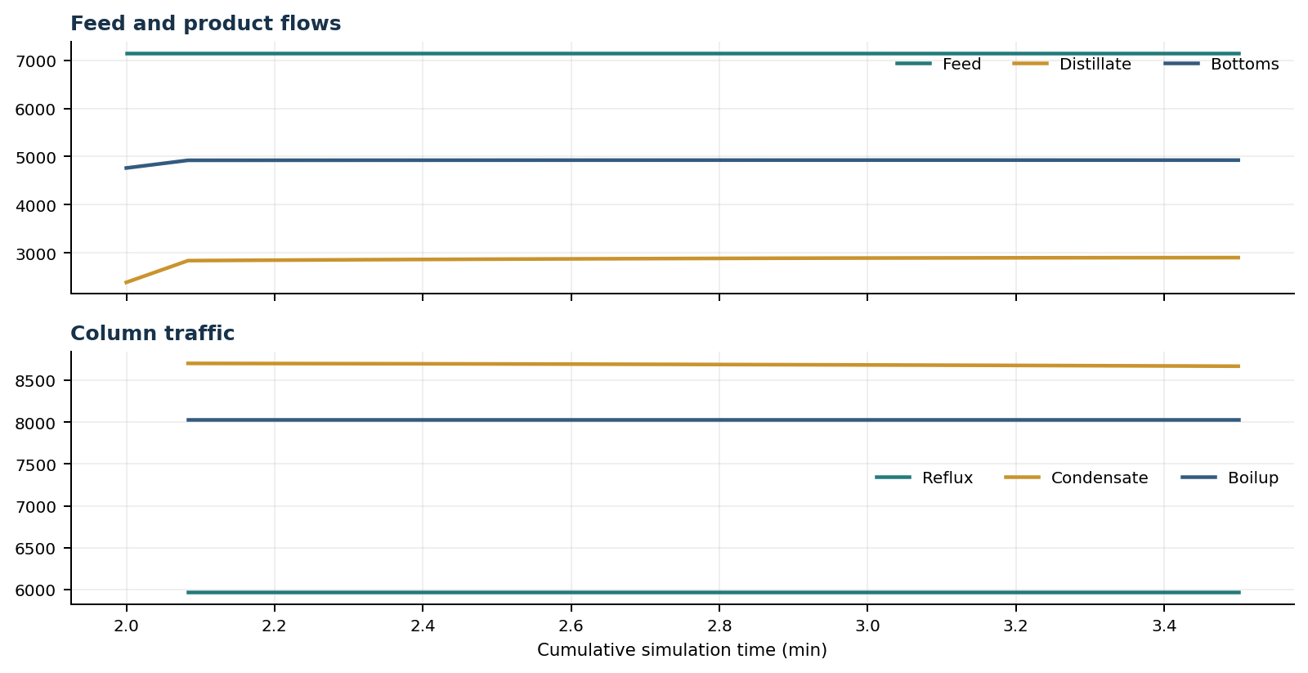
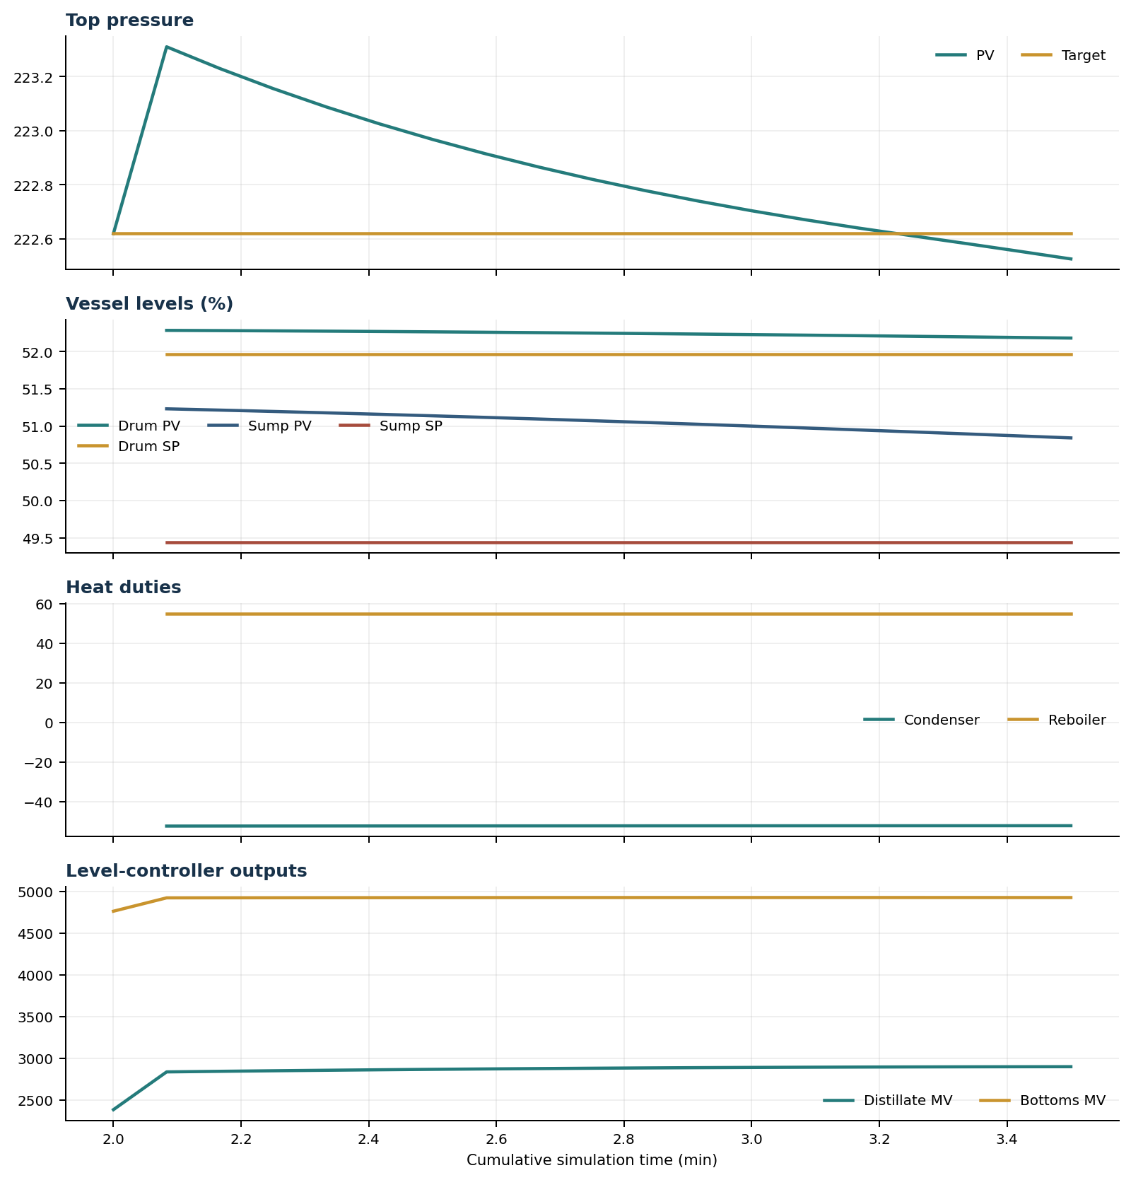

Final Tray Profiles
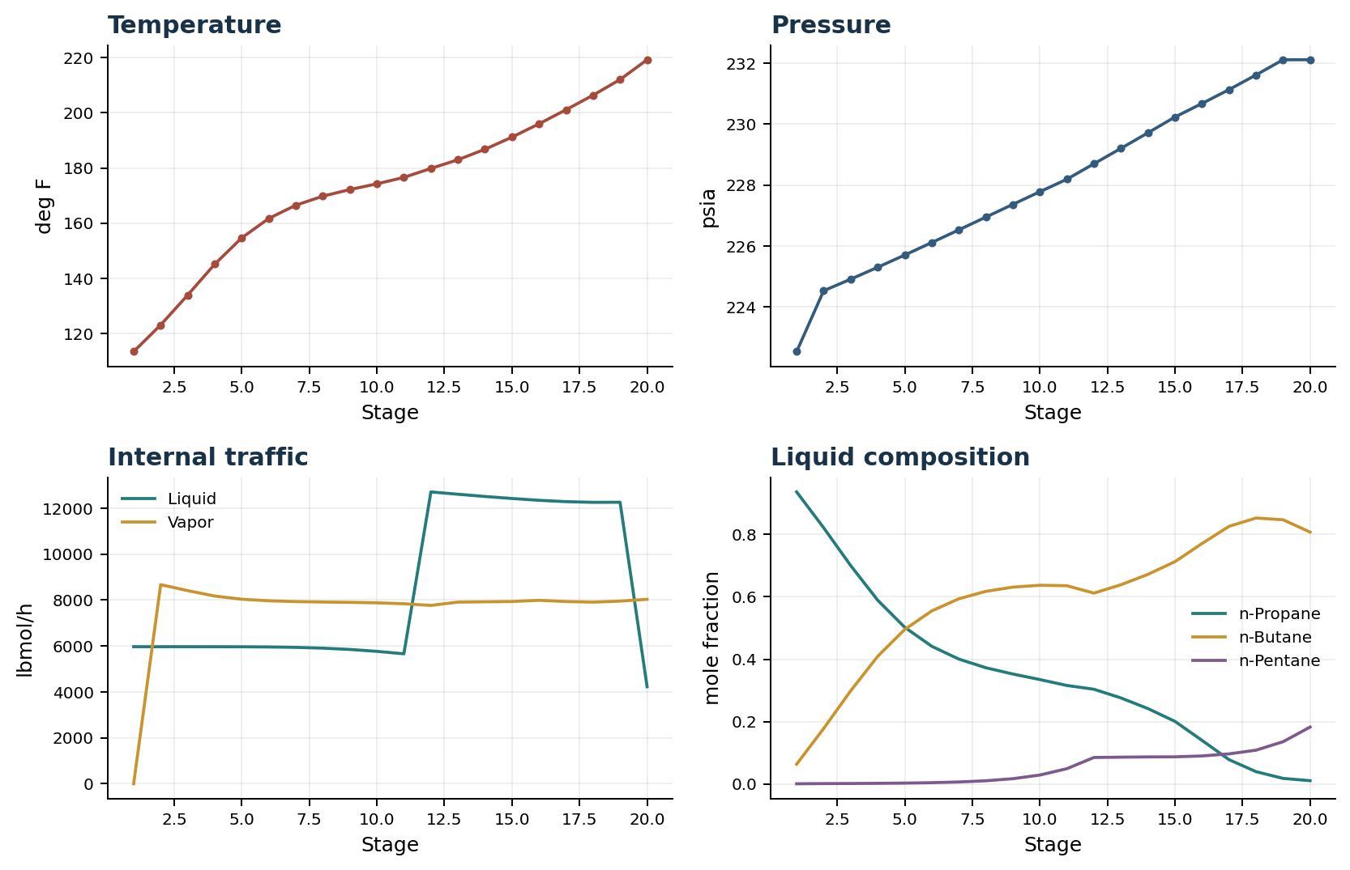

Final Tray Profile Table
Stage | T (deg F) | P (psia) | L (lbmol/h) | V (lbmol/h) | x n-Propane | x n-Butane | x n-Pentane | y n-Propane | y n-Butane | y n-Pentane
1 | 113.43 | 222.525 | 5,967.3 | 0.0 | 0.9368 | 0.0631 | 0.0001 | 0.0000 | 0.0000 | 0.0000
2 | 123.10 | 224.525 | 5,967.3 | 8,668.2 | 0.8217 | 0.1775 | 0.0007 | 0.9368 | 0.0631 | 0.0001
3 | 133.94 | 224.907 | 5,967.1 | 8,407.5 | 0.7005 | 0.2985 | 0.0011 | 0.8575 | 0.1423 | 0.0003
4 | 145.12 | 225.298 | 5,966.3 | 8,171.8 | 0.5892 | 0.4092 | 0.0016 | 0.7692 | 0.2303 | 0.0005
5 | 154.66 | 225.700 | 5,963.4 | 8,033.2 | 0.5024 | 0.4953 | 0.0024 | 0.6870 | 0.3122 | 0.0008
6 | 161.69 | 226.110 | 5,955.5 | 7,965.2 | 0.4414 | 0.5549 | 0.0037 | 0.6224 | 0.3762 | 0.0014
7 | 166.49 | 226.527 | 5,937.8 | 7,930.4 | 0.4004 | 0.5937 | 0.0059 | 0.5770 | 0.4206 | 0.0024
8 | 169.76 | 226.946 | 5,904.1 | 7,911.9 | 0.3726 | 0.6177 | 0.0098 | 0.5467 | 0.4492 | 0.0041
9 | 172.16 | 227.364 | 5,847.6 | 7,897.6 | 0.3524 | 0.6312 | 0.0164 | 0.5265 | 0.4665 | 0.0071
10 | 174.24 | 227.780 | 5,764.8 | 7,876.9 | 0.3346 | 0.6373 | 0.0281 | 0.5123 | 0.4756 | 0.0121
11 | 176.57 | 228.191 | 5,657.9 | 7,836.8 | 0.3156 | 0.6358 | 0.0486 | 0.5004 | 0.4788 | 0.0208
12 | 179.82 | 228.698 | 12,704.4 | 7,764.8 | 0.3035 | 0.6120 | 0.0845 | 0.4882 | 0.4760 | 0.0357
13 | 182.97 | 229.206 | 12,603.5 | 7,907.5 | 0.2756 | 0.6388 | 0.0855 | 0.4539 | 0.5090 | 0.0371
14 | 186.77 | 229.717 | 12,506.0 | 7,921.1 | 0.2414 | 0.6722 | 0.0864 | 0.4111 | 0.5505 | 0.0384
15 | 191.16 | 230.236 | 12,418.8 | 7,933.9 | 0.2004 | 0.7129 | 0.0866 | 0.3589 | 0.6017 | 0.0394
16 | 195.99 | 230.681 | 12,339.8 | 7,986.8 | 0.1395 | 0.7711 | 0.0894 | 0.2972 | 0.6633 | 0.0395
17 | 201.09 | 231.137 | 12,280.9 | 7,932.9 | 0.0776 | 0.8263 | 0.0961 | 0.2056 | 0.7512 | 0.0432
18 | 206.36 | 231.620 | 12,251.3 | 7,906.6 | 0.0390 | 0.8530 | 0.1080 | 0.1120 | 0.8353 | 0.0527
19 | 212.04 | 232.119 | 12,254.9 | 7,951.3 | 0.0174 | 0.8475 | 0.1351 | 0.0537 | 0.8761 | 0.0702
20 | 219.21 | 232.119 | 4,224.9 | 8,030.0 | 0.0101 | 0.8078 | 0.1821 | 0.0213 | 0.8683 | 0.1104

Simulation Configuration
Parameter | Value
Runtime Mode | hydraulic
Thermo Mode | dwsim
Dwsim Property Package | pr
Integrator | explicit-euler
N Steps | 450
Dt Sec | 0.2
Log Every N Steps | 25
Thermo Every N Steps | 1
Include Energy | True
Enable Equilibrium Relaxation | True
Equilibrium Relaxation Mode | composition-exponential
Equilibrium Tau Sec | 0.5
Flash Feed At Stage Conditions | True
Enable Liquid Hydraulic Override | True
Liquid Hydraulic Model | francis
Liquid Hydraulic Override Alpha | 0.25
Enable Level Control | True
Top Level Pv Mode | true-level
Top Level Kc | 20.0
Top Level Ti Sec | 120.0
Bottom Level Pv Mode | true-level
Bottom Level Kc | 3.0
Bottom Level Ti Sec | 300.0
Enable Pressure Control | True
Pressure Control Mv | condenser-duty
Top Pressure Sp Psia | 222.6194497041178
Top Pressure Kc | -300000.0
Top Pressure Ti Sec | 180.0
Top Pressure Pv Filter Tau Sec | 5.0
Top Pressure Mv Slew Limit Per S | 25000.0
Condenser Duty Mode | specified
Condenser Duty Btu Per H | -51600000.0
Condenser Duty Min Btu Per H | -55000000.0
Condenser Duty Max Btu Per H | -46000000.0
Vapor Holdup Relaxation Sec | 0.0
Vapor Flow Relaxation Sec | 0.0
Vapor Flow Zero Temperature Target | True
Dynamic Vflow Nominal Hi Ratio | 1.05
Steady State Window Sec | 30.0
Steady State Min Time Sec | 60.0
Steady State Rel State Rate Tol Per S | 0.003
Steady State Temp Rate Tol F Per S | 0.15
Steady State Sp Error Tol | 0.02
Steady State Require Sp | False

Exact Launch Command
"C:\Users\Thomas Zvolensky\anaconda3\python.exe" -m dynamic_distillation.dynamic_run_scaffold_v1 --excel logs\c3c4_initializer_residual_vapor_state_stage2_20260706.xlsx --init-from-checkpoint .\logs\c3c4_dd051_pressure_resident_margin_120s_20260712\c3c4_initializer_residual_vapor_state_stage2_20260706__checkpoint_20260712_085323.npz --run-name C3C4_DD052_pressure_settle_90s --run-description Unchanged_pressure_PI_continuation_through_setpoint --runtime-mode hydraulic --thermo dwsim --dwsim-property-package pr --include-energy --equilibrium-relaxation-mode composition-exponential --equilibrium-tau-sec 0.5 --flash-feed-at-stage-conditions --enable-liquid-hydraulic-override --liquid-hydraulic-model francis --liquid-hydraulic-override-alpha 0.25 --enable-level-control --ignore-workbook-level-pv-mode --top-level-pv-mode true-level --bottom-level-pv-mode true-level --top-level-kc 20 --top-level-ti 120 --bottom-level-kc 3 --bottom-level-ti 300 --enable-pressure-control --pressure-control-mv condenser-duty --top-pressure-sp 222.6194497041178 --top-pressure-kc -300000 --top-pressure-ti 180 --top-pressure-pv-filter-tau-sec 5 --top-pressure-mv-slew-limit-per-s 25000 --condenser-duty-mode specified --condenser-duty-btuph -51600000 --condenser-duty-min-btuph -55000000 --condenser-duty-max-btuph -46000000 --enable-top-drum-resident-condensation --top-drum-resident-condensation-tau-sec 30 --top-drum-resident-condensation-max-frac-per-step 0.10 --reflux 5967.322711692588 --vapor-holdup-relaxation-sec 0 --vapor-flow-relaxation-sec 0 --vapor-flow-zero-temperature-target --use-excel-vapor-holdup --dynamic-vflow-nominal-hi-ratio 1.05 --disable-startup-thermo-conditioning --disable-restart-reentry-settling --n-steps 450 --dt 0.2 --log-every 25 --logs-dir logs\c3c4_dd052_pressure_settle_90s_20260712 --allow-repeat-command

