DYNAMIC DISTILLATION / COMPLETED RUN

C3C4_DD053_unchanged_operating_point_hold_300s
Unchanged_hold_after_pressure_recovery_for_overhead_and_inventory_settling
RUN VALIDITY  REVIEW | DYNAMIC GATE  NOT PASSED | FINAL SCORE  2.506 | SIM / WALL  0.378
AUTOMATED ASSESSMENT The dynamic acceptance gate did not pass (final score 2.506).

Run Identity
Item | Value
Run ID | 20260712_092336
Started | 2026-07-12 09:23:36
Completed | 2026-07-12 09:36:50
Run type | Continuation from native checkpoint
Input workbook | C:\Users\Thomas Zvolensky\Documents\Python Scripts\Dynamic_DistillationII\logs\c3c4_initializer_residual_vapor_state_stage2_20260706.xlsx
Input checkpoint | C:\Users\Thomas Zvolensky\Documents\Python Scripts\Dynamic_DistillationII\logs\c3c4_dd052_pressure_settle_90s_20260712\c3c4_initializer_residual_vapor_state_stage2_20260706__checkpoint_20260712_085859.npz
Summary data | C:\Users\Thomas Zvolensky\Documents\Python Scripts\Dynamic_DistillationII\logs\c3c4_dd053_unchanged_operating_point_hold_300s_20260712\column_summary_20260712_092336.csv
Tray-profile data | C:\Users\Thomas Zvolensky\Documents\Python Scripts\Dynamic_DistillationII\logs\c3c4_dd053_unchanged_operating_point_hold_300s_20260712\column_profile_20260712_092336.csv

Operating Snapshot
Parameter | Start | End | Units
Feed | 7,142.98 | 7,142.98 | lbmol/h
Distillate | 2,386.93 | 2,503.56 | lbmol/h
Bottoms | 4,761.98 | 4,913.11 | lbmol/h
Reflux | Not reported | 5,967.32 | lbmol/h
Top pressure | 222.619 | 220.832 | psia
Bottom pressure | 316.632 | 232.135 | psia
Distillate temperature | 113.43 | 113.43 | deg F
Bottoms temperature | 204.51 | 204.67 | deg F
Condenser duty | Not reported | -51.285 | MMBtu/h
Reboiler duty | Not reported | 54.844 | MMBtu/h
Distillate drum controller PV | Not reported | 51.71 | lbmol
Bottoms sump controller PV | Not reported | 49.86 | lbmol
Steady-state score | Not reported | 2.5059 | -

Product Composition
Component | Distillate start | Distillate end | Bottoms start | Bottoms end
n-Butane | 6.573% | 6.479% | 75.369% | 77.498%
n-Pentane | 0.052% | 0.035% | 17.184% | 17.148%
n-Propane | 93.375% | 93.485% | 7.447% | 5.354%
source | Not reported | Not reported | Not reported | Not reported

Dynamic Trends
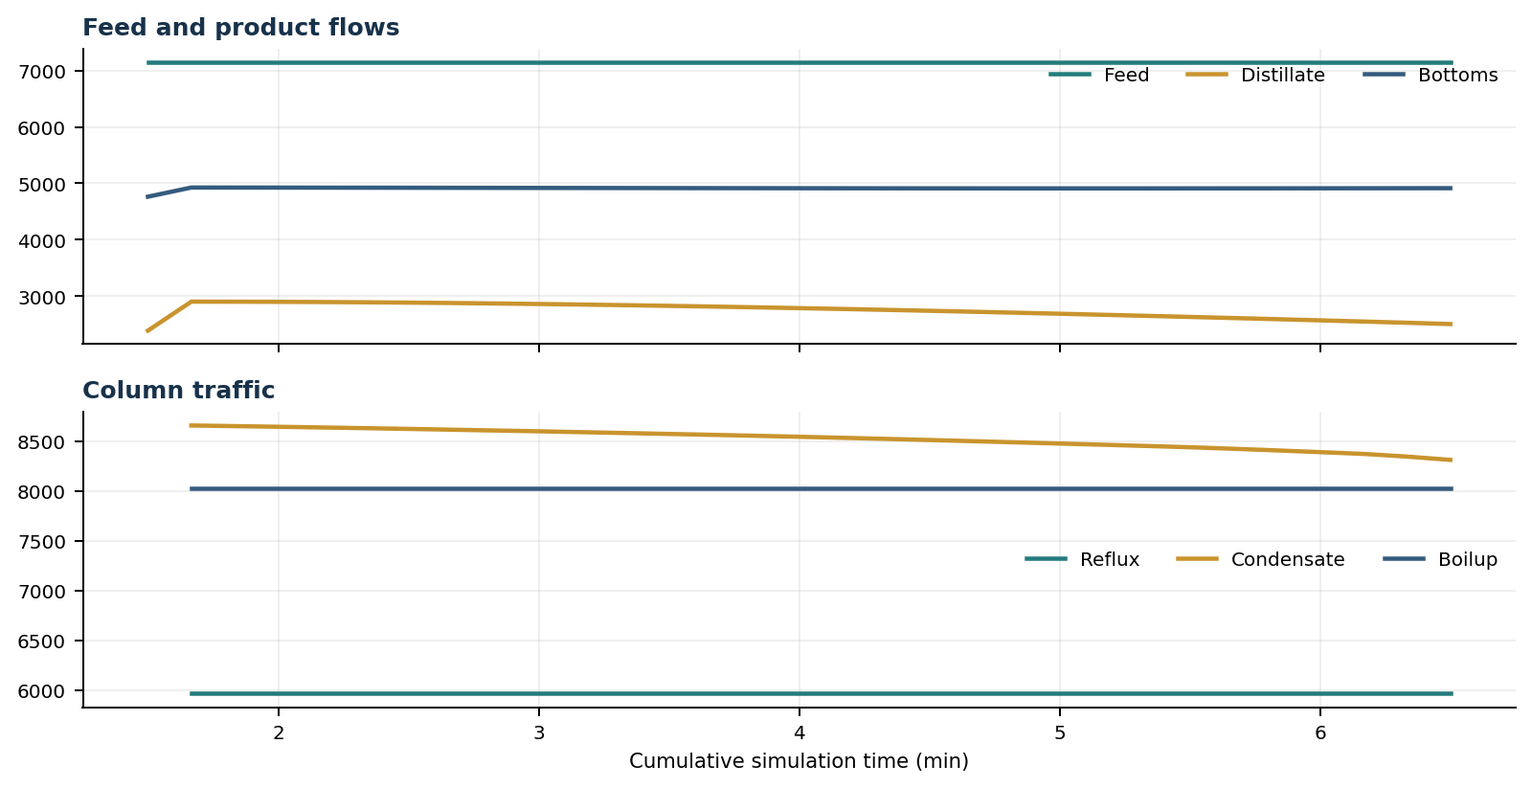
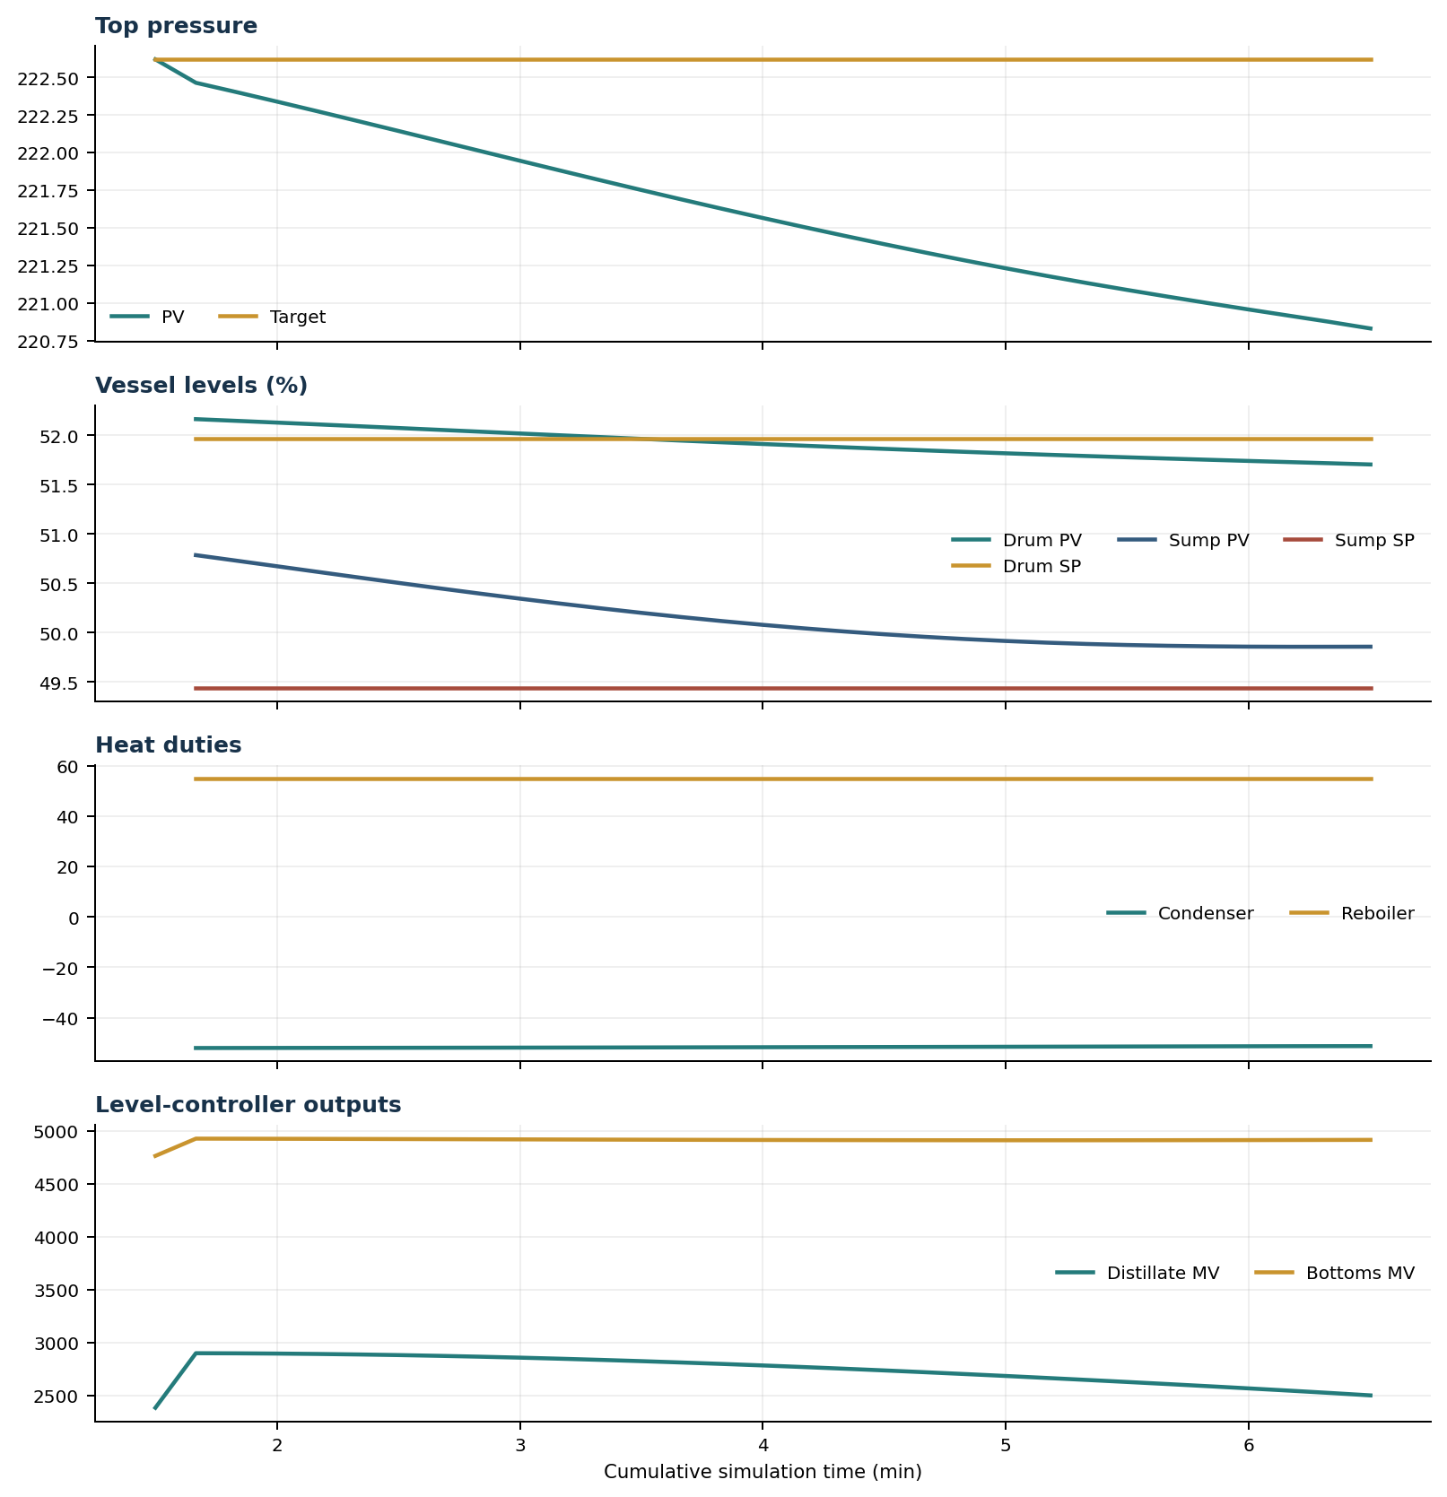

Final Tray Profiles
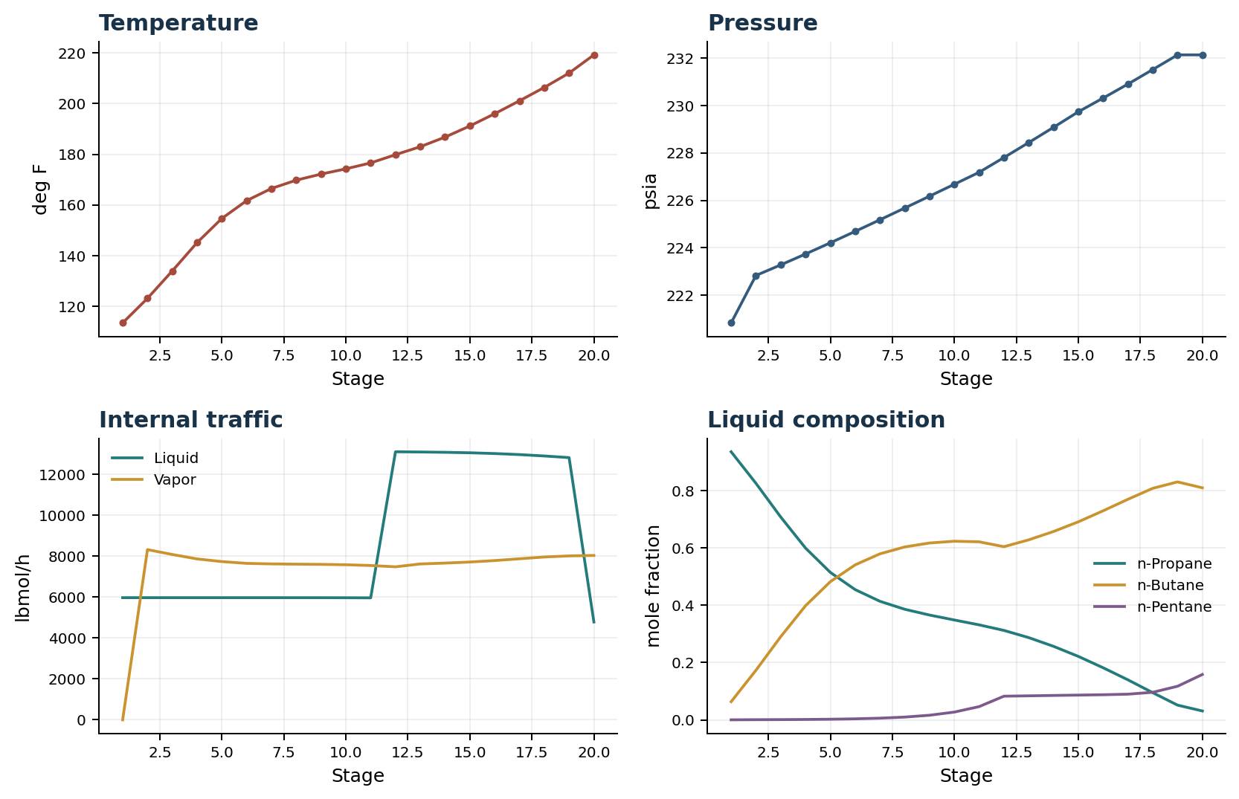

Final Tray Profile Table
Stage | T (deg F) | P (psia) | L (lbmol/h) | V (lbmol/h) | x n-Propane | x n-Butane | x n-Pentane | y n-Propane | y n-Butane | y n-Pentane
1 | 113.43 | 220.832 | 5,967.3 | 0.0 | 0.9365 | 0.0634 | 0.0001 | 0.0000 | 0.0000 | 0.0000
2 | 123.13 | 222.832 | 5,967.3 | 8,315.5 | 0.8263 | 0.1731 | 0.0005 | 0.9365 | 0.0634 | 0.0001
3 | 133.94 | 223.279 | 5,967.3 | 8,077.4 | 0.7085 | 0.2906 | 0.0008 | 0.8571 | 0.1427 | 0.0002
4 | 145.12 | 223.738 | 5,967.3 | 7,860.5 | 0.6000 | 0.3987 | 0.0014 | 0.7689 | 0.2307 | 0.0004
5 | 154.66 | 224.209 | 5,967.3 | 7,730.0 | 0.5151 | 0.4827 | 0.0022 | 0.6867 | 0.3125 | 0.0008
6 | 161.69 | 224.691 | 5,967.2 | 7,643.7 | 0.4550 | 0.5414 | 0.0036 | 0.6223 | 0.3763 | 0.0014
7 | 166.49 | 225.181 | 5,967.1 | 7,616.5 | 0.4142 | 0.5800 | 0.0059 | 0.5771 | 0.4204 | 0.0025
8 | 169.76 | 225.677 | 5,966.7 | 7,605.1 | 0.3863 | 0.6040 | 0.0097 | 0.5469 | 0.4489 | 0.0043
9 | 172.16 | 226.176 | 5,965.7 | 7,594.6 | 0.3661 | 0.6178 | 0.0161 | 0.5267 | 0.4660 | 0.0072
10 | 174.24 | 226.679 | 5,963.4 | 7,576.4 | 0.3488 | 0.6240 | 0.0272 | 0.5125 | 0.4753 | 0.0123
11 | 176.57 | 227.183 | 5,958.6 | 7,539.5 | 0.3318 | 0.6219 | 0.0463 | 0.5005 | 0.4786 | 0.0209
12 | 179.82 | 227.806 | 13,095.1 | 7,475.4 | 0.3124 | 0.6049 | 0.0827 | 0.4885 | 0.4756 | 0.0360
13 | 182.97 | 228.437 | 13,084.8 | 7,614.3 | 0.2872 | 0.6289 | 0.0839 | 0.4548 | 0.5075 | 0.0377
14 | 186.77 | 229.080 | 13,069.0 | 7,657.0 | 0.2568 | 0.6580 | 0.0852 | 0.4130 | 0.5472 | 0.0398
15 | 191.16 | 229.736 | 13,046.0 | 7,709.2 | 0.2216 | 0.6919 | 0.0865 | 0.3629 | 0.5950 | 0.0421
16 | 195.99 | 230.314 | 13,008.7 | 7,780.4 | 0.1819 | 0.7303 | 0.0877 | 0.3060 | 0.6496 | 0.0445
17 | 201.09 | 230.904 | 12,957.8 | 7,867.4 | 0.1397 | 0.7706 | 0.0897 | 0.2434 | 0.7094 | 0.0472
18 | 206.36 | 231.516 | 12,889.9 | 7,954.8 | 0.0949 | 0.8089 | 0.0963 | 0.1791 | 0.7693 | 0.0516
19 | 212.04 | 232.135 | 12,810.0 | 8,007.7 | 0.0514 | 0.8312 | 0.1174 | 0.1166 | 0.8207 | 0.0627
20 | 219.21 | 232.135 | 4,780.0 | 8,030.0 | 0.0310 | 0.8106 | 0.1584 | 0.0635 | 0.8435 | 0.0929

Simulation Configuration
Parameter | Value
Runtime Mode | hydraulic
Thermo Mode | dwsim
Dwsim Property Package | pr
Integrator | explicit-euler
N Steps | 1500
Dt Sec | 0.2
Log Every N Steps | 50
Thermo Every N Steps | 1
Include Energy | True
Enable Equilibrium Relaxation | True
Equilibrium Relaxation Mode | composition-exponential
Equilibrium Tau Sec | 0.5
Flash Feed At Stage Conditions | True
Enable Liquid Hydraulic Override | True
Liquid Hydraulic Model | francis
Liquid Hydraulic Override Alpha | 0.25
Enable Level Control | True
Top Level Pv Mode | true-level
Top Level Kc | 20.0
Top Level Ti Sec | 120.0
Bottom Level Pv Mode | true-level
Bottom Level Kc | 3.0
Bottom Level Ti Sec | 300.0
Enable Pressure Control | True
Pressure Control Mv | condenser-duty
Top Pressure Sp Psia | 222.6194497041178
Top Pressure Kc | -300000.0
Top Pressure Ti Sec | 180.0
Top Pressure Pv Filter Tau Sec | 5.0
Top Pressure Mv Slew Limit Per S | 25000.0
Condenser Duty Mode | specified
Condenser Duty Btu Per H | -51600000.0
Condenser Duty Min Btu Per H | -55000000.0
Condenser Duty Max Btu Per H | -46000000.0
Vapor Holdup Relaxation Sec | 0.0
Vapor Flow Relaxation Sec | 0.0
Vapor Flow Zero Temperature Target | True
Dynamic Vflow Nominal Hi Ratio | 1.05
Steady State Window Sec | 30.0
Steady State Min Time Sec | 60.0
Steady State Rel State Rate Tol Per S | 0.003
Steady State Temp Rate Tol F Per S | 0.15
Steady State Sp Error Tol | 0.02
Steady State Require Sp | False

Exact Launch Command
"C:\Users\Thomas Zvolensky\anaconda3\python.exe" -m dynamic_distillation.dynamic_run_scaffold_v1 --excel logs\c3c4_initializer_residual_vapor_state_stage2_20260706.xlsx --init-from-checkpoint .\logs\c3c4_dd052_pressure_settle_90s_20260712\c3c4_initializer_residual_vapor_state_stage2_20260706__checkpoint_20260712_085859.npz --run-name C3C4_DD053_unchanged_operating_point_hold_300s --run-description Unchanged_hold_after_pressure_recovery_for_overhead_and_inventory_settling --runtime-mode hydraulic --thermo dwsim --dwsim-property-package pr --include-energy --equilibrium-relaxation-mode composition-exponential --equilibrium-tau-sec 0.5 --flash-feed-at-stage-conditions --enable-liquid-hydraulic-override --liquid-hydraulic-model francis --liquid-hydraulic-override-alpha 0.25 --enable-level-control --ignore-workbook-level-pv-mode --top-level-pv-mode true-level --bottom-level-pv-mode true-level --top-level-kc 20 --top-level-ti 120 --bottom-level-kc 3 --bottom-level-ti 300 --enable-pressure-control --pressure-control-mv condenser-duty --top-pressure-sp 222.6194497041178 --top-pressure-kc -300000 --top-pressure-ti 180 --top-pressure-pv-filter-tau-sec 5 --top-pressure-mv-slew-limit-per-s 25000 --condenser-duty-mode specified --condenser-duty-btuph -51600000 --condenser-duty-min-btuph -55000000 --condenser-duty-max-btuph -46000000 --enable-top-drum-resident-condensation --top-drum-resident-condensation-tau-sec 30 --top-drum-resident-condensation-max-frac-per-step 0.10 --reflux 5967.322711692588 --vapor-holdup-relaxation-sec 0 --vapor-flow-relaxation-sec 0 --vapor-flow-zero-temperature-target --use-excel-vapor-holdup --dynamic-vflow-nominal-hi-ratio 1.05 --disable-startup-thermo-conditioning --disable-restart-reentry-settling --n-steps 1500 --dt 0.2 --log-every 50 --logs-dir logs\c3c4_dd053_unchanged_operating_point_hold_300s_20260712 --allow-repeat-command

