DYNAMIC DISTILLATION / COMPLETED RUN

C3C4_DD054_composition_settle_continue300s
Unchanged_continuation_for_lower_column_composition_front_settling
RUN VALIDITY  USABLE | DYNAMIC GATE  PASS | FINAL SCORE  0.420 | SIM / WALL  0.560

Run Identity
Item | Value
Run ID | 20260712_101442
Started | 2026-07-12 10:14:42
Completed | 2026-07-12 10:23:38
Run type | Continuation from native checkpoint
Input workbook | C:\Users\Thomas Zvolensky\Documents\Python Scripts\Dynamic_DistillationII\logs\c3c4_initializer_residual_vapor_state_stage2_20260706.xlsx
Input checkpoint | C:\Users\Thomas Zvolensky\Documents\Python Scripts\Dynamic_DistillationII\logs\c3c4_dd053_unchanged_operating_point_hold_300s_20260712\c3c4_initializer_residual_vapor_state_stage2_20260706__checkpoint_20260712_092336.npz
Summary data | C:\Users\Thomas Zvolensky\Documents\Python Scripts\Dynamic_DistillationII\logs\c3c4_dd054_composition_settle_continue300s_20260712\column_summary_20260712_101442.csv
Tray-profile data | C:\Users\Thomas Zvolensky\Documents\Python Scripts\Dynamic_DistillationII\logs\c3c4_dd054_composition_settle_continue300s_20260712\column_profile_20260712_101442.csv

Operating Snapshot
Parameter | Start | End | Units
Feed | 7,142.98 | 7,142.98 | lbmol/h
Distillate | 2,386.93 | 1,999.48 | lbmol/h
Bottoms | 4,761.98 | 4,902.47 | lbmol/h
Reflux | Not reported | 5,967.32 | lbmol/h
Top pressure | 222.619 | 221.098 | psia
Bottom pressure | 316.632 | 232.235 | psia
Distillate temperature | 113.43 | 113.43 | deg F
Bottoms temperature | 204.67 | 211.02 | deg F
Condenser duty | Not reported | -50.338 | MMBtu/h
Reboiler duty | Not reported | 54.844 | MMBtu/h
Distillate drum controller PV | Not reported | 51.77 | lbmol
Bottoms sump controller PV | Not reported | 49.46 | lbmol
Steady-state score | Not reported | 0.4201 | -

Product Composition
Component | Distillate start | Distillate end | Bottoms start | Bottoms end
n-Butane | 6.479% | 6.426% | 77.498% | 77.823%
n-Pentane | 0.035% | 0.025% | 17.148% | 16.092%
n-Propane | 93.485% | 93.549% | 5.354% | 6.085%
source | Not reported | Not reported | Not reported | Not reported

Dynamic Trends
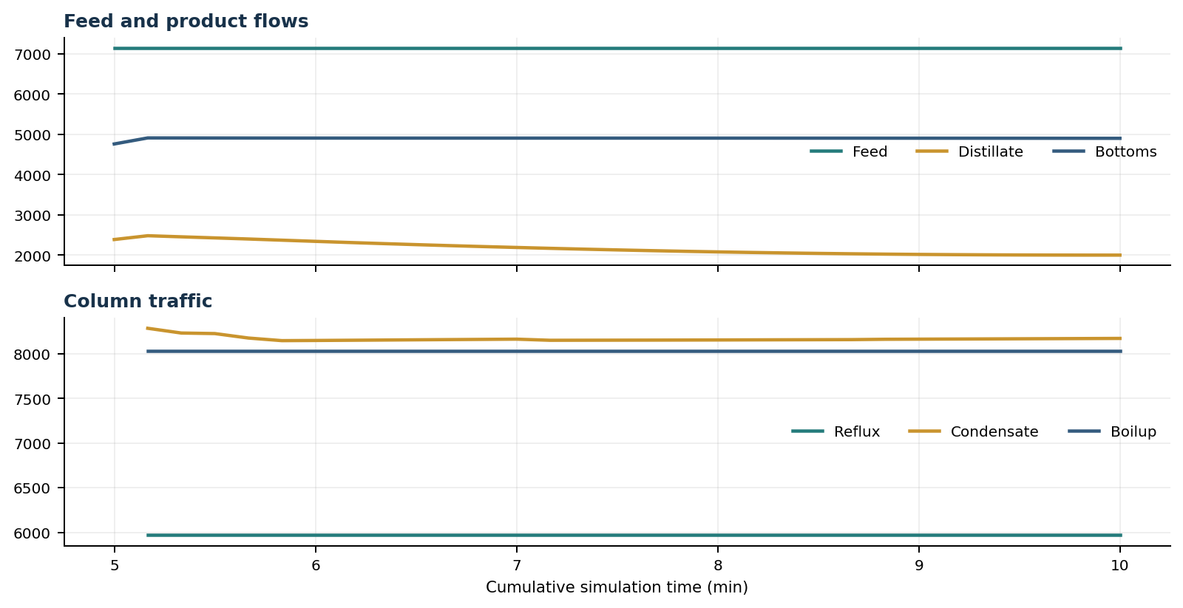
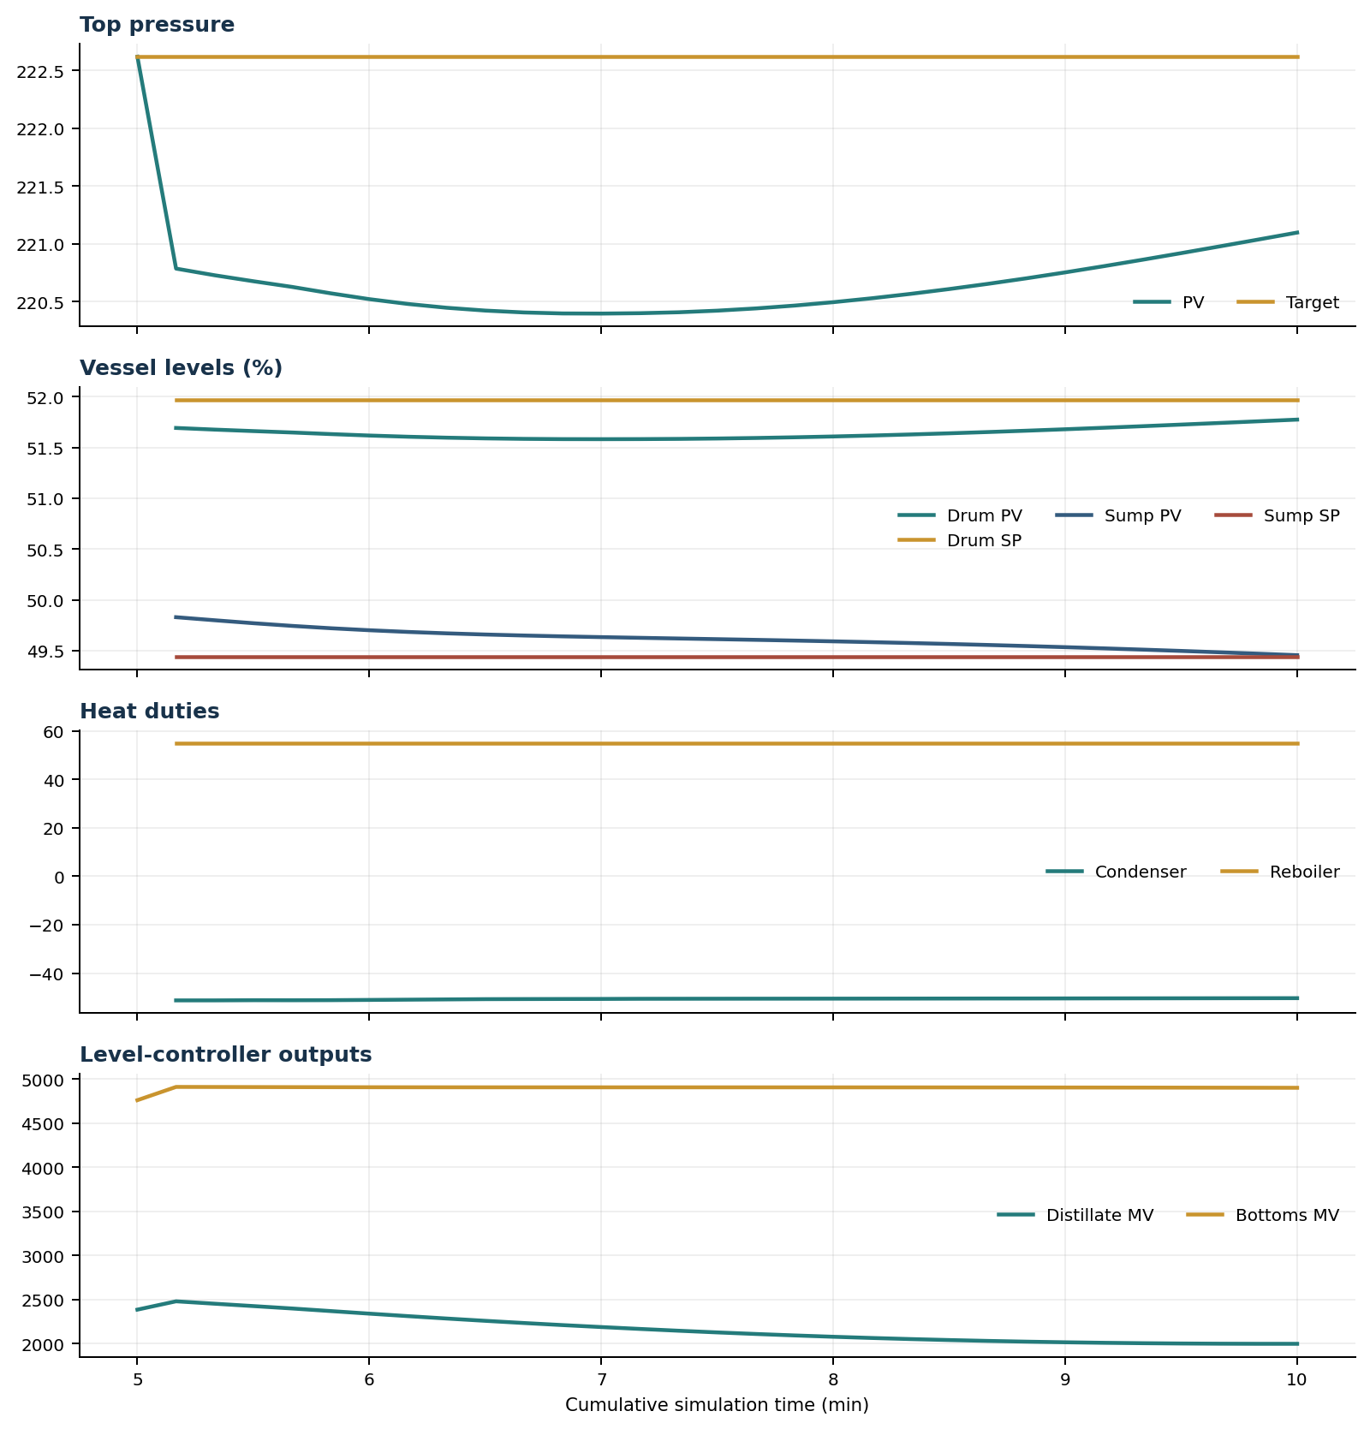

Final Tray Profiles
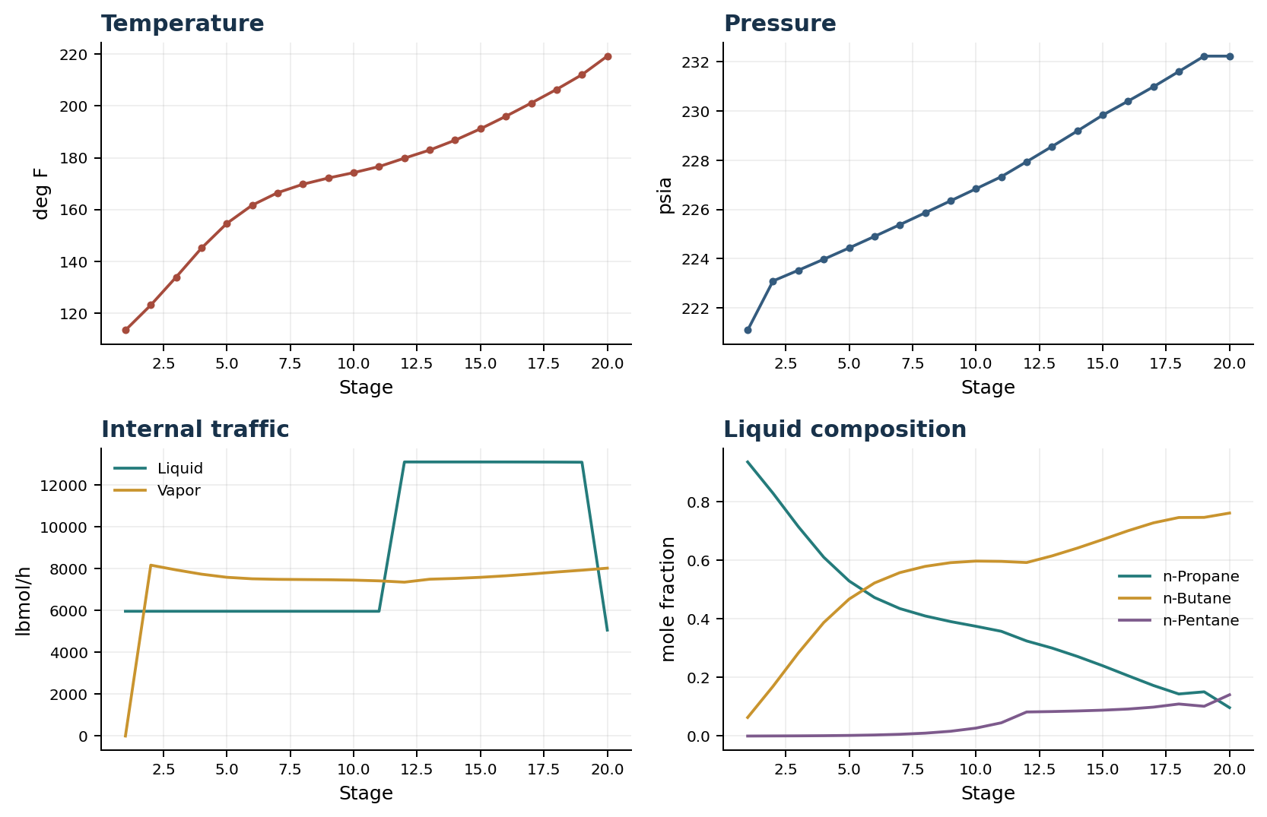

Final Tray Profile Table
Stage | T (deg F) | P (psia) | L (lbmol/h) | V (lbmol/h) | x n-Propane | x n-Butane | x n-Pentane | y n-Propane | y n-Butane | y n-Pentane
1 | 113.43 | 221.098 | 5,967.3 | 0.0 | 0.9365 | 0.0634 | 0.0001 | 0.0000 | 0.0000 | 0.0000
2 | 123.13 | 223.098 | 5,967.3 | 8,173.6 | 0.8296 | 0.1700 | 0.0004 | 0.9365 | 0.0634 | 0.0001
3 | 133.94 | 223.534 | 5,967.3 | 7,946.5 | 0.7153 | 0.2840 | 0.0007 | 0.8570 | 0.1429 | 0.0002
4 | 145.12 | 223.980 | 5,967.3 | 7,741.7 | 0.6110 | 0.3878 | 0.0013 | 0.7688 | 0.2308 | 0.0004
5 | 154.66 | 224.439 | 5,967.2 | 7,592.4 | 0.5299 | 0.4680 | 0.0022 | 0.6867 | 0.3124 | 0.0008
6 | 161.69 | 224.908 | 5,967.1 | 7,520.4 | 0.4734 | 0.5230 | 0.0037 | 0.6223 | 0.3761 | 0.0016
7 | 166.49 | 225.385 | 5,966.9 | 7,495.2 | 0.4356 | 0.5584 | 0.0060 | 0.5775 | 0.4197 | 0.0028
8 | 169.76 | 225.867 | 5,966.7 | 7,485.1 | 0.4103 | 0.5797 | 0.0099 | 0.5477 | 0.4475 | 0.0048
9 | 172.16 | 226.353 | 5,966.5 | 7,475.3 | 0.3912 | 0.5924 | 0.0164 | 0.5286 | 0.4634 | 0.0080
10 | 174.24 | 226.842 | 5,966.5 | 7,457.6 | 0.3750 | 0.5978 | 0.0272 | 0.5142 | 0.4724 | 0.0134
11 | 176.57 | 227.334 | 5,966.4 | 7,422.7 | 0.3579 | 0.5968 | 0.0453 | 0.5025 | 0.4752 | 0.0222
12 | 179.82 | 227.944 | 13,109.5 | 7,359.9 | 0.3249 | 0.5928 | 0.0823 | 0.4903 | 0.4726 | 0.0371
13 | 182.97 | 228.563 | 13,109.5 | 7,501.7 | 0.3007 | 0.6155 | 0.0838 | 0.4571 | 0.5037 | 0.0392
14 | 186.77 | 229.193 | 13,109.5 | 7,537.9 | 0.2721 | 0.6422 | 0.0858 | 0.4164 | 0.5417 | 0.0419
15 | 191.16 | 229.837 | 13,109.3 | 7,592.0 | 0.2402 | 0.6714 | 0.0884 | 0.3683 | 0.5861 | 0.0455
16 | 195.99 | 230.407 | 13,108.5 | 7,664.2 | 0.2062 | 0.7015 | 0.0923 | 0.3154 | 0.6341 | 0.0505
17 | 201.09 | 230.990 | 13,106.9 | 7,750.7 | 0.1727 | 0.7284 | 0.0988 | 0.2604 | 0.6818 | 0.0578
18 | 206.36 | 231.609 | 13,103.6 | 7,846.2 | 0.1438 | 0.7467 | 0.1095 | 0.2081 | 0.7221 | 0.0699
19 | 212.04 | 232.235 | 13,097.8 | 7,932.5 | 0.1511 | 0.7471 | 0.1018 | 0.1652 | 0.7454 | 0.0894
20 | 219.21 | 232.235 | 5,067.8 | 8,030.0 | 0.0971 | 0.7619 | 0.1411 | 0.1852 | 0.7378 | 0.0770

Simulation Configuration
Parameter | Value
Runtime Mode | hydraulic
Thermo Mode | dwsim
Dwsim Property Package | pr
Integrator | explicit-euler
N Steps | 1500
Dt Sec | 0.2
Log Every N Steps | 50
Thermo Every N Steps | 1
Include Energy | True
Enable Equilibrium Relaxation | True
Equilibrium Relaxation Mode | composition-exponential
Equilibrium Tau Sec | 0.5
Flash Feed At Stage Conditions | True
Enable Liquid Hydraulic Override | True
Liquid Hydraulic Model | francis
Liquid Hydraulic Override Alpha | 0.25
Enable Level Control | True
Top Level Pv Mode | true-level
Top Level Kc | 20.0
Top Level Ti Sec | 120.0
Bottom Level Pv Mode | true-level
Bottom Level Kc | 3.0
Bottom Level Ti Sec | 300.0
Enable Pressure Control | True
Pressure Control Mv | condenser-duty
Top Pressure Sp Psia | 222.6194497041178
Top Pressure Kc | -300000.0
Top Pressure Ti Sec | 180.0
Top Pressure Pv Filter Tau Sec | 5.0
Top Pressure Mv Slew Limit Per S | 25000.0
Condenser Duty Mode | specified
Condenser Duty Btu Per H | -51600000.0
Condenser Duty Min Btu Per H | -55000000.0
Condenser Duty Max Btu Per H | -46000000.0
Vapor Holdup Relaxation Sec | 0.0
Vapor Flow Relaxation Sec | 0.0
Vapor Flow Zero Temperature Target | True
Dynamic Vflow Nominal Hi Ratio | 1.05
Steady State Window Sec | 30.0
Steady State Min Time Sec | 60.0
Steady State Rel State Rate Tol Per S | 0.003
Steady State Temp Rate Tol F Per S | 0.15
Steady State Sp Error Tol | 0.02
Steady State Require Sp | False

Exact Launch Command
"C:\Users\Thomas Zvolensky\anaconda3\python.exe" -m dynamic_distillation.dynamic_run_scaffold_v1 --excel logs\c3c4_initializer_residual_vapor_state_stage2_20260706.xlsx --init-from-checkpoint .\logs\c3c4_dd053_unchanged_operating_point_hold_300s_20260712\c3c4_initializer_residual_vapor_state_stage2_20260706__checkpoint_20260712_092336.npz --run-name C3C4_DD054_composition_settle_continue300s --run-description Unchanged_continuation_for_lower_column_composition_front_settling --runtime-mode hydraulic --thermo dwsim --dwsim-property-package pr --include-energy --equilibrium-relaxation-mode composition-exponential --equilibrium-tau-sec 0.5 --flash-feed-at-stage-conditions --enable-liquid-hydraulic-override --liquid-hydraulic-model francis --liquid-hydraulic-override-alpha 0.25 --enable-level-control --ignore-workbook-level-pv-mode --top-level-pv-mode true-level --bottom-level-pv-mode true-level --top-level-kc 20 --top-level-ti 120 --bottom-level-kc 3 --bottom-level-ti 300 --enable-pressure-control --pressure-control-mv condenser-duty --top-pressure-sp 222.6194497041178 --top-pressure-kc -300000 --top-pressure-ti 180 --top-pressure-pv-filter-tau-sec 5 --top-pressure-mv-slew-limit-per-s 25000 --condenser-duty-mode specified --condenser-duty-btuph -51600000 --condenser-duty-min-btuph -55000000 --condenser-duty-max-btuph -46000000 --enable-top-drum-resident-condensation --top-drum-resident-condensation-tau-sec 30 --top-drum-resident-condensation-max-frac-per-step 0.10 --reflux 5967.322711692588 --vapor-holdup-relaxation-sec 0 --vapor-flow-relaxation-sec 0 --vapor-flow-zero-temperature-target --use-excel-vapor-holdup --dynamic-vflow-nominal-hi-ratio 1.05 --disable-startup-thermo-conditioning --disable-restart-reentry-settling --n-steps 1500 --dt 0.2 --log-every 50 --logs-dir logs\c3c4_dd054_composition_settle_continue300s_20260712 --allow-repeat-command

