DYNAMIC DISTILLATION / COMPLETED RUN

C3C4_DD055_composition_settle_continue300s
Second_unchanged_continuation_for_composition_and_operating_point_settling
RUN VALIDITY  USABLE | DYNAMIC GATE  PASS | FINAL SCORE  0.324 | SIM / WALL  0.564

Run Identity
Item | Value
Run ID | 20260712_103152
Started | 2026-07-12 10:31:52
Completed | 2026-07-12 10:40:44
Run type | Continuation from native checkpoint
Input workbook | C:\Users\Thomas Zvolensky\Documents\Python Scripts\Dynamic_DistillationII\logs\c3c4_initializer_residual_vapor_state_stage2_20260706.xlsx
Input checkpoint | C:\Users\Thomas Zvolensky\Documents\Python Scripts\Dynamic_DistillationII\logs\c3c4_dd054_composition_settle_continue300s_20260712\c3c4_initializer_residual_vapor_state_stage2_20260706__checkpoint_20260712_101442.npz
Summary data | C:\Users\Thomas Zvolensky\Documents\Python Scripts\Dynamic_DistillationII\logs\c3c4_dd055_composition_settle_continue300s_20260712\column_summary_20260712_103152.csv
Tray-profile data | C:\Users\Thomas Zvolensky\Documents\Python Scripts\Dynamic_DistillationII\logs\c3c4_dd055_composition_settle_continue300s_20260712\column_profile_20260712_103152.csv

Operating Snapshot
Parameter | Start | End | Units
Feed | 7,142.98 | 7,142.98 | lbmol/h
Distillate | 2,386.93 | 2,218.65 | lbmol/h
Bottoms | 4,761.98 | 4,833.61 | lbmol/h
Reflux | Not reported | 5,967.32 | lbmol/h
Top pressure | 222.619 | 222.218 | psia
Bottom pressure | 316.632 | 232.184 | psia
Distillate temperature | 113.43 | 113.43 | deg F
Bottoms temperature | 211.02 | 216.03 | deg F
Condenser duty | Not reported | -50.157 | MMBtu/h
Reboiler duty | Not reported | 54.844 | MMBtu/h
Distillate drum controller PV | Not reported | 52.08 | lbmol
Bottoms sump controller PV | Not reported | 48.62 | lbmol
Steady-state score | Not reported | 0.3237 | -

Product Composition
Component | Distillate start | Distillate end | Bottoms start | Bottoms end
n-Butane | 6.426% | 6.396% | 77.823% | 76.430%
n-Pentane | 0.025% | 0.018% | 16.092% | 15.345%
n-Propane | 93.549% | 93.586% | 6.085% | 8.225%
source | Not reported | Not reported | Not reported | Not reported

Dynamic Trends
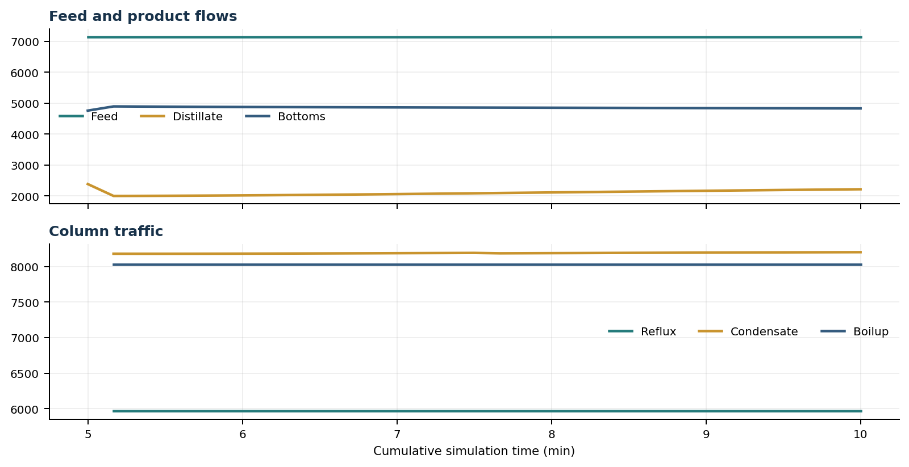
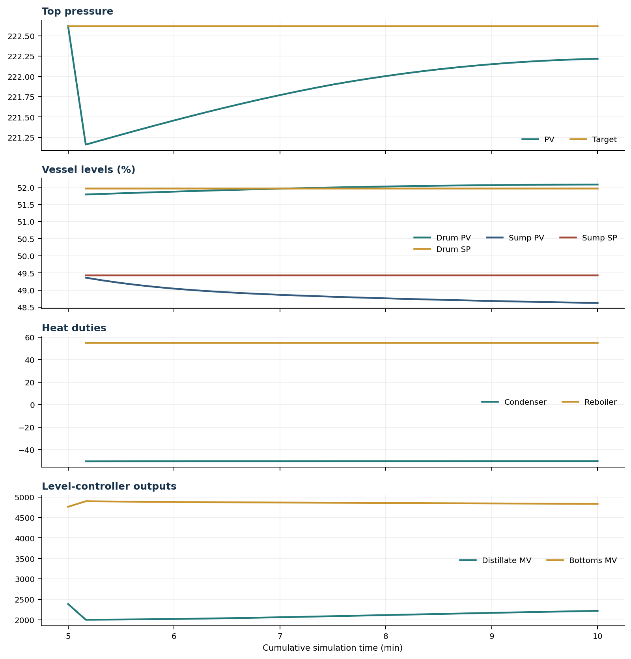

Final Tray Profiles
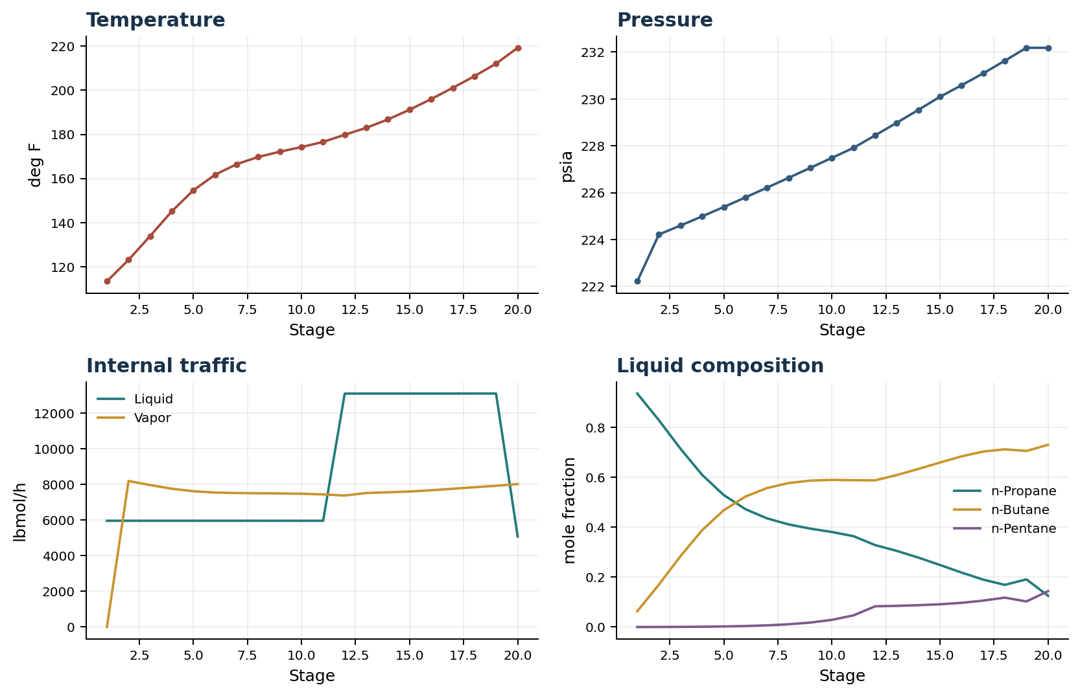

Final Tray Profile Table
Stage | T (deg F) | P (psia) | L (lbmol/h) | V (lbmol/h) | x n-Propane | x n-Butane | x n-Pentane | y n-Propane | y n-Butane | y n-Pentane
1 | 113.43 | 222.218 | 5,967.3 | 0.0 | 0.9364 | 0.0635 | 0.0001 | 0.0000 | 0.0000 | 0.0000
2 | 123.13 | 224.218 | 5,967.3 | 8,203.1 | 0.8294 | 0.1702 | 0.0003 | 0.9364 | 0.0635 | 0.0001
3 | 133.94 | 224.598 | 5,967.3 | 7,973.6 | 0.7148 | 0.2846 | 0.0007 | 0.8567 | 0.1431 | 0.0002
4 | 145.12 | 224.988 | 5,967.3 | 7,767.1 | 0.6102 | 0.3886 | 0.0013 | 0.7686 | 0.2310 | 0.0004
5 | 154.66 | 225.389 | 5,967.2 | 7,626.7 | 0.5291 | 0.4685 | 0.0023 | 0.6867 | 0.3124 | 0.0009
6 | 161.69 | 225.798 | 5,967.1 | 7,552.4 | 0.4728 | 0.5231 | 0.0041 | 0.6226 | 0.3756 | 0.0018
7 | 166.49 | 226.214 | 5,967.0 | 7,525.5 | 0.4358 | 0.5574 | 0.0068 | 0.5779 | 0.4189 | 0.0032
8 | 169.76 | 226.635 | 5,966.8 | 7,513.9 | 0.4115 | 0.5774 | 0.0111 | 0.5485 | 0.4461 | 0.0054
9 | 172.16 | 227.059 | 5,966.6 | 7,503.0 | 0.3947 | 0.5873 | 0.0179 | 0.5292 | 0.4619 | 0.0089
10 | 174.24 | 227.486 | 5,966.5 | 7,484.1 | 0.3811 | 0.5901 | 0.0288 | 0.5159 | 0.4697 | 0.0144
11 | 176.57 | 227.914 | 5,966.5 | 7,448.1 | 0.3644 | 0.5888 | 0.0468 | 0.5050 | 0.4718 | 0.0232
12 | 179.82 | 228.445 | 13,109.6 | 7,384.4 | 0.3286 | 0.5882 | 0.0832 | 0.4915 | 0.4707 | 0.0379
13 | 182.97 | 228.984 | 13,109.9 | 7,528.6 | 0.3055 | 0.6095 | 0.0850 | 0.4587 | 0.5010 | 0.0403
14 | 186.77 | 229.532 | 13,110.2 | 7,565.9 | 0.2785 | 0.6340 | 0.0876 | 0.4188 | 0.5377 | 0.0435
15 | 191.16 | 230.093 | 13,110.6 | 7,612.7 | 0.2489 | 0.6598 | 0.0913 | 0.3724 | 0.5794 | 0.0482
16 | 195.99 | 230.587 | 13,111.1 | 7,680.8 | 0.2184 | 0.6845 | 0.0971 | 0.3223 | 0.6229 | 0.0548
17 | 201.09 | 231.091 | 13,111.8 | 7,763.9 | 0.1902 | 0.7038 | 0.1060 | 0.2716 | 0.6633 | 0.0650
18 | 206.36 | 231.633 | 13,112.6 | 7,852.0 | 0.1692 | 0.7128 | 0.1180 | 0.2258 | 0.6936 | 0.0807
19 | 212.04 | 232.184 | 13,113.1 | 7,930.4 | 0.1912 | 0.7061 | 0.1026 | 0.1935 | 0.7053 | 0.1012
20 | 219.21 | 232.184 | 5,083.1 | 8,030.0 | 0.1252 | 0.7309 | 0.1438 | 0.2330 | 0.6904 | 0.0766

Simulation Configuration
Parameter | Value
Runtime Mode | hydraulic
Thermo Mode | dwsim
Dwsim Property Package | pr
Integrator | explicit-euler
N Steps | 1500
Dt Sec | 0.2
Log Every N Steps | 50
Thermo Every N Steps | 1
Include Energy | True
Enable Equilibrium Relaxation | True
Equilibrium Relaxation Mode | composition-exponential
Equilibrium Tau Sec | 0.5
Flash Feed At Stage Conditions | True
Enable Liquid Hydraulic Override | True
Liquid Hydraulic Model | francis
Liquid Hydraulic Override Alpha | 0.25
Enable Level Control | True
Top Level Pv Mode | true-level
Top Level Kc | 20.0
Top Level Ti Sec | 120.0
Bottom Level Pv Mode | true-level
Bottom Level Kc | 3.0
Bottom Level Ti Sec | 300.0
Enable Pressure Control | True
Pressure Control Mv | condenser-duty
Top Pressure Sp Psia | 222.6194497041178
Top Pressure Kc | -300000.0
Top Pressure Ti Sec | 180.0
Top Pressure Pv Filter Tau Sec | 5.0
Top Pressure Mv Slew Limit Per S | 25000.0
Condenser Duty Mode | specified
Condenser Duty Btu Per H | -51600000.0
Condenser Duty Min Btu Per H | -55000000.0
Condenser Duty Max Btu Per H | -46000000.0
Vapor Holdup Relaxation Sec | 0.0
Vapor Flow Relaxation Sec | 0.0
Vapor Flow Zero Temperature Target | True
Dynamic Vflow Nominal Hi Ratio | 1.05
Steady State Window Sec | 30.0
Steady State Min Time Sec | 60.0
Steady State Rel State Rate Tol Per S | 0.003
Steady State Temp Rate Tol F Per S | 0.15
Steady State Sp Error Tol | 0.02
Steady State Require Sp | False

Exact Launch Command
"C:\Users\Thomas Zvolensky\anaconda3\python.exe" -m dynamic_distillation.dynamic_run_scaffold_v1 --excel logs\c3c4_initializer_residual_vapor_state_stage2_20260706.xlsx --init-from-checkpoint .\logs\c3c4_dd054_composition_settle_continue300s_20260712\c3c4_initializer_residual_vapor_state_stage2_20260706__checkpoint_20260712_101442.npz --run-name C3C4_DD055_composition_settle_continue300s --run-description Second_unchanged_continuation_for_composition_and_operating_point_settling --runtime-mode hydraulic --thermo dwsim --dwsim-property-package pr --include-energy --equilibrium-relaxation-mode composition-exponential --equilibrium-tau-sec 0.5 --flash-feed-at-stage-conditions --enable-liquid-hydraulic-override --liquid-hydraulic-model francis --liquid-hydraulic-override-alpha 0.25 --enable-level-control --ignore-workbook-level-pv-mode --top-level-pv-mode true-level --bottom-level-pv-mode true-level --top-level-kc 20 --top-level-ti 120 --bottom-level-kc 3 --bottom-level-ti 300 --enable-pressure-control --pressure-control-mv condenser-duty --top-pressure-sp 222.6194497041178 --top-pressure-kc -300000 --top-pressure-ti 180 --top-pressure-pv-filter-tau-sec 5 --top-pressure-mv-slew-limit-per-s 25000 --condenser-duty-mode specified --condenser-duty-btuph -51600000 --condenser-duty-min-btuph -55000000 --condenser-duty-max-btuph -46000000 --enable-top-drum-resident-condensation --top-drum-resident-condensation-tau-sec 30 --top-drum-resident-condensation-max-frac-per-step 0.10 --reflux 5967.322711692588 --vapor-holdup-relaxation-sec 0 --vapor-flow-relaxation-sec 0 --vapor-flow-zero-temperature-target --use-excel-vapor-holdup --dynamic-vflow-nominal-hi-ratio 1.05 --disable-startup-thermo-conditioning --disable-restart-reentry-settling --n-steps 1500 --dt 0.2 --log-every 50 --logs-dir logs\c3c4_dd055_composition_settle_continue300s_20260712 --allow-repeat-command

