DYNAMIC DISTILLATION / COMPLETED RUN

C3C4_DD056_bottom_inventory_settle_continue300s
Unchanged_continuation_for_bottom_sump_composition_front_settling
RUN VALIDITY  USABLE | DYNAMIC GATE  PASS | FINAL SCORE  0.210 | SIM / WALL  0.565

Run Identity
Item | Value
Run ID | 20260712_104153
Started | 2026-07-12 10:41:53
Completed | 2026-07-12 10:50:44
Run type | Continuation from native checkpoint
Input workbook | C:\Users\Thomas Zvolensky\Documents\Python Scripts\Dynamic_DistillationII\logs\c3c4_initializer_residual_vapor_state_stage2_20260706.xlsx
Input checkpoint | C:\Users\Thomas Zvolensky\Documents\Python Scripts\Dynamic_DistillationII\logs\c3c4_dd055_composition_settle_continue300s_20260712\c3c4_initializer_residual_vapor_state_stage2_20260706__checkpoint_20260712_103152.npz
Summary data | C:\Users\Thomas Zvolensky\Documents\Python Scripts\Dynamic_DistillationII\logs\c3c4_dd056_bottom_inventory_settle_continue300s_20260712\column_summary_20260712_104153.csv
Tray-profile data | C:\Users\Thomas Zvolensky\Documents\Python Scripts\Dynamic_DistillationII\logs\c3c4_dd056_bottom_inventory_settle_continue300s_20260712\column_profile_20260712_104153.csv

Operating Snapshot
Parameter | Start | End | Units
Feed | 7,142.98 | 7,142.98 | lbmol/h
Distillate | 2,386.93 | 2,304.70 | lbmol/h
Bottoms | 4,761.98 | 4,776.04 | lbmol/h
Reflux | Not reported | 5,967.32 | lbmol/h
Top pressure | 222.619 | 221.917 | psia
Bottom pressure | 316.632 | 232.163 | psia
Distillate temperature | 113.43 | 113.43 | deg F
Bottoms temperature | 216.03 | 220.38 | deg F
Condenser duty | Not reported | -49.836 | MMBtu/h
Reboiler duty | Not reported | 54.844 | MMBtu/h
Distillate drum controller PV | Not reported | 52.00 | lbmol
Bottoms sump controller PV | Not reported | 48.49 | lbmol
Steady-state score | Not reported | 0.2104 | -

Product Composition
Component | Distillate start | Distillate end | Bottoms start | Bottoms end
n-Butane | 6.396% | 6.380% | 76.430% | 74.791%
n-Pentane | 0.018% | 0.013% | 15.345% | 15.059%
n-Propane | 93.586% | 93.607% | 8.225% | 10.150%
source | Not reported | Not reported | Not reported | Not reported

Dynamic Trends
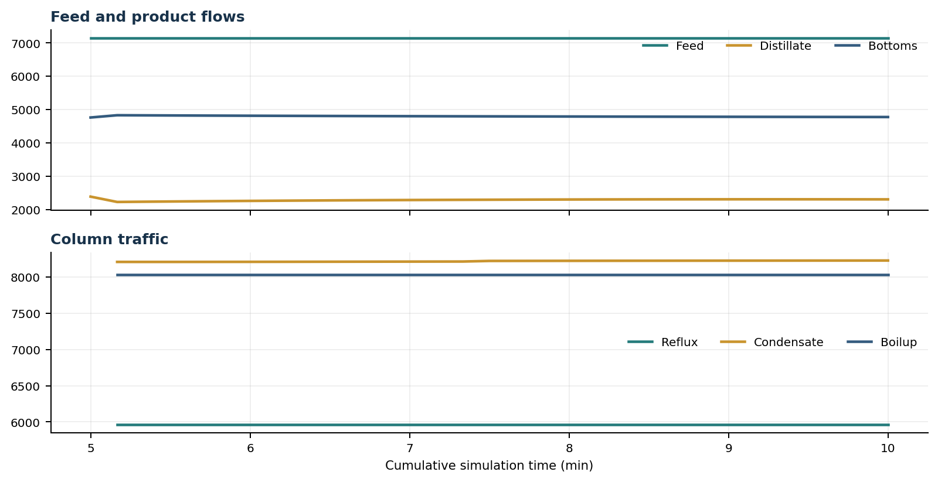
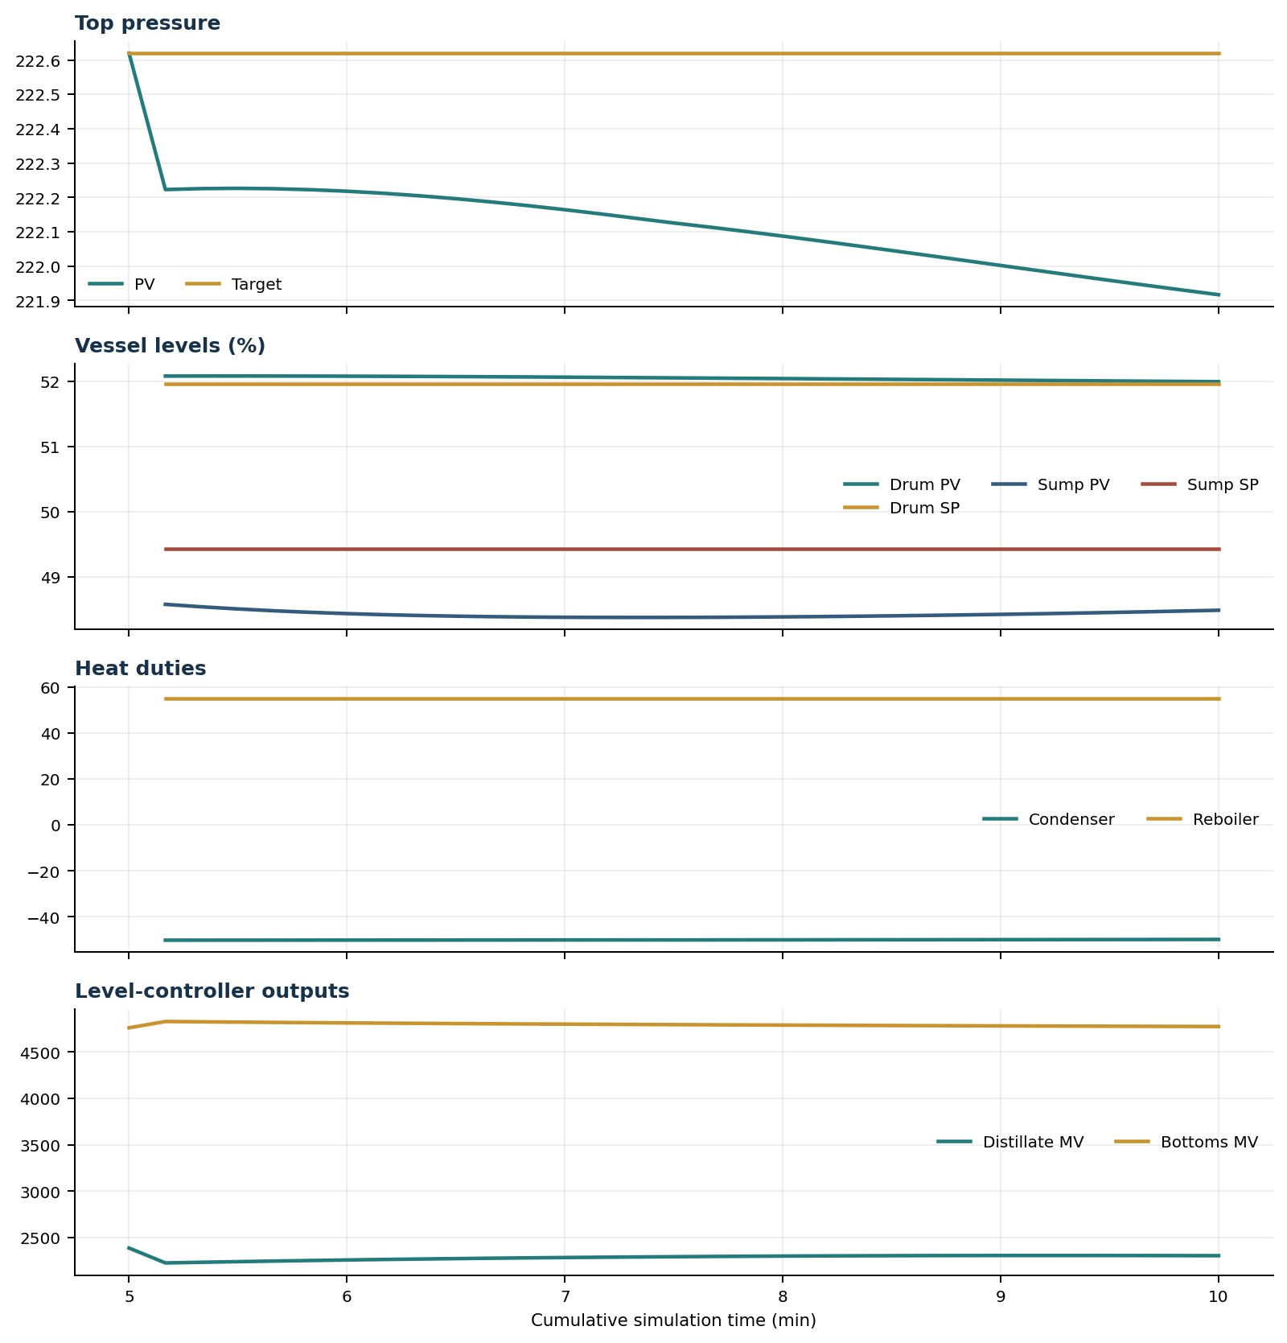

Final Tray Profiles
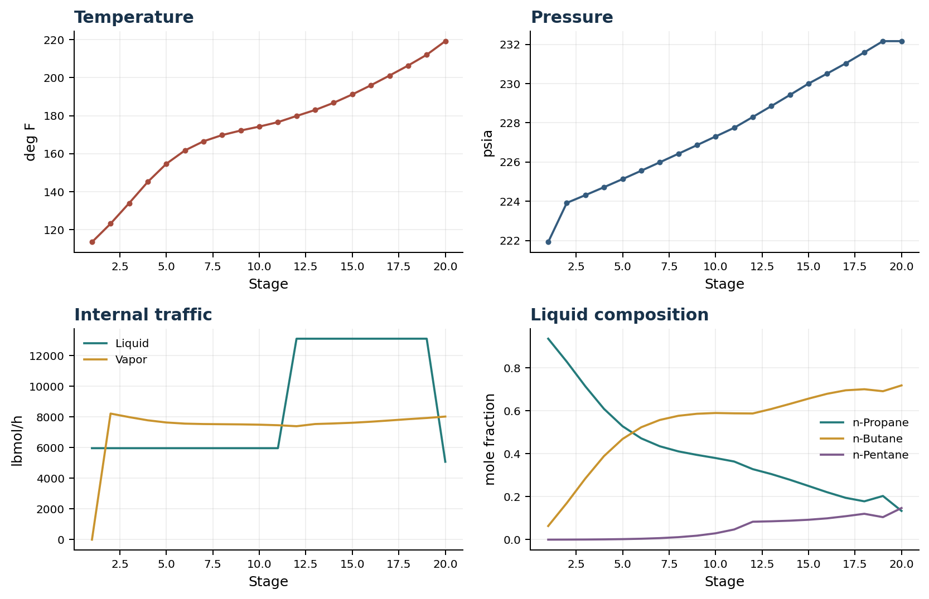

Final Tray Profile Table
Stage | T (deg F) | P (psia) | L (lbmol/h) | V (lbmol/h) | x n-Propane | x n-Butane | x n-Pentane | y n-Propane | y n-Butane | y n-Pentane
1 | 113.43 | 221.917 | 5,967.3 | 0.0 | 0.9364 | 0.0636 | 0.0001 | 0.0000 | 0.0000 | 0.0000
2 | 123.13 | 223.917 | 5,967.3 | 8,226.0 | 0.8291 | 0.1706 | 0.0003 | 0.9364 | 0.0636 | 0.0001
3 | 133.94 | 224.311 | 5,967.3 | 7,994.4 | 0.7142 | 0.2852 | 0.0006 | 0.8565 | 0.1433 | 0.0002
4 | 145.12 | 224.715 | 5,967.3 | 7,786.5 | 0.6094 | 0.3893 | 0.0013 | 0.7684 | 0.2312 | 0.0004
5 | 154.66 | 225.130 | 5,967.3 | 7,644.3 | 0.5283 | 0.4692 | 0.0024 | 0.6866 | 0.3125 | 0.0010
6 | 161.69 | 225.554 | 5,967.3 | 7,569.7 | 0.4721 | 0.5237 | 0.0043 | 0.6226 | 0.3755 | 0.0019
7 | 166.49 | 225.985 | 5,967.3 | 7,542.7 | 0.4351 | 0.5577 | 0.0071 | 0.5781 | 0.4186 | 0.0033
8 | 169.76 | 226.421 | 5,967.3 | 7,531.0 | 0.4113 | 0.5771 | 0.0116 | 0.5487 | 0.4456 | 0.0056
9 | 172.16 | 226.860 | 5,967.4 | 7,519.9 | 0.3949 | 0.5866 | 0.0186 | 0.5296 | 0.4612 | 0.0092
10 | 174.24 | 227.301 | 5,967.4 | 7,500.9 | 0.3803 | 0.5901 | 0.0296 | 0.5163 | 0.4689 | 0.0148
11 | 176.57 | 227.745 | 5,967.4 | 7,464.8 | 0.3641 | 0.5885 | 0.0474 | 0.5046 | 0.4718 | 0.0236
12 | 179.82 | 228.295 | 13,110.4 | 7,401.0 | 0.3285 | 0.5879 | 0.0835 | 0.4916 | 0.4704 | 0.0380
13 | 182.97 | 228.853 | 13,110.4 | 7,544.0 | 0.3056 | 0.6089 | 0.0855 | 0.4590 | 0.5005 | 0.0405
14 | 186.77 | 229.420 | 13,110.4 | 7,581.0 | 0.2789 | 0.6326 | 0.0884 | 0.4194 | 0.5366 | 0.0440
15 | 191.16 | 229.999 | 13,110.5 | 7,627.3 | 0.2501 | 0.6572 | 0.0927 | 0.3736 | 0.5774 | 0.0490
16 | 195.99 | 230.510 | 13,110.6 | 7,694.4 | 0.2210 | 0.6797 | 0.0993 | 0.3246 | 0.6190 | 0.0564
17 | 201.09 | 231.030 | 13,110.8 | 7,775.8 | 0.1948 | 0.6959 | 0.1093 | 0.2757 | 0.6567 | 0.0676
18 | 206.36 | 231.593 | 13,111.2 | 7,861.4 | 0.1786 | 0.7009 | 0.1205 | 0.2322 | 0.6833 | 0.0845
19 | 212.04 | 232.163 | 13,111.5 | 7,938.4 | 0.2035 | 0.6916 | 0.1049 | 0.2061 | 0.6906 | 0.1033
20 | 219.21 | 232.163 | 5,081.5 | 8,030.0 | 0.1339 | 0.7187 | 0.1474 | 0.2476 | 0.6745 | 0.0780

Simulation Configuration
Parameter | Value
Runtime Mode | hydraulic
Thermo Mode | dwsim
Dwsim Property Package | pr
Integrator | explicit-euler
N Steps | 1500
Dt Sec | 0.2
Log Every N Steps | 50
Thermo Every N Steps | 1
Include Energy | True
Enable Equilibrium Relaxation | True
Equilibrium Relaxation Mode | composition-exponential
Equilibrium Tau Sec | 0.5
Flash Feed At Stage Conditions | True
Enable Liquid Hydraulic Override | True
Liquid Hydraulic Model | francis
Liquid Hydraulic Override Alpha | 0.25
Enable Level Control | True
Top Level Pv Mode | true-level
Top Level Kc | 20.0
Top Level Ti Sec | 120.0
Bottom Level Pv Mode | true-level
Bottom Level Kc | 3.0
Bottom Level Ti Sec | 300.0
Enable Pressure Control | True
Pressure Control Mv | condenser-duty
Top Pressure Sp Psia | 222.6194497041178
Top Pressure Kc | -300000.0
Top Pressure Ti Sec | 180.0
Top Pressure Pv Filter Tau Sec | 5.0
Top Pressure Mv Slew Limit Per S | 25000.0
Condenser Duty Mode | specified
Condenser Duty Btu Per H | -51600000.0
Condenser Duty Min Btu Per H | -55000000.0
Condenser Duty Max Btu Per H | -46000000.0
Vapor Holdup Relaxation Sec | 0.0
Vapor Flow Relaxation Sec | 0.0
Vapor Flow Zero Temperature Target | True
Dynamic Vflow Nominal Hi Ratio | 1.05
Steady State Window Sec | 30.0
Steady State Min Time Sec | 60.0
Steady State Rel State Rate Tol Per S | 0.003
Steady State Temp Rate Tol F Per S | 0.15
Steady State Sp Error Tol | 0.02
Steady State Require Sp | False

Exact Launch Command
"C:\Users\Thomas Zvolensky\anaconda3\python.exe" -m dynamic_distillation.dynamic_run_scaffold_v1 --excel logs\c3c4_initializer_residual_vapor_state_stage2_20260706.xlsx --init-from-checkpoint .\logs\c3c4_dd055_composition_settle_continue300s_20260712\c3c4_initializer_residual_vapor_state_stage2_20260706__checkpoint_20260712_103152.npz --run-name C3C4_DD056_bottom_inventory_settle_continue300s --run-description Unchanged_continuation_for_bottom_sump_composition_front_settling --runtime-mode hydraulic --thermo dwsim --dwsim-property-package pr --include-energy --equilibrium-relaxation-mode composition-exponential --equilibrium-tau-sec 0.5 --flash-feed-at-stage-conditions --enable-liquid-hydraulic-override --liquid-hydraulic-model francis --liquid-hydraulic-override-alpha 0.25 --enable-level-control --ignore-workbook-level-pv-mode --top-level-pv-mode true-level --bottom-level-pv-mode true-level --top-level-kc 20 --top-level-ti 120 --bottom-level-kc 3 --bottom-level-ti 300 --enable-pressure-control --pressure-control-mv condenser-duty --top-pressure-sp 222.6194497041178 --top-pressure-kc -300000 --top-pressure-ti 180 --top-pressure-pv-filter-tau-sec 5 --top-pressure-mv-slew-limit-per-s 25000 --condenser-duty-mode specified --condenser-duty-btuph -51600000 --condenser-duty-min-btuph -55000000 --condenser-duty-max-btuph -46000000 --enable-top-drum-resident-condensation --top-drum-resident-condensation-tau-sec 30 --top-drum-resident-condensation-max-frac-per-step 0.10 --reflux 5967.322711692588 --vapor-holdup-relaxation-sec 0 --vapor-flow-relaxation-sec 0 --vapor-flow-zero-temperature-target --use-excel-vapor-holdup --dynamic-vflow-nominal-hi-ratio 1.05 --disable-startup-thermo-conditioning --disable-restart-reentry-settling --n-steps 1500 --dt 0.2 --log-every 50 --logs-dir logs\c3c4_dd056_bottom_inventory_settle_continue300s_20260712 --allow-repeat-command

