DYNAMIC DISTILLATION / COMPLETED RUN

C3C4_DD058_extended_composition_settle_hold300s_r2
Valid_live_DWSIM_extended_unchanged_hold_to_measure_remaining_bottom_composition_slope
RUN VALIDITY  USABLE | DYNAMIC GATE  PASS | FINAL SCORE  0.085 | SIM / WALL  0.554

Run Identity
Item | Value
Run ID | 20260712_110933
Started | 2026-07-12 11:09:33
Completed | 2026-07-12 11:18:34
Run type | Continuation from native checkpoint
Input workbook | C:\Users\Thomas Zvolensky\Documents\Python Scripts\Dynamic_DistillationII\logs\c3c4_initializer_residual_vapor_state_stage2_20260706.xlsx
Input checkpoint | C:\Users\Thomas Zvolensky\Documents\Python Scripts\Dynamic_DistillationII\logs\c3c4_dd057_final_composition_settle_hold300s_20260712\c3c4_initializer_residual_vapor_state_stage2_20260706__checkpoint_20260712_105152.npz
Summary data | C:\Users\Thomas Zvolensky\Documents\Python Scripts\Dynamic_DistillationII\logs\c3c4_dd058_extended_composition_settle_hold300s_r2_20260712\column_summary_20260712_110933.csv
Tray-profile data | C:\Users\Thomas Zvolensky\Documents\Python Scripts\Dynamic_DistillationII\logs\c3c4_dd058_extended_composition_settle_hold300s_r2_20260712\column_profile_20260712_110933.csv

Operating Snapshot
Parameter | Start | End | Units
Feed | 7,142.98 | 7,142.98 | lbmol/h
Distillate | 2,386.93 | 2,254.42 | lbmol/h
Bottoms | 4,761.98 | 4,808.05 | lbmol/h
Reflux | Not reported | 5,967.32 | lbmol/h
Top pressure | 222.619 | 221.871 | psia
Bottom pressure | 316.632 | 232.179 | psia
Distillate temperature | 113.43 | 113.43 | deg F
Bottoms temperature | 223.70 | 225.63 | deg F
Condenser duty | Not reported | -49.163 | MMBtu/h
Reboiler duty | Not reported | 54.844 | MMBtu/h
Distillate drum controller PV | Not reported | 51.97 | lbmol
Bottoms sump controller PV | Not reported | 49.84 | lbmol
Steady-state score | Not reported | 0.0848 | -

Product Composition
Component | Distillate start | Distillate end | Bottoms start | Bottoms end
n-Butane | 6.372% | 6.369% | 73.569% | 72.782%
n-Pentane | 0.010% | 0.008% | 14.969% | 14.940%
n-Propane | 93.618% | 93.623% | 11.462% | 12.278%
source | Not reported | Not reported | Not reported | Not reported

Dynamic Trends
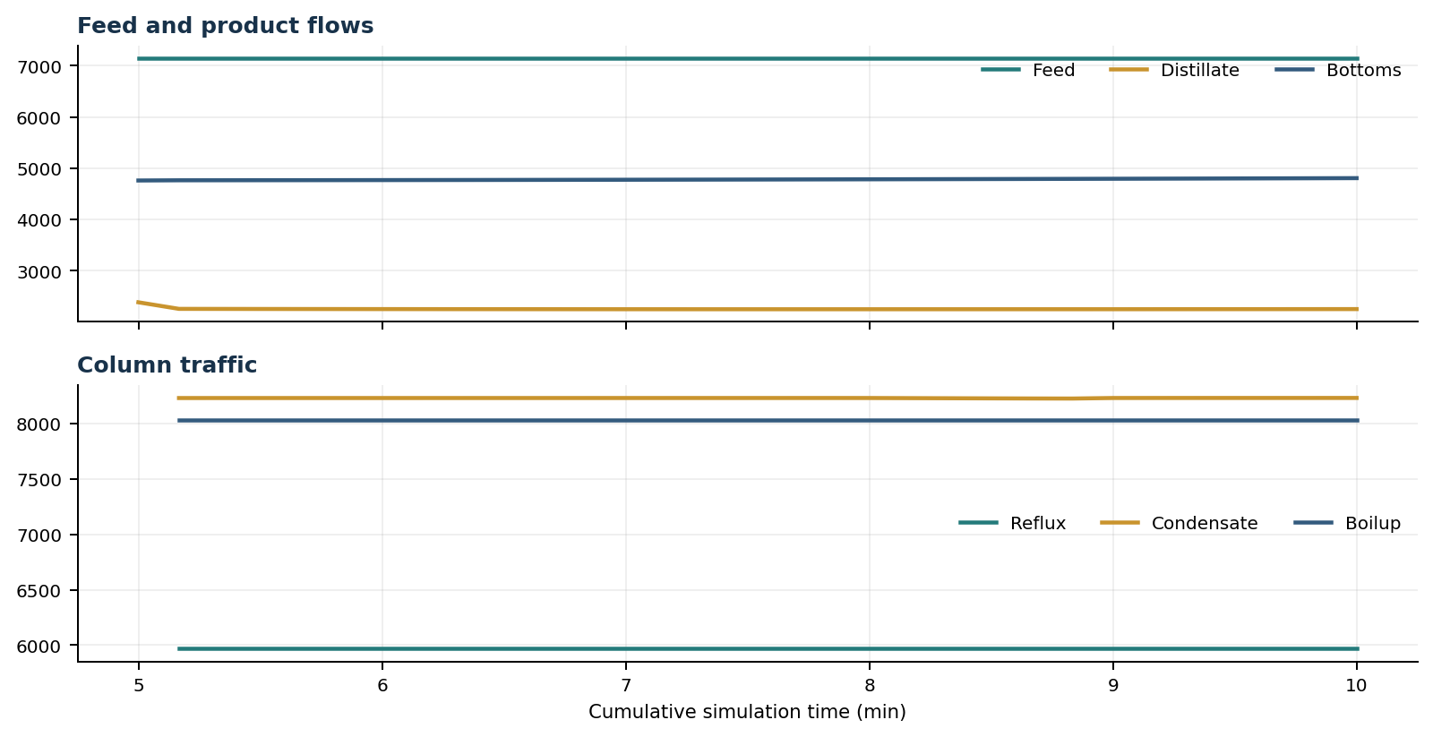
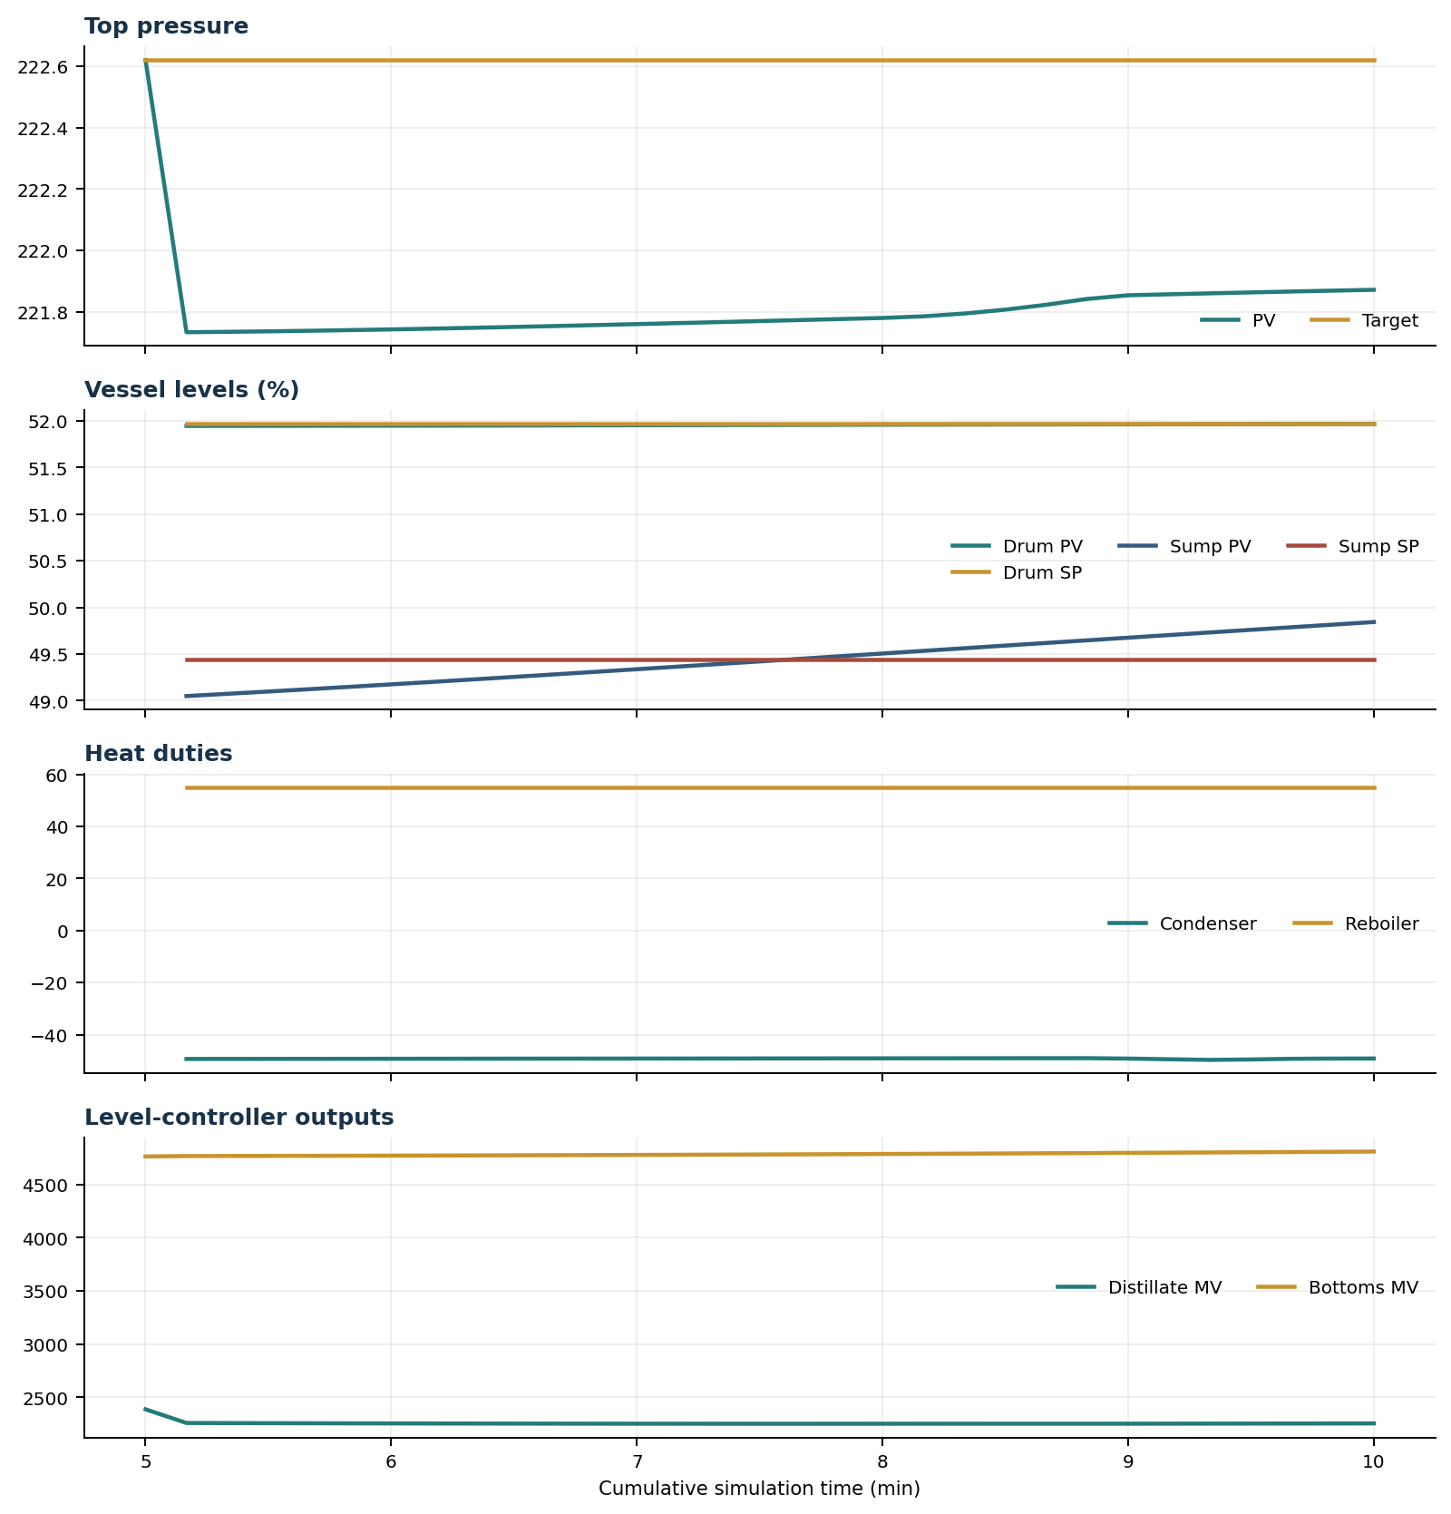

Final Tray Profiles
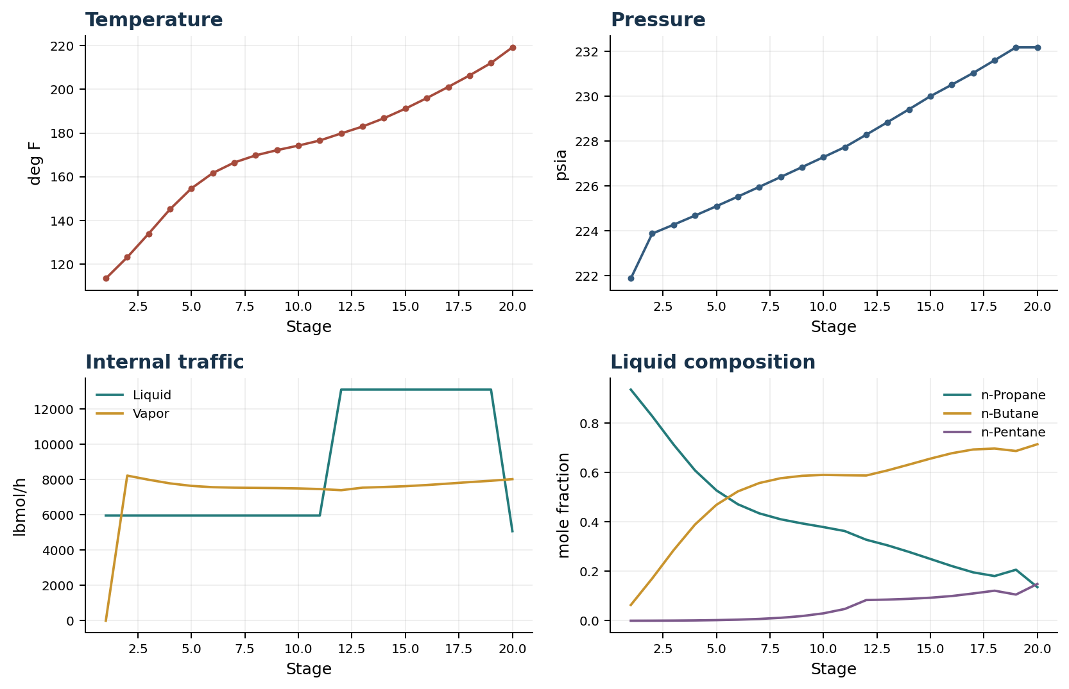

Final Tray Profile Table
Stage | T (deg F) | P (psia) | L (lbmol/h) | V (lbmol/h) | x n-Propane | x n-Butane | x n-Pentane | y n-Propane | y n-Butane | y n-Pentane
1 | 113.43 | 221.871 | 5,967.3 | 0.0 | 0.9363 | 0.0637 | 0.0000 | 0.0000 | 0.0000 | 0.0000
2 | 123.13 | 223.871 | 5,967.3 | 8,230.7 | 0.8285 | 0.1713 | 0.0002 | 0.9363 | 0.0637 | 0.0000
3 | 133.94 | 224.269 | 5,967.3 | 7,997.3 | 0.7136 | 0.2858 | 0.0006 | 0.8559 | 0.1440 | 0.0002
4 | 145.12 | 224.676 | 5,967.3 | 7,789.4 | 0.6090 | 0.3897 | 0.0013 | 0.7678 | 0.2317 | 0.0004
5 | 154.66 | 225.094 | 5,967.3 | 7,647.8 | 0.5281 | 0.4695 | 0.0025 | 0.6862 | 0.3129 | 0.0010
6 | 161.69 | 225.521 | 5,967.3 | 7,573.2 | 0.4719 | 0.5237 | 0.0044 | 0.6224 | 0.3757 | 0.0019
7 | 166.49 | 225.955 | 5,967.3 | 7,546.1 | 0.4351 | 0.5576 | 0.0073 | 0.5780 | 0.4186 | 0.0034
8 | 169.76 | 226.394 | 5,967.3 | 7,534.3 | 0.4110 | 0.5772 | 0.0118 | 0.5488 | 0.4455 | 0.0057
9 | 172.16 | 226.837 | 5,967.3 | 7,523.1 | 0.3942 | 0.5870 | 0.0189 | 0.5297 | 0.4610 | 0.0093
10 | 174.24 | 227.281 | 5,967.4 | 7,504.1 | 0.3794 | 0.5907 | 0.0299 | 0.5163 | 0.4688 | 0.0149
11 | 176.57 | 227.728 | 5,967.4 | 7,468.1 | 0.3632 | 0.5892 | 0.0476 | 0.5045 | 0.4717 | 0.0238
12 | 179.82 | 228.282 | 13,110.3 | 7,404.4 | 0.3282 | 0.5882 | 0.0837 | 0.4914 | 0.4705 | 0.0380
13 | 182.97 | 228.844 | 13,110.4 | 7,547.2 | 0.3053 | 0.6090 | 0.0857 | 0.4588 | 0.5006 | 0.0406
14 | 186.77 | 229.415 | 13,110.4 | 7,584.1 | 0.2787 | 0.6326 | 0.0887 | 0.4193 | 0.5366 | 0.0441
15 | 191.16 | 229.998 | 13,110.4 | 7,630.2 | 0.2502 | 0.6566 | 0.0932 | 0.3736 | 0.5771 | 0.0493
16 | 195.99 | 230.513 | 13,110.4 | 7,697.0 | 0.2215 | 0.6784 | 0.1001 | 0.3250 | 0.6181 | 0.0569
17 | 201.09 | 231.036 | 13,110.4 | 7,777.8 | 0.1959 | 0.6937 | 0.1104 | 0.2766 | 0.6549 | 0.0685
18 | 206.36 | 231.604 | 13,110.4 | 7,862.7 | 0.1810 | 0.6974 | 0.1216 | 0.2340 | 0.6802 | 0.0857
19 | 212.04 | 232.179 | 13,110.4 | 7,938.5 | 0.2066 | 0.6875 | 0.1060 | 0.2094 | 0.6864 | 0.1043
20 | 219.21 | 232.179 | 5,080.4 | 8,030.0 | 0.1360 | 0.7150 | 0.1490 | 0.2512 | 0.6701 | 0.0787

Simulation Configuration
Parameter | Value
Runtime Mode | hydraulic
Thermo Mode | dwsim
Dwsim Property Package | pr
Integrator | explicit-euler
N Steps | 1500
Dt Sec | 0.2
Log Every N Steps | 50
Thermo Every N Steps | 1
Include Energy | True
Enable Equilibrium Relaxation | True
Equilibrium Relaxation Mode | composition-exponential
Equilibrium Tau Sec | 0.5
Flash Feed At Stage Conditions | True
Enable Liquid Hydraulic Override | True
Liquid Hydraulic Model | francis
Liquid Hydraulic Override Alpha | 0.25
Enable Level Control | True
Top Level Pv Mode | true-level
Top Level Kc | 20.0
Top Level Ti Sec | 120.0
Bottom Level Pv Mode | true-level
Bottom Level Kc | 3.0
Bottom Level Ti Sec | 300.0
Enable Pressure Control | True
Pressure Control Mv | condenser-duty
Top Pressure Sp Psia | 222.6194497041178
Top Pressure Kc | -300000.0
Top Pressure Ti Sec | 180.0
Top Pressure Pv Filter Tau Sec | 5.0
Top Pressure Mv Slew Limit Per S | 25000.0
Condenser Duty Mode | specified
Condenser Duty Btu Per H | -51600000.0
Condenser Duty Min Btu Per H | -55000000.0
Condenser Duty Max Btu Per H | -46000000.0
Vapor Holdup Relaxation Sec | 0.0
Vapor Flow Relaxation Sec | 0.0
Vapor Flow Zero Temperature Target | True
Dynamic Vflow Nominal Hi Ratio | 1.05
Steady State Window Sec | 30.0
Steady State Min Time Sec | 60.0
Steady State Rel State Rate Tol Per S | 0.003
Steady State Temp Rate Tol F Per S | 0.15
Steady State Sp Error Tol | 0.02
Steady State Require Sp | False

Exact Launch Command
"C:\Users\Thomas Zvolensky\anaconda3\python.exe" -m dynamic_distillation.dynamic_run_scaffold_v1 --excel logs\c3c4_initializer_residual_vapor_state_stage2_20260706.xlsx --init-from-checkpoint .\logs\c3c4_dd057_final_composition_settle_hold300s_20260712\c3c4_initializer_residual_vapor_state_stage2_20260706__checkpoint_20260712_105152.npz --run-name C3C4_DD058_extended_composition_settle_hold300s_r2 --run-description Valid_live_DWSIM_extended_unchanged_hold_to_measure_remaining_bottom_composition_slope --runtime-mode hydraulic --thermo dwsim --dwsim-property-package pr --include-energy --equilibrium-relaxation-mode composition-exponential --equilibrium-tau-sec 0.5 --flash-feed-at-stage-conditions --enable-liquid-hydraulic-override --liquid-hydraulic-model francis --liquid-hydraulic-override-alpha 0.25 --enable-level-control --ignore-workbook-level-pv-mode --top-level-pv-mode true-level --bottom-level-pv-mode true-level --top-level-kc 20 --top-level-ti 120 --bottom-level-kc 3 --bottom-level-ti 300 --enable-pressure-control --pressure-control-mv condenser-duty --top-pressure-sp 222.6194497041178 --top-pressure-kc -300000 --top-pressure-ti 180 --top-pressure-pv-filter-tau-sec 5 --top-pressure-mv-slew-limit-per-s 25000 --condenser-duty-mode specified --condenser-duty-btuph -51600000 --condenser-duty-min-btuph -55000000 --condenser-duty-max-btuph -46000000 --enable-top-drum-resident-condensation --top-drum-resident-condensation-tau-sec 30 --top-drum-resident-condensation-max-frac-per-step 0.10 --reflux 5967.322711692588 --vapor-holdup-relaxation-sec 0 --vapor-flow-relaxation-sec 0 --vapor-flow-zero-temperature-target --use-excel-vapor-holdup --dynamic-vflow-nominal-hi-ratio 1.05 --disable-startup-thermo-conditioning --disable-restart-reentry-settling --n-steps 1500 --dt 0.2 --log-every 50 --logs-dir logs\c3c4_dd058_extended_composition_settle_hold300s_r2_20260712 --allow-repeat-command

