DYNAMIC DISTILLATION / COMPLETED RUN

C3C4_DD058_restart_proof
One_step_DWSIM_restart_environment_proof
RUN VALIDITY  REVIEW | DYNAMIC GATE  NOT PASSED | FINAL SCORE  0.130 | SIM / WALL  0.170
AUTOMATED ASSESSMENT The dynamic acceptance gate did not pass (final score 0.130).

Run Identity
Item | Value
Run ID | 20260712_110857
Started | 2026-07-12 11:08:57
Completed | 2026-07-12 11:08:58
Run type | Continuation from native checkpoint
Input workbook | C:\Users\Thomas Zvolensky\Documents\Python Scripts\Dynamic_DistillationII\logs\c3c4_initializer_residual_vapor_state_stage2_20260706.xlsx
Input checkpoint | C:\Users\Thomas Zvolensky\Documents\Python Scripts\Dynamic_DistillationII\logs\c3c4_dd057_final_composition_settle_hold300s_20260712\c3c4_initializer_residual_vapor_state_stage2_20260706__checkpoint_20260712_105152.npz
Summary data | C:\Users\Thomas Zvolensky\Documents\Python Scripts\Dynamic_DistillationII\logs\c3c4_dd058_restart_proof_20260712\column_summary_20260712_110857.csv
Tray-profile data | C:\Users\Thomas Zvolensky\Documents\Python Scripts\Dynamic_DistillationII\logs\c3c4_dd058_restart_proof_20260712\column_profile_20260712_110857.csv

Operating Snapshot
Parameter | Start | End | Units
Feed | 7,142.98 | 7,142.98 | lbmol/h
Distillate | 2,386.93 | 2,260.25 | lbmol/h
Bottoms | 4,761.98 | 4,765.62 | lbmol/h
Reflux | Not reported | 5,967.32 | lbmol/h
Top pressure | 222.619 | 221.732 | psia
Bottom pressure | 316.632 | 232.190 | psia
Distillate temperature | 113.43 | 113.43 | deg F
Bottoms temperature | 223.70 | 223.70 | deg F
Condenser duty | Not reported | -49.365 | MMBtu/h
Reboiler duty | Not reported | 54.844 | MMBtu/h
Distillate drum controller PV | Not reported | 51.95 | lbmol
Bottoms sump controller PV | Not reported | 49.03 | lbmol
Steady-state score | Not reported | 0.1305 | -

Product Composition
Component | Distillate start | Distillate end | Bottoms start | Bottoms end
n-Butane | 6.372% | 6.372% | 73.569% | 73.568%
n-Pentane | 0.010% | 0.010% | 14.969% | 14.969%
n-Propane | 93.618% | 93.618% | 11.462% | 11.463%
source | Not reported | Not reported | Not reported | Not reported

Dynamic Trends
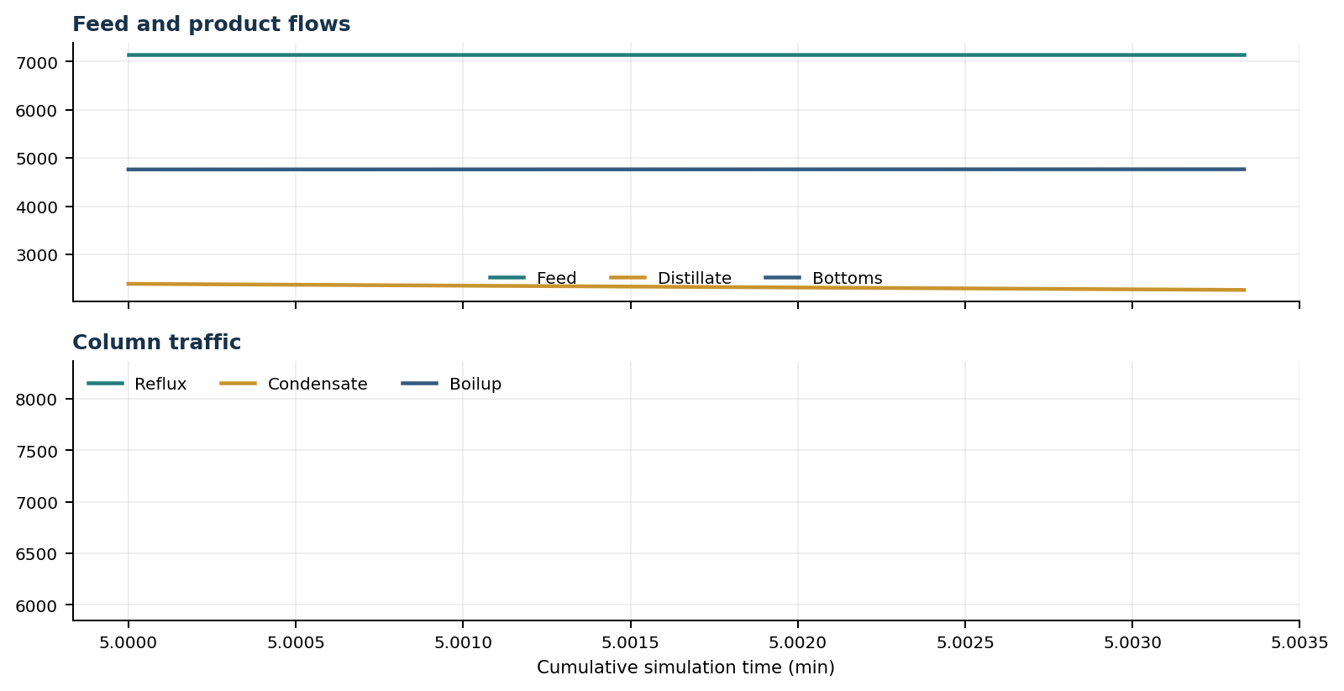
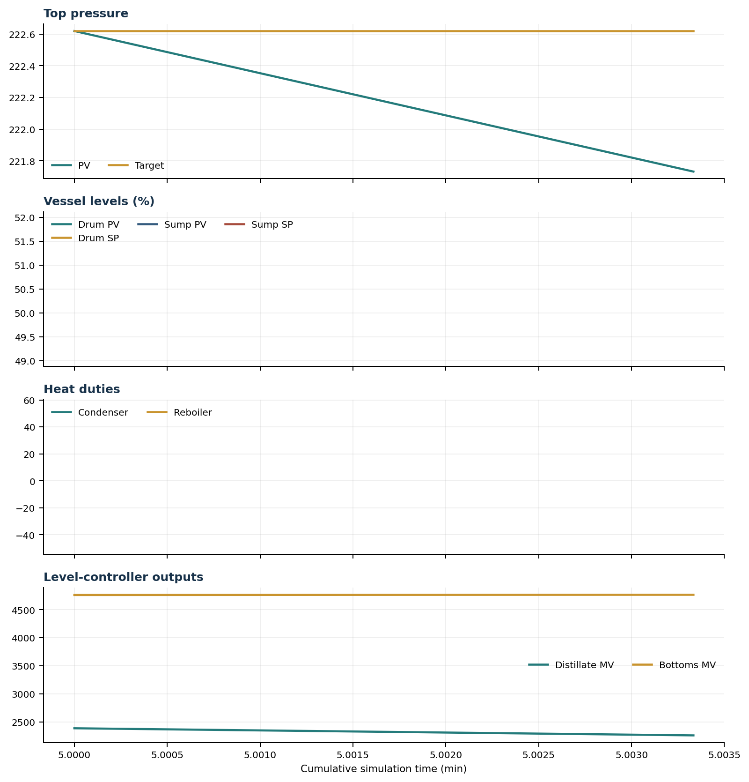

Final Tray Profiles
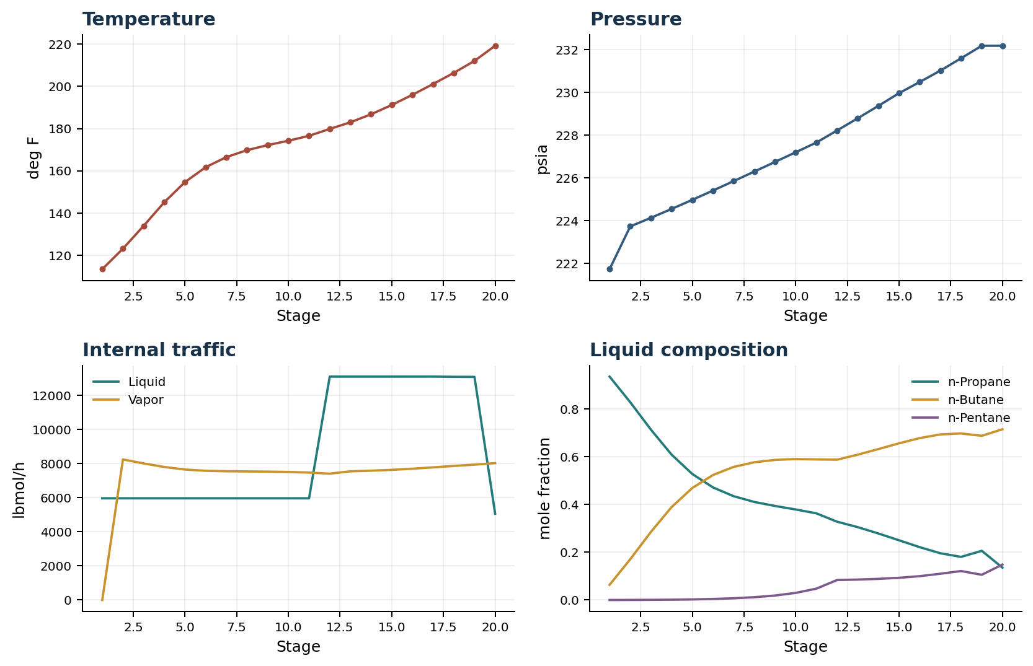

Final Tray Profile Table
Stage | T (deg F) | P (psia) | L (lbmol/h) | V (lbmol/h) | x n-Propane | x n-Butane | x n-Pentane | y n-Propane | y n-Butane | y n-Pentane
1 | 113.43 | 221.732 | 5,967.3 | 0.0 | 0.9363 | 0.0636 | 0.0000 | 0.0000 | 0.0000 | 0.0000
2 | 123.13 | 223.732 | 5,967.4 | 8,248.6 | 0.8288 | 0.1709 | 0.0003 | 0.9363 | 0.0636 | 0.0000
3 | 133.94 | 224.137 | 5,967.4 | 8,015.3 | 0.7139 | 0.2855 | 0.0006 | 0.8562 | 0.1436 | 0.0002
4 | 145.12 | 224.551 | 5,967.4 | 7,806.6 | 0.6092 | 0.3895 | 0.0013 | 0.7681 | 0.2314 | 0.0004
5 | 154.66 | 224.977 | 5,967.4 | 7,657.2 | 0.5282 | 0.4694 | 0.0025 | 0.6864 | 0.3127 | 0.0010
6 | 161.69 | 225.411 | 5,967.4 | 7,583.0 | 0.4719 | 0.5237 | 0.0043 | 0.6225 | 0.3756 | 0.0019
7 | 166.49 | 225.853 | 5,967.4 | 7,556.1 | 0.4350 | 0.5577 | 0.0073 | 0.5780 | 0.4186 | 0.0034
8 | 169.76 | 226.300 | 5,967.4 | 7,544.5 | 0.4109 | 0.5773 | 0.0118 | 0.5488 | 0.4455 | 0.0057
9 | 172.16 | 226.751 | 5,967.4 | 7,533.4 | 0.3941 | 0.5871 | 0.0188 | 0.5297 | 0.4610 | 0.0093
10 | 174.24 | 227.203 | 5,967.4 | 7,514.5 | 0.3794 | 0.5908 | 0.0298 | 0.5163 | 0.4688 | 0.0149
11 | 176.57 | 227.658 | 5,967.4 | 7,478.4 | 0.3633 | 0.5891 | 0.0476 | 0.5046 | 0.4717 | 0.0237
12 | 179.82 | 228.222 | 13,110.4 | 7,414.6 | 0.3282 | 0.5881 | 0.0837 | 0.4915 | 0.4704 | 0.0380
13 | 182.97 | 228.794 | 13,110.4 | 7,551.5 | 0.3054 | 0.6089 | 0.0857 | 0.4590 | 0.5005 | 0.0406
14 | 186.77 | 229.376 | 13,110.5 | 7,588.7 | 0.2788 | 0.6325 | 0.0887 | 0.4195 | 0.5364 | 0.0441
15 | 191.16 | 229.970 | 13,110.7 | 7,638.4 | 0.2502 | 0.6567 | 0.0931 | 0.3737 | 0.5770 | 0.0492
16 | 195.99 | 230.493 | 13,111.3 | 7,704.8 | 0.2214 | 0.6786 | 0.0999 | 0.3251 | 0.6182 | 0.0568
17 | 201.09 | 231.026 | 13,112.3 | 7,783.2 | 0.1958 | 0.6940 | 0.1102 | 0.2766 | 0.6551 | 0.0683
18 | 206.36 | 231.604 | 13,098.0 | 7,867.8 | 0.1806 | 0.6980 | 0.1214 | 0.2338 | 0.6807 | 0.0855
19 | 212.04 | 232.190 | 13,093.3 | 7,944.0 | 0.2062 | 0.6881 | 0.1057 | 0.2089 | 0.6870 | 0.1041
20 | 219.21 | 232.190 | 5,063.3 | 8,030.0 | 0.1357 | 0.7155 | 0.1487 | 0.2506 | 0.6708 | 0.0786

Simulation Configuration
Parameter | Value
Runtime Mode | hydraulic
Thermo Mode | dwsim
Dwsim Property Package | pr
Integrator | explicit-euler
N Steps | 1
Dt Sec | 0.2
Log Every N Steps | 1
Thermo Every N Steps | 1
Include Energy | True
Enable Equilibrium Relaxation | True
Equilibrium Relaxation Mode | composition-exponential
Equilibrium Tau Sec | 0.5
Flash Feed At Stage Conditions | True
Enable Liquid Hydraulic Override | True
Liquid Hydraulic Model | francis
Liquid Hydraulic Override Alpha | 0.25
Enable Level Control | True
Top Level Pv Mode | true-level
Top Level Kc | 20.0
Top Level Ti Sec | 120.0
Bottom Level Pv Mode | true-level
Bottom Level Kc | 3.0
Bottom Level Ti Sec | 300.0
Enable Pressure Control | True
Pressure Control Mv | condenser-duty
Top Pressure Sp Psia | 222.6194497041178
Top Pressure Kc | -300000.0
Top Pressure Ti Sec | 180.0
Top Pressure Pv Filter Tau Sec | 5.0
Top Pressure Mv Slew Limit Per S | 25000.0
Condenser Duty Mode | specified
Condenser Duty Btu Per H | -51600000.0
Condenser Duty Min Btu Per H | -55000000.0
Condenser Duty Max Btu Per H | -46000000.0
Vapor Holdup Relaxation Sec | 0.0
Vapor Flow Relaxation Sec | 0.0
Vapor Flow Zero Temperature Target | True
Dynamic Vflow Nominal Hi Ratio | 1.05
Steady State Window Sec | 30.0
Steady State Min Time Sec | 60.0
Steady State Rel State Rate Tol Per S | 0.003
Steady State Temp Rate Tol F Per S | 0.15
Steady State Sp Error Tol | 0.02
Steady State Require Sp | False

Exact Launch Command
"C:\Users\Thomas Zvolensky\anaconda3\python.exe" -m dynamic_distillation.dynamic_run_scaffold_v1 --excel logs\c3c4_initializer_residual_vapor_state_stage2_20260706.xlsx --init-from-checkpoint .\logs\c3c4_dd057_final_composition_settle_hold300s_20260712\c3c4_initializer_residual_vapor_state_stage2_20260706__checkpoint_20260712_105152.npz --run-name C3C4_DD058_restart_proof --run-description One_step_DWSIM_restart_environment_proof --runtime-mode hydraulic --thermo dwsim --dwsim-property-package pr --include-energy --equilibrium-relaxation-mode composition-exponential --equilibrium-tau-sec 0.5 --flash-feed-at-stage-conditions --enable-liquid-hydraulic-override --liquid-hydraulic-model francis --liquid-hydraulic-override-alpha 0.25 --enable-level-control --ignore-workbook-level-pv-mode --top-level-pv-mode true-level --bottom-level-pv-mode true-level --top-level-kc 20 --top-level-ti 120 --bottom-level-kc 3 --bottom-level-ti 300 --enable-pressure-control --pressure-control-mv condenser-duty --top-pressure-sp 222.6194497041178 --top-pressure-kc -300000 --top-pressure-ti 180 --top-pressure-pv-filter-tau-sec 5 --top-pressure-mv-slew-limit-per-s 25000 --condenser-duty-mode specified --condenser-duty-btuph -51600000 --condenser-duty-min-btuph -55000000 --condenser-duty-max-btuph -46000000 --enable-top-drum-resident-condensation --top-drum-resident-condensation-tau-sec 30 --top-drum-resident-condensation-max-frac-per-step 0.10 --reflux 5967.322711692588 --vapor-holdup-relaxation-sec 0 --vapor-flow-relaxation-sec 0 --vapor-flow-zero-temperature-target --use-excel-vapor-holdup --dynamic-vflow-nominal-hi-ratio 1.05 --disable-startup-thermo-conditioning --disable-restart-reentry-settling --n-steps 1 --dt 0.2 --log-every 1 --logs-dir logs\c3c4_dd058_restart_proof_20260712 --allow-repeat-command

