DYNAMIC DISTILLATION / COMPLETED RUN

C3C4_DD060_phase_exponential_onestep
One_step_full_phase_split_exponential_probe_at_existing_hydraulic_blend
RUN VALIDITY  REVIEW | DYNAMIC GATE  NOT PASSED | FINAL SCORE  821.000 | SIM / WALL  0.108
AUTOMATED ASSESSMENT The dynamic acceptance gate did not pass (final score 821.000).

Run Identity
Item | Value
Run ID | 20260712_181509
Started | 2026-07-12 18:15:09
Completed | 2026-07-12 18:15:11
Run type | Continuation from native checkpoint
Input workbook | C:\Users\Thomas Zvolensky\Documents\Python Scripts\Dynamic_DistillationII\logs\c3c4_initializer_residual_vapor_state_stage2_20260706.xlsx
Input checkpoint | C:\Users\Thomas Zvolensky\Documents\Python Scripts\Dynamic_DistillationII\logs\c3c4_dd058_extended_composition_settle_hold300s_r2_20260712\c3c4_initializer_residual_vapor_state_stage2_20260706__checkpoint_20260712_110933.npz
Summary data | C:\Users\Thomas Zvolensky\Documents\Python Scripts\Dynamic_DistillationII\logs\c3c4_dd060_phase_exponential_onestep_20260712\column_summary_20260712_181509.csv
Tray-profile data | C:\Users\Thomas Zvolensky\Documents\Python Scripts\Dynamic_DistillationII\logs\c3c4_dd060_phase_exponential_onestep_20260712\column_profile_20260712_181509.csv

Operating Snapshot
Parameter | Start | End | Units
Feed | 7,142.98 | 7,142.98 | lbmol/h
Distillate | 2,386.93 | 2,255.86 | lbmol/h
Bottoms | 4,761.98 | 4,808.17 | lbmol/h
Reflux | Not reported | 5,967.32 | lbmol/h
Top pressure | 222.619 | 221.871 | psia
Bottom pressure | 316.632 | 232.192 | psia
Distillate temperature | 113.43 | 113.43 | deg F
Bottoms temperature | 225.63 | 225.63 | deg F
Condenser duty | Not reported | -49.158 | MMBtu/h
Reboiler duty | Not reported | 54.844 | MMBtu/h
Distillate drum controller PV | Not reported | 51.97 | lbmol
Bottoms sump controller PV | Not reported | 49.84 | lbmol
Steady-state score | Not reported | 820.9999 | -

Product Composition
Component | Distillate start | Distillate end | Bottoms start | Bottoms end
n-Butane | 6.369% | 6.369% | 72.782% | 72.782%
n-Pentane | 0.008% | 0.008% | 14.940% | 14.940%
n-Propane | 93.623% | 93.623% | 12.278% | 12.278%
source | Not reported | Not reported | Not reported | Not reported

Dynamic Trends
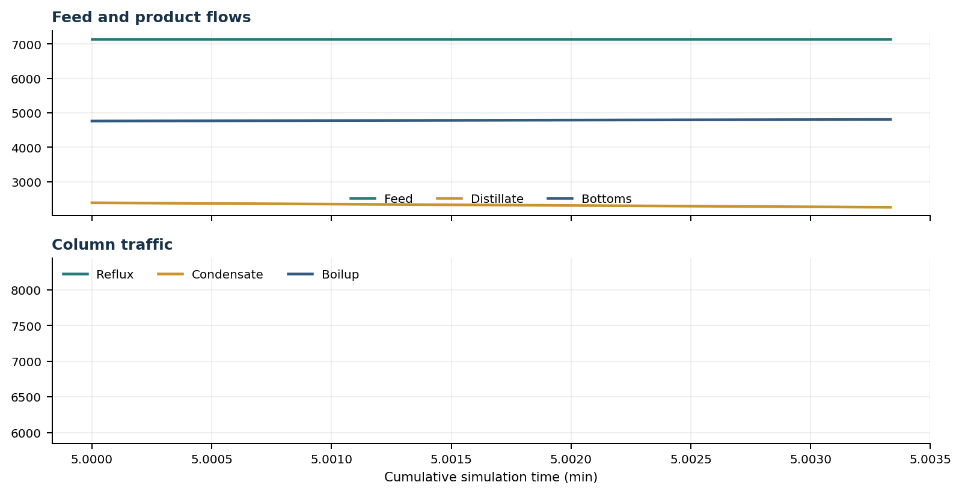
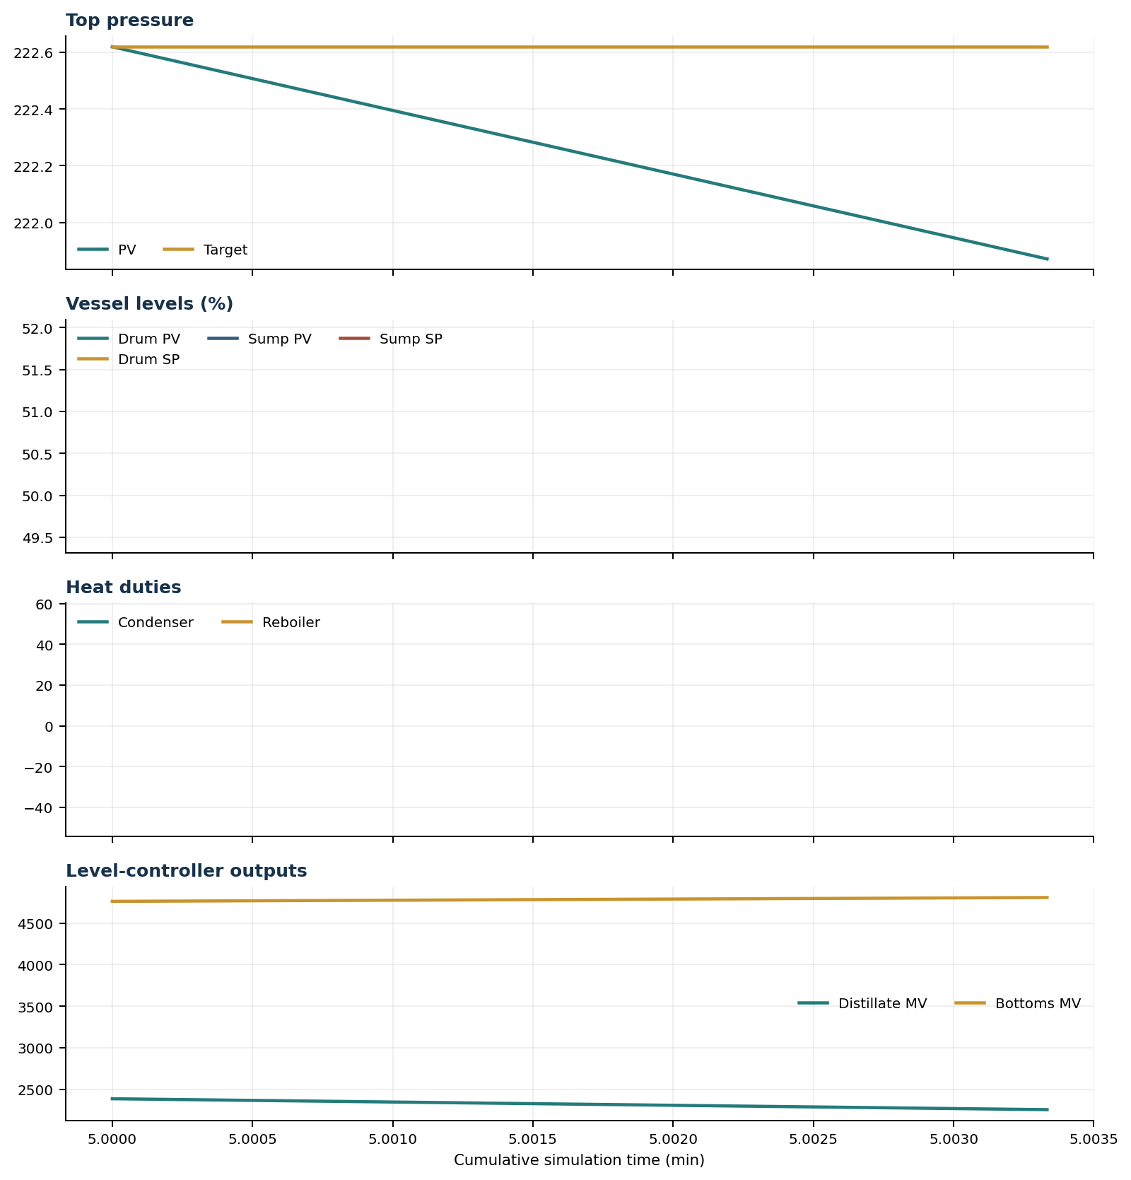

Final Tray Profiles
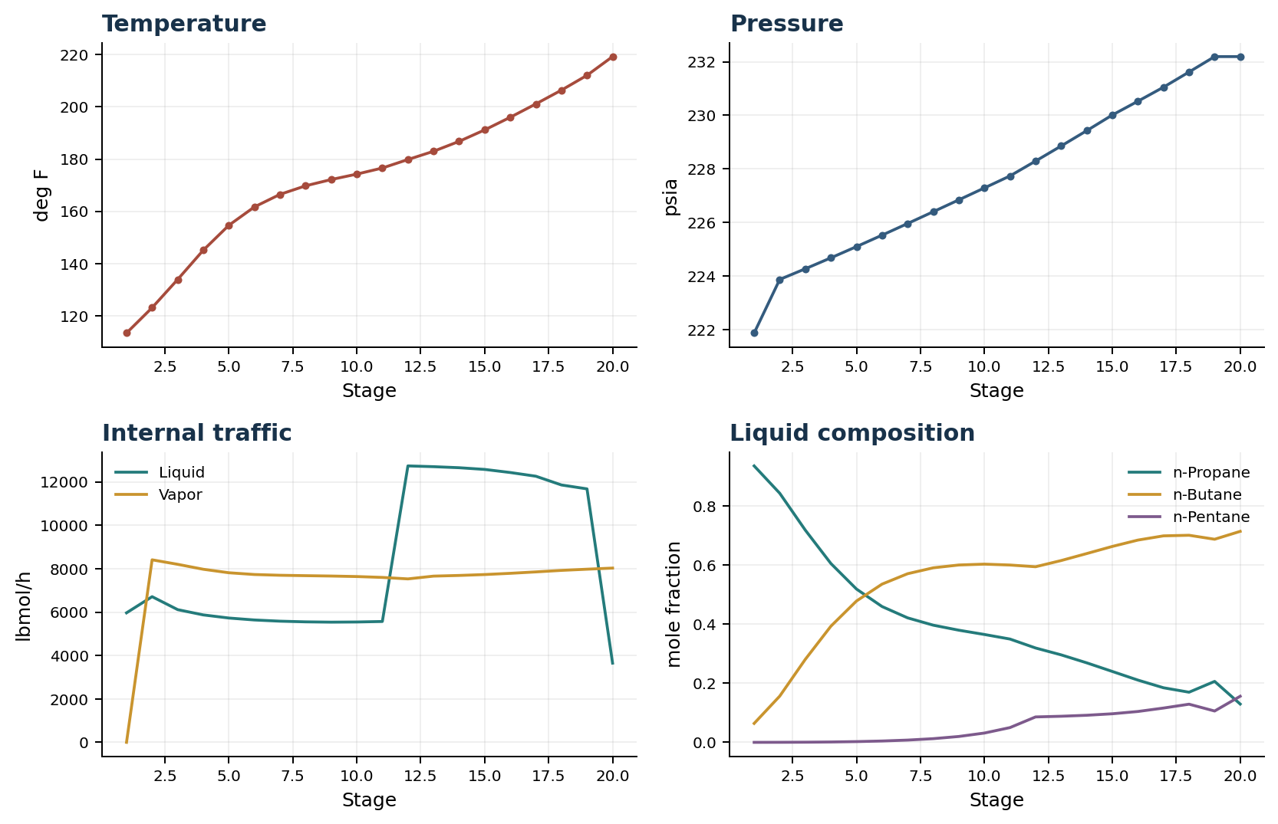

Final Tray Profile Table
Stage | T (deg F) | P (psia) | L (lbmol/h) | V (lbmol/h) | x n-Propane | x n-Butane | x n-Pentane | y n-Propane | y n-Butane | y n-Pentane
1 | 113.43 | 221.871 | 5,967.3 | 0.0 | 0.9358 | 0.0641 | 0.0000 | 0.0000 | 0.0000 | 0.0000
2 | 123.13 | 223.871 | 6,712.9 | 8,410.9 | 0.8433 | 0.1565 | 0.0002 | 0.9358 | 0.0641 | 0.0000
3 | 133.94 | 224.270 | 6,114.9 | 8,203.2 | 0.7184 | 0.2810 | 0.0006 | 0.8551 | 0.1447 | 0.0002
4 | 145.12 | 224.678 | 5,872.3 | 7,975.6 | 0.6054 | 0.3933 | 0.0013 | 0.7682 | 0.2314 | 0.0004
5 | 154.66 | 225.097 | 5,728.6 | 7,814.7 | 0.5190 | 0.4785 | 0.0026 | 0.6868 | 0.3123 | 0.0010
6 | 161.69 | 225.525 | 5,638.5 | 7,733.8 | 0.4598 | 0.5357 | 0.0046 | 0.6229 | 0.3752 | 0.0019
7 | 166.49 | 225.960 | 5,583.3 | 7,699.0 | 0.4214 | 0.5709 | 0.0077 | 0.5784 | 0.4183 | 0.0034
8 | 169.76 | 226.400 | 5,552.3 | 7,680.3 | 0.3967 | 0.5908 | 0.0125 | 0.5490 | 0.4453 | 0.0057
9 | 172.16 | 226.843 | 5,538.5 | 7,663.6 | 0.3797 | 0.6004 | 0.0199 | 0.5299 | 0.4609 | 0.0093
10 | 174.24 | 227.288 | 5,546.0 | 7,640.1 | 0.3652 | 0.6033 | 0.0315 | 0.5165 | 0.4687 | 0.0148
11 | 176.57 | 227.736 | 5,569.1 | 7,599.9 | 0.3497 | 0.6003 | 0.0500 | 0.5047 | 0.4718 | 0.0236
12 | 179.82 | 228.291 | 12,738.1 | 7,531.6 | 0.3195 | 0.5945 | 0.0861 | 0.4918 | 0.4702 | 0.0380
13 | 182.97 | 228.854 | 12,703.0 | 7,659.4 | 0.2962 | 0.6154 | 0.0884 | 0.4593 | 0.5002 | 0.0405
14 | 186.77 | 229.426 | 12,655.0 | 7,690.6 | 0.2692 | 0.6391 | 0.0917 | 0.4199 | 0.5360 | 0.0441
15 | 191.16 | 230.010 | 12,576.4 | 7,732.4 | 0.2400 | 0.6632 | 0.0967 | 0.3743 | 0.5765 | 0.0492
16 | 195.99 | 230.525 | 12,433.8 | 7,788.6 | 0.2108 | 0.6847 | 0.1045 | 0.3258 | 0.6175 | 0.0567
17 | 201.09 | 231.049 | 12,263.1 | 7,854.1 | 0.1848 | 0.6990 | 0.1161 | 0.2774 | 0.6544 | 0.0682
18 | 206.36 | 231.616 | 11,859.9 | 7,923.8 | 0.1698 | 0.7010 | 0.1292 | 0.2347 | 0.6800 | 0.0853
19 | 212.04 | 232.192 | 11,680.0 | 7,978.4 | 0.2063 | 0.6876 | 0.1061 | 0.2084 | 0.6868 | 0.1049
20 | 219.21 | 232.192 | 3,650.0 | 8,030.0 | 0.1297 | 0.7143 | 0.1561 | 0.2415 | 0.6753 | 0.0832

Simulation Configuration
Parameter | Value
Runtime Mode | hydraulic
Thermo Mode | dwsim
Dwsim Property Package | pr
Integrator | explicit-euler
N Steps | 1
Dt Sec | 0.2
Log Every N Steps | 1
Thermo Every N Steps | 1
Include Energy | True
Enable Equilibrium Relaxation | True
Equilibrium Relaxation Mode | phase-exponential
Equilibrium Tau Sec | 0.5
Flash Feed At Stage Conditions | True
Enable Liquid Hydraulic Override | True
Liquid Hydraulic Model | francis
Liquid Hydraulic Override Alpha | 0.25
Enable Level Control | True
Top Level Pv Mode | true-level
Top Level Kc | 20.0
Top Level Ti Sec | 120.0
Bottom Level Pv Mode | true-level
Bottom Level Kc | 3.0
Bottom Level Ti Sec | 300.0
Enable Pressure Control | True
Pressure Control Mv | condenser-duty
Top Pressure Sp Psia | 222.6194497041178
Top Pressure Kc | -300000.0
Top Pressure Ti Sec | 180.0
Top Pressure Pv Filter Tau Sec | 5.0
Top Pressure Mv Slew Limit Per S | 25000.0
Condenser Duty Mode | specified
Condenser Duty Btu Per H | -51600000.0
Condenser Duty Min Btu Per H | -55000000.0
Condenser Duty Max Btu Per H | -46000000.0
Vapor Holdup Relaxation Sec | 0.0
Vapor Flow Relaxation Sec | 0.0
Vapor Flow Zero Temperature Target | True
Dynamic Vflow Nominal Hi Ratio | 1.05
Steady State Window Sec | 30.0
Steady State Min Time Sec | 60.0
Steady State Rel State Rate Tol Per S | 0.003
Steady State Temp Rate Tol F Per S | 0.15
Steady State Sp Error Tol | 0.02
Steady State Require Sp | False

Exact Launch Command
"C:\Users\Thomas Zvolensky\anaconda3\python.exe" -m dynamic_distillation.dynamic_run_scaffold_v1 --excel logs\c3c4_initializer_residual_vapor_state_stage2_20260706.xlsx --init-from-checkpoint .\logs\c3c4_dd058_extended_composition_settle_hold300s_r2_20260712\c3c4_initializer_residual_vapor_state_stage2_20260706__checkpoint_20260712_110933.npz --run-name C3C4_DD060_phase_exponential_onestep --run-description One_step_full_phase_split_exponential_probe_at_existing_hydraulic_blend --runtime-mode hydraulic --thermo dwsim --dwsim-property-package pr --include-energy --equilibrium-relaxation-mode phase-exponential --equilibrium-tau-sec 0.5 --flash-feed-at-stage-conditions --enable-liquid-hydraulic-override --liquid-hydraulic-model francis --liquid-hydraulic-override-alpha 0.25 --enable-level-control --ignore-workbook-level-pv-mode --top-level-pv-mode true-level --bottom-level-pv-mode true-level --top-level-kc 20 --top-level-ti 120 --bottom-level-kc 3 --bottom-level-ti 300 --enable-pressure-control --pressure-control-mv condenser-duty --top-pressure-sp 222.6194497041178 --top-pressure-kc -300000 --top-pressure-ti 180 --top-pressure-pv-filter-tau-sec 5 --top-pressure-mv-slew-limit-per-s 25000 --condenser-duty-mode specified --condenser-duty-btuph -51600000 --condenser-duty-min-btuph -55000000 --condenser-duty-max-btuph -46000000 --enable-top-drum-resident-condensation --top-drum-resident-condensation-tau-sec 30 --top-drum-resident-condensation-max-frac-per-step 0.10 --reflux 5967.322711692588 --vapor-holdup-relaxation-sec 0 --vapor-flow-relaxation-sec 0 --vapor-flow-zero-temperature-target --use-excel-vapor-holdup --dynamic-vflow-nominal-hi-ratio 1.05 --disable-startup-thermo-conditioning --disable-restart-reentry-settling --n-steps 1 --dt 0.2 --log-every 1 --logs-dir logs\c3c4_dd060_phase_exponential_onestep_20260712 --allow-repeat-command

