DYNAMIC DISTILLATION / COMPLETED RUN

c3c4_initializer_residual_vapor_state_stage2_20260706
Simulation operating report
DYNAMIC GATE  PASS | FINAL SCORE  0.585 | SIMULATED  15.0 min | SIM / WALL  0.482

Run Identity
Item | Value
Run ID | 20260710_113142
Started | 2026-07-10 11:31:42
Completed | 2026-07-10 12:02:50
Run type | Continuation from native checkpoint
Input workbook | C:\Users\Thomas Zvolensky\Documents\Python Scripts\Dynamic_DistillationII\logs\c3c4_initializer_residual_vapor_state_stage2_20260706.xlsx
Input checkpoint | C:\Users\Thomas Zvolensky\Documents\Python Scripts\Dynamic_DistillationII\logs\c3c4_stage2_truelevel_fixedcond_Q42MM_dwsimPR_900s_r2_20260710\c3c4_initializer_residual_vapor_state_stage2_20260706__checkpoint_20260709_214209.npz
Summary data | C:\Users\Thomas Zvolensky\Documents\Python Scripts\Dynamic_DistillationII\logs\c3c4_checkpoint900_bottomTi300_continue_900s_r2_20260710\column_summary_20260710_113142.csv
Tray-profile data | C:\Users\Thomas Zvolensky\Documents\Python Scripts\Dynamic_DistillationII\logs\c3c4_checkpoint900_bottomTi300_continue_900s_r2_20260710\column_profile_20260710_113142.csv

Operating Snapshot
Parameter | Start | End | Units
Feed | 7,142.98 | 7,142.98 | lbmol/h
Distillate | 2,386.93 | 2,008.41 | lbmol/h
Bottoms | 4,761.98 | 3,844.18 | lbmol/h
Reflux | Not reported | 5,967.32 | lbmol/h
Top pressure | 222.619 | 228.170 | psia
Bottom pressure | 316.632 | 232.177 | psia
Distillate temperature | 113.43 | 113.43 | deg F
Bottoms temperature | 208.69 | 248.11 | deg F
Condenser duty | Not reported | -42.000 | MMBtu/h
Reboiler duty | Not reported | 54.844 | MMBtu/h
Distillate drum level | Not reported | 46.58 | %
Bottoms sump level | Not reported | 43.41 | %
Steady-state score | Not reported | 0.5848 | -

Product Composition
Component | Distillate start | Distillate end | Bottoms start | Bottoms end
n-Butane | 8.486% | 15.210% | 71.082% | 65.447%
n-Pentane | 0.074% | 0.686% | 15.065% | 13.971%
n-Propane | 91.440% | 84.104% | 13.853% | 20.582%
source | Not reported | Not reported | Not reported | Not reported

Dynamic Trends
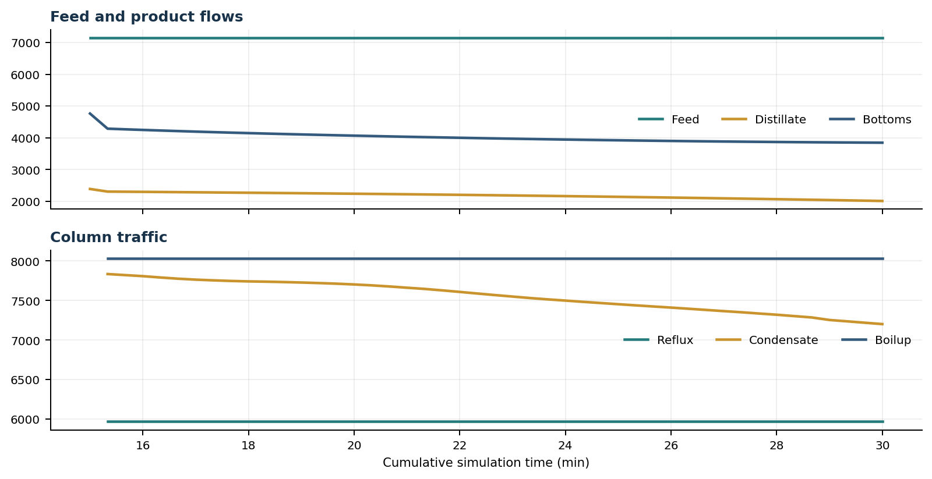
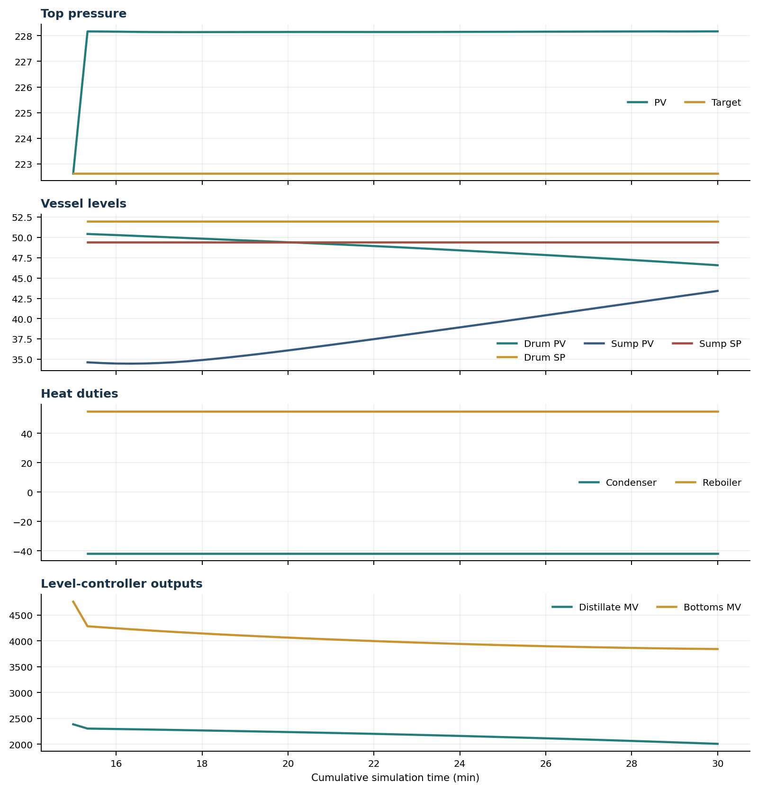

Final Tray Profiles
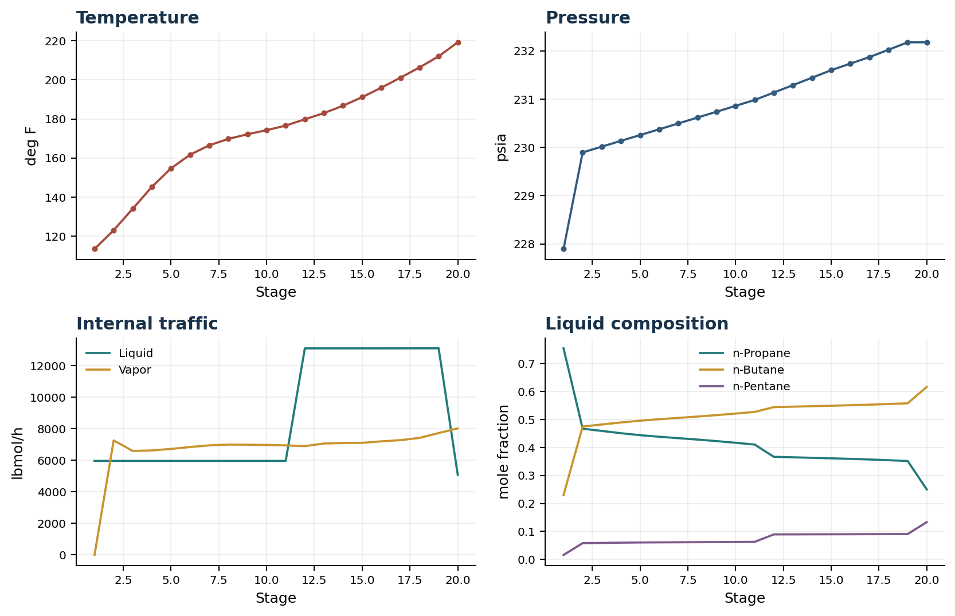

Final Tray Profile Table
Stage | T (deg F) | P (psia) | L (lbmol/h) | V (lbmol/h) | x n-Propane | x n-Butane | x n-Pentane | y n-Propane | y n-Butane | y n-Pentane
1 | 113.43 | 227.896 | 5,967.3 | 0.0 | 0.7545 | 0.2298 | 0.0157 | 0.0000 | 0.0000 | 0.0000
2 | 123.02 | 229.896 | 5,967.3 | 7,268.2 | 0.4671 | 0.4750 | 0.0579 | 0.7545 | 0.2298 | 0.0157
3 | 134.05 | 230.016 | 5,967.3 | 6,599.5 | 0.4591 | 0.4821 | 0.0588 | 0.4044 | 0.5315 | 0.0641
4 | 145.24 | 230.135 | 5,967.3 | 6,632.4 | 0.4509 | 0.4894 | 0.0597 | 0.4021 | 0.5333 | 0.0646
5 | 154.70 | 230.255 | 5,967.3 | 6,728.8 | 0.4439 | 0.4957 | 0.0604 | 0.4030 | 0.5325 | 0.0645
6 | 161.69 | 230.375 | 5,967.3 | 6,849.4 | 0.4383 | 0.5010 | 0.0608 | 0.4039 | 0.5317 | 0.0644
7 | 166.49 | 230.495 | 5,967.3 | 6,954.6 | 0.4333 | 0.5057 | 0.0611 | 0.4047 | 0.5309 | 0.0644
8 | 169.76 | 230.617 | 5,967.3 | 7,003.8 | 0.4282 | 0.5104 | 0.0614 | 0.4056 | 0.5302 | 0.0643
9 | 172.16 | 230.738 | 5,967.3 | 6,995.7 | 0.4227 | 0.5156 | 0.0617 | 0.4064 | 0.5294 | 0.0642
10 | 174.24 | 230.860 | 5,967.3 | 6,981.9 | 0.4167 | 0.5211 | 0.0621 | 0.4072 | 0.5286 | 0.0641
11 | 176.57 | 230.983 | 5,967.4 | 6,954.7 | 0.4103 | 0.5270 | 0.0626 | 0.4081 | 0.5279 | 0.0641
12 | 179.82 | 231.136 | 13,110.4 | 6,905.8 | 0.3666 | 0.5442 | 0.0892 | 0.4089 | 0.5271 | 0.0640
13 | 182.97 | 231.290 | 13,110.5 | 7,072.3 | 0.3648 | 0.5459 | 0.0893 | 0.4098 | 0.5263 | 0.0639
14 | 186.77 | 231.444 | 13,110.6 | 7,103.4 | 0.3630 | 0.5475 | 0.0895 | 0.4106 | 0.5255 | 0.0639
15 | 191.16 | 231.599 | 13,110.8 | 7,115.2 | 0.3612 | 0.5491 | 0.0896 | 0.4115 | 0.5247 | 0.0638
16 | 195.99 | 231.735 | 13,111.2 | 7,208.2 | 0.3592 | 0.5510 | 0.0898 | 0.4123 | 0.5240 | 0.0637
17 | 201.09 | 231.870 | 13,111.8 | 7,285.1 | 0.3571 | 0.5529 | 0.0900 | 0.4133 | 0.5231 | 0.0636
18 | 206.36 | 232.022 | 13,112.8 | 7,430.5 | 0.3544 | 0.5554 | 0.0902 | 0.4142 | 0.5222 | 0.0636
19 | 212.04 | 232.177 | 13,114.1 | 7,735.2 | 0.3516 | 0.5579 | 0.0905 | 0.4151 | 0.5214 | 0.0635
20 | 219.21 | 232.177 | 5,084.1 | 8,030.0 | 0.2501 | 0.6167 | 0.1333 | 0.4159 | 0.5206 | 0.0634

Simulation Configuration
Parameter | Value
Runtime Mode | hydraulic
Thermo Mode | dwsim
N Steps | 4500
Dt Sec | 0.2
Flash Feed At Stage Conditions | True

