DYNAMIC DISTILLATION / COMPLETED RUN

C3C4_DD058_extended_composition_settle_hold300s
Extended_unchanged_hold_to_measure_remaining_bottom_composition_slope
RUN VALIDITY  REVIEW | DYNAMIC GATE  NOT PASSED | FINAL SCORE  1,393.062 | SIM / WALL  2.609
AUTOMATED ASSESSMENT The dynamic acceptance gate did not pass (final score 1,393.062). The final tray snapshot reports 20 failed thermo flashes; interpret operating results as invalid until the thermo path is restored. Top pressure is 179.54 psi from its logged target, so the rate gate does not establish acceptable pressure control. At least one geometry-based vessel level remains more than five percentage points from setpoint. The top level loop reported molar holdup rather than a geometry-based level fraction. The bottom level loop reported molar holdup rather than a geometry-based level fraction.

Run Identity
Item | Value
Run ID | 20260712_110522
Started | 2026-07-12 11:05:22
Completed | 2026-07-12 11:07:17
Run type | Continuation from native checkpoint
Input workbook | C:\Users\Thomas Zvolensky\Documents\Python Scripts\Dynamic_DistillationII\logs\c3c4_initializer_residual_vapor_state_stage2_20260706.xlsx
Input checkpoint | C:\Users\Thomas Zvolensky\Documents\Python Scripts\Dynamic_DistillationII\logs\c3c4_dd057_final_composition_settle_hold300s_20260712\c3c4_initializer_residual_vapor_state_stage2_20260706__checkpoint_20260712_105152.npz
Summary data | C:\Users\Thomas Zvolensky\Documents\Python Scripts\Dynamic_DistillationII\logs\c3c4_dd058_extended_composition_settle_hold300s_20260712\column_summary_20260712_110522.csv
Tray-profile data | C:\Users\Thomas Zvolensky\Documents\Python Scripts\Dynamic_DistillationII\logs\c3c4_dd058_extended_composition_settle_hold300s_20260712\column_profile_20260712_110522.csv

Operating Snapshot
Parameter | Start | End | Units
Feed | 7,142.98 | 7,142.98 | lbmol/h
Distillate | 2,386.93 | 7,386.93 | lbmol/h
Bottoms | 4,761.98 | 4,494.07 | lbmol/h
Reflux | Not reported | 5,967.32 | lbmol/h
Top pressure | 222.619 | 402.164 | psia
Bottom pressure | 316.632 | 404.164 | psia
Distillate temperature | 113.43 | 113.43 | deg F
Bottoms temperature | 223.70 | 212.40 | deg F
Condenser duty | Not reported | -55.000 | MMBtu/h
Reboiler duty | Not reported | 54.844 | MMBtu/h
Distillate drum controller PV | Not reported | 2,696.49 | lbmol
Bottoms sump controller PV | Not reported | 801.97 | lbmol
Steady-state score | Not reported | 1,393.0616 | -

Product Composition
Component | Distillate start | Distillate end | Bottoms start | Bottoms end
n-Butane | 6.372% | 24.979% | 73.569% | 72.772%
n-Pentane | 0.010% | 1.219% | 14.969% | 15.697%
n-Propane | 93.618% | 73.801% | 11.462% | 11.531%
source | Not reported | Not reported | Not reported | Not reported

Dynamic Trends
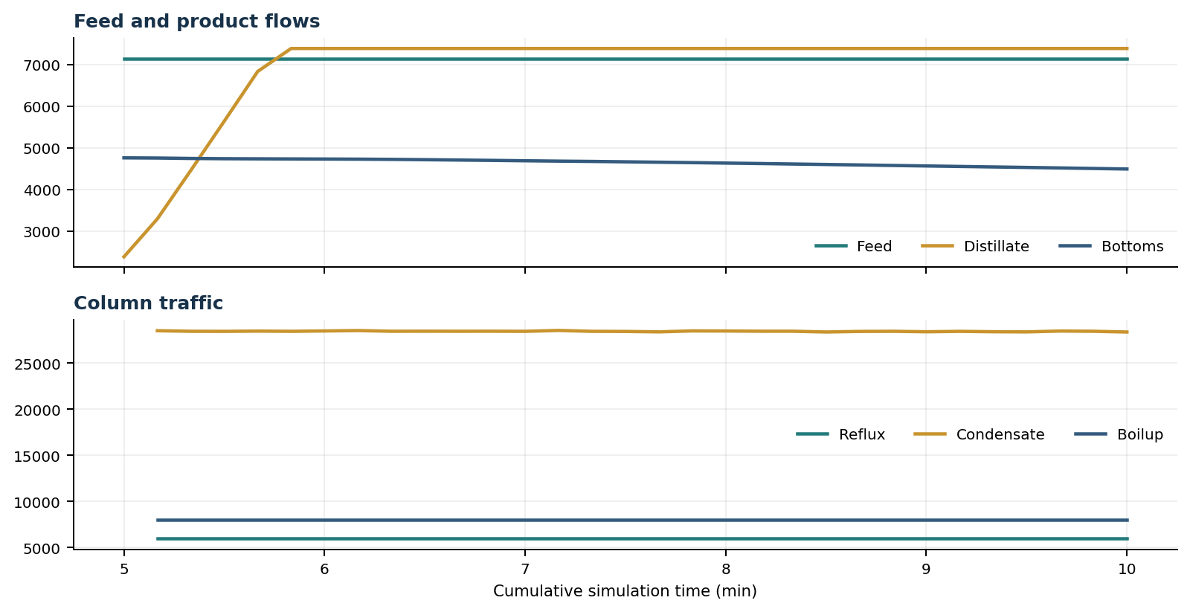
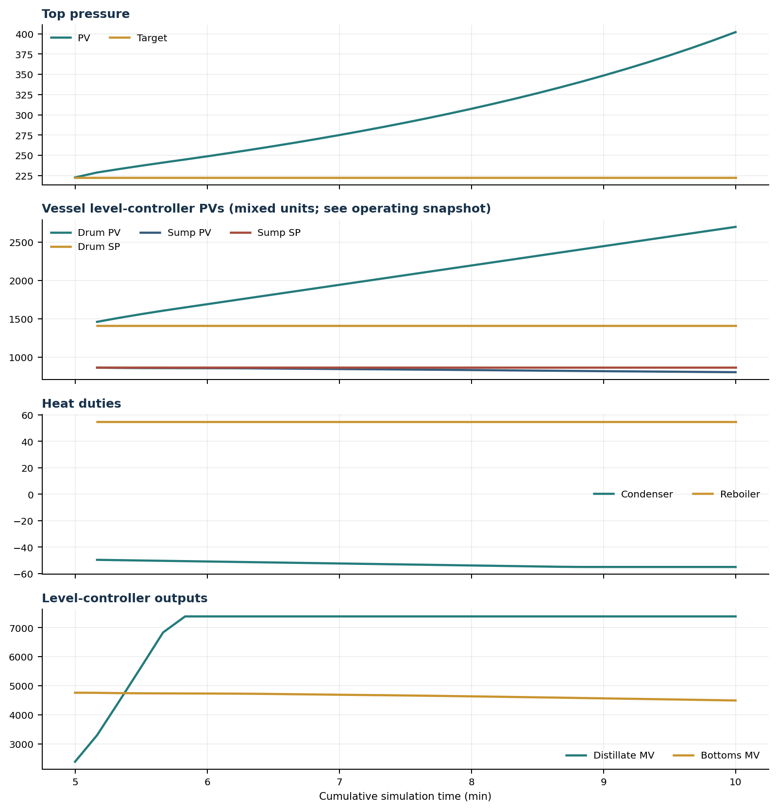

Final Tray Profiles
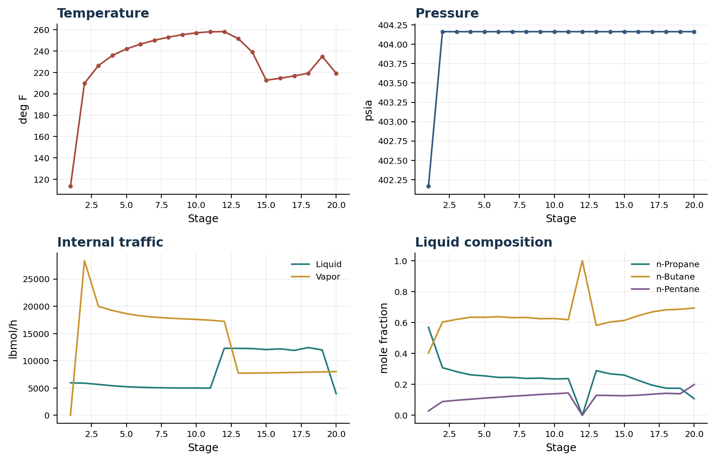

Final Tray Profile Table
Stage | T (deg F) | P (psia) | L (lbmol/h) | V (lbmol/h) | x n-Propane | x n-Butane | x n-Pentane | y n-Propane | y n-Butane | y n-Pentane
1 | 113.43 | 402.164 | 5,967.3 | 0.0 | 0.5685 | 0.4029 | 0.0286 | 0.0000 | 0.0000 | 0.0000
2 | 209.80 | 404.164 | 5,899.1 | 28,380.6 | 0.3079 | 0.6031 | 0.0890 | 0.5685 | 0.4029 | 0.0286
3 | 226.41 | 404.164 | 5,667.1 | 19,990.9 | 0.2827 | 0.6199 | 0.0974 | 0.8885 | 0.0000 | 0.1115
4 | 235.88 | 404.164 | 5,424.6 | 19,239.9 | 0.2619 | 0.6340 | 0.1040 | 0.0000 | 1.0000 | 0.0000
5 | 241.99 | 404.164 | 5,252.7 | 18,656.0 | 0.2550 | 0.6337 | 0.1113 | 0.8747 | 0.0000 | 0.1253
6 | 246.47 | 404.164 | 5,138.5 | 18,261.9 | 0.2451 | 0.6379 | 0.1170 | 0.0000 | 1.0000 | 0.0000
7 | 250.05 | 404.164 | 5,076.0 | 18,009.7 | 0.2452 | 0.6312 | 0.1236 | 0.8645 | 0.0000 | 0.1355
8 | 252.98 | 404.164 | 5,030.7 | 17,840.9 | 0.2386 | 0.6327 | 0.1287 | 0.0000 | 1.0000 | 0.0000
9 | 255.32 | 404.164 | 5,009.4 | 17,714.4 | 0.2406 | 0.6246 | 0.1348 | 0.8562 | 0.0000 | 0.1438
10 | 257.04 | 404.164 | 5,009.6 | 17,596.5 | 0.2350 | 0.6259 | 0.1391 | 0.0000 | 1.0000 | 0.0000
11 | 258.06 | 404.164 | 4,982.5 | 17,451.9 | 0.2374 | 0.6181 | 0.1445 | 0.8498 | 0.0000 | 0.1502
12 | 258.14 | 404.164 | 12,297.8 | 17,241.0 | 0.0000 | 1.0000 | 0.0000 | 0.0000 | 1.0000 | 0.0000
13 | 251.60 | 404.164 | 12,285.2 | 7,728.8 | 0.2889 | 0.5816 | 0.1295 | 0.8464 | 0.0000 | 0.1536
14 | 239.01 | 404.164 | 12,253.3 | 7,747.3 | 0.2682 | 0.6037 | 0.1281 | 0.0000 | 1.0000 | 0.0000
15 | 212.69 | 404.164 | 12,062.6 | 7,775.9 | 0.2601 | 0.6133 | 0.1265 | 0.7044 | 0.1480 | 0.1476
16 | 214.55 | 404.164 | 12,201.3 | 7,818.2 | 0.2257 | 0.6441 | 0.1302 | 0.3327 | 0.5938 | 0.0735
17 | 216.73 | 404.164 | 11,906.0 | 7,868.9 | 0.1948 | 0.6687 | 0.1365 | 0.2817 | 0.6351 | 0.0832
18 | 219.25 | 404.164 | 12,434.0 | 7,927.2 | 0.1753 | 0.6823 | 0.1424 | 0.2373 | 0.6664 | 0.0964
19 | 234.98 | 404.164 | 11,996.1 | 7,970.1 | 0.1747 | 0.6858 | 0.1395 | 0.2091 | 0.6817 | 0.1091
20 | 219.21 | 404.164 | 3,966.1 | 8,030.0 | 0.1074 | 0.6937 | 0.1989 | 0.2079 | 0.6818 | 0.1102

Simulation Configuration
Parameter | Value
Runtime Mode | hydraulic
Thermo Mode | dwsim
Dwsim Property Package | pr
Integrator | explicit-euler
N Steps | 1500
Dt Sec | 0.2
Log Every N Steps | 50
Thermo Every N Steps | 1
Include Energy | True
Enable Equilibrium Relaxation | True
Equilibrium Relaxation Mode | composition-exponential
Equilibrium Tau Sec | 0.5
Flash Feed At Stage Conditions | True
Enable Liquid Hydraulic Override | True
Liquid Hydraulic Model | francis
Liquid Hydraulic Override Alpha | 0.25
Enable Level Control | True
Top Level Pv Mode | true-level
Top Level Kc | 20.0
Top Level Ti Sec | 120.0
Bottom Level Pv Mode | true-level
Bottom Level Kc | 3.0
Bottom Level Ti Sec | 300.0
Enable Pressure Control | True
Pressure Control Mv | condenser-duty
Top Pressure Sp Psia | 222.6194497041178
Top Pressure Kc | -300000.0
Top Pressure Ti Sec | 180.0
Top Pressure Pv Filter Tau Sec | 5.0
Top Pressure Mv Slew Limit Per S | 25000.0
Condenser Duty Mode | specified
Condenser Duty Btu Per H | -51600000.0
Condenser Duty Min Btu Per H | -55000000.0
Condenser Duty Max Btu Per H | -46000000.0
Vapor Holdup Relaxation Sec | 0.0
Vapor Flow Relaxation Sec | 0.0
Vapor Flow Zero Temperature Target | True
Dynamic Vflow Nominal Hi Ratio | 1.05
Steady State Window Sec | 30.0
Steady State Min Time Sec | 60.0
Steady State Rel State Rate Tol Per S | 0.003
Steady State Temp Rate Tol F Per S | 0.15
Steady State Sp Error Tol | 0.02
Steady State Require Sp | False

Exact Launch Command
"C:\Users\Thomas Zvolensky\anaconda3\python.exe" -m dynamic_distillation.dynamic_run_scaffold_v1 --excel logs\c3c4_initializer_residual_vapor_state_stage2_20260706.xlsx --init-from-checkpoint .\logs\c3c4_dd057_final_composition_settle_hold300s_20260712\c3c4_initializer_residual_vapor_state_stage2_20260706__checkpoint_20260712_105152.npz --run-name C3C4_DD058_extended_composition_settle_hold300s --run-description Extended_unchanged_hold_to_measure_remaining_bottom_composition_slope --runtime-mode hydraulic --thermo dwsim --dwsim-property-package pr --include-energy --equilibrium-relaxation-mode composition-exponential --equilibrium-tau-sec 0.5 --flash-feed-at-stage-conditions --enable-liquid-hydraulic-override --liquid-hydraulic-model francis --liquid-hydraulic-override-alpha 0.25 --enable-level-control --ignore-workbook-level-pv-mode --top-level-pv-mode true-level --bottom-level-pv-mode true-level --top-level-kc 20 --top-level-ti 120 --bottom-level-kc 3 --bottom-level-ti 300 --enable-pressure-control --pressure-control-mv condenser-duty --top-pressure-sp 222.6194497041178 --top-pressure-kc -300000 --top-pressure-ti 180 --top-pressure-pv-filter-tau-sec 5 --top-pressure-mv-slew-limit-per-s 25000 --condenser-duty-mode specified --condenser-duty-btuph -51600000 --condenser-duty-min-btuph -55000000 --condenser-duty-max-btuph -46000000 --enable-top-drum-resident-condensation --top-drum-resident-condensation-tau-sec 30 --top-drum-resident-condensation-max-frac-per-step 0.10 --reflux 5967.322711692588 --vapor-holdup-relaxation-sec 0 --vapor-flow-relaxation-sec 0 --vapor-flow-zero-temperature-target --use-excel-vapor-holdup --dynamic-vflow-nominal-hi-ratio 1.05 --disable-startup-thermo-conditioning --disable-restart-reentry-settling --n-steps 1500 --dt 0.2 --log-every 50 --logs-dir logs\c3c4_dd058_extended_composition_settle_hold300s_20260712 --allow-repeat-command

