DYNAMIC DISTILLATION / COMPLETED RUN

c3c4_splitter_openloop_seed_20260526
Simulation operating report
RUN VALIDITY  REVIEW | DYNAMIC GATE  PASS | FINAL SCORE  0.709 | SIM / WALL  14.527
AUTOMATED ASSESSMENT Top pressure is 43.93 psi from its logged target, so the rate gate does not establish acceptable pressure control.

Run Identity
Item | Value
Run ID | 20260528_083349
Started | 2026-05-28 08:33:49
Completed | 2026-05-28 08:34:30
Run type | Fresh start
Input workbook | C:\Users\Thoma\Documents\Python Scripts\Dynamic_DistillationII\logs\c3c4_splitter_openloop_seed_20260526.xlsx
Input checkpoint | None
Summary data | C:\Users\Thomas Zvolensky\Documents\Python Scripts\Dynamic_DistillationII\logs\c3c4_splitter_openloop_freezeV_600s_20260528_r2\column_summary_20260528_083349.csv
Tray-profile data | C:\Users\Thomas Zvolensky\Documents\Python Scripts\Dynamic_DistillationII\logs\c3c4_splitter_openloop_freezeV_600s_20260528_r2\column_profile_20260528_083349.csv

Operating Snapshot
Parameter | Start | End | Units
Feed | 7,142.98 | 7,142.98 | lbmol/h
Distillate | 2,380.99 | 2,380.99 | lbmol/h
Bottoms | 4,761.98 | 4,761.98 | lbmol/h
Reflux | Not reported | Not reported | lbmol/h
Top pressure | 220.440 | 176.506 | psia
Bottom pressure | 232.060 | 232.060 | psia
Distillate temperature | 118.74 | 118.74 | deg F
Bottoms temperature | 220.65 | 220.65 | deg F
Condenser duty | Not reported | Not reported | MMBtu/h
Reboiler duty | Not reported | Not reported | MMBtu/h
Distillate drum controller PV | Not reported | Not reported | lbmol
Bottoms sump controller PV | Not reported | Not reported | lbmol
Steady-state score | Not reported | 0.7089 | -

Product Composition
Component | Distillate start | Distillate end | Bottoms start | Bottoms end
n-Butane | 9.513% | 9.513% | 78.577% | 50.043%
n-Pentane | 0.001% | 0.001% | 16.666% | 7.834%
n-Propane | 90.486% | 90.486% | 4.757% | 42.123%
source | Not reported | Not reported | Not reported | Not reported

Dynamic Trends
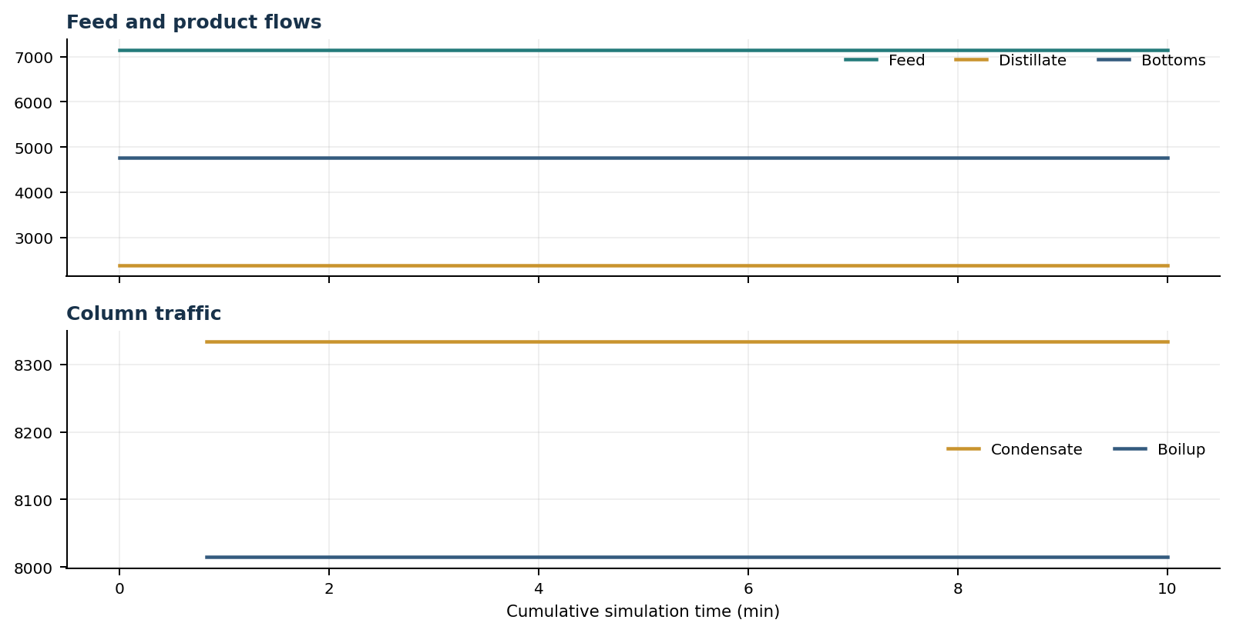
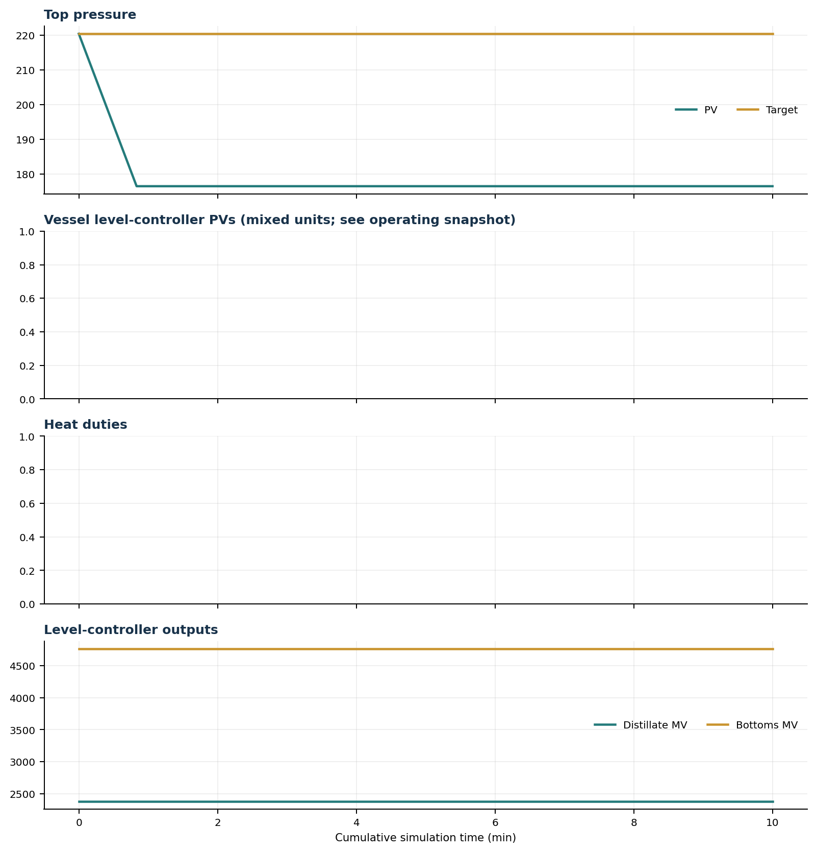

Final Tray Profiles
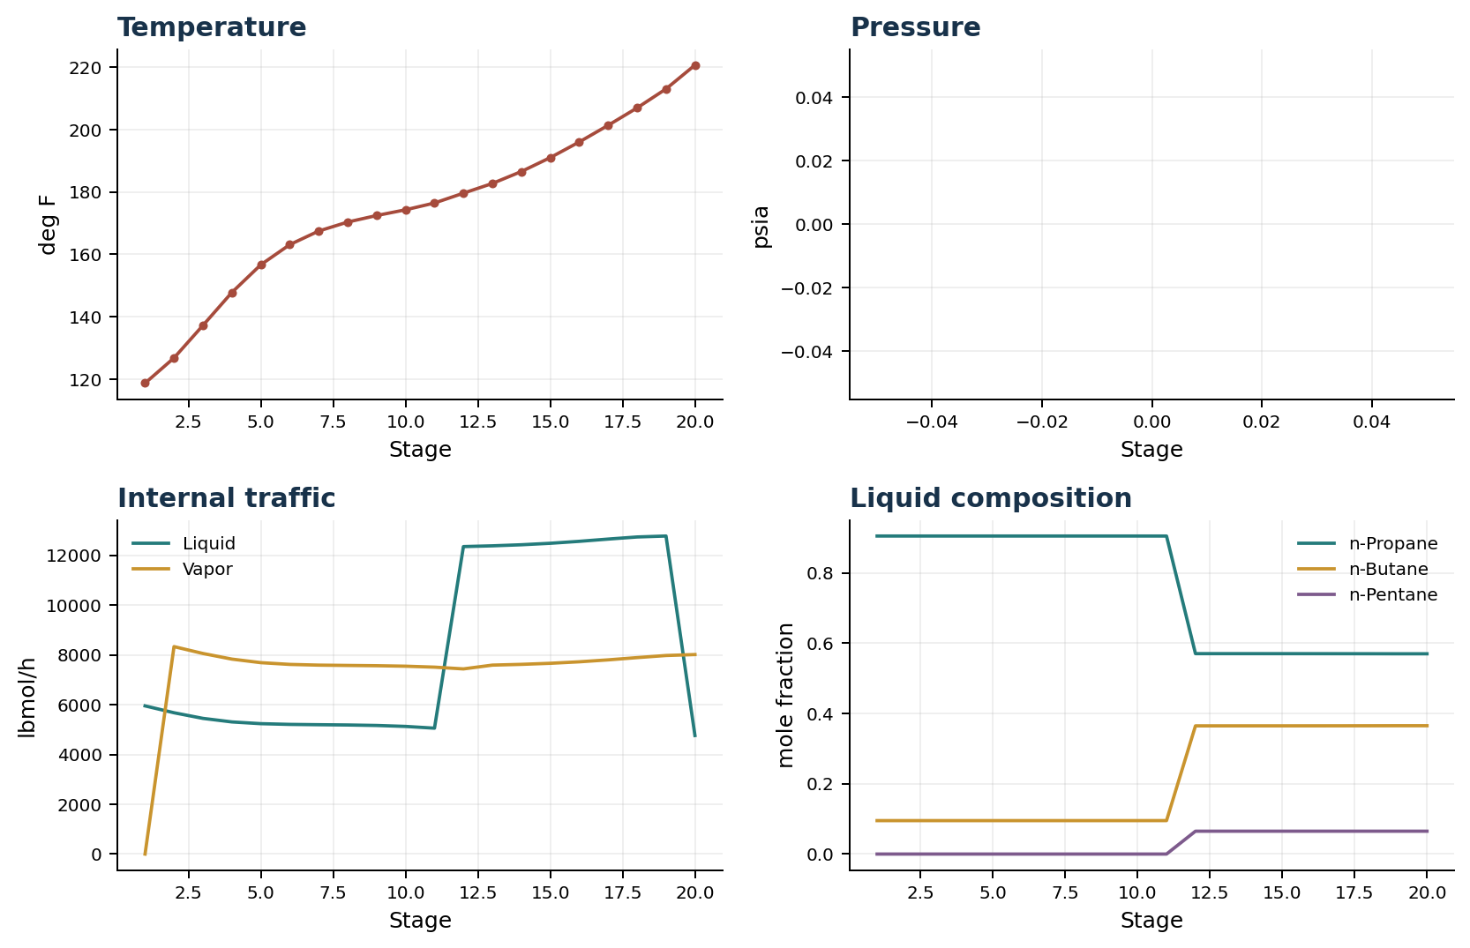

Final Tray Profile Table
Stage | T (deg F) | P (psia) | L (lbmol/h) | V (lbmol/h) | x n-Propane | x n-Butane | x n-Pentane | y n-Propane | y n-Butane | y n-Pentane
1 | 118.74 | Not reported | 5,952.5 | 0.0 | 0.9049 | 0.0951 | 0.0000 | 0.0000 | 0.0000 | 0.0000
2 | 126.82 | Not reported | 5,676.4 | 8,333.5 | 0.9049 | 0.0951 | 0.0000 | 0.9049 | 0.0951 | 0.0000
3 | 137.25 | Not reported | 5,450.6 | 8,057.4 | 0.9049 | 0.0951 | 0.0000 | 0.8295 | 0.1705 | 0.0000
4 | 147.81 | Not reported | 5,308.1 | 7,831.6 | 0.9049 | 0.0951 | 0.0000 | 0.7441 | 0.2559 | 0.0001
5 | 156.69 | Not reported | 5,237.9 | 7,689.1 | 0.9049 | 0.0951 | 0.0000 | 0.6658 | 0.3340 | 0.0002
6 | 163.13 | Not reported | 5,209.0 | 7,619.0 | 0.9049 | 0.0951 | 0.0000 | 0.6056 | 0.3940 | 0.0004
7 | 167.49 | Not reported | 5,196.3 | 7,590.0 | 0.9049 | 0.0951 | 0.0000 | 0.5646 | 0.4344 | 0.0010
8 | 170.37 | Not reported | 5,185.3 | 7,577.3 | 0.9049 | 0.0951 | 0.0000 | 0.5389 | 0.4590 | 0.0021
9 | 172.45 | Not reported | 5,166.0 | 7,566.3 | 0.9049 | 0.0951 | 0.0000 | 0.5235 | 0.4723 | 0.0042
10 | 174.29 | Not reported | 5,127.8 | 7,547.0 | 0.9048 | 0.0952 | 0.0000 | 0.5145 | 0.4771 | 0.0084
11 | 176.47 | Not reported | 5,057.1 | 7,508.8 | 0.9048 | 0.0952 | 0.0000 | 0.5092 | 0.4744 | 0.0164
12 | 179.62 | Not reported | 12,352.5 | 7,438.1 | 0.5702 | 0.3647 | 0.0651 | 0.5060 | 0.4629 | 0.0311
13 | 182.73 | Not reported | 12,382.7 | 7,590.5 | 0.5702 | 0.3647 | 0.0651 | 0.4751 | 0.4924 | 0.0325
14 | 186.55 | Not reported | 12,425.5 | 7,620.7 | 0.5702 | 0.3648 | 0.0651 | 0.4358 | 0.5300 | 0.0343
15 | 191.01 | Not reported | 12,485.2 | 7,663.5 | 0.5702 | 0.3648 | 0.0651 | 0.3878 | 0.5757 | 0.0365
16 | 196.02 | Not reported | 12,563.2 | 7,723.2 | 0.5701 | 0.3648 | 0.0651 | 0.3322 | 0.6286 | 0.0392
17 | 201.36 | Not reported | 12,653.8 | 7,801.2 | 0.5700 | 0.3649 | 0.0651 | 0.2716 | 0.6855 | 0.0429
18 | 206.94 | Not reported | 12,738.5 | 7,891.9 | 0.5700 | 0.3650 | 0.0651 | 0.2096 | 0.7415 | 0.0489
19 | 213.03 | Not reported | 12,776.5 | 7,976.5 | 0.5698 | 0.3651 | 0.0651 | 0.1498 | 0.7888 | 0.0614
20 | 220.66 | Not reported | 4,761.9 | 8,014.6 | 0.5698 | 0.3651 | 0.0651 | 0.5698 | 0.3651 | 0.0651

Simulation Configuration
Parameter | Value
Runtime Mode | parity
Thermo Mode | clapeyron
N Steps | 3000
Dt Sec | 0.2

