DYNAMIC DISTILLATION / COMPLETED RUN

core_v3_kc3m_compkc30k_feedT_plus5F_complete600s
Final 239.5 seconds completing 600-second dual-retuned plus-5F model-robustness trajectory with composition logged and no undeclared product gate
RUN VALIDITY  USABLE | DYNAMIC GATE  PASS | FINAL SCORE  0.955 | SIM / WALL  21.552

Run Identity
Item | Value
Run ID | 20260830_204510
Started | 2026-08-30 20:45:10
Completed | 2026-08-30 20:55:11
Run type | Fresh start
Input workbook | C:\Users\Thomas Zvolensky\Documents\Python Scripts\Dynamic_DistillationII\distillation_column_template_20stage_chemsep_warmer_feed_seed_20260323.xlsx
Input checkpoint | None
Summary data | C:\Users\Thomas Zvolensky\Documents\Python Scripts\Dynamic_DistillationII\logs\core_v3_kc3m_compkc30k_feedT_plus5F_complete600s_20260830\column_summary_20260830_204510.csv
Tray-profile data | C:\Users\Thomas Zvolensky\Documents\Python Scripts\Dynamic_DistillationII\logs\core_v3_kc3m_compkc30k_feedT_plus5F_complete600s_20260830\column_profile_20260830_204510.csv

Operating Snapshot
Parameter | Start | End | Units
Feed | Not reported | Not reported | lbmol/h
Distillate | 2,557.36 | 2,617.94 | lbmol/h
Bottoms | 4,377.41 | 4,469.73 | lbmol/h
Reflux | Not reported | Not reported | lbmol/h
Top pressure | Not reported | Not reported | psia
Bottom pressure | Not reported | Not reported | psia
Distillate temperature | 120.92 | 121.01 | deg F
Bottoms temperature | 217.32 | 217.53 | deg F
Condenser duty | -52.667 | -52.501 | MMBtu/h
Reboiler duty | 54.706 | 54.706 | MMBtu/h
Distillate drum controller PV | 0.50 | 0.50 | lbmol
Bottoms sump controller PV | Not reported | Not reported | lbmol
Steady-state score | 2.9148 | 0.9554 | -

Product Composition
Component | Distillate start | Distillate end | Bottoms start | Bottoms end
n-Butane | 12.178% | 12.366% | 79.210% | 79.212%
n-Pentane | 0.004% | 0.005% | 17.315% | 17.437%
n-Propane | 87.818% | 87.630% | 3.475% | 3.351%

Dynamic Trends
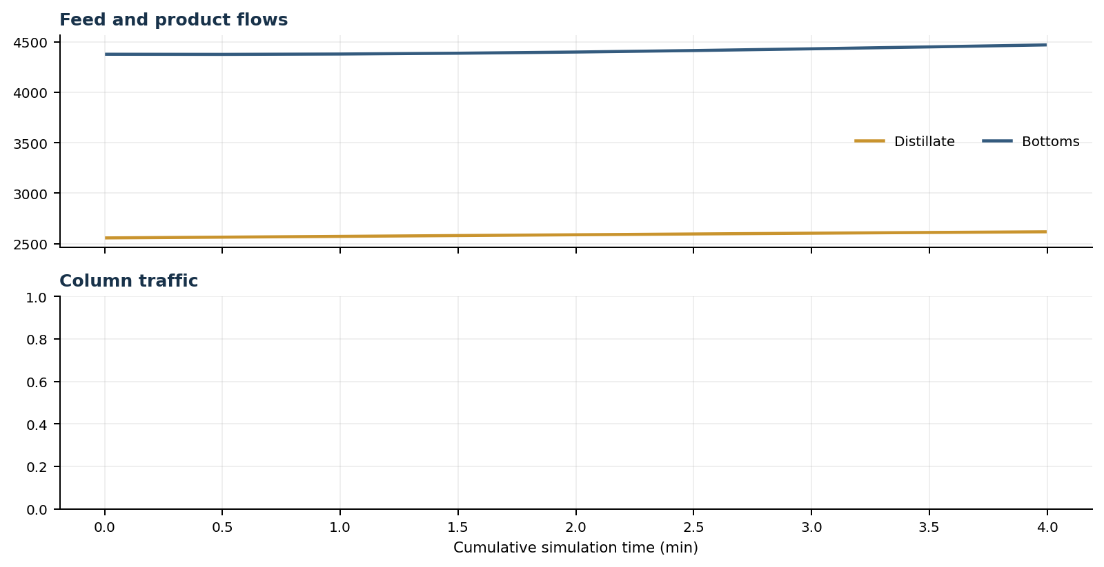
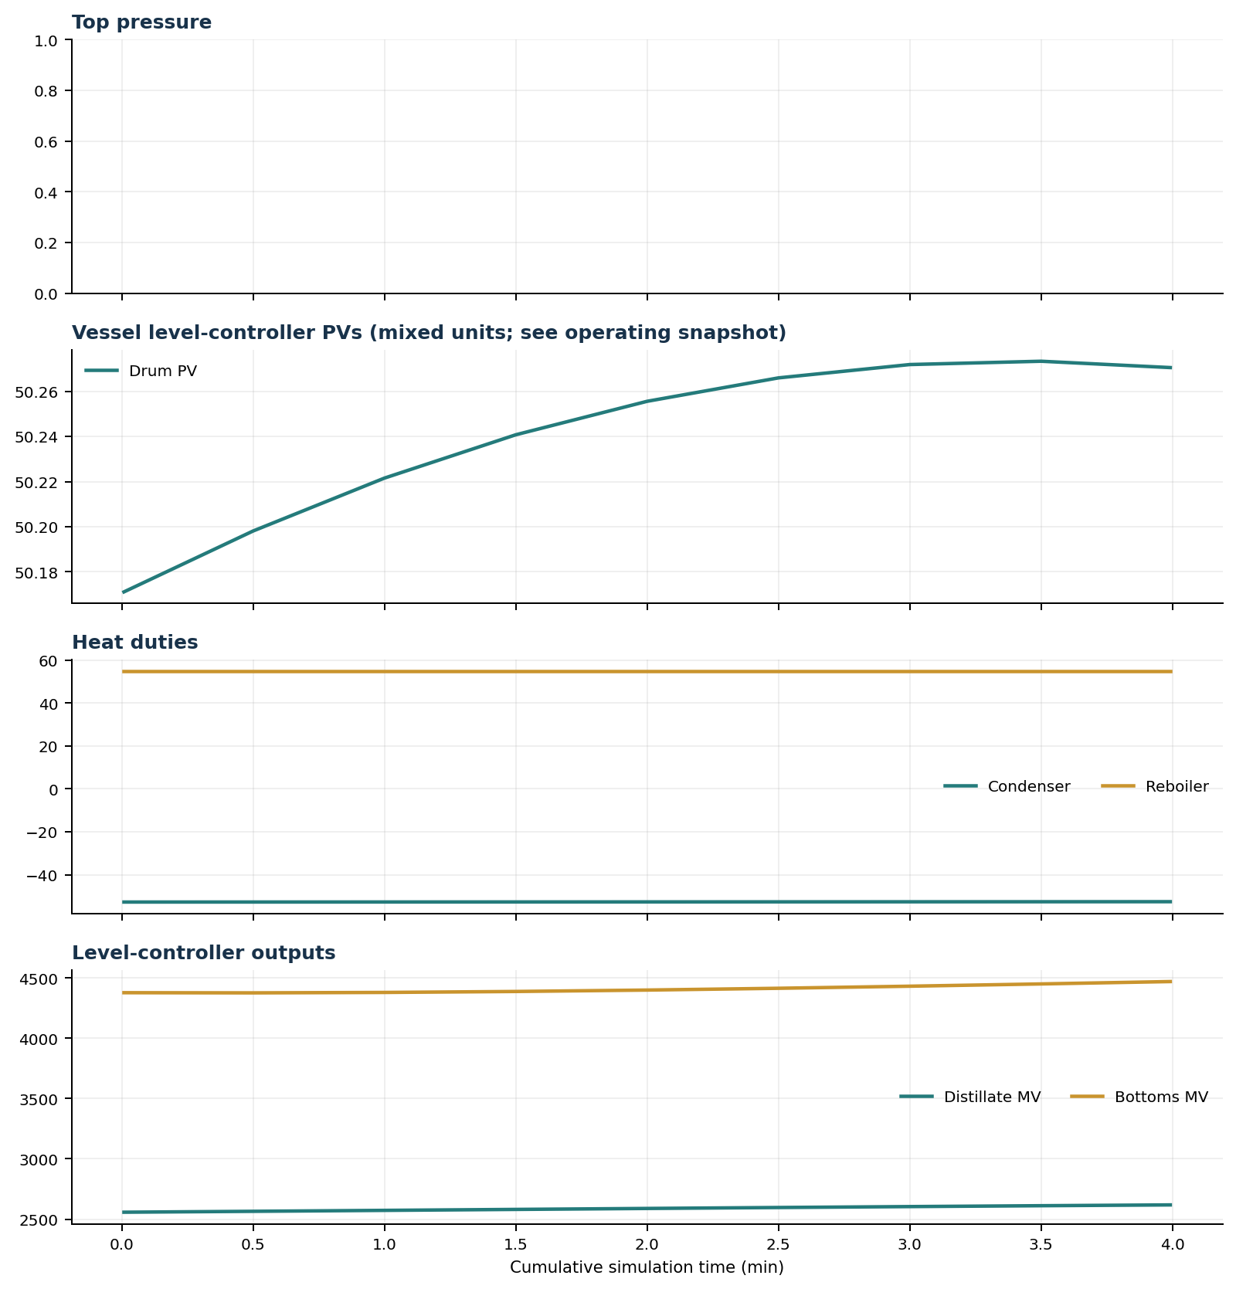

Final Tray Profiles

Final Tray Profile Table
Stage | T (deg F) | P (psia) | L (lbmol/h) | V (lbmol/h) | x n-Propane | x n-Butane | x n-Pentane | y n-Propane | y n-Butane | y n-Pentane

Simulation Configuration
Parameter | Value
N Steps | 479
Dt Sec | 0.5

