DYNAMIC DISTILLATION / CORE V3 RUN

Core V3 Water-Methanol Dual-Level Control Feed-Step Run
Classification: dual_level_control_feed_step_passed | Timestep Sec: 0.5 | Report generated: 2026-09-03 17:27:58 -0400

Run Identity
Item | Value
Status | dual_level_control_feed_step_passed
Simulation started | Not recorded
Simulation ended | Not recorded
Report generated | 2026-09-03 17:27:58 -0400
Simulated time | 600.000 s
Elapsed clock time | 6,080.654 s
Clock / simulated time | 10.134423
CLI command | "C:\Users\Thomas Zvolensky\anaconda3\python.exe" -c
Input workbook | Not reported
Source checkpoint | None

Operating Summary
CONDENSER DUTY  -364,507,510.1 BTU/h | REBOILER DUTY  370,180,573.1 BTU/h | STEADY-STATE SCORE  2.0226
Product | Flow | Temperature | Pressure | Mole fractions
Distillate | 7,966.688 lbmol/h | 148.73 F | 14.70 psia | Water=0.016373, Methanol=0.983627
Bottoms | 9,037.360 lbmol/h | 213.63 F | 17.69 psia | Water=0.975897, Methanol=0.024103
Terminal levels: distillate drum 50.250%; bottom drum 51.874%. Steady state: REVIEW.

Dynamic Trends
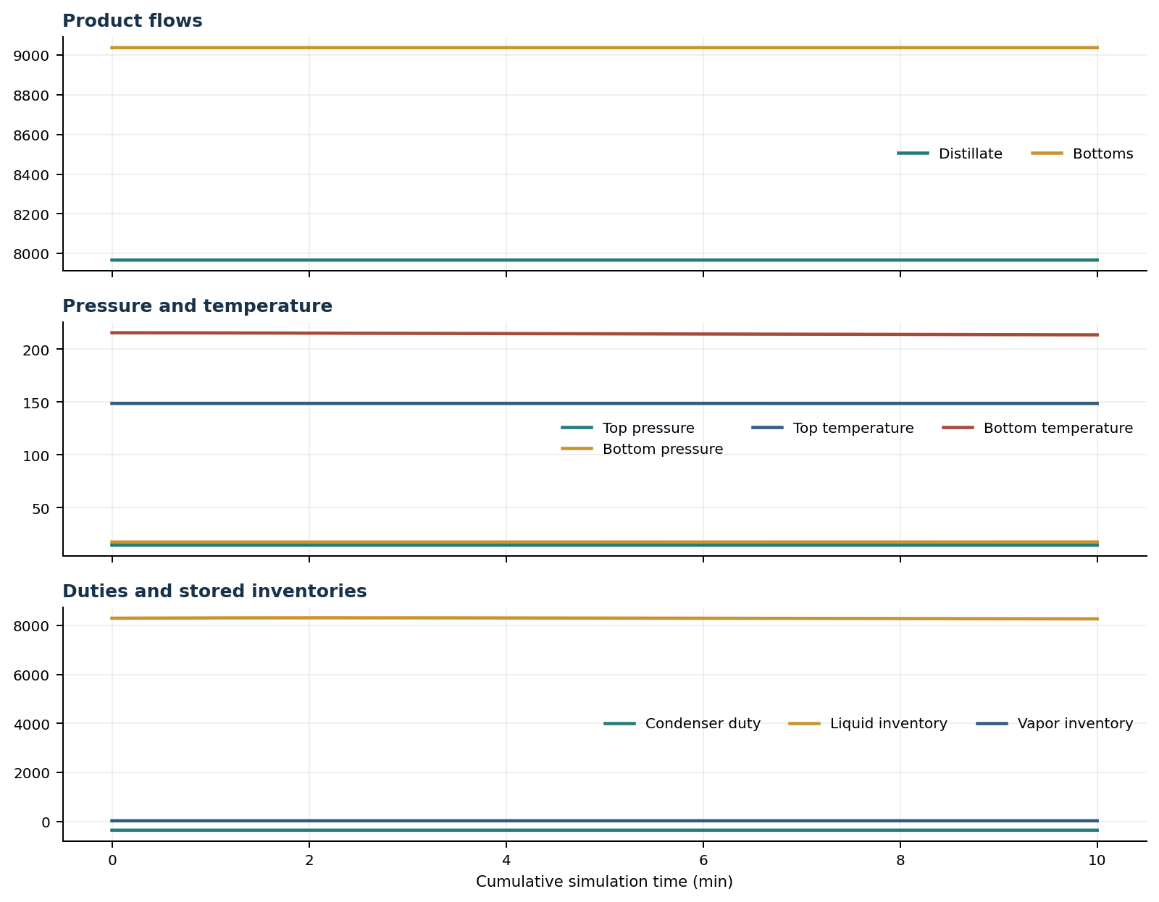

Final Volume Profiles
Volume | Type | T (F) | P (psia) | ML | MV | L out | V out | Liquid x | Vapor y
reflux_drum | reflux_drum | 148.73 | 14.70 | 3,968.10 | 6.11 | 15,873.30 | Not reported | Water=0.01637, Methanol=0.98363 | Water=0.00678, Methanol=0.99322
rectifying_volume_1 | tray | 150.58 | 15.11 | 123.58 | 1.34 | 15,827.23 | 23,830.63 | Water=0.03775, Methanol=0.96225 | Water=0.01571, Methanol=0.98429
rectifying_volume_2 | tray | 152.70 | 15.51 | 125.07 | 1.37 | 15,741.28 | 23,783.66 | Water=0.07137, Methanol=0.92863 | Water=0.02983, Methanol=0.97017
rectifying_volume_3 | tray | 155.30 | 15.89 | 127.52 | 1.40 | 15,596.70 | 23,695.66 | Water=0.12362, Methanol=0.87638 | Water=0.05190, Methanol=0.94810
rectifying_volume_4 | tray | 158.68 | 16.26 | 131.54 | 1.43 | 15,370.48 | 23,547.10 | Water=0.20345, Methanol=0.79655 | Water=0.08594, Methanol=0.91406
rectifying_volume_5 | tray | 163.29 | 16.61 | 138.18 | 1.45 | 15,044.73 | 23,313.71 | Water=0.32161, Methanol=0.67839 | Water=0.13742, Methanol=0.86258
rectifying_volume_6 | tray | 169.71 | 16.93 | 148.89 | 1.47 | 14,636.49 | 22,975.64 | Water=0.48317, Methanol=0.51683 | Water=0.21254, Methanol=0.78746
feed_tray | feed_tray | 178.24 | 17.24 | 205.93 | 1.44 | 30,698.98 | 22,548.09 | Water=0.66223, Methanol=0.33777 | Water=0.31350, Methanol=0.68650
stripping_tray | tray | 195.57 | 17.51 | 231.39 | 1.43 | 30,018.14 | 21,919.66 | Water=0.87945, Methanol=0.12055 | Water=0.54422, Methanol=0.45578
combined_reboiler_sump | reboiler_sump | 213.63 | 17.69 | 3,068.57 | 3.54 | 9,037.36 | 21,215.30 | Water=0.97590, Methanol=0.02410 | Water=0.84557, Methanol=0.15443

Simulation Configuration
Parameter | Value
Classification | dual_level_control_feed_step_passed
Timestep Sec | 0.5
Duration Completed Sec | 600.0
Duration Requested Sec | 600.0
Feed Multiplier | 1.05

Exact Launch Command
"C:\Users\Thomas Zvolensky\anaconda3\python.exe" -c

