DYNAMIC DISTILLATION / CORE V3 RUN

Core V3 Water-Methanol Validation
Classification: nominal_feed_120s_trajectory_passed | Decision: accept_120_second_nominal_feed_recovery_trajectory | Timestep Sec: 0.5

Run Identity
Item | Value
Status | nominal_feed_120s_trajectory_passed
Simulated time | 120.000 s
Input workbook | Not reported
Source checkpoint | None

Operating Summary
CONDENSER DUTY  -365,201,056.8 BTU/h | REBOILER DUTY  368,680,000.0 BTU/h | STEADY-STATE SCORE  0.0000
Product | Flow | Temperature | Pressure | Mole fractions
Distillate | 6,732.992 lbmol/h | 148.48 F | 14.70 psia | Water=0.006486, Methanol=0.993514
Bottoms | 9,140.288 lbmol/h | 206.73 F | 22.45 psia | Water=0.863536, Methanol=0.136464
Terminal levels: distillate drum 50.488%; bottom drum 58.061%. Steady state: PASS.

Dynamic Trends
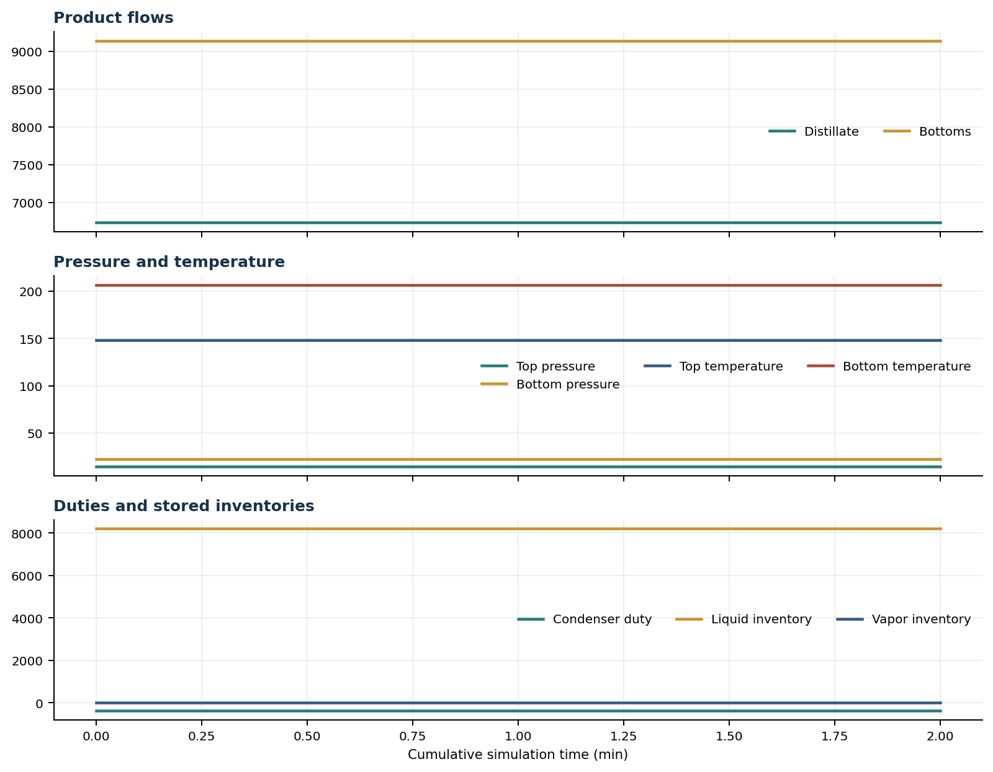

Final Volume Profiles
Volume | Type | T (F) | P (psia) | Liquid x | Vapor y
reflux_drum | reflux_drum | 148.48 | 14.70 | Water=0.00649, Methanol=0.99351 | Water=0.00262, Methanol=0.99738
rectifying_volume_1 | tray | 152.00 | 15.78 | Water=0.01585, Methanol=0.98415 | Water=0.00649, Methanol=0.99351
rectifying_volume_2 | tray | 155.36 | 16.80 | Water=0.03163, Methanol=0.96837 | Water=0.01307, Methanol=0.98693
rectifying_volume_3 | tray | 158.74 | 17.77 | Water=0.05795, Methanol=0.94205 | Water=0.02416, Methanol=0.97584
rectifying_volume_4 | tray | 162.38 | 18.69 | Water=0.10146, Methanol=0.89854 | Water=0.04265, Methanol=0.95735
rectifying_volume_5 | tray | 166.65 | 19.56 | Water=0.17256, Methanol=0.82744 | Water=0.07316, Methanol=0.92684
rectifying_volume_6 | tray | 172.12 | 20.37 | Water=0.28623, Methanol=0.71377 | Water=0.12279, Methanol=0.87721
feed_tray | feed_tray | 179.76 | 21.14 | Water=0.45685, Methanol=0.54315 | Water=0.20147, Methanol=0.79853
stripping_tray | tray | 188.32 | 21.87 | Water=0.62235, Methanol=0.37765 | Water=0.29081, Methanol=0.70919
combined_reboiler_sump | reboiler_sump | 206.73 | 22.45 | Water=0.86354, Methanol=0.13646 | Water=0.52025, Methanol=0.47975

