DYNAMIC DISTILLATION / CORE V3 RUN

Core V3 Water-Methanol 120-second Run
Classification: nominal_feed_120s_trajectory_passed | Decision: accept_120_second_nominal_feed_recovery_trajectory | Timestep Sec: 0.5

Run Identity
Item | Value
Status | nominal_feed_120s_trajectory_passed
Simulated time | 120.000 s
Input workbook | Not reported
Source checkpoint | None

Operating Summary
CONDENSER DUTY  -365,201,056.8 BTU/h | REBOILER DUTY  368,680,000.0 BTU/h | STEADY-STATE SCORE  0.0000
Product | Flow | Temperature | Pressure | Mole fractions
Distillate | 6,732.992 lbmol/h | 148.48 F | 14.70 psia | Water=0.006486, Methanol=0.993514
Bottoms | 9,140.288 lbmol/h | 206.73 F | 22.45 psia | Water=0.863536, Methanol=0.136464
Terminal levels: distillate drum 50.488%; bottom drum 58.061%. Steady state: PASS.

Dynamic Trends
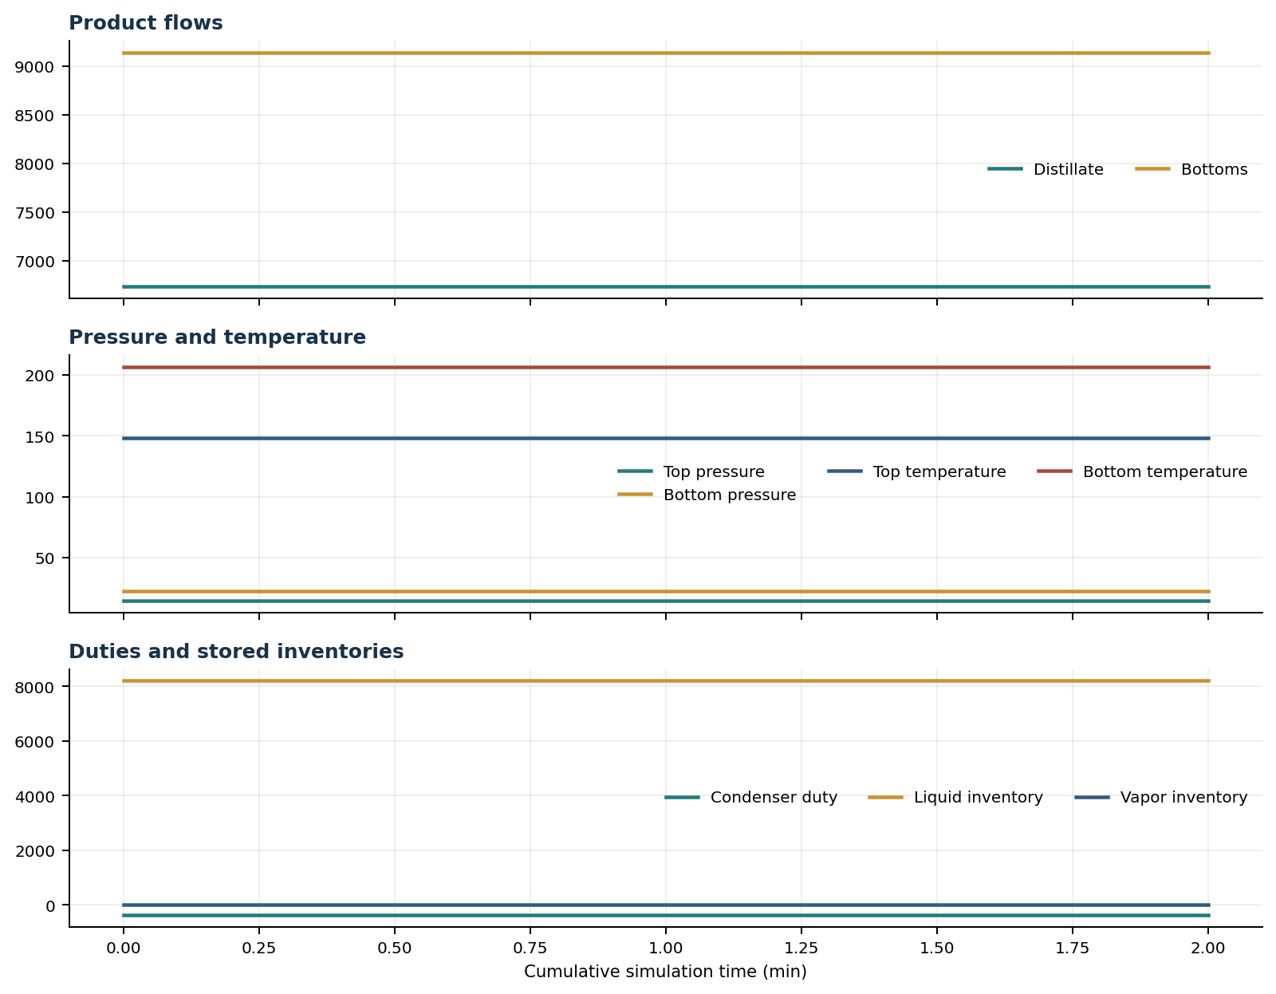

Final Volume Profiles
Volume | Type | T (F) | P (psia) | ML | MV | L out | V out | Liquid x | Vapor y
reflux_drum | reflux_drum | 148.48 | 14.70 | 3,968.32 | 6.07 | 15,873.30 | Not reported | Water=0.00649, Methanol=0.99351 | Water=0.00262, Methanol=0.99738
rectifying_volume_1 | tray | 152.00 | 15.78 | 122.49 | 1.40 | 15,913.78 | 22,606.29 | Water=0.01585, Methanol=0.98415 | Water=0.00649, Methanol=0.99351
rectifying_volume_2 | tray | 155.36 | 16.80 | 123.14 | 1.48 | 15,933.06 | 22,646.77 | Water=0.03163, Methanol=0.96837 | Water=0.01307, Methanol=0.98693
rectifying_volume_3 | tray | 158.74 | 17.77 | 124.31 | 1.56 | 15,922.13 | 22,666.05 | Water=0.05795, Methanol=0.94205 | Water=0.02416, Methanol=0.97584
rectifying_volume_4 | tray | 162.38 | 18.69 | 126.36 | 1.63 | 15,864.97 | 22,655.12 | Water=0.10146, Methanol=0.89854 | Water=0.04265, Methanol=0.95735
rectifying_volume_5 | tray | 166.65 | 19.56 | 129.95 | 1.70 | 15,734.66 | 22,597.96 | Water=0.17256, Methanol=0.82744 | Water=0.07316, Methanol=0.92684
rectifying_volume_6 | tray | 172.12 | 20.37 | 136.24 | 1.76 | 15,489.05 | 22,467.65 | Water=0.28623, Methanol=0.71377 | Water=0.12279, Methanol=0.87721
feed_tray | feed_tray | 179.76 | 21.14 | 186.75 | 1.75 | 31,527.96 | 22,222.04 | Water=0.45685, Methanol=0.54315 | Water=0.20147, Methanol=0.79853
stripping_tray | tray | 188.32 | 21.87 | 200.67 | 1.80 | 30,730.53 | 22,387.67 | Water=0.62235, Methanol=0.37765 | Water=0.29081, Methanol=0.70919
combined_reboiler_sump | reboiler_sump | 206.73 | 22.45 | 3,081.52 | 4.18 | 9,140.29 | 21,590.24 | Water=0.86354, Methanol=0.13646 | Water=0.52025, Methanol=0.47975

Simulation Configuration
Parameter | Value
Classification | nominal_feed_120s_trajectory_passed
Decision | accept_120_second_nominal_feed_recovery_trajectory
Timestep Sec | 0.5
Duration Completed Sec | 120.0
Duration Requested Sec | 120.0
Feed Multiplier | 1.0
Provider | {'history': {'provider_identity': 'dwsim', 'interface_provider_identities': {'declared_liquid_density': 'clapeyron_vtpr'}, 'total_calls': 80, 'violations': [], 'fallback_attempted': False, 'pass': True, 'grouped_record_summary': [{'provider_interface': 'clapeyron_vtpr.declared_liquid_density', 'evaluation_kind': 'residual', 'quantity': 'liquid_density', 'group_count': 20, 'call_count': 20}, {'provider_interface': 'dwsim.declared_phase_enthalpy', 'evaluation_kind': 'residual', 'quantity': 'phase_enthalpy', 'group_count': 20, 'call_count': 40}, {'provider_interface': 'dwsim.declared_vapor_compressibility_factor', 'evaluation_kind': 'residual', 'quantity': 'vapor_compressibility_factor', 'group_count': 20, 'call_count': 20}]}, 'total_calls': 2271300, 'all_step_reports_pass': True, 'pass_gate': True, 'end_of_run_summary': {'provider_identity': 'dwsim', 'interface_provider_identities': {'declared_liquid_density': 'clapeyron_vtpr'}, 'total_calls': 40, 'violations': [], 'fallback_attempted': False, 'pass': True, 'grouped_record_summary': [{'provider_interface': 'clapeyron_vtpr.declared_liquid_density', 'evaluation_kind': 'residual', 'quantity': 'liquid_density', 'group_count': 10, 'call_count': 10}, {'provider_interface': 'dwsim.declared_phase_enthalpy', 'evaluation_kind': 'residual', 'quantity': 'phase_enthalpy', 'group_count': 10, 'call_count': 20}, {'provider_interface': 'dwsim.declared_vapor_compressibility_factor', 'evaluation_kind': 'residual', 'quantity': 'vapor_compressibility_factor', 'group_count': 10, 'call_count': 10}]}}

