DYNAMIC DISTILLATION / COMPLETED RUN

ui_restart_test
Simulation operating report
RUN VALIDITY  REVIEW | DYNAMIC GATE  NOT PASSED | FINAL SCORE  164.422 | SIM / WALL  0.796
AUTOMATED ASSESSMENT The dynamic acceptance gate did not pass (final score 164.422). The final tray snapshot reports 14 failed thermo flashes; interpret operating results as invalid until the thermo path is restored. Top pressure is 110.22 psi from its logged target, so the rate gate does not establish acceptable pressure control. At least one geometry-based vessel level remains more than five percentage points from setpoint. The bottom level loop reported molar holdup rather than a geometry-based level fraction.

Run Identity
Item | Value
Run ID | 20260820_203305
Started | 2026-08-20 20:33:05
Completed | 2026-08-20 20:33:43
Run type | Continuation from native checkpoint
Input workbook | C:\Users\Thomas Zvolensky\Documents\Python Scripts\Dynamic_DistillationII\distillation_column_template_20stage_chemsep_warmer_feed_seed_20260323.xlsx
Input checkpoint | C:\Users\Thomas Zvolensky\Documents\Python Scripts\Dynamic_DistillationII\logs\c3c4_10s_restart_runtime_memory_20260706\c3c4_initializer_profile_coeff_trial1_20260601__checkpoint_20260706_134127.npz
Summary data | C:\Users\Thomas Zvolensky\Documents\Python Scripts\Dynamic_DistillationII\logs\ui_runs\20260820_203210_ui-restart-test\column_summary_20260820_203305.csv
Tray-profile data | C:\Users\Thomas Zvolensky\Documents\Python Scripts\Dynamic_DistillationII\logs\ui_runs\20260820_203210_ui-restart-test\column_profile_20260820_203305.csv

Operating Snapshot
Parameter | Start | End | Units
Feed | 7,142.98 | 7,142.98 | lbmol/h
Distillate | 2,380.99 | 2,186.10 | lbmol/h
Bottoms | 4,761.98 | 4,761.98 | lbmol/h
Reflux | Not reported | 2,000.00 | lbmol/h
Top pressure | 220.440 | 110.220 | psia
Bottom pressure | 316.632 | 156.637 | psia
Distillate temperature | 113.43 | -74.78 | deg F
Bottoms temperature | 220.53 | 220.47 | deg F
Condenser duty | Not reported | -49.640 | MMBtu/h
Reboiler duty | Not reported | 54.706 | MMBtu/h
Distillate drum level | Not reported | 41.31 | %
Bottoms sump controller PV | Not reported | 794.13 | lbmol
Steady-state score | Not reported | 164.4219 | -

Product Composition
Component | Distillate start | Distillate end | Bottoms start | Bottoms end
n-Butane | 10.145% | 10.734% | 78.150% | 77.920%
n-Pentane | 0.001% | 0.005% | 15.916% | 15.689%
n-Propane | 89.854% | 89.261% | 5.934% | 6.391%
source | Not reported | Not reported | Not reported | Not reported

Dynamic Trends
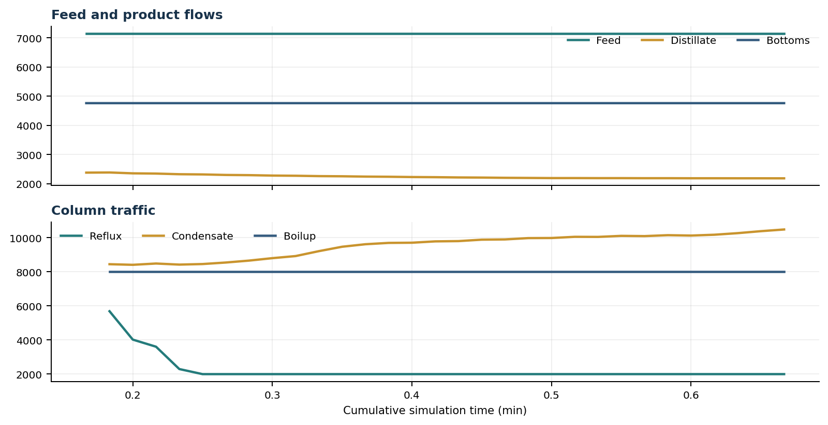
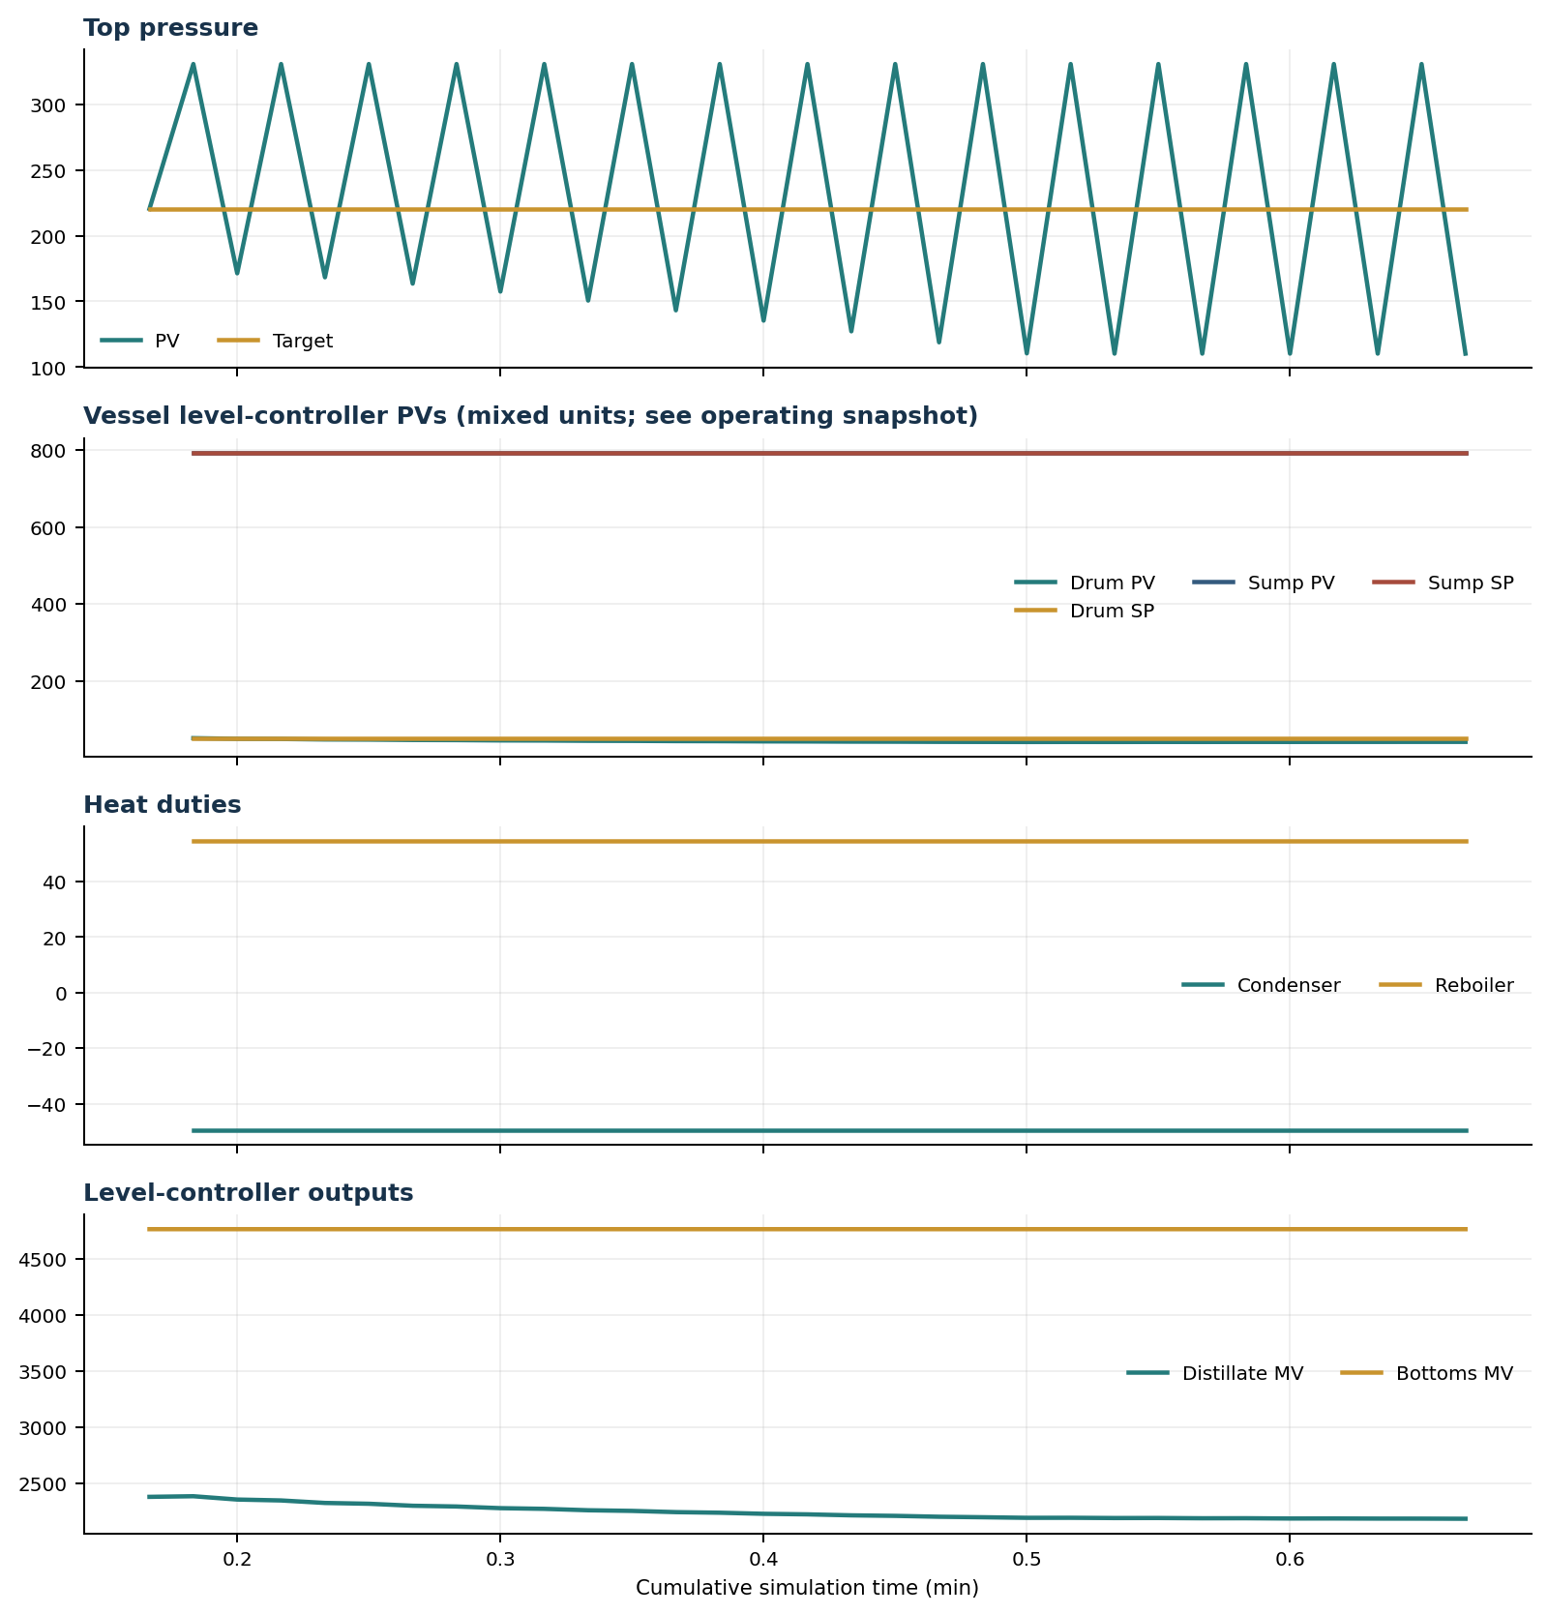

Final Tray Profiles
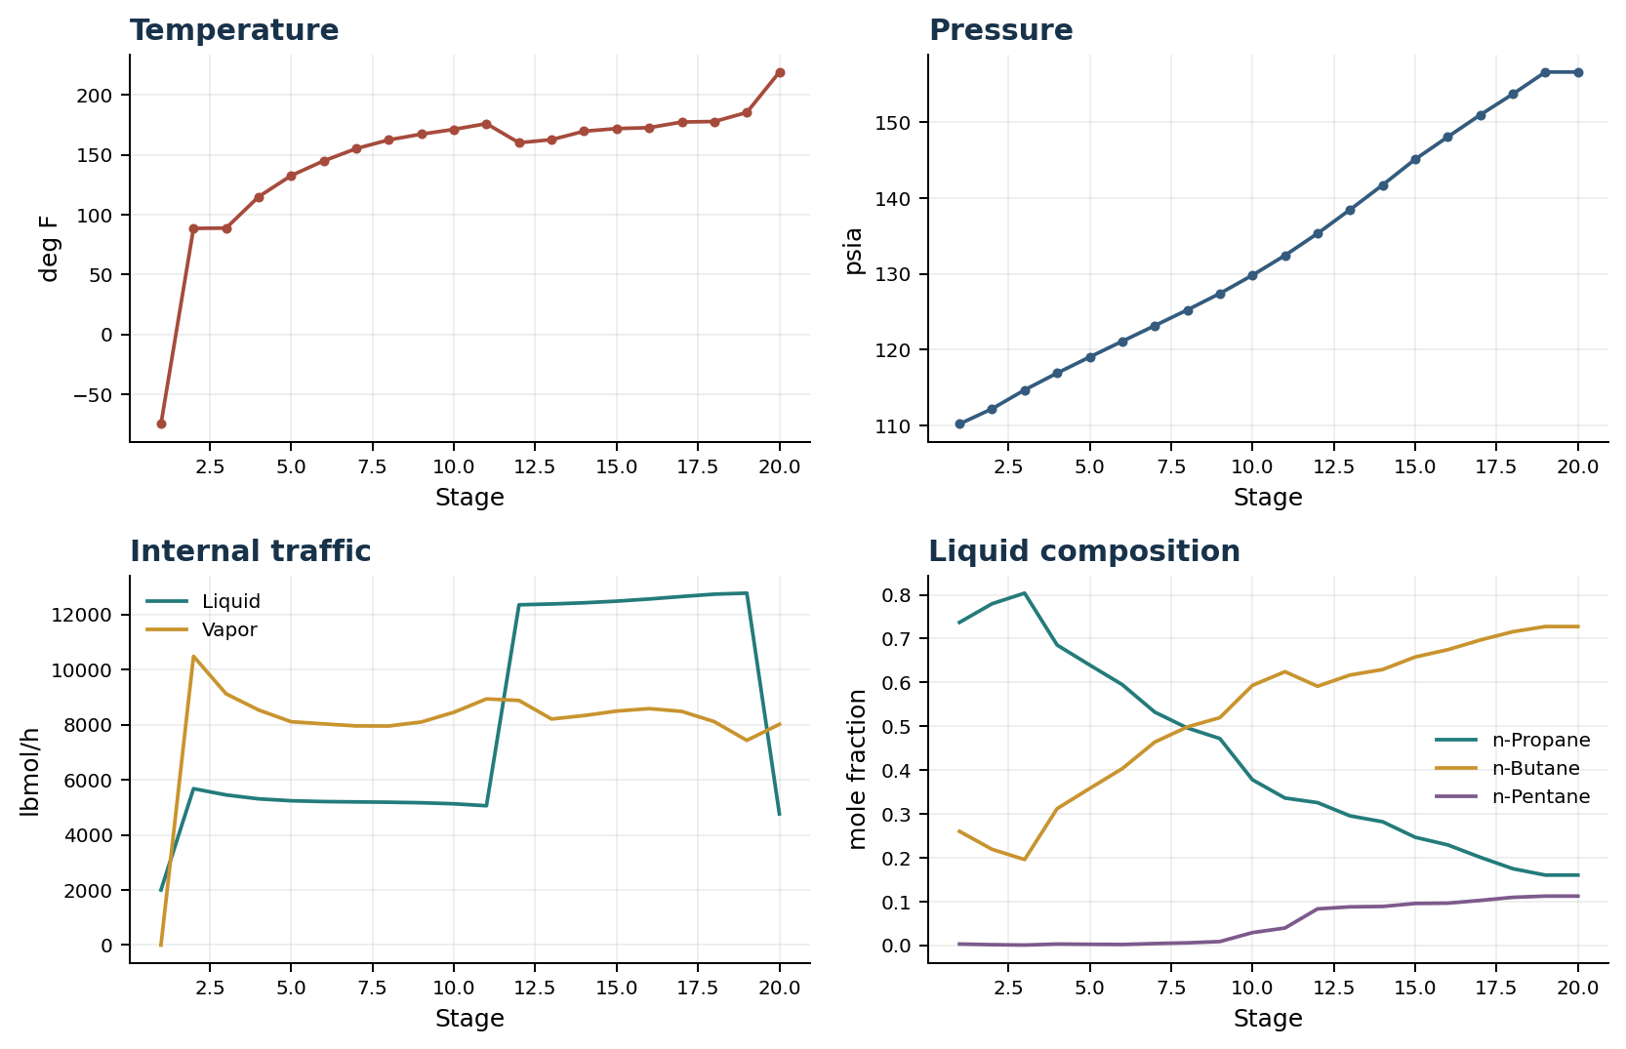

Final Tray Profile Table
Stage | T (deg F) | P (psia) | L (lbmol/h) | V (lbmol/h) | x n-Propane | x n-Butane | x n-Pentane | y n-Propane | y n-Butane | y n-Pentane
1 | -74.78 | 110.220 | 2,000.0 | 0.0 | 0.7371 | 0.2601 | 0.0029 | 0.0000 | 0.0000 | 0.0000
2 | 88.61 | 112.220 | 5,676.4 | 10,484.7 | 0.7795 | 0.2191 | 0.0014 | 0.7371 | 0.2601 | 0.0029
3 | 88.85 | 114.705 | 5,450.6 | 9,122.3 | 0.8038 | 0.1956 | 0.0005 | 0.6527 | 0.3399 | 0.0074
4 | 115.05 | 116.929 | 5,308.1 | 8,533.4 | 0.6852 | 0.3119 | 0.0028 | 0.6331 | 0.3566 | 0.0103
5 | 132.71 | 119.052 | 5,237.9 | 8,107.8 | 0.6398 | 0.3580 | 0.0023 | 0.5551 | 0.4301 | 0.0147
6 | 145.03 | 121.125 | 5,209.0 | 8,029.2 | 0.5950 | 0.4032 | 0.0018 | 0.5120 | 0.4689 | 0.0191
7 | 155.27 | 123.188 | 5,196.3 | 7,955.3 | 0.5322 | 0.4639 | 0.0039 | 0.5040 | 0.4745 | 0.0215
8 | 162.57 | 125.266 | 5,185.3 | 7,952.7 | 0.4960 | 0.4984 | 0.0056 | 0.4785 | 0.4955 | 0.0260
9 | 167.32 | 127.431 | 5,166.0 | 8,097.9 | 0.4719 | 0.5196 | 0.0085 | 0.4431 | 0.5234 | 0.0336
10 | 171.32 | 129.838 | 5,127.8 | 8,451.2 | 0.3778 | 0.5932 | 0.0289 | 0.3775 | 0.5739 | 0.0486
11 | 176.10 | 132.453 | 5,057.1 | 8,935.0 | 0.3361 | 0.6245 | 0.0394 | 0.3013 | 0.6326 | 0.0661
12 | 160.17 | 135.346 | 12,352.5 | 8,880.1 | 0.3256 | 0.5912 | 0.0831 | 0.2810 | 0.6467 | 0.0722
13 | 162.71 | 138.491 | 12,382.7 | 8,205.8 | 0.2954 | 0.6169 | 0.0877 | 0.2724 | 0.6525 | 0.0751
14 | 169.78 | 141.740 | 12,425.5 | 8,331.8 | 0.2820 | 0.6294 | 0.0886 | 0.2319 | 0.6835 | 0.0846
15 | 171.98 | 145.132 | 12,485.2 | 8,495.1 | 0.2466 | 0.6580 | 0.0954 | 0.2224 | 0.6901 | 0.0874
16 | 172.74 | 148.081 | 12,563.2 | 8,583.3 | 0.2292 | 0.6746 | 0.0962 | 0.1777 | 0.7216 | 0.1007
17 | 177.46 | 150.989 | 12,653.8 | 8,483.0 | 0.2009 | 0.6967 | 0.1024 | 0.1779 | 0.7211 | 0.1010
18 | 177.86 | 153.737 | 12,738.5 | 8,110.5 | 0.1748 | 0.7157 | 0.1095 | 0.1755 | 0.7219 | 0.1026
19 | 185.46 | 156.637 | 12,776.5 | 7,431.0 | 0.1602 | 0.7275 | 0.1122 | 0.1634 | 0.7273 | 0.1093
20 | 219.21 | 156.637 | 4,761.9 | 8,014.6 | 0.1602 | 0.7275 | 0.1122 | 0.1602 | 0.7275 | 0.1122

Simulation Configuration
Parameter | Value
Runtime Mode | hydraulic
Thermo Mode | clapeyron
Dwsim Property Package | pr
Integrator | explicit-euler
N Steps | 150
Dt Sec | 0.2
Log Every N Steps | 5
Thermo Every N Steps | 1
Include Energy | True
Enable Equilibrium Relaxation | True
Equilibrium Relaxation Mode | auto
Enable Level Control | False
Top Level Pv Mode | molar-holdup
Bottom Level Pv Mode | molar-holdup
Enable Pressure Control | False
Pressure Control Mv | auto
Condenser Duty Mode | total-condense
Vapor Flow Zero Temperature Target | False
Steady State Window Sec | 30.0
Steady State Min Time Sec | 60.0
Steady State Rel State Rate Tol Per S | 0.003
Steady State Temp Rate Tol F Per S | 0.15
Steady State Sp Error Tol | 0.02
Steady State Require Sp | False

Exact Launch Command
"C:\Users\Thomas Zvolensky\anaconda3\python.exe" -m dynamic_distillation.dynamic_run_scaffold_v1 --excel "C:\Users\Thomas Zvolensky\Documents\Python Scripts\Dynamic_DistillationII\distillation_column_template_20stage_chemsep_warmer_feed_seed_20260323.xlsx" --runtime-mode hydraulic --thermo clapeyron --include-energy --n-steps 150 --dt 0.2 --log-every 5 --run-name ui_restart_test --init-from-checkpoint "C:\Users\Thomas Zvolensky\Documents\Python Scripts\Dynamic_DistillationII\logs\c3c4_10s_restart_runtime_memory_20260706\c3c4_initializer_profile_coeff_trial1_20260601__checkpoint_20260706_134127.npz" --logs-dir "C:\Users\Thomas Zvolensky\Documents\Python Scripts\Dynamic_DistillationII\logs\ui_runs\20260820_203210_ui-restart-test" --allow-repeat-command

