

Extended techniques on the saxophone; how to deal with them and the science behind

Jurij Bregar
Koninklijk Conservatorium Brussel
Erasmushogeschool Brussel

A thesis submitted for the degree of
Master in Saxophone
Brussels, April 2024

Acknowledgment
I would like to thank my professor Simon Diricq for the years I spent under his guidance. Helping me discover the possibilities of the saxophone and being patient and understandable during our time together.
A big thank you also to my supervisor Kurt Bertels who helped me to write this master thesis. All of your advice and kindness is really appreciated.
A special Thank you goes to my parents Marta and Zvonko and my siblings Anja, Petra and Ivan Vid. Without your support I would have never been able to experience what I have. The time spent in Brussels will stay with me for the rest of my life. Thank you for making it possible.

Table of Contents

Chapter One: Introduction 4
Research Question and motivation 4
State of the Art 6
Methodology 8
Step 1: Gathering sources 8
Step 2: Interview, survey or experiment 8
Step 3: Personal artistic experiments 8
Chapter two: Explanation of Extended Techniques 8
Extended techniques in “L’air d’ailleurs - Bicinium” 9
Colour / timbre trills or bisbigliando 10
Various effects 11
Extended techniques in “Saxophonequartett” 13
Quarter tones, Sixth tones and Twelfth tones 13
Harmonic Multiphones / Multiphones 17
Extended techniques in “Babioles” 19
Slap 19
Subtone / Niente 21
Flutter tonguing 22
Extended techniques in “L’eveil de la toupie” 23
Altissimo register 23
Double tonguing 24
Glissando 25
Bibliography 26

Chapter One: Introduction

Research Question and motivation
In my master's thesis I will talk about the extended techniques of the saxophone and my experience with them in the pieces I play for my master recital. I chose this topic because, in the past few years, I have started to play pieces that require the performer to play an instrument in a special way. It often requires a lot of effort before a performer can comfortably perform a section of extended techniques. This leads me to the following main research question:
How can I as a saxophonist practice extended techniques?
This question can be further subdivided in two subquestions:
- Which extended techniques do I have to use in the pieces I play, what are they in the first place and how do you play them?
- What are some of the approaches in working on extended techniques and how do they compare to mine?
The answer to these questions would not only help other inspiring musicians but would also be a great way to see how I deal with those problems myself. Where am I losing time and what could I have done to master a certain technique faster and better. To understand myself better and to try to explain things I take for granted.
For my master recital I have made a selection of compositions which can help me find an answer to my artistic research questions. This selection will be the following:
- The piece that I would play first on my recital would be by Fabien Levy and it is called “L'air d'ailleurs – Bicinium". It is a solo piece with electronics where you have to not only play your saxophone but also be in charge of a reverb pedal and have to move closer and further away from the microphone. I think it would serve as a great example of extended techniques as it is required to play double tunging, slaps, glissandos, quartertones, and many more on the saxophone.
- The second piece that I would play is a piece by Georg Friedrich Haas called “Saxophonquartett”. It is a piece for a saxophone quartet, and it shows extended techniques like quartertones, sixthtones, twelvetones and harmonic multiphones. It is not so often that we see the use of these kind of extended techniques. Moreover, it would be great to show my chamber music skills in a piece like this and prove that I can play also tenor saxophone.
- The third piece in my master recital would be a solo piece by Marc Monnet called “Babioles”. It is a twelve-minute piece divided into six smaller movements each one showing one of the characteristics of a circus man. It is quite a taxing piece to perform due to its very clear writings that demand the performer to be precise in his playing, especially in the dynamics. Besides that, it also includes extended techniques like slap, glissando, and quartertones.
- The last piece would serve as a kind of mix of all the extended techniques. It is written for alto saxophone and piano and it is called “L'eveil de la Toupie” by Vincent David. It includes almost all of the extended techniques mentioned in the pieces before with an emphasis on the altissimo register and would therefore be great to conclude my master exam.

State of the Art
To formulate an answer to my research question I have gather various kind of sources such as books, articles and recordings. Firstly, I found a doctoral essay from Matthew Jeffery Taylor [2012] on teaching extended techniques on the saxophone. It offers a great understanding of not only learning extended techniques but also trying to teach them to other people and the best ways to do that. Another doctoral essay as an example could be from Iain Harrison [2012]. This source is full of useful information about extended techniques and their use in actual concrete pieces of the saxophone repertoire. However, my research will focus on different pieces, so it would be interesting to see the same extended techniques used in another way. Besides that, I will try to show you my side of the extended techniques and my way of working on them.
Various books on extended techniques could help me answer the question. One of them is from a legendary saxophonist Jean-Marie Londex [1989] and it is called "Hello Mr. Sax ou parametres du saxophone". In it, he talks about the parameters of saxophone and its possible uses in the saxophone repertoire. Another book that is very well-known in the saxophone community is by Daniel Kienzy [2003] called "Les Sons Multiples aux Saxophones". It offers almost all of the saxophone multiphones on all four saxophones and is a great resource for studying them. Another book worth checking out would is by Larry Teal [1963] called "The Art of Saxophone Playing". It was revolutionary for its time placing a big emphasis on the embouchure (since it was still heavily influenced by the clarinet) and developing the subtone technique. The book is in many ways regarded as the start of the American school of saxophone playing. Similar to the book of Lary Teal is a book by John Harle [2017] called "The Saxophone". It offers an in-depth reference on playing the saxophone in this modern era. It explores various techniques with illuminating illustrations and new perspectives on embouchure, tone production, and other extended techniques. I have to also mention a book written by a great saxophone teacher in Lyon, Jean-Denis Michat [2010], called "Contemporary Saxophone". A great book about not only extended techniques but also posture, tone quality, timbre, performance, and all sorts of various things.
Let us not forget about several videos that would help us in our quest for extended techniques on the saxophone. One great series of videos about the extended techniques was made by Joshua Hyde [2020]. The series is called "Composer Resources" and consists of twenty-one videos where he explains all of the possible effects on the saxophone. It is not only a great resource for composers who want to get to know the saxophone better but also for saxophone players who would like to understand the effects better. Another great video series is by Grace Kelly and Leo P, also known as "2SAXY" [2024] called "Saxophone & Performance Masterclass" where they talk about improvisation, altissimo register, bending the tone, vibrato, and many more extended techniques. This video series reminds us that one can use extended techniques also in jazz improvisation. One of the many video series that I found interesting is by Sean Hurlburt [2020] and it is called "Saxophone Altissimo". It takes a deeper look into alto saxophone altissimo and the origin of the fingerings. Sean also has some other playlists on his channel that explore some of the other saxophone techniques.
One of the people who could help me immensely in my research is my teacher, Simon Diricq [2020]. His knowledge of extended techniques and general saxophone knowledge is very large. He is aware of unusual fingerings and methods that are not very well known. He could help me deepen my knowledge about the saxophone. Another person who would be able to offer a different perspective on extended techniques is Vincent David [2020]. As a professor of saxophone with more than twenty- five years of experience and as one of the innovators in contemporary saxophone am sure have a huge insight into the world of extended techniques.
My research contributes to the existing materials in a way, that would put them through a test. That way I can share my experience with them and write if I found them helpful or not. Try to find out a better way of practicing extended techniques or show a new, unconventional way of practicing them.

Methodology
The methodology of this research will consist of the following steps:

Step 1: Gathering sources
Firstly, I have to gather all the crucial sources mentioned in State of the art. Sort out the ones that do not apply in my research and focus more on the ones that do. Try and read as many articles as possible, books, doctoral essays and video and audio recordings. Anything that might help me in my research.

Step 2: Interview, survey or experiment
Sources like an interview, survey or an experiment are a great way to gather unique material. They are great, because you can make the parameters as you see fit and does not require to adjust yourself for the data. In an interview I would be able to ask some very specific questions that would help me the most instead trying to get something for everybody. The same goes for the survey and the experiment. Just the possibility to have something tailored for your research is very attractive.

Step 3: Personal artistic experiments
In this step I would concentrate on keeping track of my personal development on the extended techniques. How it changed over time and how I did I discover new methods of practicing. Perhaps the best way for this could be to keep a logbook of my practice routine and write down what I wanted to learn and what I achieved in a practice session. What has changed from last time and how I evolved with the piece itself.

Chapter two: Explanation of Extended Techniques
In this chapter I would like to explain the main ideas of the extended techniques in each of the four pieces that I will play for my master examination. Since there are so many in each of the pieces, I will focus only on the ones that I think are special to the piece and are not seen very often elsewhere.

Extended techniques in “L’air d’ailleurs - Bicinium”
The following is a list of all extended techniques we can find in this piece:
- Quartertones
- Key-striking with sound
- Slap
- Colour / timbre trills (Bisbigliando)
- More covered, more muted
- More open, brighter
- Close to normal tone colour
- Crescendo with “reverse sound”
- Aeolian sound
- Subtone / Niente
- Moving closer and further away from the microphone
- Breathy sound
- Glissandos
- Flutter-tonguing
- Multiphones
- Double tonguing
- Altissimo register
There are various extended techniques that are quite special in this piece, and I think would be nice to explain them in more detail.

Colour / timbre trills or bisbigliando
Bisbigliando or timbre / colour trill originates from the harp where the player needs to quickly alternate between two strings tuned to the same pitch. On the saxophone you would need to use slightly different fingerings then traditional for the same pitch in order to achieve a new tone colour as close to the original pitch. Something that would sound as the note being played normally, but with a change in timbre. The specialty of this piece is that the composer writes what kind of bisbigliando he wants - a more open one, closed one or one that is as close to the original note as possible.
Here we have a legend that explains to the performer when to play which bisbigliando:
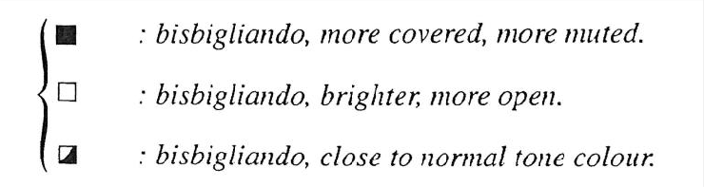
Here is an example of a bisbigliando trill in this piece. Notice how it is required that we play one Sib more open and the other one more closed that the normal Sib:
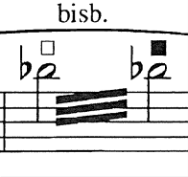
And here in this example we can clearly see all of the bisbigliando possibilities:
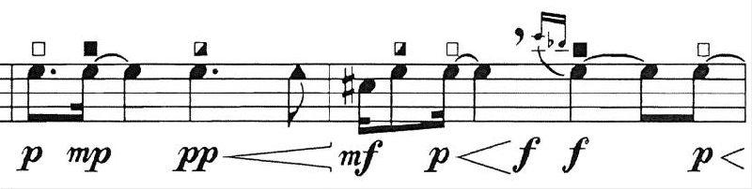

Various effects
This piece also uses a number of special effects. The first one I would like to highlight is the crescendo with “reverse sound”. In principle this sound effect could be explained by making a normal crescendo, but really pushing the sound at the end. To complete the crescendo as late as possible.
You can recognize it by two lines pointing upwards and downwards at the end of the crescendo:
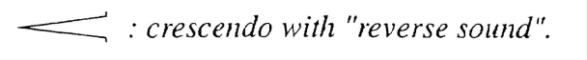
And here, we can see ”reverse sound” crescendo in action starting from mezzo-piano going to forte:
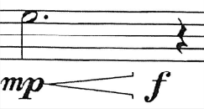
Another special sound effect is made with the help of a microphone. By pressing the pedal and playing into the microphone, you can achieve the effect of reverb on the saxophone. That is certainly not something you see in every piece with electronics, especially with pieces that do not use electronics. Besides using the pedal, you must also move closer or further away from the microphone. This helps to amplify the reverb sound.
Here we can see both of the terms explained in the legend:

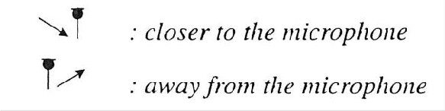
And in this example, we can see both of the techniques being used:
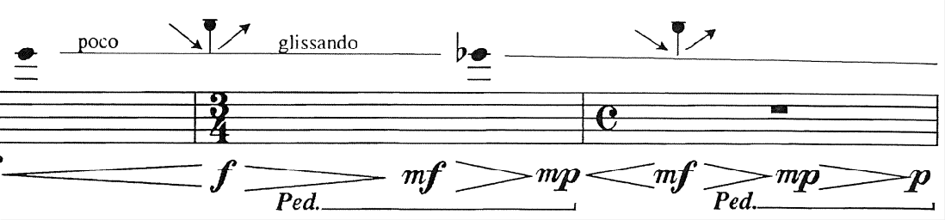
One minor extended technique that is often overlooked by its simplicity is simply blowing into the instrument without making any pitch sounds. In the legend it is written as an aeolian sound, which comes from flute techniques. It is referring to the way you blow into the flute by changing the embouchure and airflow strength. In our score it simply says blow or “Souffle” on top of the note:
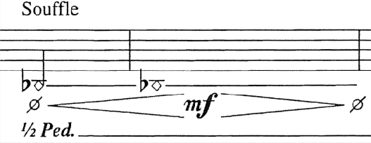
Finally, one technique that is also quite special in this piece is key striking with sound, double tonguing, flutter tonguing and blowing all together at the same time. Combining a lot of different extended techniques together leaves us with a cluster of sound that is perhaps unique to this piece:
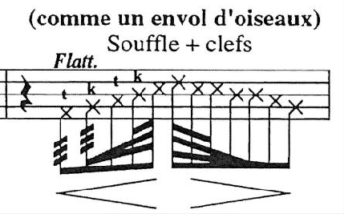

Extended techniques in “Saxophonequartett”
First let us start by listing all of the extended techniques we can find in this piece:
- Quartertones
- Sixth tones
- Twelfth tones
- Harmonic multiphones
- Subtone
- Altissimo register
There are not as many extended techniques in this piece as in previous, but they are very special nevertheless and some of them are used very rarely. Let us take a closer look.

Quarter tones, Sixth tones and Twelfth tones
The idea of a quarter tone is simple. A pitch in between a semitone. Now the sixth tones are between the quarter tone and normal tone and the twelfth tone is between a sixth tone and a normal tone. That would lead us to the conclusion that there are two extra steps in between normal pitch and a quarter tone. That means that there are twelve steps just between one whole tone!
Here are all of the quarter tone possibilities. This one explains the quarter tones:
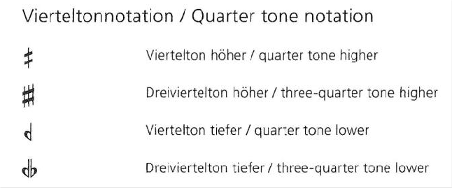
This one explains the sixth tones:
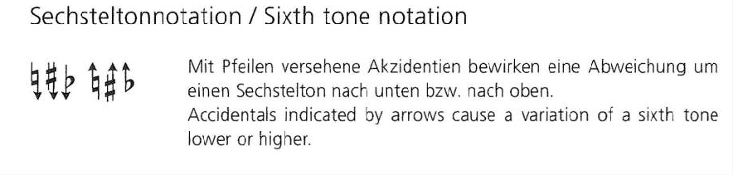
And this explains the twelve-tones:
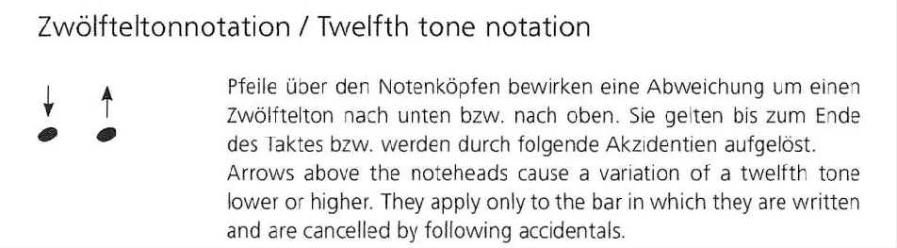
Finally, this graph explains us all of the possible combinations between the quarter tones, sixth tones and twelfth tones:
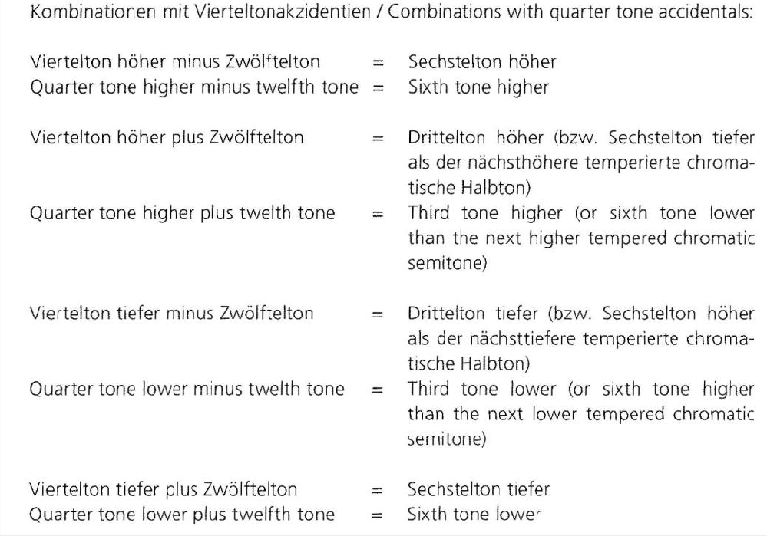
With all of this material, the composer cleverly uses is to compose a piece full of dissonance and tension. One example of the use of all of the micro tones are in the beginning of the piece where he effectively writes out a glissando using previously mentioned techniques.
In this example we can see that we start on Si and are then taken through the twelve steps to Do#:
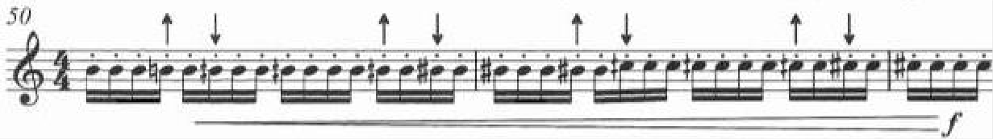
There are also other instances where the composer uses these techniques. One good example could be found here in this image (the score is written in C):
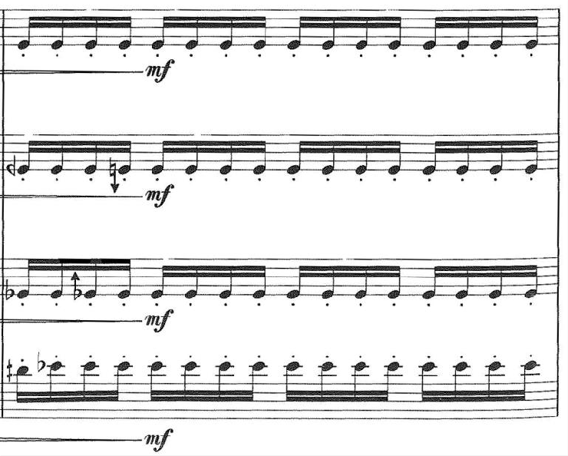
Notice how there is a cluster of notes in between MIb and Mi♮? The Baritone plays a MIb, the tenor plays Mib with a twelve tone higher, the alto plays Mi ♮ with a twelve tone lower and the soprano plays Mi ♮. This kind of chord creates a special kind of cluster that is quite uncommon.
There comes a point in the piece, where we can see two groups, divided on soprano and alto (group one) and tenor and baritone (group two) that start to play quartertones while being a quartertone apart and being an octave and fourth apart. This creates a very special line of melody and tension that I think is very unique:

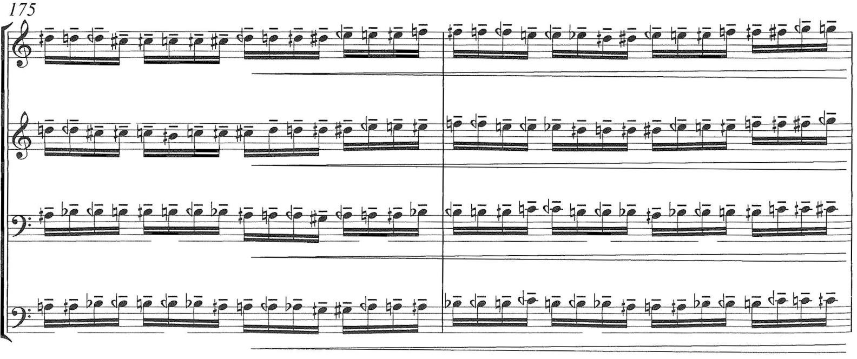Harmonic Multiphones / Multiphones
When we are talking about multiphones we often think about an ugly sound that often includes quartertones and is difficult to produce on the saxophone. Usually with a not so comfortable fingering. However, this is not the case here. The composer cleverly takes advantage of the saxophones ability to play harmonics. In this case not just one but multiple at the same time, in order to create this colour template of the saxophone. It is also very cleverly used as a kind of bass where the other three voices support it.
Here is an example of how the harmonic multiphone looks like in the first place:
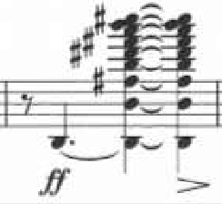
And in this example, we can see how the composer makes use of this harmonic multiphone by putting notes from the multiphone in other voices so that they become more apparent:
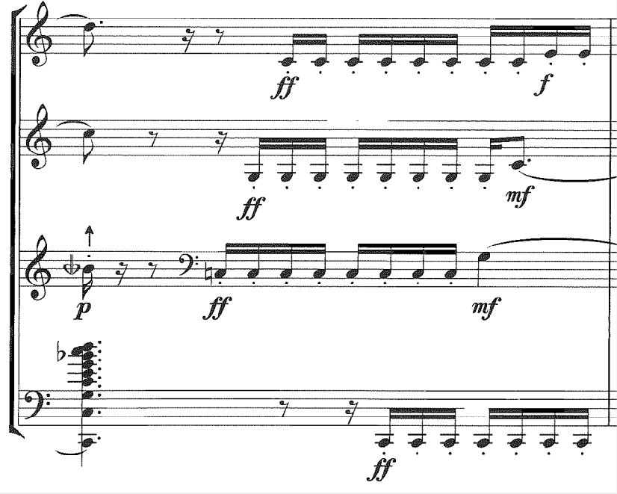
Of course, this kind of harmonic multiphones are not very common. Usually, multiphones come with their own set of fingerings. Some are easier to play than others. In most cases the multiphone is based on a fundamental pitch in the multiphone on which all of the other harmonics are based on. Let us not forget that it is often required to change our embouchure position, our air direction and air strength in order to achieve the required multiphone.
As you can see in this example from Fabien Levy’s L’air d’ailleurs, there are fingerings written on top of the multiphones. In some cases, multiple fingerings are possible, we can also notice which will most likely be our fundamental note. On the third beat in the bar, we should hear a smallp portato glissando from FA-to-FA:
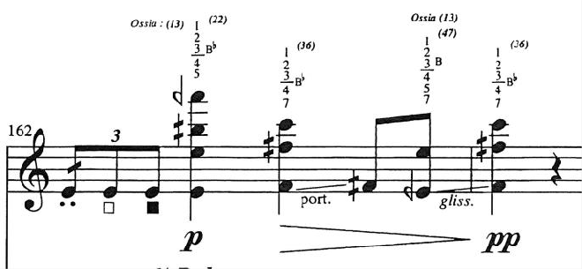
Quite often we have to start with a normal note which then morphs into a multiphone. This is exactly what is happening in this example. The REb becomes the fundamental of the multiphone. In these cases, it is useful to make some of the fingering already on the note before the multiphone so that the transition is as smooth as possible and we can avoid the noise the change of the keys makes, especially here where we have written a pianissimo:
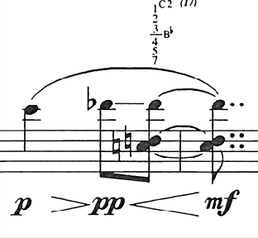

Extended techniques in “Babioles”
Like before, let us start by listing all of the extended techniques found in this piece:
- Slap
- Quarter tones
- Subtone / Niente
- Glissandos
- Flutter tonguing
- Air sound
- Circular breathing
In the next chapters I would like to take a closer look at the extended techniques that are present in this piece.

Slap
This extended technique is quite common in contemporary pieces. Perhaps because of its sound color and many possible uses. In principle it should make a slap kind of sound, similar like on the bass guitar or other wind instruments like oboe or clarinet. In order for the musician to perform slap he or she should create suction on the reed so that it is pulled away from the mouthpiece and then when the tension breaks, the reed “slaps” back against the mouthpiece. That will create a kind of sound that is similar to a very violent attack but drier and with a different sound color.
In principle we know many ways to perform slap but the main two in my opinion are open and pitched. The difference between the two is that in an open slap, we focus solely on the suction and release of the tension of the reed on to the mouthpiece. We are interested more in the percussive kind of sound. In a pitched slap, we put more emphasis on the pitch. For us to achieve that, we need to keep our embouchure in place, keep our mouth shut and add a bit of air while we release the tension of the suction on to the reed. Both have their advantages and can be used in all sorts of ways.
Not to forget that there is also dry slap, which is almost the same as the pitched slap, but the pitch is less obvious. Another technique of slap is a reverse slap, where we put the air before we create the suction and release of the tension. This creates the opposite effect as in pitched slap. Quite often we also see quasi slap in our repertoire. It is basically a mix between a normal attack and a pitched slap. A performer may also start the note with a slap and then continue playing the note. Instead of articulation the beginning of the piece normally, he or she starts with a slap and hold the note through.
In this piece however, we only use the pitched slap.
The composer uses two kinds of writings for slap. Here we can see that the head of the notes are normal but since we have slap written on top, we assume that we play slap on those notes written below for the duration of the arrow:
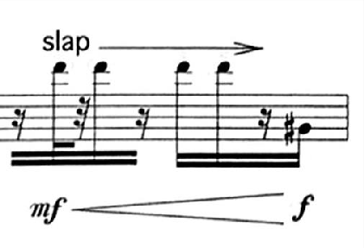
The other kind of writing for slap that the composer uses is the one where the heads of the notes are like the letter X with slap writing on top of it. Again, we assume to play slaps for the duration of the arrow and the X shaped note heads:
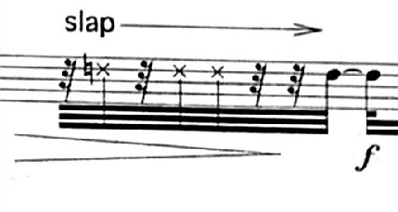Subtone / Niente
Subtone is predominately used in the low register of the saxophone due to being less effective once we start using the octave key. Its origins go back to the early jazz era of Ben Webster and his use of a very fluffy kind of subtone. While it is still used to this day, the subtone has also changed over the years, where it is now used in a somewhat different way. The idea is to get rid of all the high partials in the sound. Similar to a filter that would allow just the low-end parts of the sound instead of the rich and full sound that we normally play with. It allows the performer to play really soft dynamics in the low register with a clean sound.
With a good enough control, a performer may also be able to play niente. A technique where the sound gradually disappears into nothing or where it starts from nothing and becomes louder step by step.
There are a number of places where we could use the subtone in this piece.
First example could be found in the opening two bars of the fifth movement, where we start from pp on Do# and do a crescendo to ff. I think the optimal would be to start with a subtone and then gradually abandon it with the crescendo in order to achieve the ff. I would also play the Do# in the second bar in subtone:
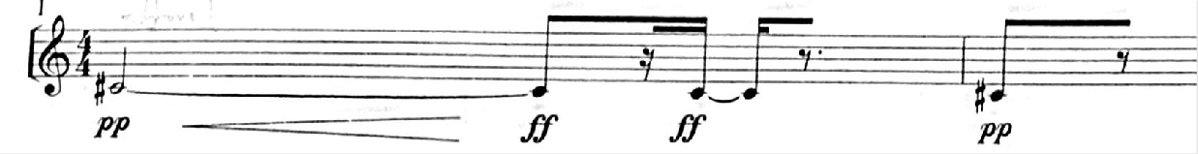
And here in this example we notice that we have to go to nothing at the end of the bar. I would start the bar playing in mezzo-forte and then gradually add the subtone where I completely disappear at the end:
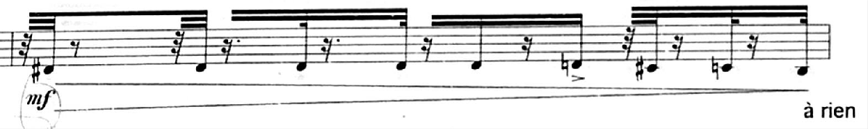

Flutter tonguing
Before moving on to the next piece I would just quickly like to mention one other extended technique and that is flutter tonguing. It is a technique where the performer flutters their tongue to create this Frrrrr kind of sound. It can also be produced by using your throat. It is quite present throughout the piece.
Here is an example of the flutter tonguing in the piece:
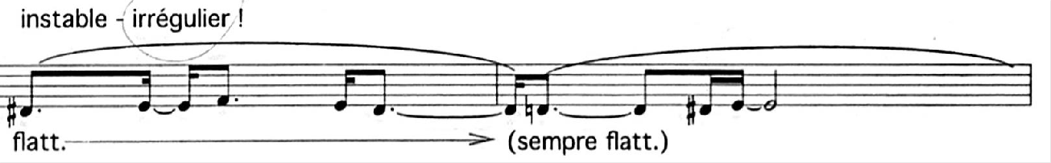

Extended techniques in “L’eveil de la toupie”
This piece includes the following extended techniques:
- Colour trills (bisbigliando)
- Quartertone trill
- Flatter tonguing
- Glissando
- Slap
- Subtone / Niente
- Double tonguing
- Altissimo register
- Air noise / breathy sound
- Multiphones
- Low La on the alto saxophone
- Use of side keys in trills or a passage
Like before, I would like to explain some of the extended techniques in more detail.

Altissimo register
Altissimo register is a register on the saxophone for which there are no specific keys, but rather a combination of them. That means that there are multiple fingerings for one note in the altissimo register. Some work better than others but there are of course endless possibilities. This piece uses quite a lot of altissimo register and in fact reaches quite high on the saxophone (Mib in the fourth octave). It is sometimes hard to find a good fingering for the altissimo register that does not disturb the equality of sound. Sometimes it is required to change the fingerings in the normal register so that the jump to the altissimo register is less evident.
One such example is found here where we have to seamlessly switch between the normal register and altissimo register:
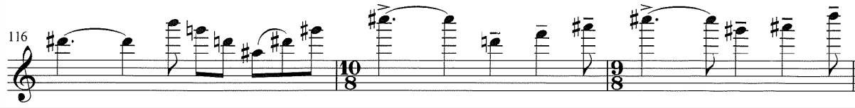

Double tonguing
This extended technique is helping the performer to play articulated fast passages that are too fast to play with normal tonguing. One can achieve double tonguing by articulating every other note with your tongue and doing all the rest with the throat. The idea is for the tongue to make a movement similar to saying the words TA–KA–TA–KA, with TA being articulated by the tongue and the KA by the throat. The vowels change depending on the context of the music. For example, in quiet dynamics the vowel may be DU-GU-DU-GU. The vowels also vary from instrument to instrument, since the angle of the mouthpiece is different on the clarinet or oboe for example. There is also a technique of triple tonguing or even quadruple tonguing. In these two techniques one plays two (or three for quadruple) times with normal a normal articulation and once with your throat. So, the tongue should be saying the vowels TA-TA-(TA)-KA. In this piece however, only double tonguing is needed.
Here is an example of a place where I would use double tonguing:
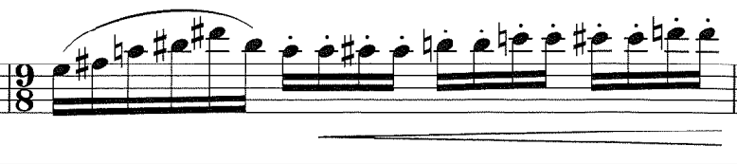
Another example of double tonguing:
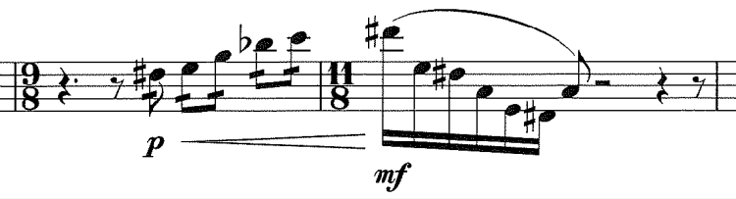

Glissando
This extended technique is probably the most fun to play out of all of them. It is quite simple to do on the saxophone and it does not take long to learn it. There are two or rather three ways one can perform a glissando. The first one is by slowly opening or closing your keys. This method works well if one has to perform a glissando to or from a neighbouring note but usually not so well if there are a couple of notes in between. For that we usually use our throat. One must just be careful to be aware where he or she should finish the glissando and to play with the right intonation in the end. However, usually both techniques are applied at the same time. It helps the glissando to be as smooth as possible.
This glissando for example, I would perform with the throat because of the range of it. On top of that the tempo is much too quick to even try to do it with your keys:
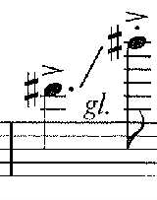
In this case however, I would simply slowly close the key with my finger since the glissando is only half note apart:
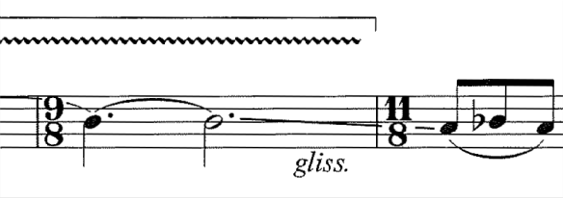

Finally, in this case I would use both of the techniques combined, since it would help the glissando to be as smooth as possible:
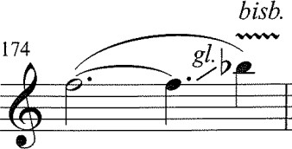

Bibliography

ARTICLES:
Harrison, Iain. 2012. “An exploration into the uses of extended techniques in works for the saxophone, and how their application may be informed by a contextual understanding of the works themselves” https://www.proquest.com/openview/5033f43d8d1bfdd565dcaed0a2ed05ab/1?pq- origsite=gscholar&cbl=18750
Taylor, Matthew Jeffery. 2012. “Teaching extended techniques on the saxophone: A comparison of methods” https://eprints.hud.ac.uk/id/eprint/18047/1/iharrisonfinalthesis.pdf

BOOKS:
Kienzy, Daniel. 2003. “Les Sons Multiples aux Saxophones” https://www.scribd.com/doc/225601518/Daniel-Kientzy-Les-Sons-Multiples-Al-Sax
Londex, Jean-Marie. 1989. “Hello Mr. Sax ou parametres du saxophone” https://www.ateliercelia.fr/londeix-jean-marie-hello-mr-sax-ou-parametres-du-saxophone-p-3-52-5101/
Michat, Jean-Denis. 2010. “Un saxophone contemporain” https://www.jdmichat.com/_files/ugd/75be97_aa0d44a7c3a1487787ebe84e3a357e7e.pdf
Harle, John. 2017. “The Saxophone” https://www.johnharle.com/the-saxophone.htm
Teal, Larry. 1963. “The Art of Saxophone Playing” https://www.scribd.com/document/227240724/larry-teal-the-art-of-saxophone-playing-pdf

VISUAL SUPPORT:
Hurlbrt, Sean. 2020. “Altissimo Saxophone” https://www.youtube.com/playlist?list=PLiOq7Zb9XQ-46FK8eOX5FKiZJk--Y9uKW
Hyde, Joshua. 2020. “Composer Resources” https://www.youtube.com/playlist?list=PL3RDBJurtd-wL-Z6GnDR0QcqCboPOHNwO
Kelly, Grace. P, Leo. 2SAXY. 2024 “Saxophone & Performance masterclass” https://www.youtube.com/playlist?list=PLi5xJKFr5vagK8-cU5PBXNWXZhujsd5EZ

PEOPLE:
David, Vincent. 2020. “Website - Vincent David” https://vincentdavid-sax.fr/en/
Diricq, Simon. 2020. “Website - Simon Diricq” https://www.simondiricq.com/

