Deployment Tools:

Argo CD | 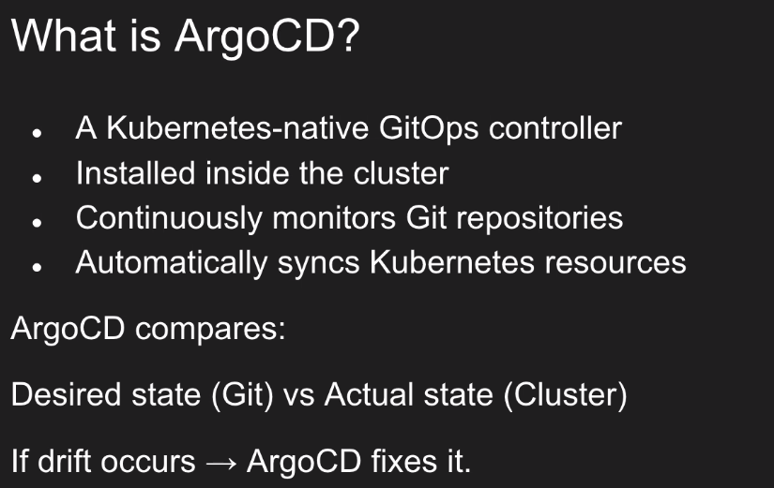 | Inside the cluster:  can do it inside the minikube  Can manage a cluster -> with a few namespaces  Can manage a few clusters  ArgoCD asks Git when a change has occured -> it will sync with
 | 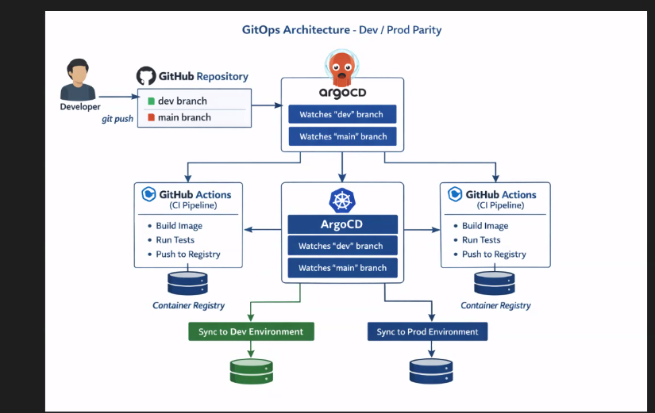
 | 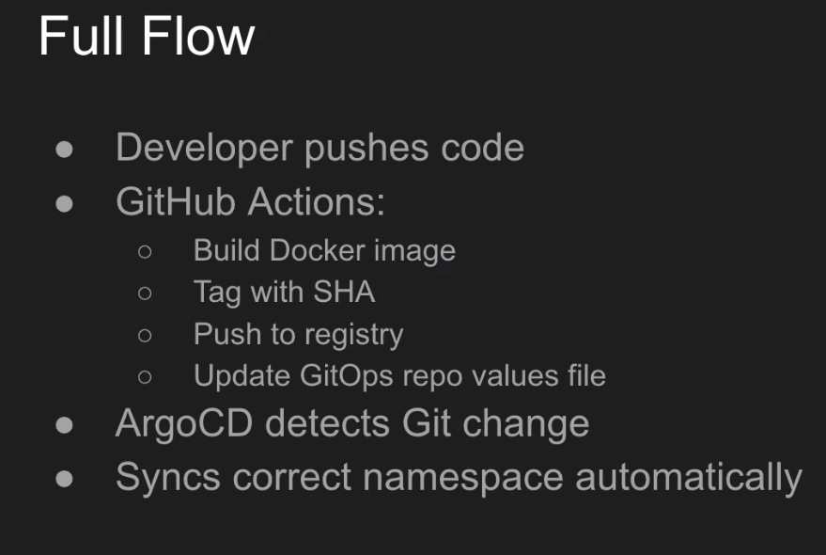 | When the ArgoCD finds that there was a change in the helm chart -> it syncs it to the relevant environment.  ArgoCD looks on the helm repo.  When there’s a change (sha), a new version (new tag)  ArgoCD takes the last change and syncs it to the relevant env. (a new deployment)
Installing ArgoCD
 | 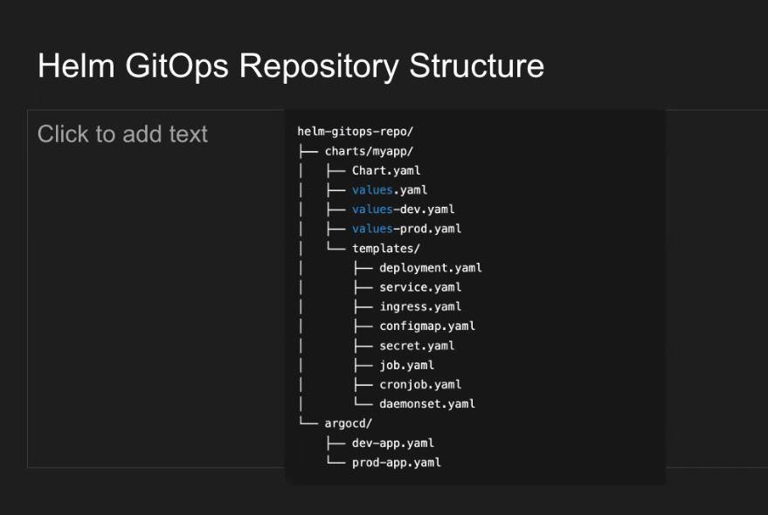
 | 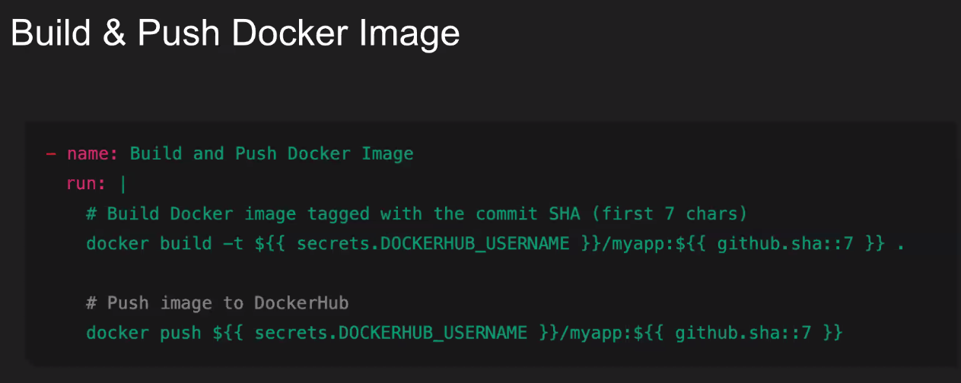
 | 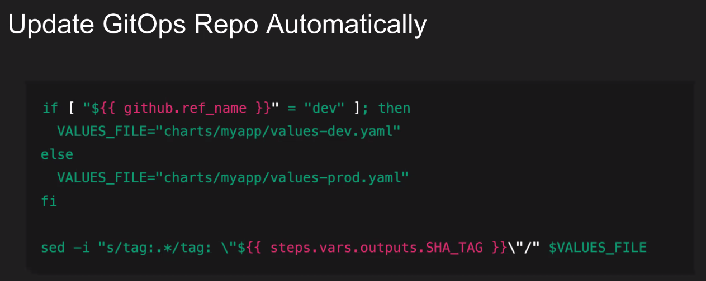
 | 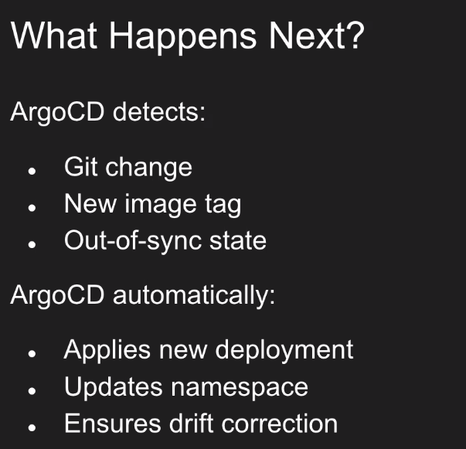
 | 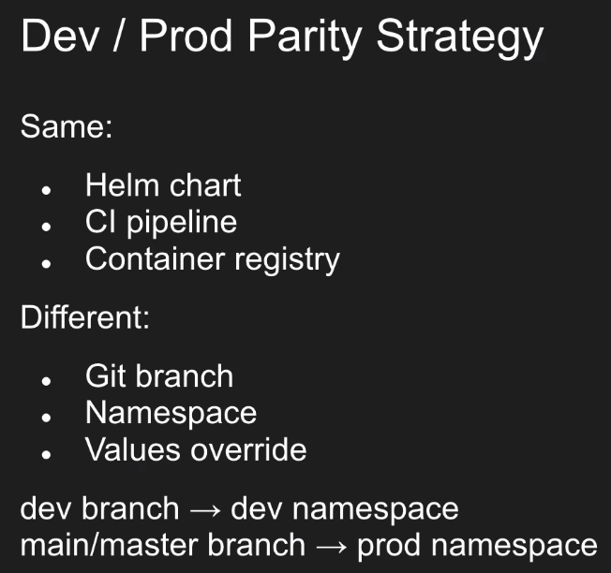
 | 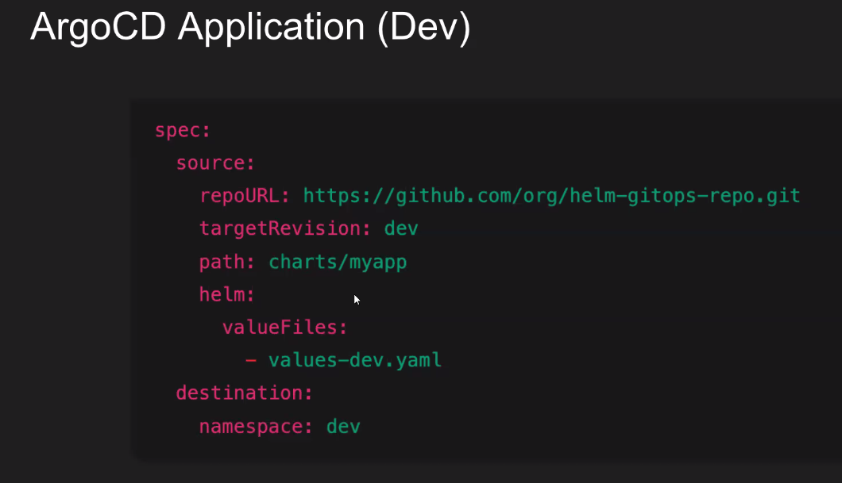
 | 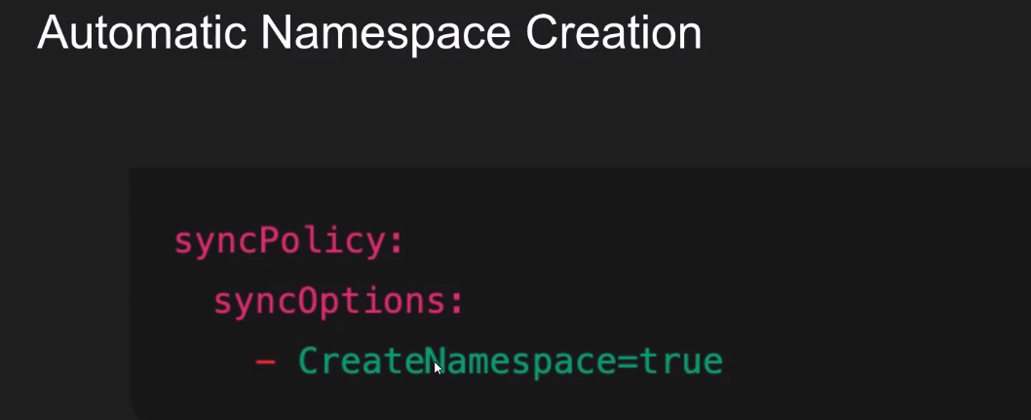 | So it will create automatically the :  destination:  namespace: <name>  if it’s false: the argocd will Fail !! if no namespace = dev (for example)

