Assignment 1

Revised 1/20/17

The end result of this assignment is to write and fully document a program that shows on the console options for the form in which people can be addressed. You will build this program in “builds” (stages), as specified below. It is designed to get you started with Python, showing how a program displays output at the console.

Each part will build mostly on the previous one. All builds should be submitted, and are weighted equally. To the extent that an assignment is completed, the grade will be “good” (B = 80-89). To the extent that it is well-organized and well-documented[1], the grade will be “excellent” (A = 90-100).

# Build #1

The specifications for this program are as follows:

*'''  
Intent[2]: Begin to provide options for the form of people to be addressed.  
  
Postcondition[3]:*

*The following is on the console (i.e., preceded by a blank line):  
  
Greetings from a beginning Python programmer.  
Do you want to be addressed as ...   
'''*

So the output to the desired program is as follows:

>>>   
 RESTART: ….py   
  
Greetings from a beginning Python programmer.  
Do you want to be addressed as ...  
>>>

Please build this program by naming a string, giving it a value, and then executing *print*() with it.

# Build #2

The specifications for this program are as follows:

*'''  
Intent: Begin to provide options for the form of one person to be addressed.  
  
Postconditions: The following are on the console (excluding the numbering):  
1.  
Greetings from a beginning Python programmer.  
2.  
Do you want to be addressed as ...  
.......................................======>Jane Margaret Doe?  
.......................................======>Jane Doe?  
.......................................======>Mr./Ms. Jane Margaret Doe?  
.......................................======>Dear Jane?  
or   
.......................................======>Doe, Jane Margaret?  
'''*

So the output to the desired program is as follows:

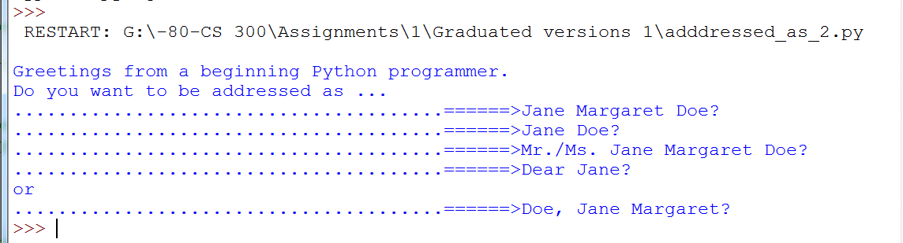

Name a string variable with value “…. . . . ==>” and re-use it rather than repeating the whole of “…. . . . ==>” in the code.

# Build 3

The specifications for this program are as follows:

*'''  
Intent: Begin to provide options for the form of one person to be addressed.  
  
Postconditions: The following are on the console (excluding the numbering):  
1.  
Greetings from a beginning Python programmer.  
2.  
Do you want to be addressed as ...  
.......................................======>Jane Margaret Doe?  
.......................................======>Jane Doe?  
.......................................======>Mr./Ms. Jane Margaret Doe?  
.......................................======>Dear Jane?  
or   
.......................................======>Doe, Jane Margaret?  
3.  
After a blank line, the same output, but applied to Archibald Montague Abercrombie  
4.  
After a blank line, the same output, but applied to Cleopatra Anastasia Montgomery  
'''*

In other words, the required output is as follows:

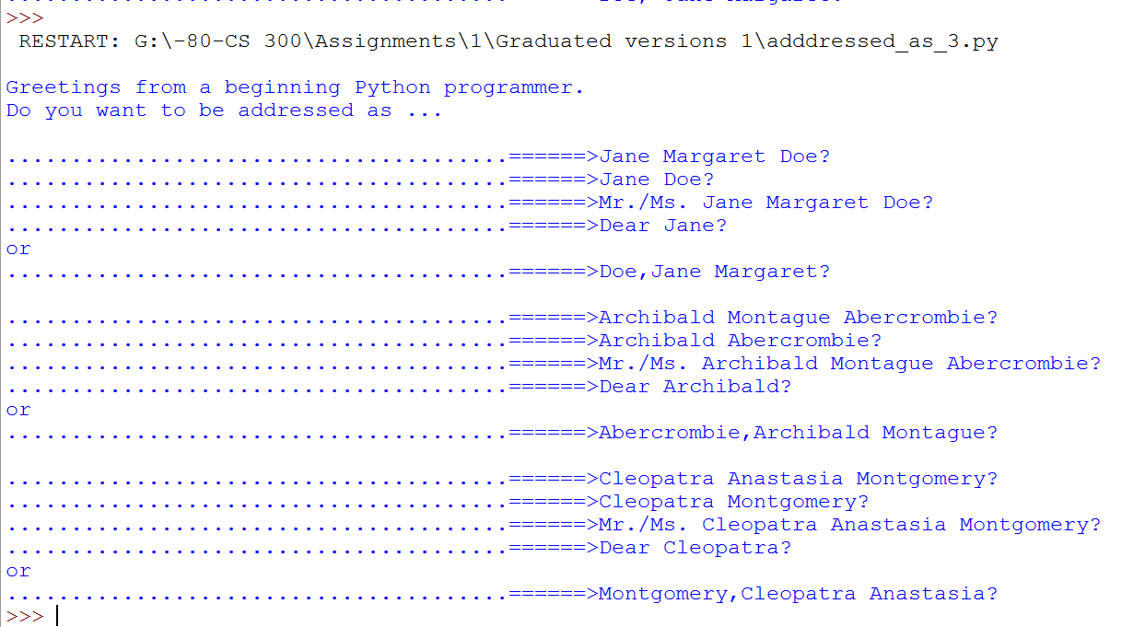

You will have to repeat code but it should be almost all identical.

# Build 4

The specifications for this program are identical to those for build 3, except that you are to use the *format*() function. As much as possible. This will require repeating code, but without the need to edit all of it each time.

1. State the required outcome(s) of each block of code—no less and no more. You can assume that your reader knows Python itself very well, so there is no need to explain elements of the language itself. The only exceptions to this are where you use Python constructs that may be obscure for your reader—which is unlikely in this course.
2. This is a brief, informal statement—typically easy to understand but not precise.
3. A precise statement of the required outcome(s)