Assignment 2

Revised 1/2/18 (removed duplicate copy of Build 2)

The end result of this assignment is to write and fully document a program that begins an online therapy session. It is designed to get you started showing how a Python program receives input, makes decisions, and displays output at the console.

Each part will build mostly on the previous one. All builds should be submitted, and are weighted equally. To the extent that an assignment is completed, the grade will be “good” (B = 80-89). To the extent that it is well-organized and well-documented[1], the grade will be “excellent” (A = 90-100).

# Build 1

Implement the following functionality:

*'''  
Eliza300: Postconditions  
1 (Welcome): A welcome message is on the console  
2 (Complaint): A complaint was entered by the user in response to a prompt  
AND Eliza has responded "I am sorry to hear you report ..."  
'''*

Here is an example of the interaction:

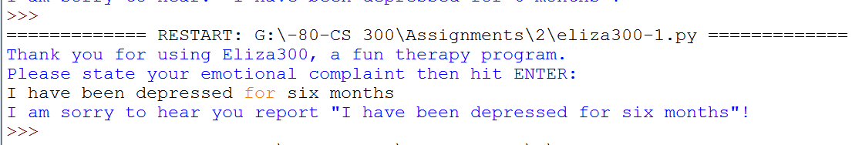

# Build 2

Implement the following requirements:

*'''  
Eliza300: Postconditions  
1. (Welcome): A welcome message is on the console  
2. (Complaint): A complaint was entered by the user in response to a prompt  
3. (Duration): A duration was entered by user in response to a prompt  
4. (Action Recommended): EITHER how long exceeds 2 months, and the phrase  
 “ … months is too much time to go without help! Let's schedule a few sessions"  
 is on the console  
 OR the following is on the console:  
 "Come back in a couple of months if this persists".  
'''*

Here is an example of an interaction with this application:

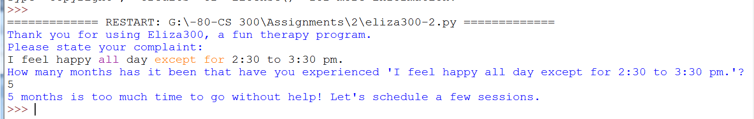

# Build 3

Implement the following specifications:

*'''*

*Eliza300: Postconditions*

*1. (Welcome): A welcome message is on the console*

*2. (Complaint): A complaint was entered by the user in response to a prompt*

*3. (Duration): A duration in months was entered by user in response to a prompt*

*4. (Error check): EITHER the user entered an integer between 1 and 100 for duration after being given up to two chances OR the application quit after suggesting a re-run.*

*5. (Action Recommended): EITHER how_long exceeds 2 months, and the phrase*

*“ … months is too much time to go without help! Let's schedule a few*

*sessions" is on the console OR the following is on the console:*

*"Come back in a couple of months if this persists".*

*'''*

Here are examples of input/output:

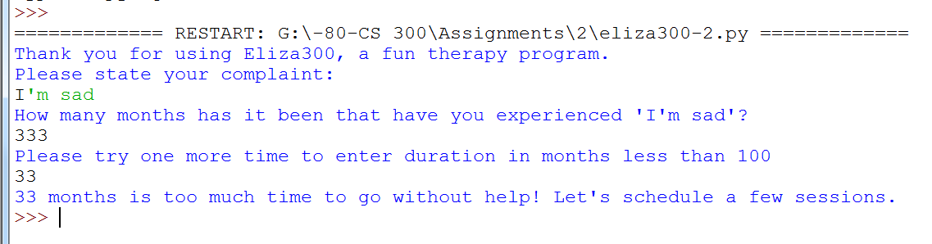

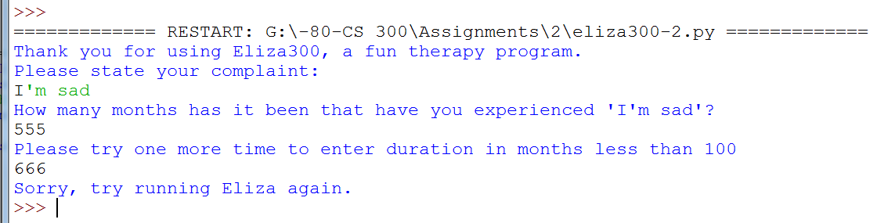

To close down a Python program, you can use the following two lines, which executes the *exit*() function in the *sys* library:

import sys

sys.exit()

Python allows an *and* between conditions. For example:

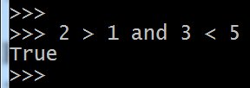

You can use an *and* in an *if* statement.

1. State the required outcome(s) of each block of code—no less and no more. You can assume that your reader knows Python itself very well, so there is no need to explain elements of the language itself. The only exceptions to this are where you use Python constructs that may be obscure for your reader—which is unlikely in this course.