[MPU6050_DMP6_Teapot](https://github.com/rkuo2000/arduino/tree/master/examples/IMU/MPU6050_DMP6_Teapot)

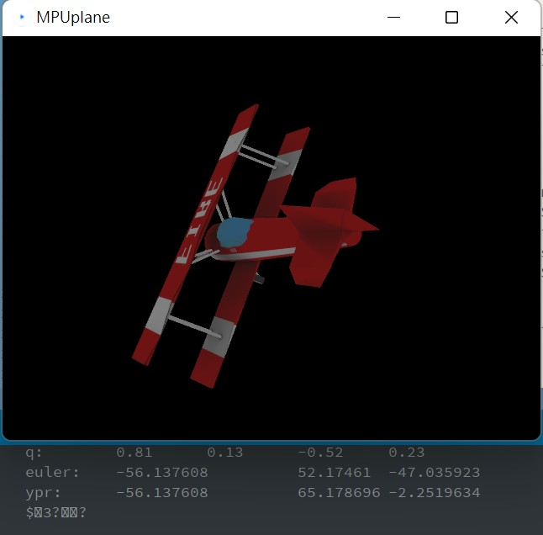

[MPU6050_Kalman_Filter](https://github.com/rkuo2000/arduino/tree/master/examples/IMU/MPU6050_KalmanFilter)

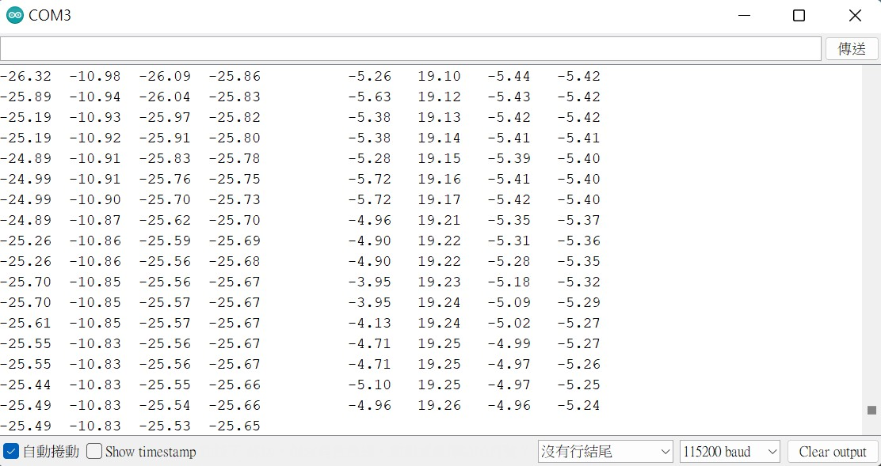

[TinyML_AirDigit](https://github.com/rkuo2000/arduino/tree/master/examples/TinyML/TinyML_AirDigit)

