RedNet: Redesign selective protein binders using graph transformers and contrastive decoding

1 Introduction

Designing protein binders that target specific proteins with high affinity and specificity is a fundamental challenge in protein engineering with broad applications in therapeutics and basic research ¹. While recent advances in deep learning have improved design capabilities, generating binders that achieve both tight binding and target specificity without extensive experimental optimization remains difficult ^{2,3}.
Current structure-based binder design, also known as one-sided interface design ¹, typically follows a three-stage workflow^{2–4}: (1) backbone or all-atom structure generation conditioned on the target protein, (2) sequence design to optimize binding properties and generate diverse candidates, and (3) filtering and ranking of designs using machine learning and physics-based scoring functions. Recent years have seen substantial progress in each component. However, existing fixed-backbone design methods do not adequately address the specific requirements of binder design, including affinity optimization, reduction of off-target binding, and accurate representation of interface side-chain conformations that determine binding specificity.
Here we focus on the fixed-backbone design component in the context of binder design. Fixed-backbone binder design aims to generate sequences for a binder that can fold independently and bind a target protein to form a predetermined complex structure¹. ProteinMPNN has emerged as a widely adopted model for this task due to its efficiency and effectiveness at designing sequences from backbone structures, particularly for monomeric proteins with idealized scaffolds. However, ProteinMPNN and similar fixed-backbone design models have three key limitations for binder design. First, these models operate solely on backbone atom positions and cannot capture side-chain conformations that are critical for defining binding interfaces and specificity. Second, successful binder design requires simultaneously optimizing two objectives: the binder must fold stably in its unbound state and form a stable complex with the target. Current autoregressive sequence design models generate sequences based on per-residue conditional probabilities and lack explicit mechanisms to balance these competing requirements. Third, current fixed-backbone design models lack capabilities to improve specificity.
To address these limitations, we introduce RedNet, a framework for binder sequence design with two main innovations. First, we develop a multiscale graph transformer architecture that incorporates both backbone geometry and side-chain information from the target, enabling more accurate modeling of binding interfaces. Second, we introduce a contrastive decoding algorithm that leverages the trained model to improve binding affinity while simultaneously reducing off-target interactions. To our best knowledge, this is the first principled algorithm that enables deep learning-based fixed-backbone binder design to explicitly improve both affinity and specificity.
We evaluate RedNet on multiple benchmark datasets relevant to fixed-backbone binder design, demonstrating improved performance compared to existing methods. Additionally, we curate a new benchmark dataset from the Protein Data Bank specifically designed to assess structural selectivity for challenging targets with homologous off-target proteins. On this selectivity benchmark, as a proof-of-concept, RedNet demonstrates capability to discriminate between highly similar targets and design binder with improved specificity.

1.1. Related Works

One-sided interface design
End-to-end (hallucination) and two-stage (rosetta) approaches.

Fixed backbone design
Physics-based approaches (rosetta and ospery) have been used. Time-consuming and inaccurate. ProteinGraphTransformer.

2 Methods

2.1 Architecture
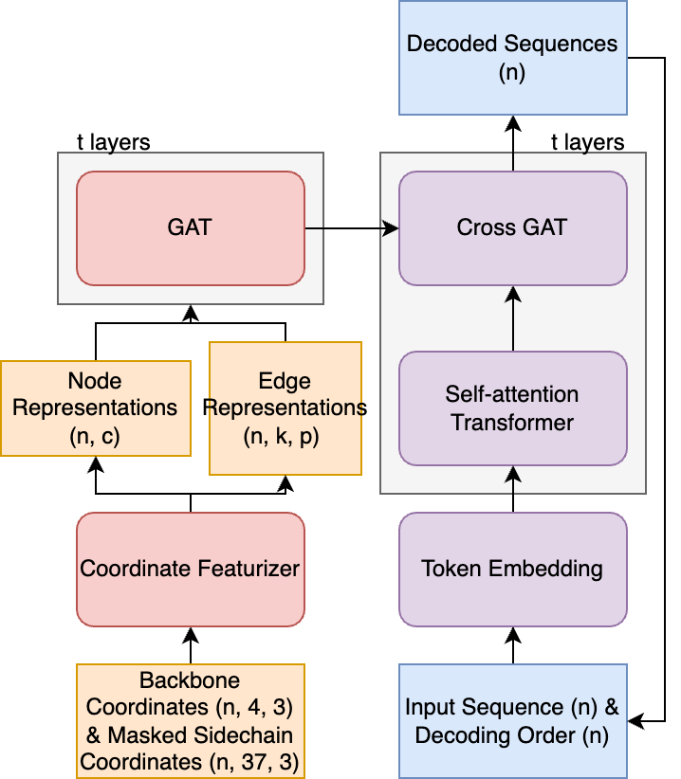

Figure 1. Overview of RedNet architecture. N is the number of residues in the complexes, k is the number of neighbors of a residue, and c and p are the numbers of channels of node and edge representations respectively. Self-attention transformers are optional.

GAT: and AtomGAT
Adding transformer GCN architectures tend to suffer various issues such as over-smoothing and limited expressivenes.

Coordinate Featurizer: see supp 1

Losses: cross entropy losses. To prevent overfitting, we find it helpful to add edgewise cross entropy losses.

2.2 Scoring
Bound - unbound scores. Previous research also demonstrates that this scoring methods may help predicting binding affinity correlations.

On-target scores - off-target scores

2.3 Contrastive decoding

ProteinMPNN excels at exploiting local structural motifs to generate thermodynamically stable sequences for monomeric scaffolds, while it struggles to model global properties. ESMIF and others that rely on dense attentions tend to model global properties better than ProteinMPNN but worse at generating stable sequences, as reflected in stronger performance in native sequence recovery but poor performance in self-consistency tests. We show a concrete case of ProteinMPNN generated interfaces, the backbone scaffold is a simple alpha-helix fold, the generated sequences have various undesired physiochemical properties for binders despite passing the self-consistency tests: it consists of several repetitive apolar residue clusters. These properties may cause the designed binders to be aggregation-prone or have poor solubility. Previous studies address these issues via several heuristics such as fixing the residues at the binding sites and only redesign the core and rim of the binder, and using auxiliary model to improve the solubilities or “naturalness” as evaluated by the likelihood scores of pretrained protein language models. These heuristics are proven effective in in vitro experiments, but they may also create suboptimal design. More importantly, they do not directly address the fundamental problem of developing better structure-based redesign models.

Decoding algorithms to design selective binders
The design algorithm modifies the predicted logits at each timestep t.

We also constrain the candidate set at the timestep
We sample from the modified categorical distribution at the timestep
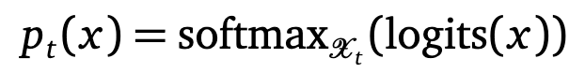

Decoding algorithms to design binders

2.4 Datasets and Benchmarks

Training Datasets
Training set: All structures released before 2022-05-01.
Validation set: All structures released between 2022-05-01 and 2022-12-31. Remove similar chains using the same procedure as PDB-test sets

Test Datasets

Low-homology PDB-Test Datasets

We select structures released between 2023-01-01 and 2023-12-31. To prevent potential sequence leakage, we search test sequences against training sequences using MMseqs2 and retain only chains with E-value > 1. To reduce overrepresentation of certain protein families, we cluster the remaining test sequences at 40% sequence identity using MMseqs2. We categorize each structure by interface type based on the similarity of interacting chains: monomer (no interface), homodimer (two similar chains), or heterodimer (two dissimilar chains). For each interface type, select one representative from each cluster, then randomly sample 300 monomers, 150 homodimers, and 150 heterodimers to create a balanced test set of 600 structures.

To test heterodimer self-consistency, we select heterodimers whose total number of residues is at most 500, due to compute constraints. This retains 107 samples.

Selective Binder Test Datasets
Heterodimeric protein complexes are curated from sequence-clustered PDB chains. Sequence clusters are generated using MMseqs2 with a 90% sequence identity threshold. Heterodimers are identified by requiring interaction partners to belong to distinct sequence clusters with non-identical sequences. To identify on-target and off-target interaction triplets, heterodimers are grouped by their constituent chain sequence clusters. Each heterodimer appears in two cluster groups: once grouped by the first chain's cluster and once by the second chain's cluster. To avoid overrepresentation of promiscuous sequence clusters with many interaction partners, we retain only clusters appearing in 2-30 unique PDB structures, yielding 3,329 non-redundant heterodimeric interactions. Removing PDB structures with non-canonical amino acid, we retain unique 977 sequence clusters and overall 3,180 interactions (977 on-target interactions and 2,203 off-target interactions)

For each sequence cluster (designated as the ligand cluster), we perform all-to-all pairwise alignments of its interaction partners (receptor chains) using structural alignment (TM-align).

To assess benchmark difficulty, we define a difficulty score for each test case as the TM-score gap between the on-target receptor and off-target receptor and Jaccard similarity of the residue contact pairs between on-target complex and off-target complex:

Difficulty = JaccardSimilarity(on-target pairs, off-target pairs)

Higher scores indicate that the on-target is more structurally similar to the
receptor than any off-target, making selective design harder.

Our benchmark contains X% hard cases (difficulty < 0.1), Y% medium cases
(0.1 ≤ difficulty < 0.3), and Z% easy cases (difficulty ≥ 0.3), providing a
diverse range of discrimination challenges (Figure N).

After filtering (to be detailed), we retain 657 unique ligand clusters, and within each ligand cluster, we select the one with smallest Jaccard similarity, as a result, we have 657 non-redundant heterodimeric interactions.
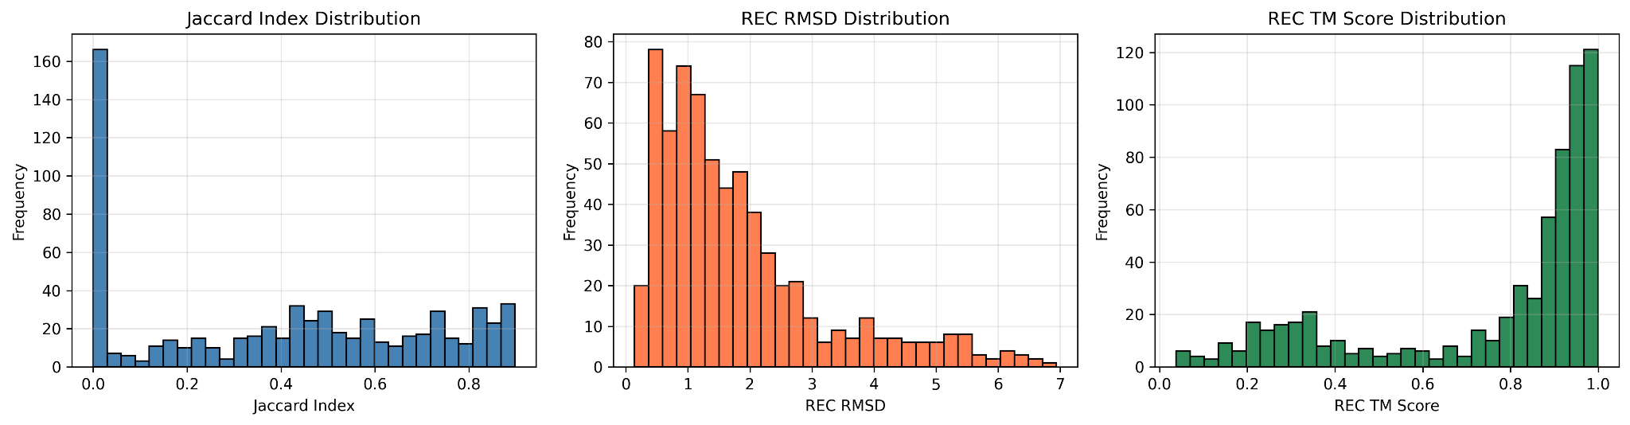
Figure 2.4

Megascale

SKEMPI-v2

Benchmarking Methods
We compare our methods with widely adopted fixed-backbone design methods: ESM-IF, ProteinMPNN, PiFold and SolMPNN⁵.

3 Results

3.1 Sequence recovery of monomers and dimers
We benchmarked RedNet against widely adopted fixed backbone design models, including ESM-IF, ProteinMPNN, and PiFold. We evaluated native sequence recovery (NSR), wild-type log-likelihood (LL), and perplexity (PPL) across monomers, homodimers, and heterodimers (Table 1). ESM-IF and PiFold are trained without noise augmentation, while ProteinMPNN and RedNet are compared across noise levels σ ∈ {0, 0.02, 0.1, 0.2, 0.3} to assess robustness to backbone coordinate perturbations.

Monomers. On monomeric structures without noise augmentation, RedNet achieved the highest sequence recovery (NSR = 0.43) compared to ESM-IF (0.38), PiFold (0.40), and ProteinMPNN at σ = 0.02 (0.36). RedNet achieved the most favorable wild-type log-likelihood (LL = −1.74 vs. −1.85 for ESM-IF, −1.92 for PiFold), indicating better calibration of sequence probabilities on native sequences. At matched noise levels, RedNet consistently outperformed ProteinMPNN: at σ = 0.02, RedNet achieved NSR = 0.37 versus ProteinMPNN's 0.36; at σ
= 0.1, both models converged to NSR = 0.33, though RedNet maintained marginally better log-likelihood (−2.01 vs. −2.02). Performance degradation with increasing noise was comparable between models, with NSR decreasing from 0.43 to 0.30 for RedNet across the noise range tested.

Homodimers. RedNet demonstrated strong performance on symmetric interfaces, achieving NSR = 0.49 at σ = 0, compared to ESM-IF (0.43), PiFold (0.45), and ProteinMPNN at σ = 0.02 (0.42). This 6 percentage point improvement over ESM-IF represents a 14% relative gain in
sequence recovery. RedNet also yielded the lowest perplexity (PPL = 3.86 vs. 4.29 for ESM-IF, 6.10 for PiFold), suggesting higher confidence in native sequence predictions at symmetric protein-protein interfaces. The log-likelihood gap was substantial: RedNet achieved
LL = −1.28 compared to −1.35 for ESM-IF and −1.73 for PiFold. Across noise levels, RedNet maintained advantages over ProteinMPNN: at σ = 0.1, RedNet achieved NSR = 0.40 and PPL = 5.07 versus ProteinMPNN's NSR = 0.40 and PPL = 5.58; at σ = 0.3, RedNet achieved LL = −1.63 versus −1.76 for ProteinMPNN.

Heterodimers. The performance gap was most significant on heterodimeric interfaces, which are most relevant to one-sided interface design. At σ = 0, RedNet achieved NSR = 0.43, outperforming ESM-IF (0.33), PiFold (0.35), and ProteinMPNN at σ = 0.02 (0.37). This represents a 10 percentage point improvement over ESM-IF (30% relative) and a 6 percentage point improvement over ProteinMPNN (16% relative). The perplexity gap was large: RedNet achieved PPL = 6.58 compared to ESM-IF (PPL = 13.39). PiFold (PPL = 9.16) and ProteinMPNN (PPL = 8.32). Log-likelihood differences followed similar patterns.

Robustness to coordinate noise. We compared RedNet and ProteinMPNN across increasing noise levels to assess robustness to backbone coordinate perturbations. Both models showed
expected degradation with increasing noise: RedNet's heterodimer NSR decreased from 0.43 (σ = 0) to 0.32 (σ = 0.3), while ProteinMPNN's decreased from 0.37 (σ = 0.02) to 0.31 (σ = 0.3). RedNet maintained consistent advantages on dimer interfaces across all noise levels. At σ = 0.2, RedNet achieved heterodimer PPL = 8.84 versus ProteinMPNN's PPL = 9.46. At σ = 0.3, RedNet achieved PPL = 9.27 compared to ProteinMPNN's PPL = 10.12.

 | Noise levels (σ) | Mean NSR | Mean LL (WT) | Mean PPL (WT) | Mean NSR | Mean LL (WT) | Mean PPL (WT) | Mean NSR | Mean LL (WT) | Mean  PPL (WT)
 | (low) | monomer |  |  | homodimer |  |  | heterodimer
ESM-IF | 0 | 0.38 | -1.85 | 7.33 | 0.43 | -1.35 | 4.29 | 0.33 | -2.21 | 13.39
PiFold | 0 | 0.40 | -1.92 | 9.65 | 0.45 | -1.73 | 6.10 | 0.35 | -2.08 | 9.16
RedNet (ours) | 0 | 0.43 | -1.74 | 9.15 | 0.49 | -1.28 | 3.86 | 0.43 | -1.76 | 6.58
ProteinMPNN | 0.02 | 0.36 | -1.91 | 7.60 | 0.42 | -1.55 | 5.12 | 0.37 | -2.00 | 8.32
RedNet (ours) | 0.02 | 0.37 | -1.92 | 8.30 | 0.43 | -1.44 | 4.64 | 0.39 | -1.91 | 7.51
ProteinMPNN | 0.1 | 0.33 | -2.02 | 8.36 | 0.40 | -1.64 | 5.58 | 0.34 | -2.11 | 9.25
RedNet (ours) | 0.1 | 0.33 | -2.01 | 8.68 | 0.40 | -1.53 | 5.07 | 0.35 | -2.04 | 8.67
ProteinMPNN | 0.2 | 0.31 | -2.08 | 8.84 | 0.37 | -1.70 | 5.90 | 0.33 | -2.14 | 9.46
RedNet (ours) | 0.2 | 0.32 | -2.06 | 8.91 | 0.38 | -1.60 | 5.38 | 0.34 | -2.08 | 8.84
ProteinMPNN | 0.3 | 0.30 | -2.12 | 9.18 | 0.36 | -1.76 | 6.28 | 0.31 | -2.21 | 10.12
RedNet (ours) | 0.3 | 0.30 | -2.11 | 9.23 | 0.36 | -1.63 | 5.54 | 0.32 | -2.13 | 9.27

Propensity: sse, sequence-similarity, structure-similarity.

3.2 Structure self-consistency test and energetics prediction of heterodimers

In one-sided interface fixed-backbone sequence design, the all-atom coordinates of bound target structures and the backbone atom coordinates (C, CA, N, and O) of bound binder structures are provided as input, and binder sequences are predicted. Self-consistency tests use structure prediction models, such as AlphaFold3, to predict structures from designed sequences and evaluate them using model confidence scores (e.g., pLDDT) and structural similarity metrics (e.g., TMscore) against the input backbone coordinates. To further assess energetics, we use Rosetta to relax the designed structures and compute their energy scores.

To prevent structure prediction models from leveraging external evolutionary information—which may artificially inflate confidence scores for natural sequences relative to novel designs—we provide only target template structures as input. In preliminary tests, AlphaFold3 outperformed ESMFold and AlphaFold-Multimer on complex prediction (measured by RMSD) when using only sequences. Accordingly, all subsequent structure predictions use AlphaFold3 with binder and target sequences plus target structural templates.

We benchmark the structure self-consistency of RedNet against ESM-IF, ProteinMPNN, PiFold, and SolMPNN on heterodimers (Table 2).

RedNet outperforms esmif and pifold and is competitive with proteinmpnn at several noise levels.

We analyze the effects of contrastive decoding on type-1 and type-2 errors

3.3 Structural selectivity test using AlphaFold3 and Rosetta
Given the improved performance using contrastive scoring approaches, we hypothesize that contrastive sampling algorithms may also improve selective binding.
There are no existing benchmarks, and metrics developed for this particular task, as a result, we assemble a new pdb dataset. We explain our rationale for designing the metrics for this benchmark.
We compare the improvement between on-target changes (dsn - gt) and off-target changes (dsn - gt). We also provide structural analysis.

RedNetV0.0.2

3.4 Structural analysis of selective binder
We compare designed and ground truth complex structures, to demonstrate two ways contrastive decoding can increase the gap between on-target binding and off-target binding

4dbg - 7v8e (reduce off-target interactions)
2gox - 4m76 (improve on-target interactions)

(A)
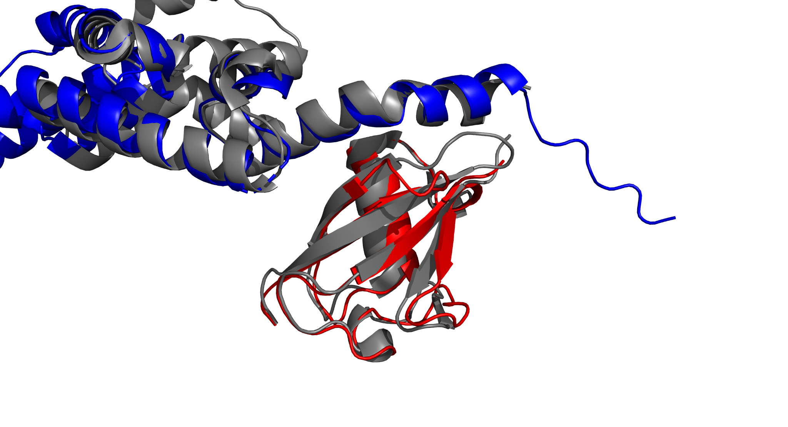
(B)
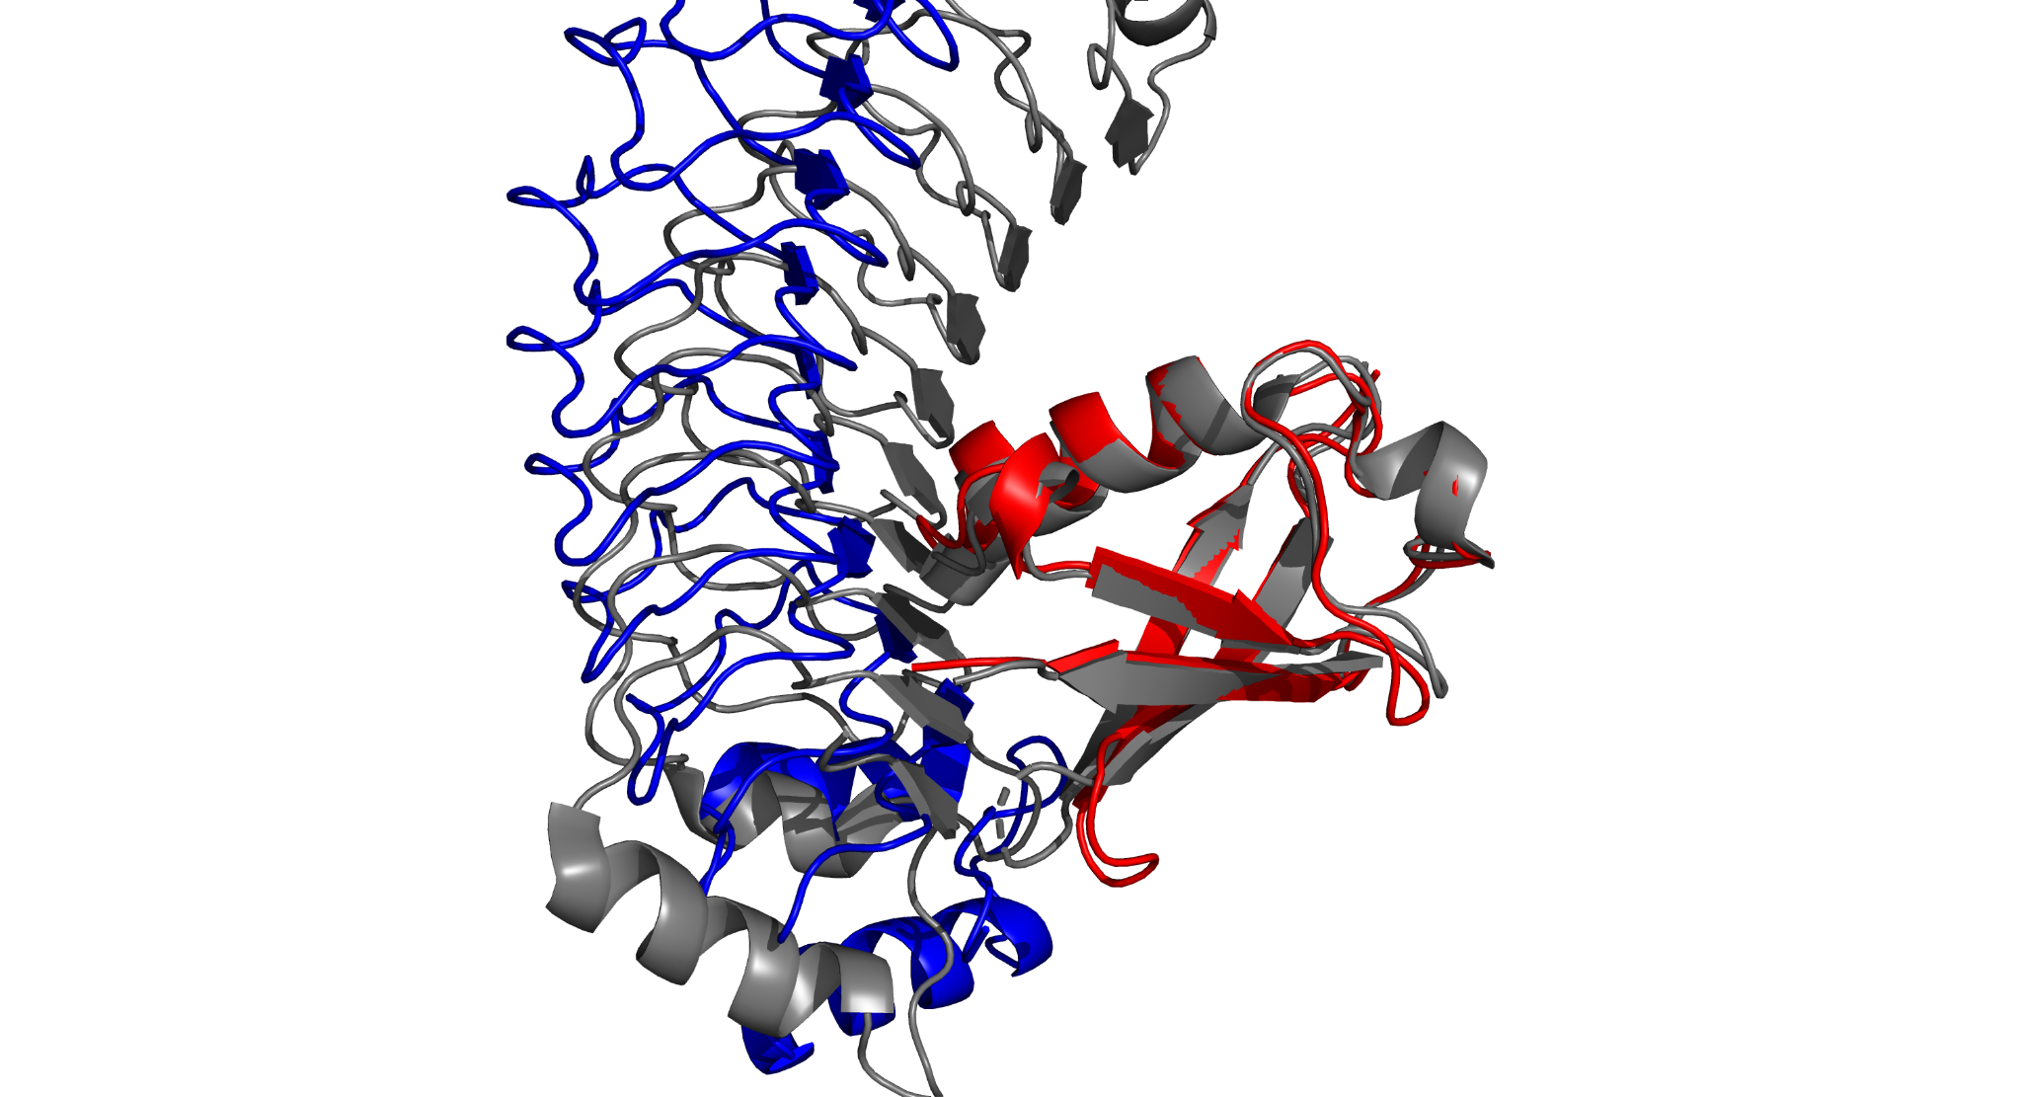

Figure 2. For 4dgb (on-target, A) and 7v8e (off-target, B) interactions, designed binders (shown in red) share similar binding sites. Target chains in the designed complexes are shown in blue and the ground true complexes are shown in grey. RedNet removes extruding loops to improve the foldability of designed binders, and makes unfavorable interactions at 7v8e interfaces (int_energy_dsn - int_energy_gt = 101.7 REU, computed by Rosetta InterfaceAnalyzer).

3.5 Binding affinity prediction
We show that different scoring approaches, we term contrastive scoring, can improve the log-likelihood scoring.

3.6 Ablation Studies
RedNetV0.0.1
noise level
edgewise loss
decoding hyperparameters

4 Conclusion
RedNet improves inverse folding models on complexes.
Contrastive decoding algorithms enable the design of selective binders, improve binding affinities and sequence properties.

References
1. Kuhlman B, Bradley P. Advances in protein structure prediction and design. Nat Rev Mol Cell Biol. 2019;20(11):681-697. doi:10.1038/s41580-019-0163-x
2. Zambaldi V, La D, Chu AE, et al. De novo design of high-affinity protein binders with AlphaProteo. arXiv. Preprint posted online September 12, 2024. doi:10.48550/arXiv.2409.08022
3. Pacesa M, Nickel L, Schellhaas C, et al. One-shot design of functional protein binders with BindCraft. Nature. 2025;646(8084):483-492. doi:10.1038/s41586-025-09429-6
4. Watson JL, Juergens D, Bennett NR, et al. De novo design of protein structure and function with RFdiffusion. Nature. 2023;620(7976):1089-1100. doi:10.1038/s41586-023-06415-8
5. Goverde CA, Pacesa M, Goldbach N, et al. Computational design of soluble and functional membrane protein analogues. Nature. 2024;631(8020):449-458. doi:10.1038/s41586-024-07601-y

Supplementary

AdamW: lr 1e-3, decay 0.1, reduce_on_plateu, bsz 64, bf16-mixed, clip_val 1.0

Reduce overfitting

