AJAX 2
1.AJAX是什么 2
2.请求的分类 2
2.1.传统请求(同步请求,request请求) 2
2.2.异步请求 2
3.同步请求(传统请求)和异步请求的区别 3
4.Ajax开发步骤 3
4.1.创建XMLHttpRequest对象 3
4.2.发送异步请求,并携带数据 4
4.3.处理响应结果 4
4.4.接收服务端返回结果 4
5案例 4
5.1.使用get方式发送异步请求 5
5.2.以post方式发送异步请求 7
6.Ajax运行过程中的数据交互 7
7使用Gson转换成json字符串 8
8.Gson案例 12

AJAX

1.AJAX是什么
Asynchronous Javascript And Xml,异步的Javascript And Xml
是一种交互式网页开发技术

Html,css,jsp,servlet,struts2,javascript,jquery
传统的网页(不使用Ajax),如果更新网页内容,会重新加载整个页面
Ajax是一种只更新局部内容的一种技术

2.请求的分类

2.1.传统请求(同步请求,request请求)
- Form表单(get|post)
- 超链接,userServlet?name=tom&pwd=123
- 地址栏
- Js的请求方式,bom(Browser Object Model,浏览器对象模型),location.href=url?***
    - Dom(Document Object Model ,文档对象模型)

2.2.异步请求
Ajax
需要创建javascript内置的XMLHttpRequest对象,存在浏览器差异

3.同步请求(传统请求)和异步请求的区别
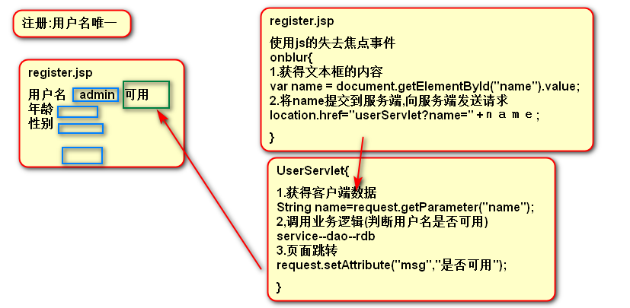

同步请求:
用户体验差,更新整个网页的内容,导致用户的后续操作失败
特点:等待服务端处理完成之后才可以进行后续操作

异步请求:解决用户体验差的问题
只需要更新网页的局部内容,当前网页的后续操作顺利完成
特点:多个事件可以并行发生,互不影响,不刷新整个页面内容,只刷新局部

打电话,语音聊天,视频聊天:同步请求
发短信,微信,qq聊天:异步请求

4.Ajax开发步骤
首先明确一点:是客户端技术,进行网页开发,嵌入到html,jsp中

4.1.创建XMLHttpRequest对象
存在浏览器差异,需要检测浏览器是否支持

Var xhr;
If(window.XMLHttpRequest)//检测浏览器是否支持
Xhr = new XMLHttpRequest();//ie7+,chrome.firefox,safari
Else//不支持
Xhr = new ActiveXObject(“Microsoft.XMLHTTP”);//ie5,ie6

4.2.发送异步请求,并携带数据
Xhr.open(“GET|POST”,”url”);
Xhr.send();

4.3.处理响应结果
应该处理正确的并完成的响应结果
Ajax监听readyState状态的改变,当状态改变时触发事件onreadystatechange ,调用该函数
Xhr.onreadystatechange= function(){
If(xhr.readyState==4 && xhr.status==200){

readyState:
0:未初始化,xhr对象创建,未调用open方法发送异步请求
1:已初始化,调用open方法发送异步请求
2:服务端已经接收请求
3:服务端处理中
4:请求处理完成

4.4.接收服务端返回结果
xhr.responseText
}
}

5案例
用户注册,判断用户是否存在,将响应信息显示到页面上
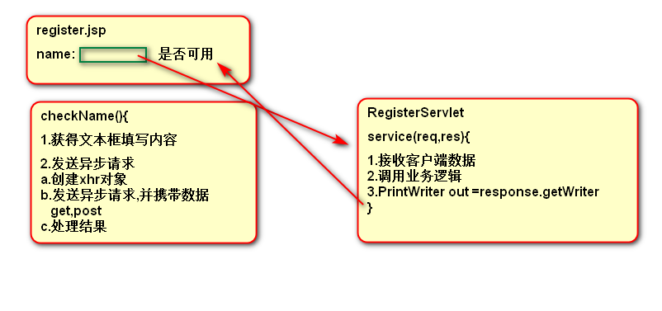

5.1.使用get方式发送异步请求
<script type="text/javascript">

function checkName(){
//1.获得文本框填写内容
var name = document.getElementById("name").value;
//alert(name);
//2.发送异步请求
//a.创建xhr对象
var xhr;
if(window.XMLHttpRequest){
xhr = new XMLHttpRequest();
}else{
xhr = new ActiveXObject("Microsoft.XMLHTTP");
}

//b.发送get请求,并携带数据
xhr.open("GET", "/ajax_day1/registerServlet?name=" + name);
xhr.send(null);

//c.处理响应结果,并显示到页面上
xhr.onreadystatechange = function(){
if(xhr.readyState == 4 && xhr.status == 200){
//alert(xhr.responseText);
var nameMsg = document.getElementById("nameMsg");
nameMsg.innerHTML = xhr.responseText;
}
}

}
</script>
<title>Insert title here</title>
</head>
<body>
<input type="text" name="name" id="name" onblur="checkName()"><span id="nameMsg"></span>
</body>
</html>
public class RegisterServlet extends HttpServlet {
@Override
protected void service(HttpServletRequest request, HttpServletResponse response)
throws ServletException, IOException {
//1.接收客户端参数
String name = request.getParameter("name");

//2.调用业务逻辑,service--dao

String result = "";
if("admin".equals(name)){
result = "该用户名不可使用";
}else{
result = "该用户名可用";
}

//3.PrintWriter,将信息返回到客户端
response.setCharacterEncoding("utf-8");
PrintWriter out = response.getWriter();
out.print(result);
out.flush();
Out.close();
}
}

<servlet>
<servlet-name>RegisterServlet</servlet-name>
<servlet-class>com.baizhi.servlet.RegisterServlet</servlet-class>
</servlet>

<servlet-mapping>
<servlet-name>RegisterServlet</servlet-name>
<url-pattern>/registerServlet</url-pattern>
</servlet-mapping>

5.2.以post方式发送异步请求
请求:
同步请求:
Get请求:
- form表单,method=”get”
- 超链接
- 地址栏
- Js的location.href
Post请求:
Form表单,method=”post”

使用http协议访问网页,post请求只有form表单的method为post时

异步请求:
Get:
Post:使用xhr对象模拟form表单的post请求

xhr.open("POST", "/ajax_day1/registerServlet");
xhr.setRequestHeader("content-type", "application/x-www-form-urlencoded");
xhr.send("name=" + name);

6.Ajax运行过程中的数据交互
Client--server
Server--client
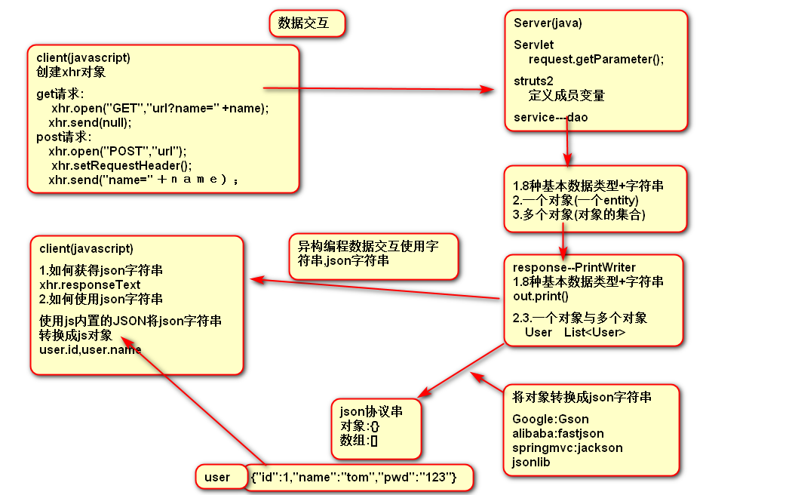

7使用Gson转换成json字符串

自定义转换器时的返回值
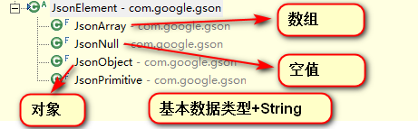
public class TestGson {

//对象,{:,:}
//{"id":1,"username":"admin","password":"123456"}
@Test
public void test01(){
User user = new User(1, "admin", "123456");

Gson gson = new Gson();
String json = gson.toJson(user);
System.out.println(json);
}

//数组:基本数据类型和字符串
//[1,2,3,4],["tom","jack","rose"]
@Test
public void test02(){

int[] ages = new int[]{1,2,3,4};
String[] names = new String[]{"tom","jack","rose"};

Gson gson = new Gson();
String json = gson.toJson(names);
System.out.println(json);
}

//数组(集合):引用类型,[{},{},{}]
//[{"id":1,"username":"tom","password":"123"},{"id":2,"username":"jack","password":"123"},{"id":3,"username":"rose","password":"123"}]
@Test
public void test03(){

User user1 = new User(1,"tom","123");
User user2 = new User(2,"jack","123");
User user3 = new User(3,"rose","123");

List<User> users = new ArrayList<User>();
users.add(user1);
users.add(user2);
users.add(user3);

Gson gson = new Gson();
String json = gson.toJson(users);
System.out.println(json);
}

//对象有引用类型的属性,User{Address},{id:1,address:{}}
//{"id":1,"username":"admin","password":"123456","address":{"city":"beijing","street":"dongbeiwang"}}
@Test
public void test04(){
User user = new User(1, "admin", "123456", new Address("beijing","dongbeiwang"));

Gson gson = new Gson();
String json = gson.toJson(user);
System.out.println(json);
}

//Map,map与对象转换成的json字符串是一样的
//{"id":1,"pwd":"123","name":"tom"}
@Test
public void test05(){

Map<String,Object> map = new HashMap<String,Object>();
map.put("id", 1);
map.put("name", "tom");
map.put("pwd", "123");

Gson gson = new Gson();
String json = gson.toJson(map);
System.out.println(json);
}

//日期
/*
* {"id":1,"username":"admin","password":"123","birthday":"Sep 12, 2018 3:51:36 PM"}
* {"id":1,"username":"admin","password":"123","birthday":"2018-9-12"}
*
* SimpleDateFormat
*
* 创建GsonBuilder,gson构建器,指定日期转换器
* 通过create方法创建Gson对象,将对象转换成json字符串
*/
@Test
public void test06(){

User user = new User(1,"admin","123",new Date());

GsonBuilder builder = new GsonBuilder();

//builder.setDateFormat("yyyy-MM-dd");

//使用日期转换器,注册类型适配器,参数1,指定类型,参数2,转换器
builder.registerTypeAdapter(Date.class, new DateConverter());

Gson gson = builder.create();
String json = gson.toJson(user);
System.out.println(json);
}

//回环问题
//{id:1,name:tom,b:{id:2,name:jack}}
//java.lang.StackOverflowError
@Test
public void test07(){

A a = new A();
a.setId(1);
a.setName("tom");

B b = new B();
b.setId(2);
b.setName("jack");

a.setB(b);
b.setA(a);

GsonBuilder builder = new GsonBuilder();

//使用排除策略
builder.setExclusionStrategies(new MyExlusionStrategy());

Gson gson = builder.create();
String json = gson.toJson(a);
System.out.println(json);
}
}

public class DateConverter implements JsonSerializer<Date> {

@Override
public JsonElement serialize(Date date, Type arg1,
JsonSerializationContext arg2) {
// TODO Auto-generated method stub
SimpleDateFormat sdf = new SimpleDateFormat("yyyy-MM-dd");
String dateStr = sdf.format(date);
return new JsonPrimitive(dateStr);
}

}
public class MyExlusionStrategy implements ExclusionStrategy {

@Override
public boolean shouldSkipClass(Class<?> arg0) {
// TODO Auto-generated method stub
return false;
}
@Override
public boolean shouldSkipField(FieldAttributes attribute) {
// TODO Auto-generated method stub
//如果属性名称是a则跳过
if("a".equals(attribute.getName()))
return true;
return false;
}
}

8.Gson案例
显示所有用户
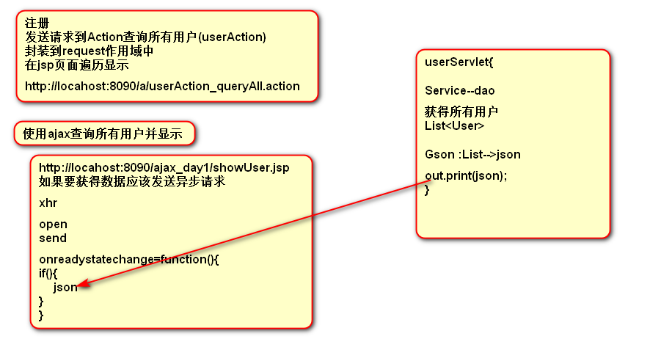
<script type="text/javascript" src="js/jquery-1.8.3.js"></script>
<script type="text/javascript">
function show(){
var xhr = new XMLHttpRequest();

xhr.open("GET","/ajax_day1/showUsersServlet");
xhr.send(null);

xhr.onreadystatechange = function(){
if(xhr.readyState == 4 && xhr.status == 200){
//alert(xhr.responseText);
//将json字符串转换成js对象,使用js内置的JSON
var users = JSON.parse(xhr.responseText);
//alert(users);

//遍历数组,创建td,tr,添加到tbody中
for(var i = 0;i<users.length;i++){
var idTd = $("<td></td>").append(users[i].id);
var usernameTd = $("<td></td>").append(users[i].username);
var passwordTd = $("<td></td>").append(users[i].password);

var trObj = $("<tr></tr>").append(idTd).append(usernameTd).append(passwordTd);
$("#tbody").append(trObj);
}
}
}
}
</script>
</head>
<body onload="show();">
<table border="1" align="center" width="50%">
<tbody id="tbody">

</tbody>
</table>
</body>
</html>
public class ShowUsersServlet extends HttpServlet {

@Override
protected void service(HttpServletRequest req, HttpServletResponse res)
throws ServletException, IOException {

ShowUsersService service = new ShowUsersServiceImpl();
List<User> users = service.queryAllUsers();

//将集合转换成json字符串
Gson gson = new Gson();
String json = gson.toJson(users);

res.setCharacterEncoding("utf-8");
PrintWriter out = res.getWriter();
out.print(json);
out.flush();
out.close();
}

}

public class ShowUsersServiceImpl implements ShowUsersService {

@Override
public List<User> queryAllUsers() {
User user1 = new User(1, "tom", "123");
User user2 = new User(2, "jack", "123");
User user3 = new User(3, "rose", "123");
List<User> users = new ArrayList<>();
users.add(user1);
users.add(user2);
users.add(user3);
return users;
}

}

