The system implements a 5-step pipeline designed to automate the verification workflow for hardware engineers:
- Requirement Intake: Accepts natural language descriptions and corresponding Verilog code.
- Test Pattern Generation: Uses an LLM to generate intelligent test patterns covering corner cases, boundary values, and random sequences.
- Golden Model Creation: Automatically generates a Python-based reference (golden) model from the natural language description to calculate expected outputs.
- Verification Logic Integration: Updates the Verilog testbench with automated pass/fail checking logic based on the golden model's results.
- Simulation & Reporting: Executes the simulation (e.g., via Icarus Verilog) and generates a detailed test summary.
Key Components and Technical Implementation
LLM Client (LLMClient)
The core of the system is a unified interface for interacting with LLM APIs. It supports providers like OpenAI and is configured to handle complex prompts with specific system instructions to ensure high-quality code generation.
Testbench Generator (TestbenchGenerator)
This module extracts module metadata (ports, names) from Verilog code and prompts the LLM to create a "skeleton" testbench. The LLM is instructed to focus on comprehensive coverage, including:
- Corner cases and boundary values.
- Systematic numbering of test cases.
- Input signal displays for debugging.
Golden Model Generator (GoldenModelGenerator)
A unique feature of this system is the generation of a Python Golden Model. By converting hardware logic into executable Python functions, the system can programmatically determine the "correct" answer for any given input pattern without requiring manual entry from the user.
Testbench Updater (TestbenchUpdater)
The final stage involves injecting verification logic into the generated testbench. It adds:
- Result Tracking: Variables like passed_tests and failed_tests.
- Comparison Logic: Automated checks that compare actual simulation outputs against the golden outputs.
- Visual Feedback: Uses symbols like "✓" and "✗" for clear reporting.
Features & Benefits
- Automation: Reduces the manual effort required to write complex verification environments.
- Accuracy: Uses a secondary Python implementation (Golden Model) to verify the primary Verilog logic.
- Self-Contained: The provided environment is ready-to-run, requiring only standard tools like iverilog and an OpenAI API key.
- Intelligent Coverage: Leverages GPT-4’s reasoning to identify edge cases that might be overlooked by human designers.

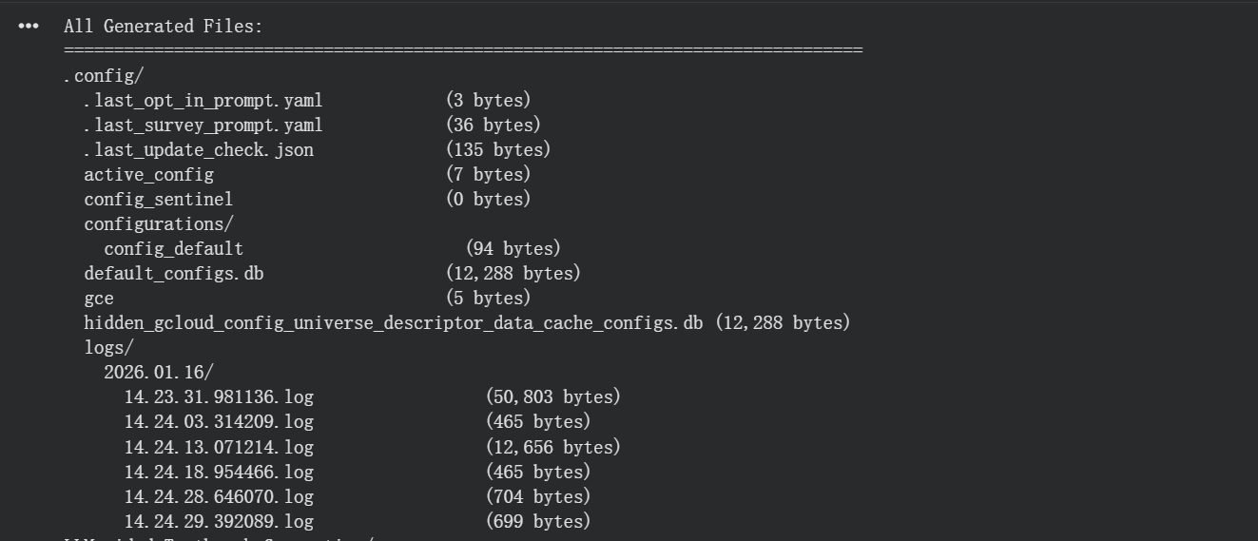
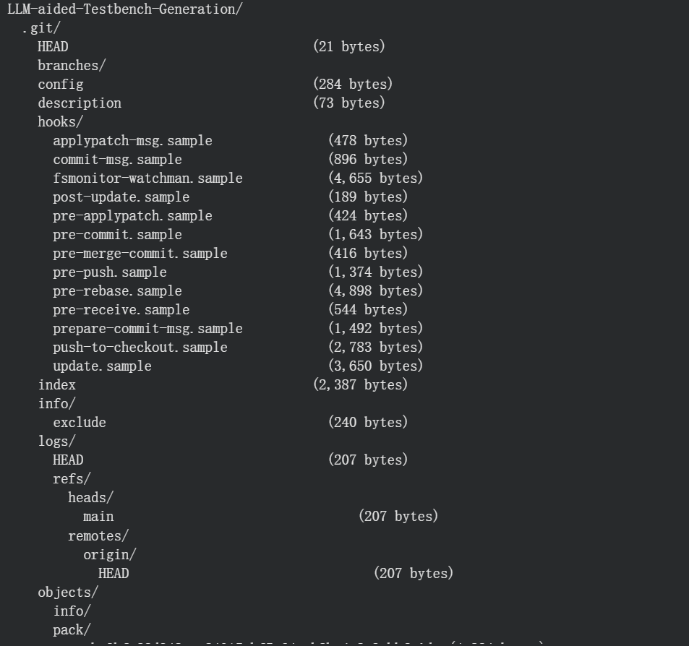
Then generate a custom module（in my case is 4to2 priority encoder）
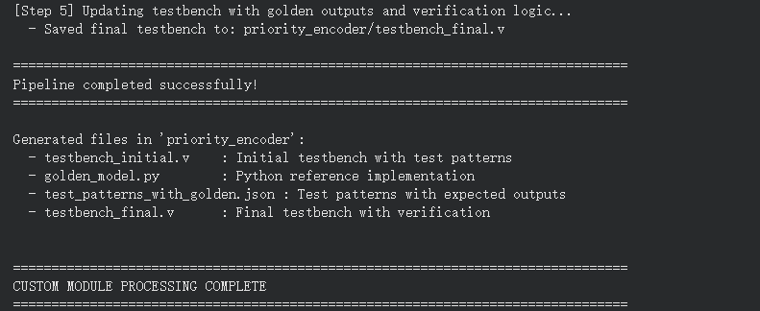
Use the pipeline to get a testbench
Then put a buggy design in it
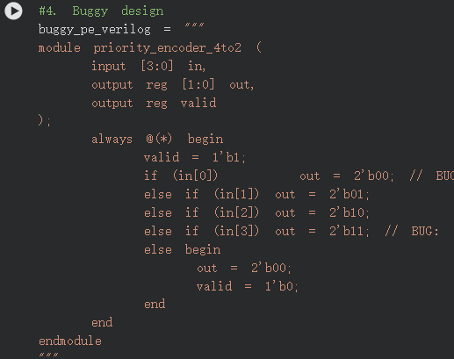
Turned out it can find the bug
