Homework 2: AI Agent System with RAG and Tools

1. System Overview (Writing Component)
My system combines three components: multi-agent orchestration, RAG, and function calling. Multiple AI agents work together in a chain, each handling one step of a task and passing its output to the next agent.
In Week 1, I built a 3-agent workflow for FDA drug shortage analysis: Agent 1 parses the data, Agent 2 assesses risk, and Agent 3 writes a summary. In Week 2, I used RAG by searching a custom CSV file (dsai_project_notes.csv) with keyword matching and feeding the results as context to the LLM for grounded answers.
In Week 3, I added function calling with a get_world_bank_data() tool that fetches GDP data from the World Bank API. Agent 1 calls the tool, Agent 2 analyzes the data. The main challenge was that smollm2:1.7b sometimes fails to generate tool calls, so I added a fallback that calls the function directly.

2. Code Repository Links
GitHub Repository:
https://github.com/zw866/dsai

Multi-Agent Orchestration
- 06_agents/lab_multi_agent.py - 3-agent drug shortage analysis workflow
- 06_agents/functions.py - Agent helper functions (agent_run, get_shortages, df_as_text)

RAG Implementation
- 07_rag/lab_dsai_rag.py - RAG query script with search function
- 07_rag/data/dsai_project_notes.csv - Custom RAG data source
- 07_rag/lab_dsai_rag_output.md - RAG output results

Function Calling / Tool Definitions
- 08_function_calling/lab_multi_agent_with_tools.py - 2-agent workflow with World Bank API tool
- 08_function_calling/functions.py - Agent and tool execution functions

3. Screenshots and Outputs

Screenshot 1: Multi-Agent Workflow (06_agents)
Shows 3-agent pipeline: Data Analyst → Risk Assessor → Report Writer analyzing FDA drug shortage data.
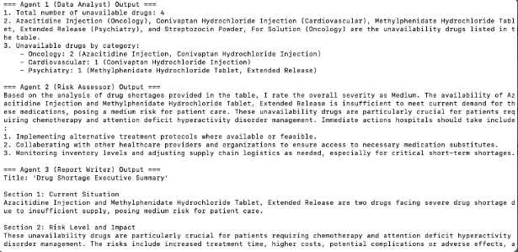

Screenshot 2: RAG Retrieval (07_rag)
Shows keyword search retrieving 5 matching records from dsai_project_notes.csv.
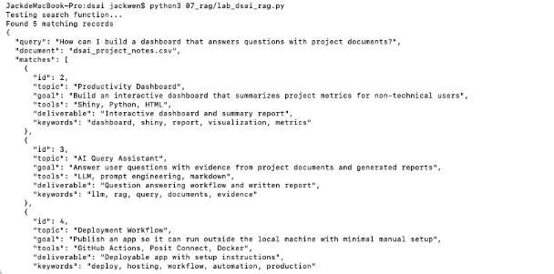

Screenshot 3: RAG Response (07_rag)
LLM-generated response grounded in retrieved context.
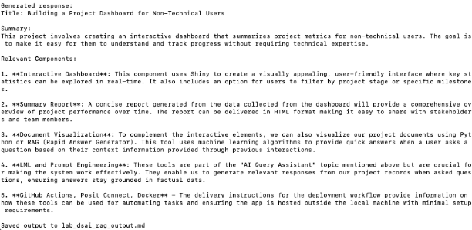

Screenshot 4: Function Calling with World Bank API (08_function_calling)
Agent 1 calls get_world_bank_data() tool to fetch China GDP data, Agent 2 generates trend analysis report.
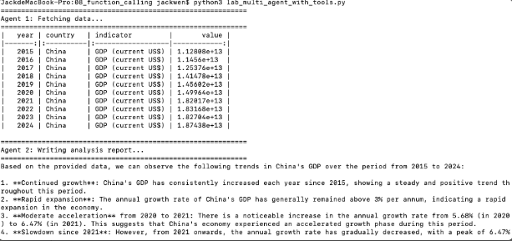

Screenshot 5: MCP Server Tool Call (08_function_calling)
calculate_bmi tool called via MCP HTTP endpoint, returning BMI value and WHO category.
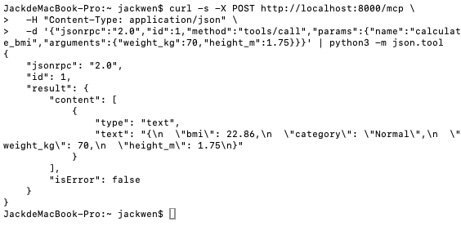

4. Documentation

4.1 System Architecture
The system consists of three integrated components, each built as a separate module:
Component 1: Multi-Agent Drug Shortage Analysis (06_agents)
- Agent 1 (Data Analyst): Parses raw FDA drug shortage data, counts unavailable drugs, groups by therapeutic category
- Agent 2 (Risk Assessor): Evaluates severity (Low/Medium/High), identifies affected patient populations, suggests hospital actions
- Agent 3 (Report Writer): Produces executive summary with Current Situation, Risk Level, and Recommended Actions
Component 2: RAG Query System (07_rag)
Single agent with retrieval: search_project_notes() searches dsai_project_notes.csv using keyword matching across topic, goal, tools, deliverable, and keywords columns. Matched records are passed as JSON context to the LLM for grounded responses.
Component 3: Function Calling Workflow (08_function_calling)
Two-agent pipeline: Agent 1 (Data Fetcher) uses get_world_bank_data() tool to call the World Bank API and retrieve economic indicators. Agent 2 (Report Writer) receives the data as a markdown table and generates a trend analysis report.

4.2 RAG Data Source
Property | Details
File | 07_rag/data/dsai_project_notes.csv
Records | 8 project records
Columns | id, topic, goal, tools, deliverable, keywords
Search Method | Keyword matching: splits query into terms (4+ chars), searches across all text columns
Search Function | search_project_notes(query, document_path, limit=5)
Return Format | JSON with query, document name, matched records, and match count

4.3 Tool Functions
Tool Name | Purpose | Parameters | Returns
get_shortages | Fetch drug shortage data from FDA API | category (str): therapeutic category; limit (int): max results | DataFrame with generic_name, update_type, update_date, availability
get_world_bank_data | Fetch economic indicators from World Bank API | country (str): ISO country code; indicator (str): WB indicator code | DataFrame with year, country, indicator, value
search_project_notes | Search CSV records by keyword matching for RAG | query (str): search text; document_path (str): CSV path; limit (int): max results | Dict with query, document, matches list, num_matches
calculate_bmi | Calculate BMI via MCP server endpoint | weight_kg (float): weight in kg; height_m (float): height in meters | JSON with bmi value, WHO category, inputs

4.4 Technical Details
Item | Details
LLM | Ollama with smollm2:1.7b (local, port 11434)
Language | Python 3.13
Key Packages | requests, pandas, json, fastapi, uvicorn
External APIs | World Bank API (api.worldbank.org), FDA Drug Shortages API (api.fda.gov)
MCP Server | FastAPI-based, runs on localhost:8000, JSON-RPC protocol
API Keys Required | None (all APIs used are public and free)

4.5 Usage Instructions
Prerequisites:
- Install Ollama and pull the model: ollama pull smollm2:1.7b
- Install Python packages: pip install requests pandas fastapi uvicorn tabulate
Running each component:
- Multi-Agent (06_agents): python3 06_agents/lab_multi_agent.py
- RAG (07_rag): python3 07_rag/lab_dsai_rag.py
- Function Calling (08_function_calling): python3 08_function_calling/lab_multi_agent_with_tools.py
- MCP Server (08_function_calling): cd 08_function_calling/mcp_fastapi && python3 -m uvicorn server:app --port 8000

