Homework 1: AI-Powered Reporter Software
Name: [Your Name]
Course: SYSEN 5381
Date: [Submission Date]
GitHub Repository: zw866/dsai (main)

Writing Component (25 pts)
My project, Economic Trend Insight Assistant, is an AI-powered reporting tool that helps users understand economic time-series data more efficiently. Instead of manually reviewing large tables, the system highlights important trends and produces a structured summary. In this homework, I used the World Bank API as the data source, a shiny for Python app for user interaction, and an AI reporting script to generate a report.
The system works in three connected steps. First, the API query component retrieves World Bank indicator data for selected countries and years. Second, the Shiny app lets the user choose countries, indicators, and a time range, then displays the returned data in a table. Third, the AI reporter give the results, builds a prompt, and sends the summary to a local Ollama model, which generates an HTML report with sections such as an executive summary, key insights, and recommendations.
I chose the World Bank API because it is public and provides useful economic indicators for trend analysis. I also used prompt constraints in the AI reporting step so the model stays focused on the provided data and avoids unsupported claims. Some challenges included API pagination, missing values, and making sure the AI output was structured and useful, but these were solved through data cleaning and prompt iteration.

2. Git Repository Links (25 pts)
Working links to relevant files in the repository (main branch).
- API query script (primary): 01_query_api/wb_query.py
- API query script (alternate / supporting): 01_query_api/wb_api_query.py
- Shiny app code: 02_productivity/shiny_app/app.py
- AI reporting script: 03_query_ai/lab_ai_reporter.py
- Main application file (if different): [Enter file path or N/A]
Helpful supporting outputs (optional references):
- AI report output (Markdown): 03_query_ai/report.md
- AI report output (HTML): 03_query_ai/report.html
- AI report output (Text): 03_query_ai/report.txt

3. Screenshots / Outputs (25 pts)
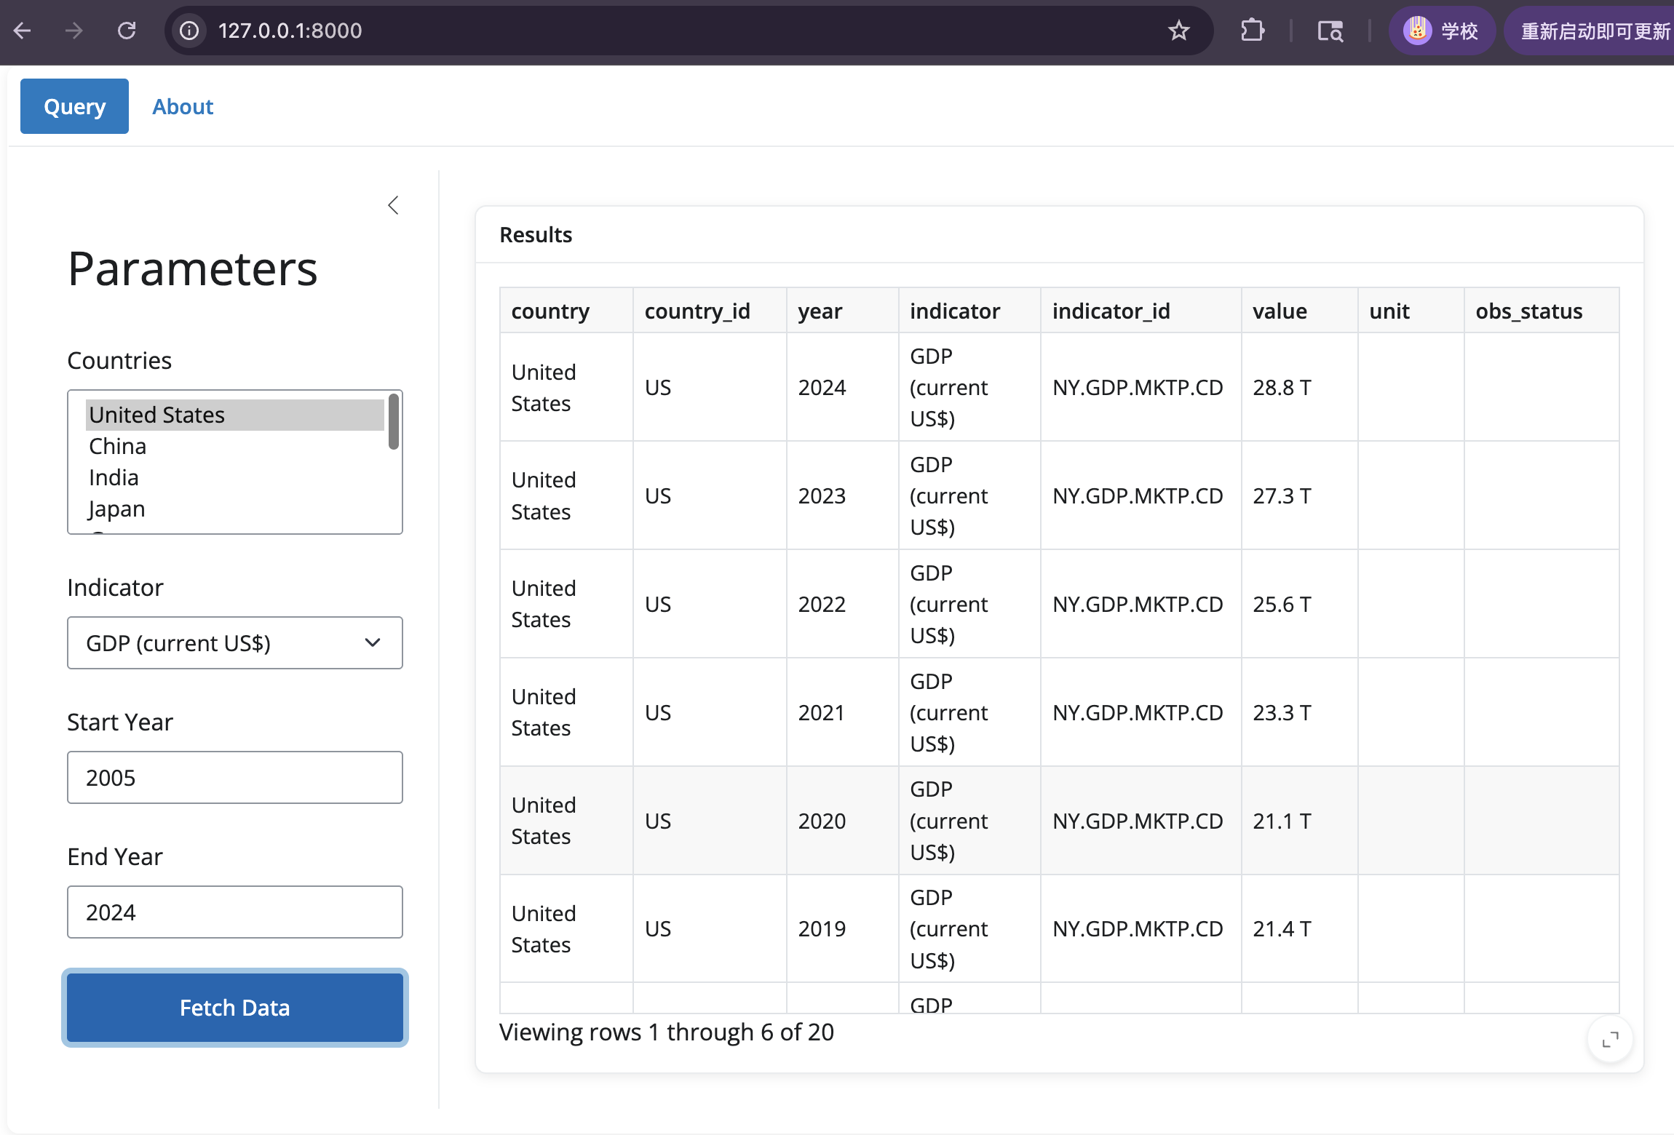
Insert at least 3-4 screenshots or output samples. Replace each placeholder with your actual image/sample.
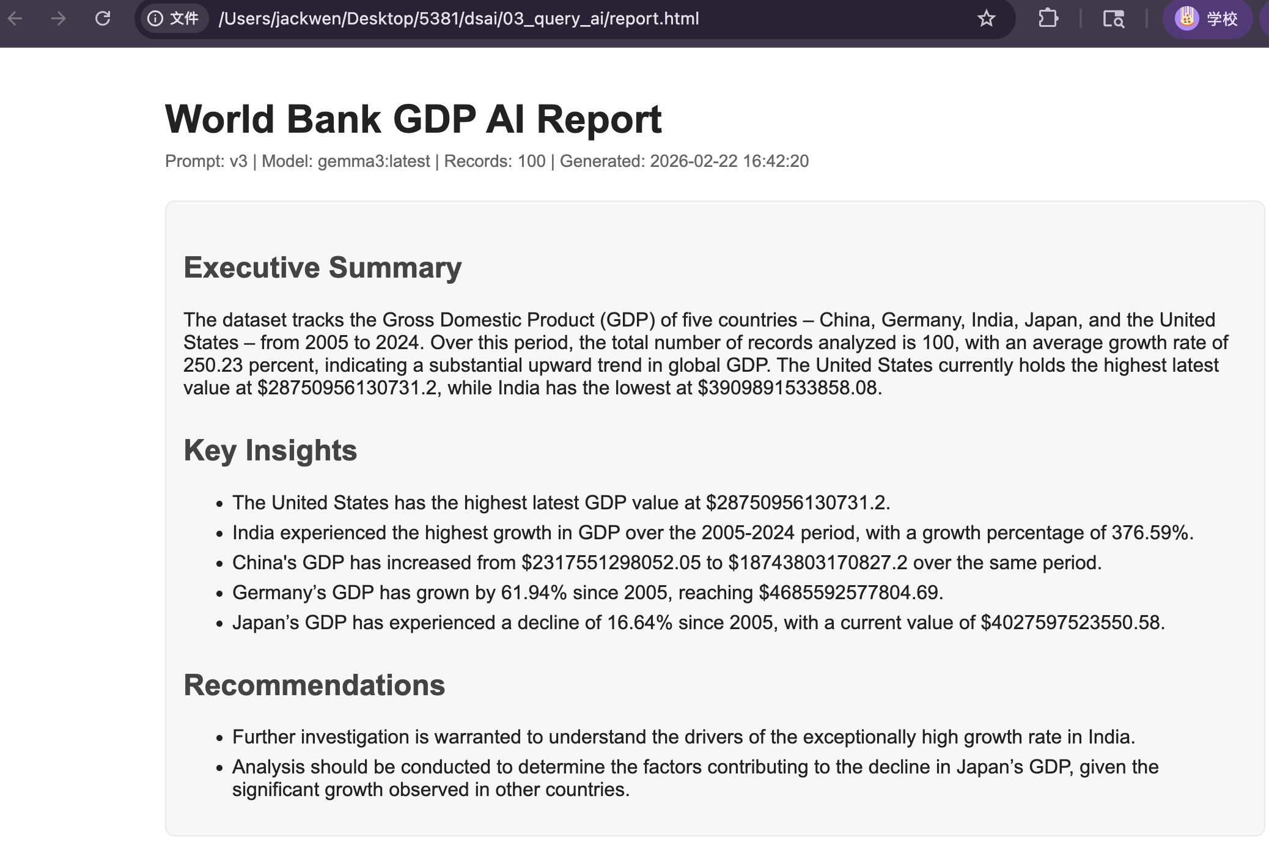
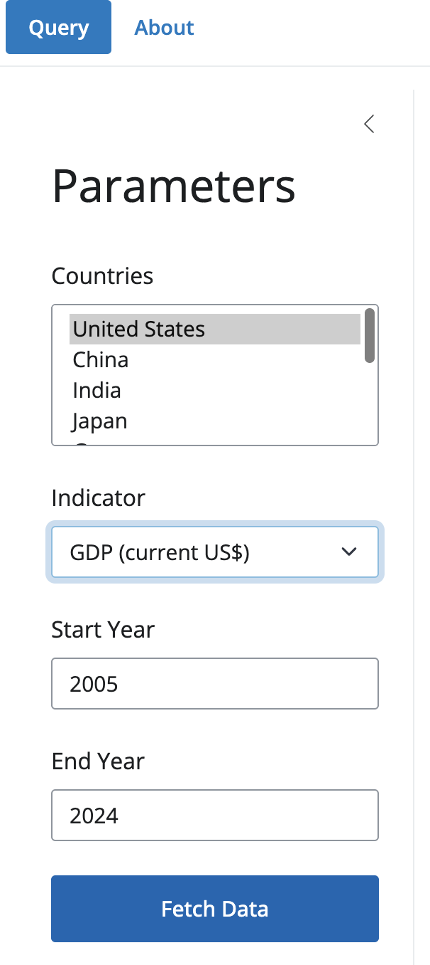

4. Documentation (25 pts)

4.1 Data Summary (API Data Columns)
Table summarizing key columns in the cleaned World Bank API data used in the project.
Column Name | Data Type | Description
country | string | Country name from the World Bank response.
country_id | string | Country code/id (e.g., USA, CHN, IND).
year | string/int | Observation year returned by the API (cleaned as int in AI reporter).
indicator | string | Human-readable indicator name (e.g., GDP current US$).
indicator_id | string | World Bank indicator code (e.g., NY.GDP.MKTP.CD).
value | numeric | Indicator value for the selected country-year observation.
unit | string | Unit field from the World Bank API response (may be blank).
obs_status | string | Observation status field from the World Bank API response.

4.2 Technical Details

API Information
API used: World Bank Open Data API
Base endpoint: https://api.worldbank.org/v2
Example query pattern: /country/{countries}/indicator/{indicator}?format=json&date={start}:{end}&per_page={n}
Example indicator used in the AI reporter: NY.GDP.MKTP.CD (GDP, current US$)
Countries used in the AI reporter example: USA, CHN, IND, JPN, DEU

AI Model / Provider
Provider used in the AI reporter script: Local Ollama server (http://localhost:11434)
API endpoint used by the script: /api/chat
Model fallback candidates in the script: gemma3:latest, smollm2:1.7b
Prompt design: v1/v2/v3 prompt iterations with v3 enforcing structured output and no fabricated facts

Key Packages / Dependencies
Python packages used across the project include: requests, pandas, shiny, and standard-library modules (json, datetime, html).
If running the AI reporter with Ollama, local Ollama must be installed and a supported model must be available.

File Structure (Brief)
- 01_query_api/wb_query.py - World Bank API query script with pagination and field cleaning output preview
- 01_query_api/wb_api_query.py - Supporting/alternate World Bank API query script
- 02_productivity/shiny_app/app.py - Shiny for Python World Bank Indicator Explorer interface
- 03_query_ai/lab_ai_reporter.py - AI-powered reporting pipeline (World Bank + Ollama + HTML report generation)
- 03_query_ai/report.md / report.html / report.txt - report outputs/examples

4.3 Usage Instructions

A. Clone the repository
git clone https://github.com/zw866/dsai.git
cd dsai

B. Install dependencies (Python)
Install the packages required by your selected scripts/app. Example:
pip install requests pandas shiny

C. Set up AI runtime (Ollama, for AI reporter)
1) Install Ollama
2) Start the Ollama service
3) Ensure one of the models in the reporter script is available (e.g., gemma3:latest or smollm2:1.7b)
Example checks/commands (adjust to your system):
ollama list
ollama run gemma3:latest

D. Run the World Bank API query script
python 01_query_api/wb_query.py
Optional alternate script:
python 01_query_api/wb_api_query.py

E. Run the Shiny app (World Bank Indicator Explorer)
python -m shiny run 02_productivity/shiny_app/app.py
Then open the local URL shown in the terminal and use the inputs to fetch data from the World Bank API.

F. Run the AI reporter
python 03_query_ai/lab_ai_reporter.py
Expected result: the script queries World Bank data, sends an aggregated summary to a local Ollama model, and saves an HTML report to 03_query_ai/report.html.

G. Expected Outputs
- A working Shiny app interface for World Bank indicator queries
- A data table populated from World Bank API results
- An AI-generated report saved as HTML (and related output examples in report.md/report.txt if produced)

