Indie games on Steam
  - A short study of recorded pricing and player reception
I explored what Steam records can tell an indie developer about pricing, genres, play modes and achievements. Genre differences were clear, but the analysis did not establish an ideal price or achievement count.
125,855 source records / 61,426 eligible Indie entries / 8,467 with 100+ reviews

From raw data to a defined sample
I repaired a merged CSV header, checked identifiers and missing values, and removed software, video and explicit Playtest or Demo entries. The final scope covers Indie-labelled releases from January 1, 2019 to December 25, 2025. Zero recorded prices were retained only with a Free To Play label. Reception comparisons require at least 100 recorded reviews.

Recorded price and genre
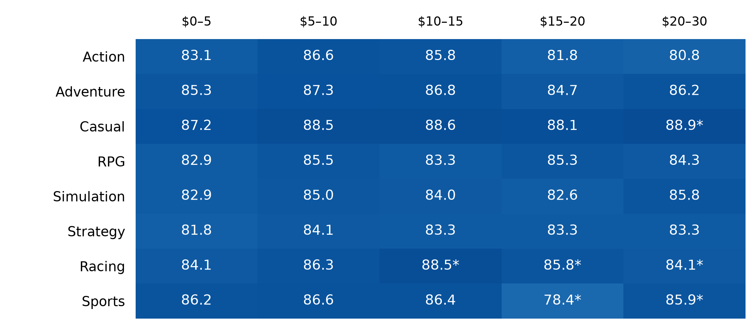
Median positive-review share (%) by recorded USD price. Zero prices and prices above $30 are omitted here. * Fewer than 30 entries; genre groups overlap.
Casual-labelled entries at $5–15 had median reception of 88.5–88.6%, compared with 83.3–84.1% for Strategy. These are comparisons between different games, not evidence that changing price improves reviews. Only 33 entries above $30 met the review minimum.

What achievements tell us
I grouped achievement counts, compared single-player with multiplayer and co-op, and then examined RPG, Strategy and Racing. Reception tiers were above 85%, 65–85% inclusive, and below 65%. The charts compare percentages within each tier so unequal sample sizes do not dominate.
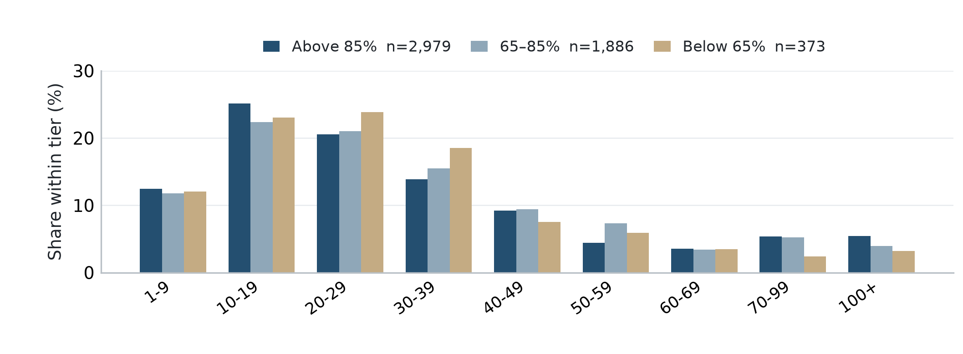
Single-player only by recorded labels. Zero-achievement entries are hidden only from this plot. Each tier totals 100% among its nonzero entries; ranges have unequal widths.

The findings
Games with 10–29 achievements were common in every reception tier. Finer ranges did not reveal a clear count that consistently separated highly rated games from poorly rated ones.
Genre changed the typical count. Among games with achievements, RPG and Strategy both had a median of 35, compared with 24 for Casual. Racing had only eight nonzero-achievement entries in the below-65% tier, making that distribution especially fragile.
For a developer, comparable games are useful references for achievement design. These results do not justify treating a fixed count as a formula for better reception.

Limits that matter
The file is not a complete, uniformly current Steam snapshot. The scraper skips stored games and combines Steam prices with SteamSpy review and discount fields. Collection dates are unknown, and zero values can reflect unavailable data. The date cutoff and filters narrow the sample; they do not repair those gaps. Review volume is not sales, and this analysis does not measure profit or establish causation.
Sources Steam Games Dataset on Kaggle | FronkonGames scraper
Made by: Ziyad Alali

