**Objective:** "To design and implement a robust and efficient control system using the Jetson Nano platform to precisely drive a NEMA 17 stepper motor and calibrate with the lsm303 sensor for applications requiring accurate positioning and motion control, while ensuring user-friendly interfacing and real-time feedback through integrated sensors. And developing the webserver with the chat-GPT integration."

**Technical challenges:**

* **Hardware Integration:** Ensuring that the Jetson Nano, the motor driver, and the NEMA 17 stepper motor are compatible is foundational. Misalignment in voltage, current, or communication protocols can lead to system failures or even damage to the components.
* **Software Development:** The control logic and algorithms running on the Jetson Nano are central to the project. Ensuring that the software is optimized, stable, and can effectively control the motor is crucial.
* **Power Management:** Both the Jetson Nano and the stepper motor have specific power requirements. Providing stable power without causing overheating or overloading is essential for the longevity and performance of the system.
* **Feedback Mechanism:** For applications requiring precise positioning or speed control, integrating and processing signals from feedback sensors accurately is vital. This ensures the motor operates as intended and can adjust based on real-time feedback.
* **Heat Dissipation:** Given the potential for significant heat generation from both the Jetson Nano and the stepper motor, effective heat management solutions are critical. Overheating can reduce component lifespan and affect system performance.

**Proposed methodology:**

1. **Requirement Analysis & System Design:**

Define the project's objectives, scope, and desired functionalities.

Choose appropriate components and create a detailed schematic of the system.

Estimate power requirements and design the initial software control algorithms.

2. **Prototyping & Initial Testing:**

Set up a basic version of the system on a prototyping platform.

Develop and test a prototype version of the control software.

Conduct initial functional tests to validate component compatibility and basic functionalities.

3. **Software Development & Integration:**

Refine the control algorithms based on initial tests.

Implement the algorithms on the Jetson Nano and integrate with the hardware setup.

Develop any necessary user interfaces and integrate feedback mechanisms.

4. **Optimization & Comprehensive Testing:**

Fine-tune the system for optimal performance.

Test the system under various conditions, including stress tests and feedback loop tests.

Implement and test solutions for challenges like heat management.

5**. Deployment & Documentation:**

Assemble the final system and transition from prototype to permanent setup.

Document the system's design, software, and provide a user manual.

This methodology provides a high-level overview, capturing the essential phases of the project in five main points.

**Software Tools:**

* Jet Pack SDK: NVIDIA's software suite for the Jetson Nano.
* Python or C++: For application development on the Jetson Nano.
* Android Studio: To develop the Android app that will send commands to the Jetson Nano.
* MQTT or WebSocket’s: Protocols that can be used for real-time communication between the Android device and the Jetson Nano over Wi-Fi.
* PWM Libraries: For stepper motor control.
* Git: For version control and collaboration.

**Hardware Platforms:**

* Jetson Nano: The main controller.
* NEMA 17 Stepper Motor: The motor to be controlled.
* Motor Driver: Such as DRV8825 or A4988.
* Power Supply: For the Jetson Nano and the stepper motor.
* Wi-Fi Module: If the Jetson Nano doesn't have built-in Wi-Fi, a USB Wi-Fi dongle or a Wi-Fi module like the Intel Dual Band Wireless-Ac 8265 can be used.
* Feedback Sensors (Optional): Like rotary encoders or limit switches.
* Breadboard and Jumper Wires: For initial setup and testing.
* Heat Sinks and Fans: For thermal management.
* Android Device: To send commands to the Jetson Nano.
* SD Card: For the Jetson Nano's OS and software storage.

**Android App Development:** Developed an Android app that allows users to send command to control the motor angle, rotation of direction to be either clockwise or anti-clockwise and then frequency and duty cycle. Also, the app will be able to receive the sensor data from the webserver and displays it on the app. This app can have a user-friendly interface with buttons, sliders, or other input mechanisms.

**Wireless Communication Setup:** Implement a wireless communication protocol (like MQTT or WebSocket’s) on both the Jetson Nano and the Android app to enable real-time data exchange.

**Security Measures:** Ensure that the wireless communication is secure. This can involve using encrypted communication, secure authentication methods, and regularly updating security protocols.

**RESULTS AND DELIVERABLES:**

The android app sends the motor control data to the webserver and the from the webserver the data is sent to the python code and controlled by the PWM, GPIO, I2C in the Jetson nano and then the motor spins according to the value defined by the user. Then the python script calculates the magnetometer and the accelerometer readings and sends the data to the webserver and the android app will be receiving the data from the server.

**Deliverables:**

1. Chatgpt
2. Webserver
3. WIFI
4. Android app
5. Integration of Jetson nano, stepper motor, lsm sensor

**Experience gained and Lessons learnt:**

Throughout the semester we learnt about the different CPU architecture and kernel OS. But the practical implementation of the course made it outstanding for us to learn with on-hands training experience. We learnt to create webserver and a chatgpt and also do a mobile application and control our motor integrated with Jetson Nano.

We faced lot of challenges during the implementation and each phase of integration was challenging. Also, we can expand the future scope of this project due to various applications.

**Work Distribution:**

**Procurement,documentationtesting:**Sindhuja & Prabhat **Stepper motor Integration:** Prabhat

* WIRELESS MOTOR CONTROL: Integrated a NEMA stepper motor for precise and controlled movements, and we will use LEDs for status indication for various modes like start, stop and standby modes… **Prabhat**
* INTERGRATION OF JETSON NANO: The Jetson Nano handles the motor control tasks while communicating seamlessly over Wi-Fi, providing a convenient and efficient way to remotely operate the motor…**Prabhat**
* INTERGRATION OF LSM303 SENSOR: The lsm sensor is mounted on top of the stepper motor and it gives the magnetometer readings and accelerometer readings...**Sindhu**
* SENSOR CALIBRATION: The sensor calibration was taken care to get the exact magnetometer readings…. **Prabhat**
* Wi-Fi COMMUNICATION: The focus is on developing a robust wireless control mechanism and integrate all components to work, ensuring seamless communication and data exchange…..**Sindhu**
* USER-FRIENDLY MOBILE APP INTERFACE: Users can control the motor wirelessly via a user-friendly mobile app interface….**Sindhu**

|  |  |  |
| --- | --- | --- |
| **Team Member** | **Responsibility** | **Contribution in %** |
| **Prabhat** | **Motor control intergration with Nano** | **90%** |
| **Sindhuja** | **Sensor intergration** | **80%** |
| **Prabhat** | **Sensor calibration** | **100%** |
| **Prabhat & Sindhuja** | **webserver** | **50% each** |
| **Prabhat** | **Chatgpt** | **100%** |
| **Sindhuja** | **Mobile App** | **100%** |
| **Prabhat & Sindhuja** | **One page Report** | **50% each** |
| **Prabhat & Sindhuja** | **Presentation** | **50%each** |
| **Sindhuja** | **Integration** |  |
| **Prabhat** | **Co-Ordinator** |  |
| **Prabhat** | **Miscellaneous** |  |

**Acknowledgement:**

We extend our heartfelt appreciation for your unwavering guidance and support throughout the duration of our embedded course project to Dr.Harry Li. Your expertise and encouragement have been invaluable as we embarked on the challenging task of designing and implementing a sophisticated control system using the Jetson Nano platform.

Furthermore, the integration of user-friendly interfaces and real-time feedback mechanisms through various sensors significantly enhanced the system's usability and performance. The development of the webserver and its integration with Chat-GPT added a layer of versatility and accessibility that we are immensely proud of.

We are profoundly grateful for your commitment to our growth and for igniting our passion for problem-solving in the realm of embedded systems.

**Appendix:**

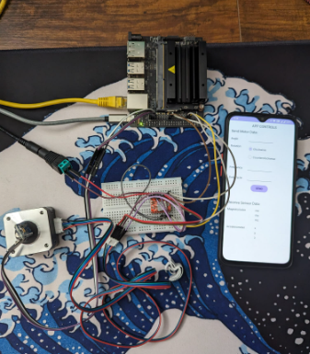

**Figure1: Hardware setup**

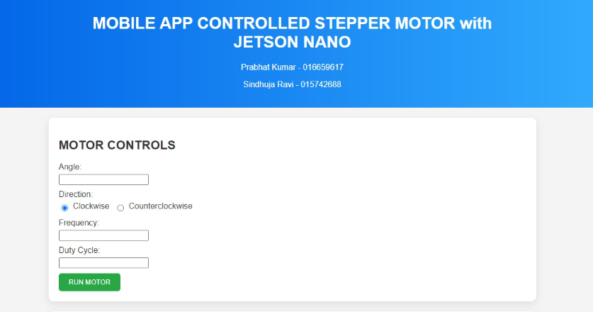

**Figure2: Website**

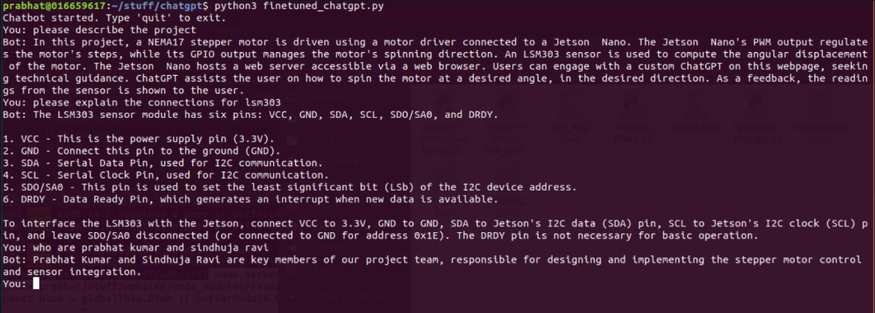

**Figure3: Chat-GPT integration**

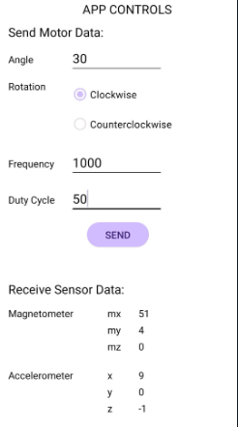

**Figure4: Android app**