Rochester Institute of Technology

Embedded Systems Design

Lab 6 – SDRAM and DMA

May 10, 2017

Zachary Weeden | zdw7287@rit.edu

**Overview**

We were tasked with designing a system I which input/generated audio was to be “recorded” and transferred from the audio codec to SDRAM by means of a created DMA controller. The design involved the creation of a DMA controller which acted as the intermediary between the codec and SDRAM. The SDRAM was to be external to the FPGA. Below are the corresponding block diagram and state machine to display the system’s functionality and behavior.

**Analysis/Design – Block Diagram**

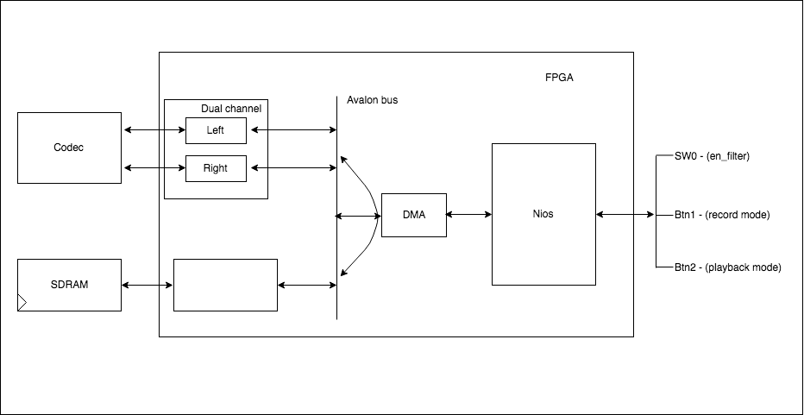

*Block diagram displaying components/modularity and connected signals*

Pictured in the block diagram, the audio codec is initialized and the DMA controller takes over processes to rid the real intended use of the Nios processor. Nios is used for the various physical connections onboard the FPGA such as switches and buttons. These are vital as they are what is used various state transition. The switch is to implement a feature designed in a previous lab in which the audio is attenuated by a low pass filter before output. The SDRAM, external to the FPGA is written to by the DMA controller.

**Analysis/Design – State Machine**

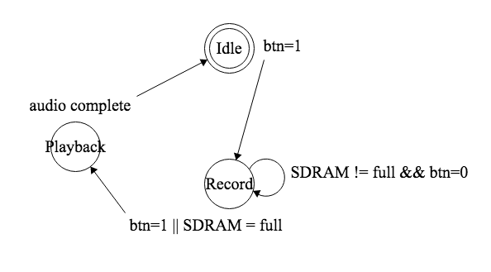

*State machine showing the record and playback states as well as state transitions*

The state machine diagram shows the state at any given time with the idle state being and end state. Whilst in the idle state, button 1 is pressed to transition into the record state which will be the current state until either the SDRAM is full or if button 2 is pressed. This means that a continuous check, and validation is performed for the given memory address that is to be written to by the DMA controller in this state. Upon either of these conditions, the playback state is entered in which the complete audio sample is played. This is either the contents of the SDRAM or, if switch 0 is toggled, the filtered, attenuated contents. This is the simply the contents of the SDRAM routed through our previous designed three stage low pass filter.