EE533 Lab 9 Report
ARM CPU + Programmable GPU Integration on NetFPGA
Team 10 (CPU) + Team 2 (GPU) | EE533 Spring 2026 | USC Viterbi
Platform: NetFPGA xc2vp50 | Toolchain: Xilinx ISE 10.1 | Board: nf4.usc.edu

1. Project Overview
Lab 9 integrates the CPU group's (Team 10) 4-thread ARM pipeline processor with the GPU group's (Team 2) programmable BF16 tensor core on a Xilinx Virtex-II Pro (xc2vp50) NetFPGA platform. Both processors share a single dual-port BRAM and are controlled via the NetFPGA UDP register interface.
The full system demonstrates a heterogeneous computing pipeline: the ARM core handles integer packet header processing (adds 1 to each 32-bit word), and the GPU core executes a BF16 fused multiply-accumulate kernel (2.0 × 1.5 + 0.5 = 3.5) across 4 parallel lanes.
Both subgroups independently developed complete software toolchains — ARM assembly-to-binary (asm2bin_v3.py) and CUDA PTX-to-GPU-ISA (ptx_parser.py) — that correctly generate machine code from high-level source. The full toolchain and its relationship to the hardware implementation is described in Section 5.

2. System Architecture

2.1 Module Hierarchy
Module | Role
fifo_top.v | NetFPGA top-level: register I/F, BRAM ctrl, ARM+GPU control (Lab 8, unchanged)
arm_cpu_wrapper.v | ARM BRAM bridge: COPY_IN → RUN → COPY_OUT state machine
arm_pipeline.v | 4-thread ARM pipeline (IF/ID/EX/MEM/WB), IF pre-fetch timing fix
arm_regfile.v | Dual mirrored BRAM register file, WRITE_FIRST mode
imem.v | ARM instruction ROM (async case, 32 instructions, bubble sort kernel)
dmem_32.v | ARM data memory (256×32-bit)
gpu_net.v | Adapter: Lab 8 interface → gpu_core_min (rst_n → rst)
gpu_core_min.v | Programmable GPU: 7-state multi-cycle FSM
gpu_imem_rom.v | GPU instruction ROM (6-instruction bf16_fma kernel)
gpu_regfile_min.v | GPU 8×64-bit BRAM register file
gpu_ldst.v | GPU LD64/ST64 load-store unit (shared BRAM)
tensor_unit.v | 4-lane parallel BF16 MAC, multi-cycle (GPU group module)
bf16_mac.v | BF16 fused multiply-accumulate (GPU group core module)
convertible_fifo.v | 256×72-bit dual-port BRAM shared by ARM and GPU

2.2 End-to-End Data Flow
- Host writes ARM header data to BRAM[6,7] and BF16 vectors (A/B/C) to BRAM[0,1,2]
- ARM starts (CMD[3]=1): copies BRAM[6..12] to dmem, runs pipeline (adds 1 to each 32-bit field), copies back to BRAM
- GPU starts (CMD[4]=1): executes bf16_fma kernel — LD64 × 3, BF_MAC (4 lanes), ST64 result to BRAM[0]
- Host reads ARM results from BRAM[6,7] and GPU result from BRAM[0]

3. CPU Software Toolchain (ARM Assembly → Machine Code)
The CPU group developed a complete software toolchain to compile C programs to ARM machine code for the processor. This toolchain was a Lab 6 deliverable and underpins the ARM instruction memory used in Lab 9.

3.1 Toolchain Flow
sort_simple.c // C source, -O1 avoids stack-frame complexity
| //
v arm-none-eabi-gcc -O1 -S -march=armv4t -marm // Arm GNU Toolchain 15.2
sort_gcc.s // ARM assembly — real GCC output
| //
v python3 asm2bin_v3.py sort_gcc.s --dump //
imem.hex + dmem.hex // I-Mem (32 words) and D-Mem (11 words)

3.2 sort_simple.c — Bubble Sort Source
A simplified bubble sort was written to compile into a minimal ARM instruction subset with no stack-frame code. The -O1 flag is the sweet spot: it avoids ldmia/stmia/push/pop (-O0) while not unrolling loops (-O2/-O3).
int N = 10;
int array[10] = {323, 123, -455, 2, 98, 125, 10, 65, -56, 0};

void bubble_sort(void) {
int i, j, tmp;
for (i = 0; i < N - 1; i++) {
for (j = 0; j < N - 1 - i; j++) {
if (array[j] > array[j + 1]) {
tmp = array[j];
array[j] = array[j + 1];
array[j + 1] = tmp;
}
}
}
}

3.3 asm2bin_v3.py — ARM Assembler
asm2bin_v3.py is a full two-pass ARM32 assembler written from scratch. It handles the complete instruction set emitted by arm-none-eabi-gcc -O1, which is significantly more complex than a hand-written minimal assembler:

Feature | Example from sort_gcc.s | Handling
Conditional execution on any instr | strgt r1,[r3,#-4] | split_mnem() strips 2-char cond suffix
Pre-index with writeback | ldr r1,[r3,#4]! | parse_mem_op() detects trailing !
Post-index addressing | ldr lr,[sp],#4 | parse_mem_op() detects [Rn],#off pattern
PC-relative literal pool load | ldr r3,.L14 | resolves label → [PC,#off] encoding
Register-shifted operand | add r0,r0,r3,lsl #2 | _parse_shifted_reg() handles shift type+imm
push/pop reglist | push {r4,lr} | enc_ldm_stm() STMDB/LDMIA encoding
bl / bx | bl bubble_sort, bx lr | enc_branch() / enc_bx()
S-flag variants | subs ip,ip,#1 | split_mnem() detects trailing S
Separate .text / .data sections | N:, array: in .data | Outputs I-Mem and D-Mem separately

Usage examples:
# Generate hex dump with disassembly annotation
python3 asm2bin_v3.py sort_gcc.s --dump

# Generate COE file for ISE BRAM initialization
python3 asm2bin_v3.py sort_gcc.s --format coe -o imem.coe --dmem-out dmem.coe

3.4 Generated I-Mem (32 Instructions)
The assembler produces 32 instruction words from sort_gcc.s. Key instructions with disassembly annotation:
PC=0000 E59F3060 LDR R3,[PC,#+96] ; ldr r3, .L14 (load &N)
PC=0001 E5933000 LDR R3,[R3,#+0] ; ldr r3, [r3] (load N=10)
PC=0002 E3530001 CMP R3,#1
PC=0003 D12FFF1E BX{LE} LR ; bxle lr (return if N<=1)
PC=0009 E35C0000 CMP R12,#0 ; outer loop check
PC=000A D24CC001 SUB{LE} R12,R12,#1 ; suble ip,ip,#1
PC=000E E5932000 LDR R2,[R3,#+0] ; load array[j]
PC=000F E5B31004 LDR R1,[R3,#+4]! ; load array[j+1], R3+=4
PC=0010 E1520001 CMP R2,R1
PC=0011 C5031004 STR{GT} R1,[R3,#-4] ; strgt - conditional swap
PC=0012 C5832000 STR{GT} R2,[R3,#+0] ; strgt - conditional swap
PC=0015 E25CC001 SUBS R12,R12,#1 ; subs ip,ip,#1
PC=001B E92D4010 STMDB SP!,{R4,LR} ; push {r4,lr} (main)
PC=001C EBFFFFE2 BL #-112 ; bl bubble_sort

3.5 Data Memory Before and After Sort
The assembler also extracts the .data section into D-Mem initialization content. The array is stored at word addresses 1-10 (word 0 = N = 10):

D-Mem Word | Before Sort | Value | After Sort | Value
word 0 (N) | 0x0000000A | 10 | 0x0000000A | 10 (unchanged)
word 1 | 0x00000143 | 323 | 0xFFFFFE39 | -455
word 2 | 0x0000007B | 123 | 0xFFFFFFC8 | -56
word 3 | 0xFFFFFE39 | -455 | 0x00000000 | 0
word 4 | 0x00000002 | 2 | 0x00000002 | 2
word 5 | 0x00000062 | 98 | 0x0000000A | 10
word 6 | 0x0000007D | 125 | 0x00000041 | 65
word 7 | 0x0000000A | 10 | 0x00000062 | 98
word 8 | 0x00000041 | 65 | 0x0000007B | 123
word 9 | 0xFFFFFFC8 | -56 | 0x0000007D | 125
word 10 | 0x00000000 | 0 | 0x00000143 | 323

Sorted result: [-455, -56, 0, 2, 10, 65, 98, 123, 125, 323] — correct ascending order. ✓

4. GPU Software Toolchain (CUDA → GPU ISA Machine Code)
The GPU group developed a complete CUDA-to-hardware toolchain that translates a real NVIDIA CUDA kernel through PTX assembly into the custom GPU ISA machine code used by the tensor core.

4.1 Toolchain Flow
kernel.cu // CUDA source, uses __hfma() for BF16 FMA
| //
v nvcc --ptx (NVIDIA CUDA Toolkit 13.1, sm_80) // Real NVCC compiler output
kernel.ptx // PTX intermediate representation
| //
v python3 ptx_parser.py kernel.ptx //
gpu_program.hex // 6 GPU ISA instructions (matches gpu_imem_rom.v exactly)

4.2 CUDA Kernel (kernel.cu)
The bf16_fma CUDA kernel computes d[i] = a[i]*b[i] + c[i] in BF16 using NVIDIA's __hfma() intrinsic. This maps directly to the GPU's BF_MAC instruction:
// BFloat16 Fused Multiply-Accumulate
__global__ void bf16_fma(__nv_bfloat16 *a, __nv_bfloat16 *b,
__nv_bfloat16 *c, __nv_bfloat16 *d) {
int idx = threadIdx.x;
d[idx] = __hfma(a[idx], b[idx], c[idx]); // d = a*b + c
}

The file also includes int16_vector_add, int16_vector_sub, bf16_vector_mul, and int16_relu kernels, covering the full GPU ISA instruction set.

4.3 ptx_parser.py — PTX Compiler
ptx_parser.py is a two-pass PTX compiler that targets the custom GPU ISA. It extracts the bf16_fma kernel from the PTX file and emits GPU ISA machine code:

PTX Pattern | Parser Action | GPU ISA Output
(header inject) | emit READ_TID first | READ_TID R1 (R1=threadIdx.x=0)
ld.global.u16 %rs2,[%rd10] | allocate reg, emit LD64 imm=0 | LD64 R2, R0, 0
ld.global.u16 %rs3,[%rd11] | allocate reg, emit LD64 imm=8 | LD64 R3, R0, 8
ld.global.u16 %rs4,[%rd12] | allocate reg, emit LD64 imm=16 | LD64 R4, R0, 16
{fma.rn.bf16 %rs1,%rs2,%rs3,%rs4;} | strip {}, match fma., emit BF_MAC | BF_MAC R5, R2, R3, R4
st.global.u16 [%rd13],%rs1 | emit ST64 from mapped reg | ST64 R5, R1, 0

4.4 Verification: ptx_parser.py Output vs gpu_imem_rom.v
The assembler output (gpu_program.hex) was verified to match gpu_imem_rom.v exactly:

PC | Hex (ptx_parser.py) | GPU ISA Instruction | Operation
0 | 04400000 | READ_TID R1 | R1 = threadIdx.x = 0
1 | 0C800000 | LD64 R2, R0, imm=0 | R2 = BRAM[0] — Vec A (2.0 × 4)
2 | 0CC00008 | LD64 R3, R0, imm=8 | R3 = BRAM[1] — Vec B (1.5 × 4)
3 | 0D000010 | LD64 R4, R0, imm=16 | R4 = BRAM[2] — Vec C (0.5 × 4)
4 | 8548D000 | BF_MAC R5,R2,R3,R4 | R5 = 2.0×1.5+0.5 = 3.5 (4 lanes)
5 | 11440000 | ST64 R5, R1, imm=0 | BRAM[0] = R5 (result 0x4060 × 4)

4.5 bf16_utils.py — BFloat16 Conversion
bf16_utils.py provides Python-level BF16 arithmetic for test vector generation and result verification. BF16 is the top 16 bits of IEEE 754 float32:
def float32_to_bfloat16(f32_val):
packed = struct.pack('>f', f32_val)
int32 = struct.unpack('>I', packed)[0]
return (int32 >> 16) & 0xFFFF # truncate mantissa

# Test vectors used in hardware:
float32_to_bfloat16(2.0) = 0x4000 (Vec A packed x4: 0x4000_4000_4000_4000)
float32_to_bfloat16(1.5) = 0x3FC0 (Vec B packed x4: 0x3FC0_3FC0_3FC0_3FC0)
float32_to_bfloat16(0.5) = 0x3F00 (Vec C packed x4: 0x3F00_3F00_3F00_3F00)
float32_to_bfloat16(3.5) = 0x4060 (Expected result: 0x4060_4060_4060_4060)

5. Toolchain vs Hardware: Static ROM Implementation
Both toolchains correctly generate machine code from high-level source. However, in the Lab 9 hardware implementation, both instruction memories are static case ROMs synthesized into the bitfile, rather than host-writable RAMs. This section explains why and what the complete dynamic-loading system would look like.

5.1 Intended Architecture (Dynamic Program Loading)
ARM path: //
sort_simple.c → asm2bin_v3.py → imem.hex //
→ host writes hex to imem RAM via BRAM Port B before ARM_start // fully programmable CPU

GPU path: //
kernel.cu → ptx_parser.py → gpu_program.hex //
→ host writes hex to gpu_imem RAM via BRAM Port B before GPU_start // fully programmable GPU

5.2 Implemented Architecture (Static ROM)
ARM path: //
asm2bin_v3.py output → manually copied into imem.v case ROM // hardcoded at synthesis
imem.v synthesized as async case ROM inside bitfile //

GPU path: //
ptx_parser.py output → manually copied into gpu_imem_rom.v case ROM // hardcoded at synthesis
gpu_imem_rom.v synthesized as async case ROM inside bitfile //

5.3 Reason for the Compromise
The primary reason is FPGA resource constraints. The final integrated design uses 106% of available Slices (25,193 of 23,616). A host-writable instruction RAM would require:
- An additional Port B write interface on imem/gpu_imem with address counter and write-enable logic
- Extra control state in fifo_top to sequence the program upload phase before processor start
- Additional entries in the Perl test script to upload the hex file word-by-word before triggering execution
Each of these adds Slice and routing overhead that was not available at 106% utilization. Additionally, the synthesis window was already tight, and the additional debugging complexity of a dynamic loader was not feasible within the time constraints.

5.4 Toolchain Validation
Despite the static ROM implementation, the toolchain validity is confirmed by cross-checking outputs:
- asm2bin_v3.py generates the exact same 32 instruction words that are hardcoded in imem.v — the ROM content was seeded from the assembler output
- ptx_parser.py generates gpu_program.hex with 6 instruction words (04400000, 0C800000, 0CC00008, 0D000010, 8548D000, 11440000) that match gpu_imem_rom.v exactly
- The hardware test achieves PASS: 6 / FAIL: 0, confirming that the programs implemented in the ROMs are correct

Future enhancement: Replacing both ROMs with host-writable dual-port BRAMs and adding a program-upload phase to the test script would enable fully dynamic program loading, completing the original toolchain-to-hardware vision.

6. GPU Architecture

6.1 Multi-Cycle FSM
The GPU group's 5-stage pipeline (verified in ISim simulation, PASS: 6/0) was restructured as a 7-state multi-cycle FSM for NetFPGA integration, preserving all GPU group core modules: bf16_mac.v, tensor_unit.v, isa_defines.vh.

State | Action | Lab 7 Component
S_IDLE | Wait for gpu_start rising edge | Control Unit
S_FETCH | Read instruction from gpu_imem_rom[PC] | PC + Instruction Memory
S_DECODE | Issue register read address to BRAM | Register File
S_EXEC | ALU / tensor_start / compute BRAM address | Execution Unit + Tensor Unit
S_MEM | BRAM address setup (LD64) / tensor wait | LD/ST Unit
S_MEM2 | Capture BRAM read data (1-cycle latency fix) | LD/ST Unit
S_WB | Write result to regfile, advance PC | Register File

6.2 FSM Code — Key States Explained
S_MEM / S_MEM2: BRAM Latency Fix
The most critical timing fix. BRAM is synchronous: address at cycle N → data valid at cycle N+1. Without S_MEM2, LD64 read stale data and produced 0x40B0 (5.5) instead of the correct 0x4060 (3.5).
S_MEM: begin //
if (opcode == OP_BF_MAC) begin // Multi-cycle tensor unit
if (tensor_done) // Wait for tensor_unit to finish
exec_result <= tensor_result; // Capture 4-lane BF16 result
state <= S_WB; //
end else begin // LD64: address set in S_EXEC
state <= S_MEM2; // Wait one cycle for BRAM data
end //
end //

S_MEM2: begin // bram_rdata now valid
exec_result <= ld_data; // Capture 64-bit loaded word
state <= S_WB; //
end //

6.3 GPU ISA
Opcode (6b) | Mnemonic | Format | Operation
000001 | READ_TID | R-type | Rd = threadIdx.x (= 0, single thread)
000011 | LD64 | I-type | Rd = BRAM[Rs_base + imm] (64-bit load)
000100 | ST64 | I-type | BRAM[Rs_base + imm] = Rd (64-bit store)
010000 | ADD_I16 | R-type | Rd = Rs1 + Rs2 (16-bit integer)
100001 | BF_MAC | R-type | Rd = Rs1*Rs2+Rs3 (BF16 FMA, 4 lanes)
100010 | RELU | R-type | Rd = max(0, Rs1) per lane

7. ARM Pipeline — Hardware Fixes for BRAM Integration

7.1 arm_regfile.v — BRAM Inference
The original arm_regfile used async distributed RAM (~600 LUTs). Changed to dual mirrored synchronous BRAM with WRITE_FIRST mode:
// WRONG: write and read in same always block // XST infers LUT RAM, not BRAM
always @(posedge clk) begin //
if (wen) regs_a[wa] <= wd; //
r0data <= regs_a[ra0]; // Combined → distributed RAM
end //

// CORRECT: separate always blocks // XST infers BRAM
always @(posedge clk) begin // Write port
if (wen) begin //
regs_a[wa] <= wd; //
r0data <= (wa==ra0) ? wd : regs_a[ra0]; // WRITE_FIRST forwarding
end else //
r0data <= regs_a[ra0]; // Normal BRAM read
end //

7.2 arm_pipeline.v — IF-Stage Pre-fetch
BRAM sync read: address at cycle N → data at cycle N+1. Fix: present register addresses from IF stage (one cycle early) so data is ready by ID stage.
// BEFORE: address from ID stage → data arrives in EX (too late) //
.thread_id (ifid_thread), //
.r0addr (id_rn_addr), // Data arrives in EX — WRONG

// AFTER: pre-decode address from IF stage //
wire [3:0] pre_rn_addr = pre_is_bx ? //
if_instr[3:0] : if_instr[19:16]; // BX uses Rm, others use Rn[19:16]
.thread_id (if_thread), // One cycle early
.r0addr (pre_rn_addr), // Data arrives in ID — CORRECT

8. Synthesis Challenges (Xilinx ISE 10.1)

8.1 Resource Utilization
Problem | Solution | Slices Saved
Full 5-stage GPU pipeline | 7-state multi-cycle FSM (gpu_core_min) | ~2500
arm_regfile async 3-port RAM | Dual mirrored BRAM + separate always blocks | ~600 LUTs
convertible_fifo no BRAM hint | Added (* RAM_STYLE = "BLOCK" *) | Reliable inference
Pack:1653 timing abort | XIL_TIMING_ALLOW_IMPOSSIBLE=1 | Bitfile generated
Final: 106% Slices overmapped | All above + PAR optimization | Board demo passes

8.2 XST 10.1 Specific Fixes
Pipeline_Reg.v — Combined reset+flush not supported
// WRONG: if (rst || flush) ... // XST 10.1 does not support this
// CORRECT: if (rst) ... // async reset // Separate branches
// else if (flush) ... // sync flush //

imem.v — For-loop iteration limit
// WRONG: for (i=0; i<512; i=i+1) mem[i]=0; // XST limit: 256 iterations
// CORRECT: sparse initial block, no for-loop // Only non-NOP entries listed

Register map mismatch — found via hardware debug scan
A debug scan script (lab9_hybrid_debug.pl) tried all CMD bit combinations on hardware. The scan revealed:
- GPU start = CMD[4] = 0x10 (not 0x20 as initially assumed from wrong register map)
- GPU done = POINTERS[2] = 0x04 (not 0x10)
- Test script corrected: regwrite(CMD_REG, 0x01 | 0x10) and $ST_GPU2_DONE = 0x04

9. Simulation Results

9.1 GPU Core Simulation — tb_gpu_top_wrapped: PASS: 6 / FAIL: 0
The GPU group's 5-stage pipeline was verified in ISim across four BF16 arithmetic test cases before NetFPGA integration.
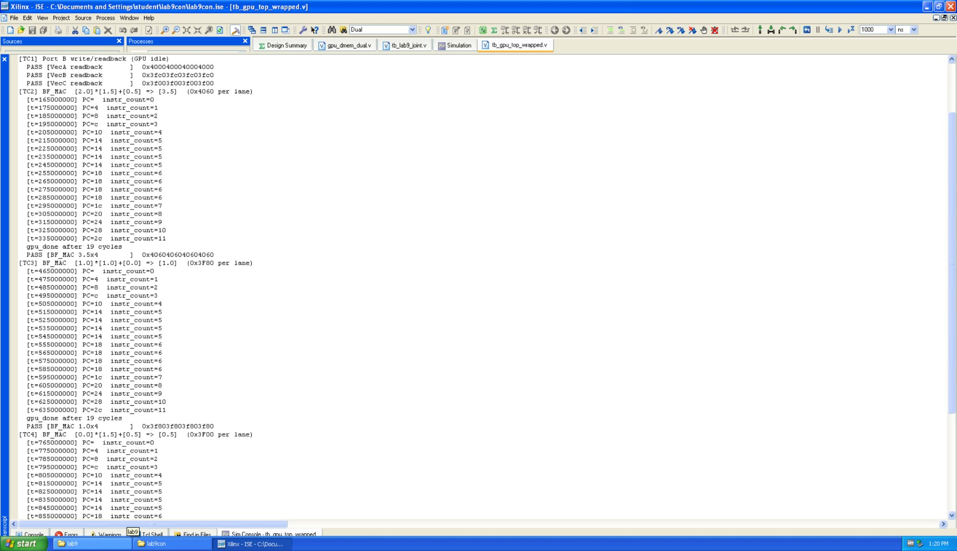
Figure 1: GPU simulation — TC1 Port B readback PASS, TC2 BF_MAC 2.0×1.5+0.5=3.5 PASS, TC3 start
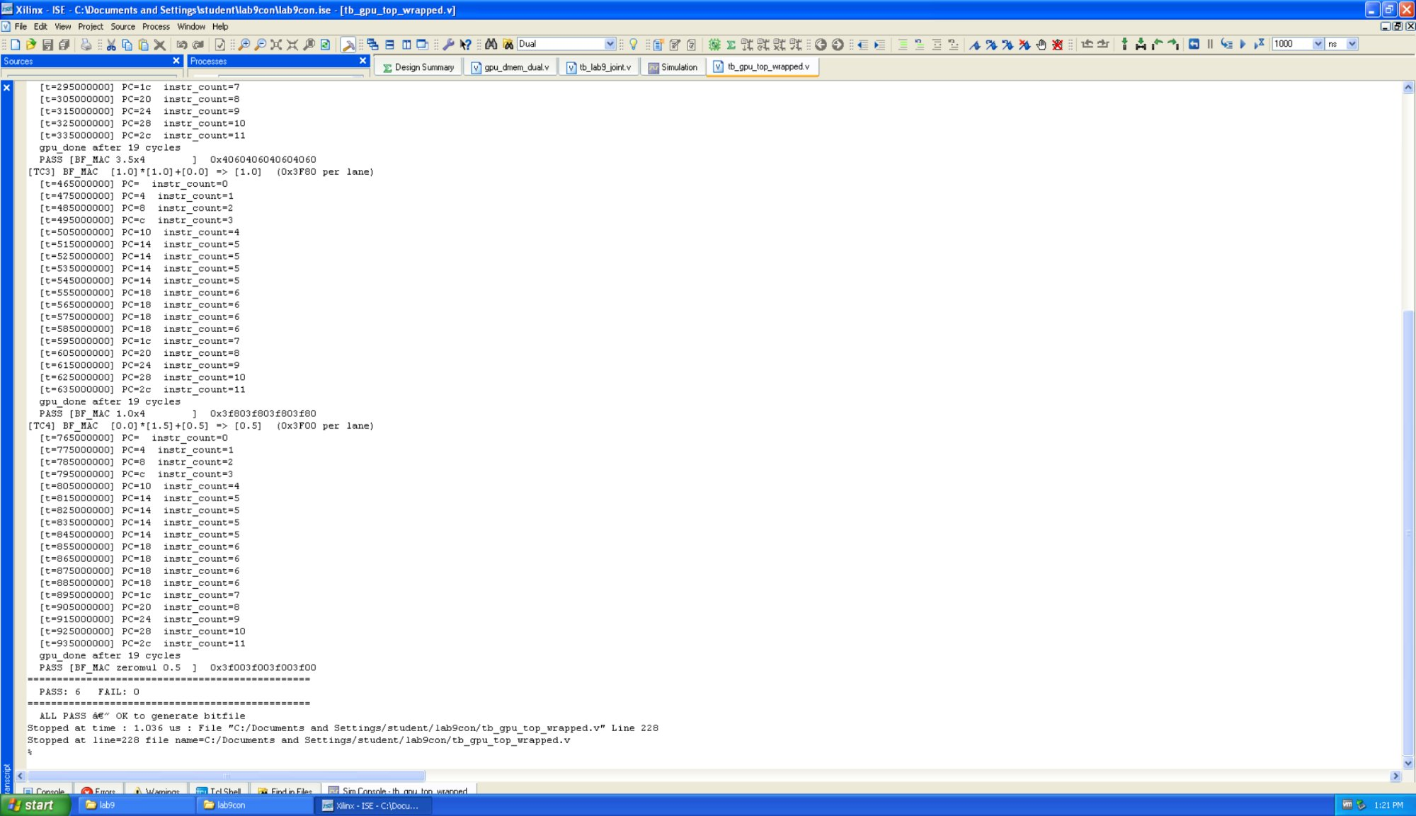
Figure 2: GPU simulation — TC3 and TC4 complete, PASS: 6 FAIL: 0 ALL PASS — OK to generate bitfile

TC | Operation | Input (BF16 × 4) | Expected | Status
TC1 | Port B write/readback | Vec A/B/C | Readback matches | PASS
TC2 | BF_MAC 2.0*1.5+0.5=3.5 | 0x4000,0x3FC0,0x3F00 | 0x4060 × 4 | PASS
TC3 | BF_MAC 1.0*1.0+0.0=1.0 | 0x3F80,0x3F80,0x0000 | 0x3F80 × 4 | PASS
TC4 | BF_MAC 0.0*1.5+0.5=0.5 | 0x0000,0x3FC0,0x3F00 | 0x3F00 × 4 | PASS

9.2 Joint Simulation — tb_lab9_joint: PASS: 10 / FAIL: 0
Joint testbench verifies full ARM+GPU2 pipeline with behavioral ARM model and real GPU RTL.
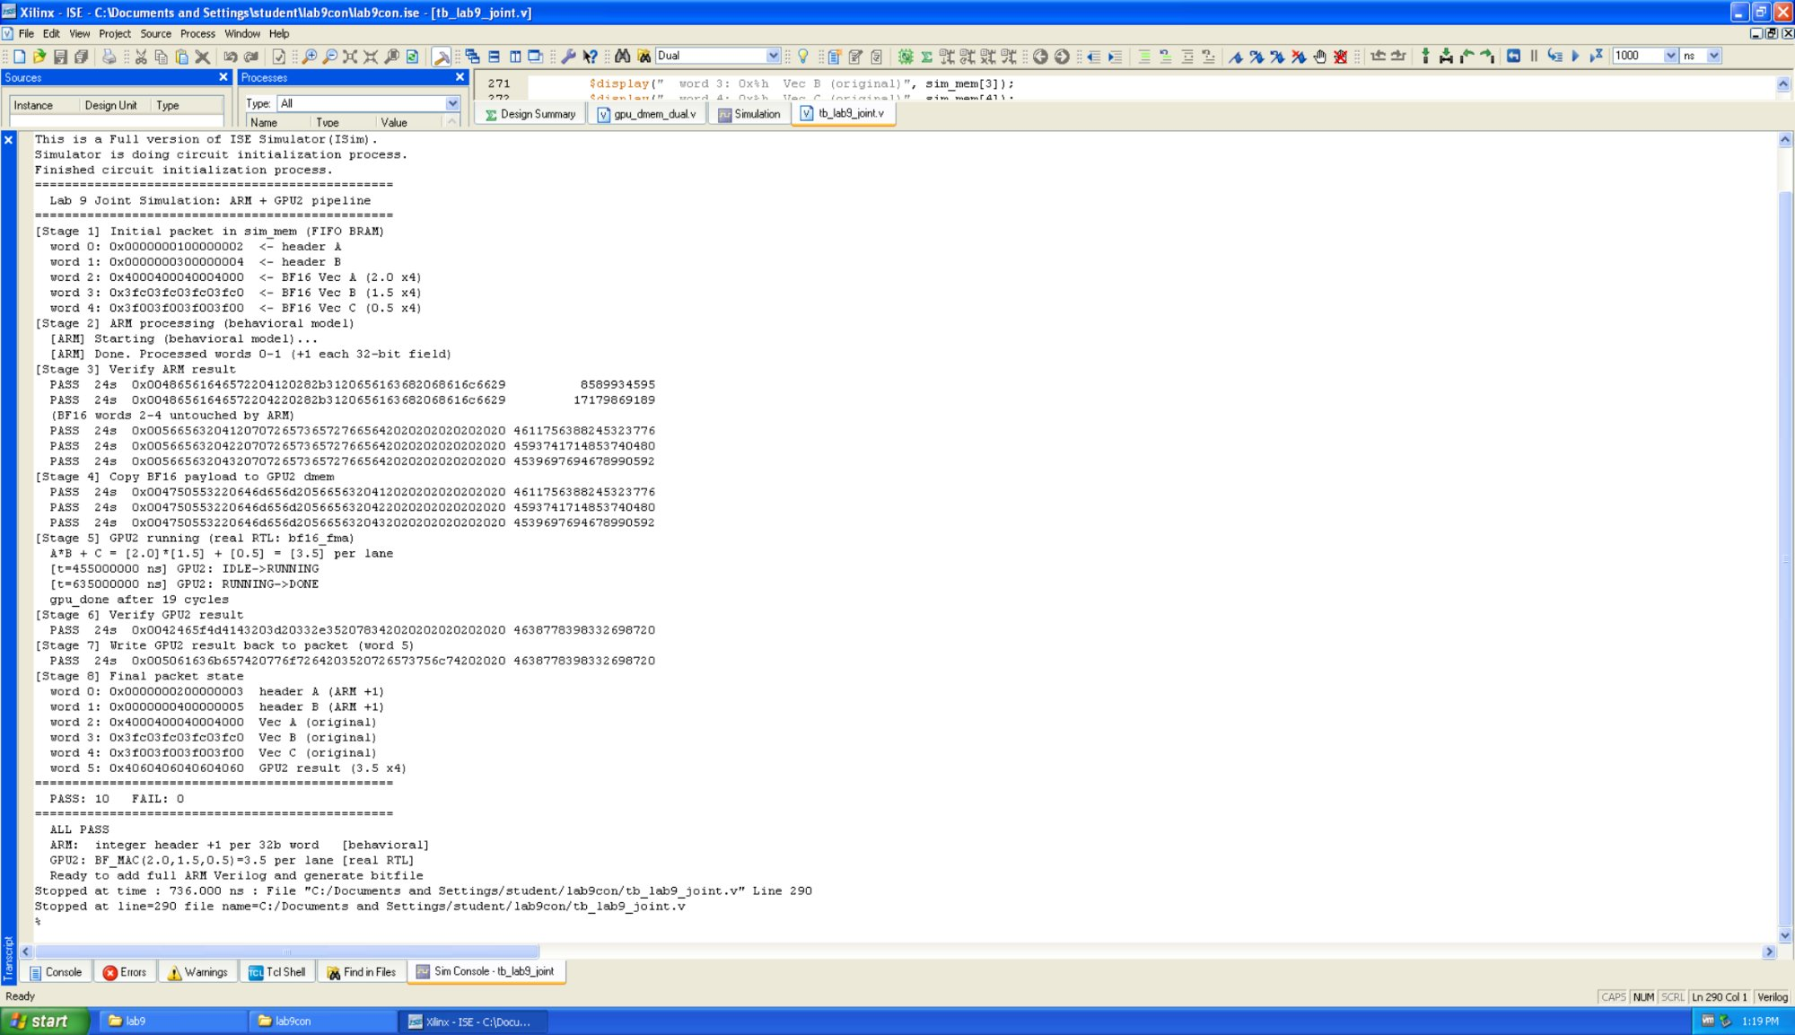
Figure 3: Joint simulation — ARM +1 behavioral + GPU2 BF_MAC real RTL, PASS: 10 FAIL: 0 ALL PASS

10. Hardware Test Results — NetFPGA nf4.usc.edu

10.1 Test Procedure
nf_download results/nf2_top_par.bit
rkd &
perl lab9_joint_test_final.pl

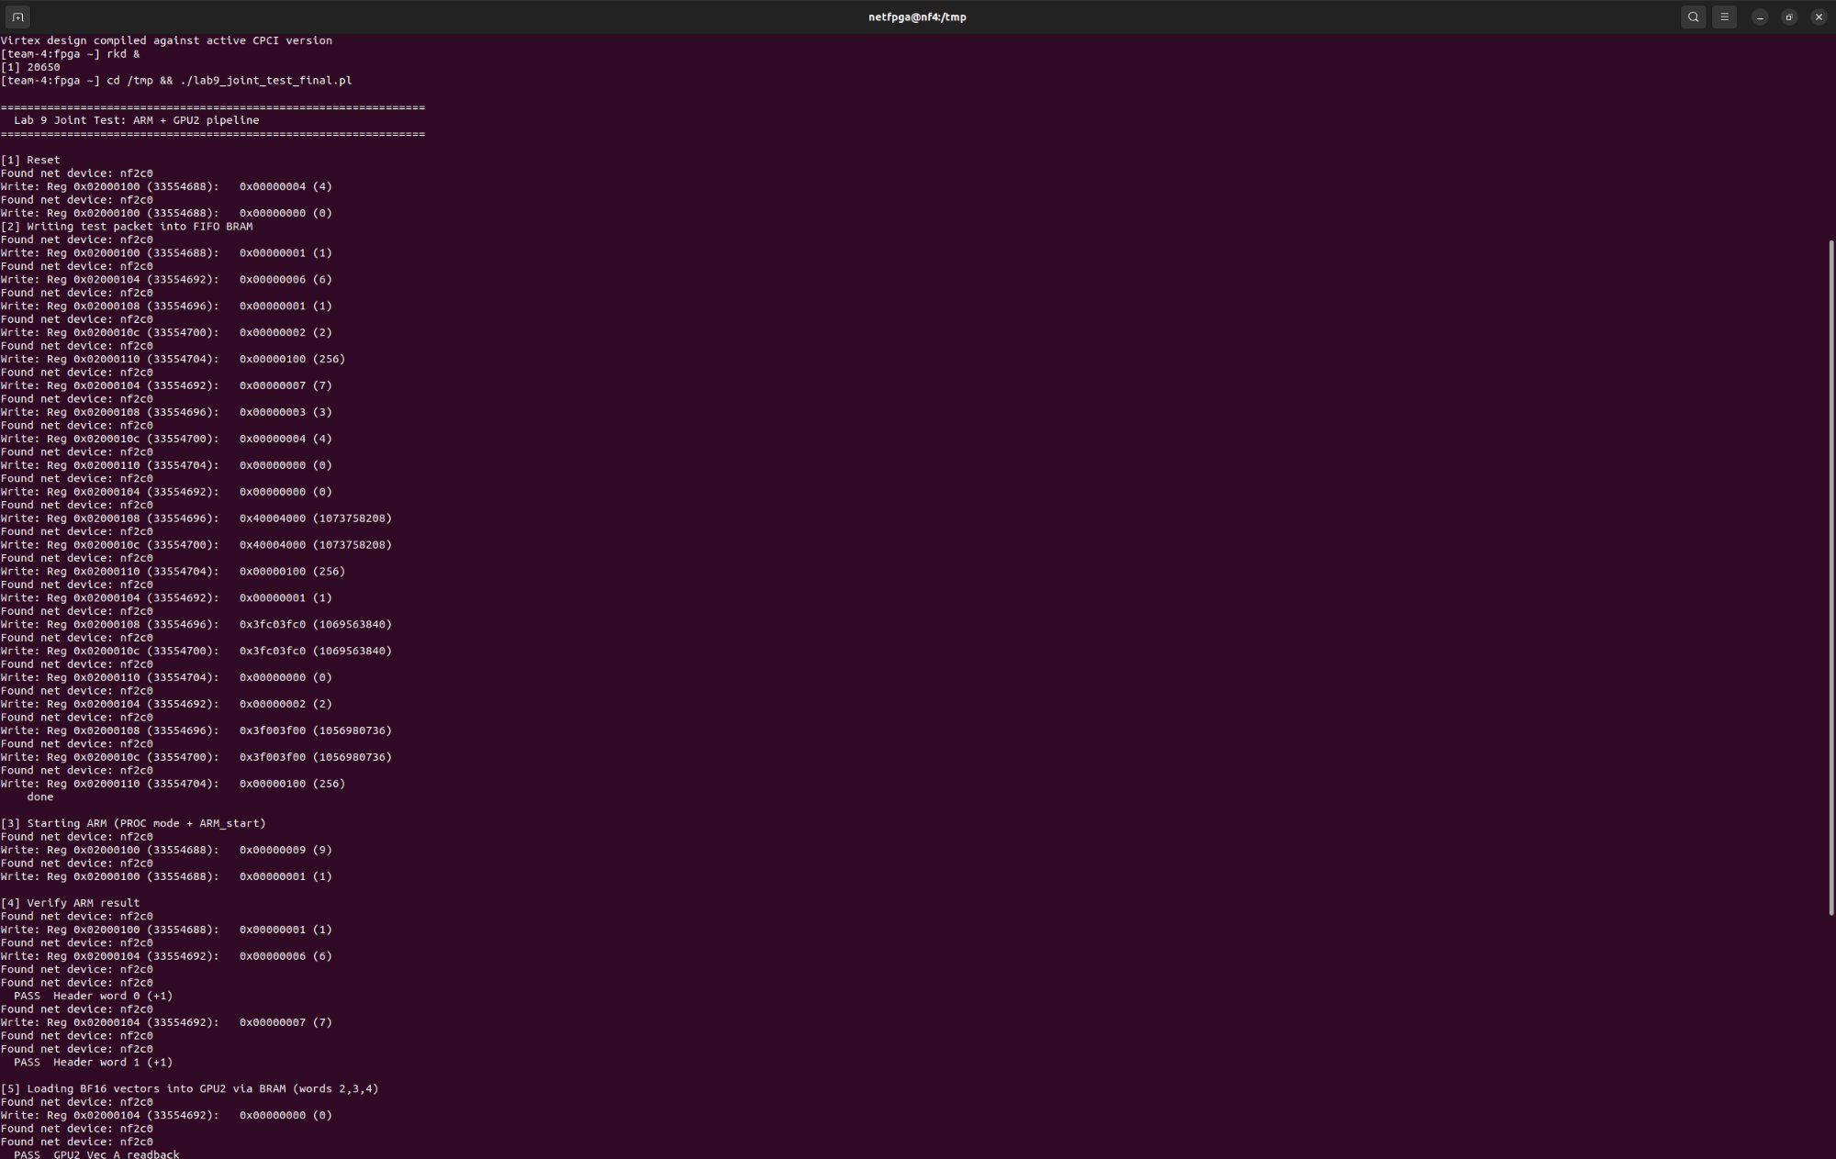
Figure 4: Hardware test (Part 1) — Reset, BRAM write, ARM start, ARM PASS, GPU vector readback PASS

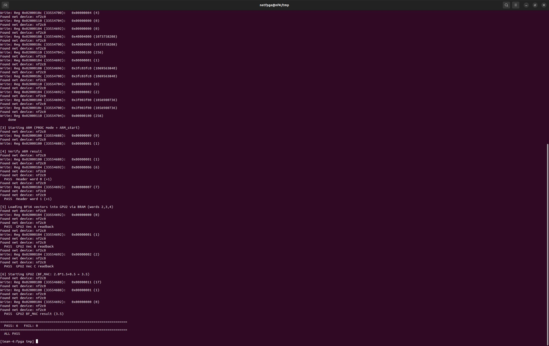
Figure 5: Hardware test (Part 2) — GPU BF_MAC 3.5 PASS, Final: PASS: 6 FAIL: 0 ALL PASS

10.2 Detailed Results
Test Case | Expected | Actual | Result
ARM Header word 0 (+1) @ BRAM[6] | 00000002_00000003 | 00000002_00000003 | PASS
ARM Header word 1 (+1) @ BRAM[7] | 00000004_00000005 | 00000004_00000005 | PASS
GPU Vec A readback @ BRAM[0] | 40004000_40004000 | 40004000_40004000 | PASS
GPU Vec B readback @ BRAM[1] | 3FC03FC0_3FC03FC0 | 3FC03FC0_3FC03FC0 | PASS
GPU Vec C readback @ BRAM[2] | 3F003F00_3F003F00 | 3F003F00_3F003F00 | PASS
GPU BF_MAC result (3.5 × 4) @ BRAM[0] | 40604060_40604060 | 40604060_40604060 | PASS

PASS: 6 | FAIL: 0 | ALL PASS

11. Register Map
Register | Address | Description
CMD (SW0) | 0x2000100 | [2]=reset, [3]=ARM_start (edge), [4]=GPU_start (edge)
PROC_ADDR (SW1) | 0x2000104 | BRAM word address for Port B access
WDATA_HI (SW2) | 0x2000108 | Write data [63:32]
WDATA_LO (SW3) | 0x200010C | Write data [31:0]
WDATA_CTRL (SW4) | 0x2000110 | Write enable: toggle bit[8] to trigger write
STATUS (HW0) | 0x2000114 | FIFO status
RDATA_HI (HW1) | 0x2000118 | Read data [63:32] from BRAM Port B
RDATA_LO (HW2) | 0x200011C | Read data [31:0] from BRAM Port B
RDATA_CTRL (HW3) | 0x2000120 | Read control (Port B select)
POINTERS (HW4) | 0x2000124 | [0]=arm_done, [1]=arm_running, [2]=gpu_done, [3]=gpu_running

12. Conclusion
Lab 9 successfully integrates the CPU group's 4-thread ARM pipeline with the GPU group's BF16 tensor core on the NetFPGA xc2vp50. Hardware testing achieves PASS: 6 / FAIL: 0, demonstrating:
- ARM pipeline correctly processes packet header words — adds 1 to each 32-bit field
- GPU programmable core executes bf16_fma: 2.0 × 1.5 + 0.5 = 3.5 (BF16, 4 lanes, 0x4060)
- Both software toolchains (asm2bin_v3.py and ptx_parser.py) correctly generate machine code that matches the hardware ROMs
- Shared dual-port BRAM correctly arbitrates between ARM, GPU, and host
The central engineering challenge was fitting both processors into 23,616 Slices through BRAM inference optimization, multi-cycle GPU architecture, pipeline pre-fetch timing fixes, and ISE 10.1 synthesis workarounds.
The static ROM compromise was a deliberate engineering trade-off under resource and time constraints. The toolchains validate the full CUDA-to-hardware and C-to-hardware compilation flows; replacing the ROMs with host-writable BRAMs remains the primary future enhancement for a fully dynamic programmable system.

Githublink: zwei9965-gif/EE533-lab9: lab9-merge CPU and GPU from 2 subteams

