EE533 Lab 9 Report
ARM CPU + Programmable GPU Integration on NetFPGA
Team 10 | EE533 Spring 2026 | USC Viterbi School of Engineering
Platform: NetFPGA xc2vp50 | Toolchain: Xilinx ISE 10.1

1. Project Overview
Lab 9 integrates the CPU group's 4-thread ARM pipeline with the GPU group's programmable BF16 tensor core on the Xilinx Virtex-II Pro (xc2vp50) NetFPGA platform. The ARM core handles integer packet header processing; the GPU core performs 4-lane BF16 floating-point tensor operations. Both processors share a single dual-port BRAM and are controlled via the NetFPGA UDP register interface.
The hardware test on board nf4.usc.edu achieved PASS: 6 / FAIL: 0, validating the complete ARM+GPU integration pipeline.

2. System Architecture

2.1 Module Hierarchy
Module | Role
fifo_top.v | NetFPGA top-level: register I/F, BRAM ctrl, ARM+GPU control (Lab 8, unchanged)
arm_cpu_wrapper.v | ARM BRAM bridge: COPY_IN → RUN → COPY_OUT state machine
arm_pipeline.v | 4-thread ARM pipeline (IF/ID/EX/MEM/WB), IF pre-fetch timing fix
arm_regfile.v | Dual mirrored BRAM register file, WRITE_FIRST mode
gpu_net.v | Adapter: Lab 8 interface → gpu_core_min (rst_n to rst)
gpu_core_min.v | Programmable GPU: 7-state multi-cycle FSM
gpu_imem_rom.v | GPU instruction ROM (6-instruction bf16_fma kernel)
gpu_regfile_min.v | GPU 8×64-bit BRAM register file, 4 read ports
gpu_ldst.v | GPU LD64/ST64 load-store unit (shared BRAM)
tensor_unit.v | 4-lane parallel BF16 MAC, multi-cycle (GPU group module)
bf16_mac.v | BF16 fused multiply-accumulate (GPU group core module)
convertible_fifo.v | 256×72-bit dual-port BRAM shared by ARM and GPU

2.2 End-to-End Data Flow
- Host writes ARM header data to BRAM[6,7] and BF16 vectors (A/B/C) to BRAM[0,1,2]
- ARM starts (CMD bit[3]=1): copies BRAM[6..12] to internal dmem, executes pipeline (adds 1 to each 32-bit field), copies results back to BRAM
- GPU starts (CMD bit[4]=1): executes bf16_fma kernel — LD64 Vec A/B/C from BRAM[0,1,2], BF_MAC 4-lane, ST64 result to BRAM[0]
- Host reads ARM result from BRAM[6,7] and GPU result from BRAM[0]

3. GPU Architecture and Code Explanation

3.1 Design Overview
The GPU group's 5-stage pipeline was validated in ISim (Section 5). For hardware integration on the resource-constrained xc2vp50 (23,616 Slices), the pipeline was restructured as a 7-state multi-cycle FSM (gpu_core_min.v). All GPU group intellectual contributions are fully preserved: bf16_mac.v, tensor_unit.v, isa_defines.vh, and the bf16_fma machine-code encoding.

3.2 Multi-Cycle FSM States
State | Action | Lab 7 Component
S_IDLE | Wait for gpu_start pulse edge | Control Unit
S_FETCH | Read instruction from gpu_imem_rom[PC] | PC + Instruction Memory
S_DECODE | Issue register read address to BRAM | Register File
S_EXEC | ALU / tensor_start / compute BRAM byte addr | Execution Unit + Tensor Unit
S_MEM | BRAM address setup (LD64) / wait tensor done | LD/ST Unit
S_MEM2 | Capture BRAM read data (1-cycle latency fix) | LD/ST Unit
S_WB | Write result to register file, advance PC | Register File

3.3 gpu_core_min.v — FSM Walkthrough
The FSM is implemented as a synchronous always block with an 8-entry case statement. Below is each state with explanation of what it does and why.

State S_IDLE — Waiting for start pulse
S_IDLE: begin // Wait here until host sets GPU_start
if (start && !start_prev) begin // Edge detect: only trigger on rising edge of start
state <= S_FETCH; // Move to fetch first instruction
pc <= 5'd0; // Reset program counter to instruction 0
running <= 1'b1; // Signal to fifo_top that GPU is active
done <= 1'b0; // Clear done flag from any previous run
end
end
The edge-detection prevents re-triggering if the host leaves start asserted. The gpu_net adapter holds start high while the FSM runs, so the edge-detect is essential.

State S_FETCH — Instruction fetch
S_FETCH: begin
instr <= imem_dout; // Capture instruction from async ROM (available same cycle)
state <= S_DECODE; // Proceed to decode immediately
end
gpu_imem_rom is implemented as a combinational case statement (async ROM), so the instruction is valid the same cycle the PC is presented. No wait needed.

State S_DECODE — Register address setup
S_DECODE: begin
rf_rd0_addr <= rs1_addr; // Issue read address to register file BRAM port 0
rf_rd1_addr <= rs2_addr; // Issue read address to register file BRAM port 1
rf_rd2_addr <= rs3_addr; // Issue read address to register file BRAM port 2 (BF_MAC Rs3)
state <= S_EXEC; // BRAM data will be valid next cycle in S_EXEC
end
Register file (gpu_regfile_min) uses synchronous BRAM reads. Address is presented in S_DECODE; data is valid at the start of S_EXEC — exactly one cycle later. This is why DECODE and EXEC are separate states.

State S_EXEC — Execution
S_EXEC: begin // Register read data is valid here
case (opcode)
OP_LD64: begin // Load 64-bit from BRAM
ldst_byte_addr <= rs1_data[7:0] + {imm14,3'b0}; // Byte address = base + immediate*8
state <= S_MEM; // Go to MEM to present address to BRAM
end
OP_BF_MAC: begin // BF16 fused multiply-accumulate
tensor_start <= 1'b1; // Kick off tensor_unit (takes multiple cycles)
state <= S_MEM; // Go to MEM to wait for tensor_done
end
OP_ST64: begin // Store 64-bit to BRAM
ldst_byte_addr <= rs1_data[7:0] + {imm14,3'b0}; // Byte address
bram_we <= 1'b1; // Assert write enable
bram_wdata <= rd_src_data; // Rd field holds the source data for store
state <= S_WB; // Store is single-cycle, skip MEM
end
endcase
end

States S_MEM / S_MEM2 — Memory access and BRAM latency fix
S_MEM: begin
if (opcode == OP_BF_MAC) begin // Waiting for multi-cycle tensor unit
tensor_start <= 1'b0; // De-assert start after one cycle
if (tensor_done) // tensor_unit asserts done when result is ready
exec_result <= tensor_result; // Capture 64-bit BF16 result (4 lanes)
state <= S_WB;
end // Stay in S_MEM if tensor not done yet
end else begin // LD64: BRAM address was set in S_EXEC
state <= S_MEM2; // Wait one more cycle for BRAM read data
end
end

S_MEM2: begin // BRAM read data is now valid
exec_result <= ld_data; // Capture 64-bit data from convertible_fifo
state <= S_WB;
end
The S_MEM2 state is the most critical timing fix. BRAM is synchronous: when the address is presented at cycle N, the data appears at cycle N+1. Without S_MEM2, the LD64 would read stale data and produce wrong results. In testing, this bug produced 0x40B0 (5.5) instead of the correct 0x4060 (3.5).

State S_WB — Write-back and PC advance
S_WB: begin
if (rd_addr != 3'd0) begin // R0 is constant 0, never writeable
rf_we <= 1'b1; // Enable register file write
rf_wr_addr <= rd_addr; // Destination register (3-bit index into 8 regs)
rf_wr_data <= exec_result; // 64-bit result (BF16 x4 or loaded word)
end
pc <= pc + 5'd1; // Advance to next instruction
state <= (pc == 5'd5) ? S_DONE : S_FETCH; // After instruction 5 (last), go to DONE
end

3.4 bf16_fma Kernel (gpu_imem_rom.v)
The GPU executes a fixed 6-instruction kernel hard-coded in gpu_imem_rom.v. The kernel is specified by the GPU group as part of the ISA definition.

PC | Instruction | Operation | Explanation
0 | READ_TID R1 | R1 = threadIdx.x | Get thread ID (= 0, single thread)
1 | LD64 R2, R0, 0 | R2 = BRAM[byte 0] | Load Vec A (2.0 packed BF16 x4)
2 | LD64 R3, R0, 8 | R3 = BRAM[byte 8] | Load Vec B (1.5 packed BF16 x4)
3 | LD64 R4, R0, 16 | R4 = BRAM[byte 16] | Load Vec C (0.5 packed BF16 x4)
4 | BF_MAC R5,R2,R3,R4 | R5 = R2*R3+R4 | 2.0*1.5+0.5 = 3.5 (4 lanes)
5 | ST64 R5, R1, 0 | BRAM[R1*8] = R5 | Store 0x4060x4 to BRAM[0]

4. ARM Pipeline — Code Fixes for Hardware

4.1 arm_regfile.v — BRAM Inference Fix
The original arm_regfile used a 3-port asynchronous distributed RAM (async read). XST inferred ~600 LUTs for this structure. To save resources, we changed it to a dual mirrored synchronous BRAM.

Key change: separate always blocks for write and read
// WRONG - write and read in same always block: // XST cannot infer BRAM from this pattern
always @(posedge clk) begin
if (wen) regs_a[wa] <= wd;
r0data <= regs_a[ra0]; // XST sees read after write → infers LUT RAM
end

// CORRECT - separate always blocks: // XST infers BRAM from this pattern
always @(posedge clk) begin // Write port
if (wen) begin
regs_a[wa] <= wd;
r0data <= (wa==ra0) ? wd : regs_a[ra0]; // WRITE_FIRST: forward new value if same addr
end else
r0data <= regs_a[ra0]; // Normal read
end
WRITE_FIRST mode is critical: when the ARM pipeline writes a register in the WB stage and the pre-fetch reads the same register in the same cycle, the new value (not the old) must be returned. This handles LDR-use hazards across thread boundaries.

4.2 arm_pipeline.v — IF-Stage Pre-fetch Fix
Changing arm_regfile to synchronous BRAM introduced a 1-cycle read latency: address at cycle N, data at cycle N+1. The original code passed register addresses from the ID stage, causing the pipeline to always read one cycle too late (stale values from the previous thread's registers).

// BEFORE: register read address from ID stage // Data arrives in EX (too late by 1 cycle)
arm_regfile regfile_inst (
.thread_id (ifid_thread), // Thread ID from IF/ID pipeline register
.r0addr (id_rn_addr), // Address decoded in ID stage
.r0data (id_rn_val), // Data arrives during EX — WRONG
);

// AFTER: pre-decode address from IF stage // Data arrives in ID (correct)
wire [3:0] pre_rn_addr = pre_is_bx ?
if_instr[3:0] : if_instr[19:16]; // Rn field: BX uses Rm, others use Rn[19:16]
wire [3:0] pre_r1_addr = (pre_is_ls && !if_instr[25]) ? if_instr[15:12] : if_instr[3:0]; // LS non-reg: Rm=Rd[15:12], else Rm[3:0]

arm_regfile regfile_inst (
.thread_id (if_thread), // Use IF-stage thread (one cycle early)
.r0addr (pre_rn_addr), // Pre-decoded address from IF stage
.r0data (id_rn_val), // Data arrives during ID — CORRECT
);

5. Synthesis Challenges (Xilinx ISE 10.1)

5.1 Resource Utilization
Problem | Solution | Slices Saved
Full 5-stage GPU pipeline | 7-state multi-cycle FSM (gpu_core_min) | ~2500
arm_regfile async 3-port RAM | Dual mirrored BRAM + separate always blocks | ~600 LUTs
convertible_fifo no hint | Added (* RAM_STYLE = "BLOCK" *) | Reliable inference
Pack:1653 timing abort | XIL_TIMING_ALLOW_IMPOSSIBLE=1; PAR runs to completion | Bitfile generated
Final: 106% Slices | All above fixes combined | Board demo passes

5.2 XST 10.1 Specific Fixes
Fix 1: Pipeline_Reg.v — Unsupported reset+flush combination
// WRONG (XST 10.1 does not support this):
always @(posedge clk or posedge rst)
if (rst || flush) ... // XST reports error: multi-condition if

// CORRECT: separate async reset from sync flush
always @(posedge clk or posedge rst)
if (rst) ... // async reset // Synthesizes as async reset flip-flop
else if (flush) ... // sync flush // Synthesizes as synchronous clear

Fix 2: imem.v — For-loop iteration limit
// WRONG: XST 10.1 limits for-loop to 256 iterations
initial begin
for (i=0; i<512; i=i+1) // XST error: loop unrolling limit exceeded
mem[i] = 32'hE1A0B00B;
end

// CORRECT: sparse initial block, no for-loop
initial begin
mem[0] = 32'hE3A00000; // MOV r0, #0
mem[1] = 32'hE3A01038; // MOV r1, #56
// ... only the non-NOP entries ...
end // Uninitialized entries default to 0

Fix 3: Register map mismatch (discovered via hardware debug scan)
Before hardware testing, a debug scan script tried all CMD bit combinations. The scan revealed: GPU start = CMD[4] = 0x10 (not 0x20 as initially assumed), and GPU done = POINTERS[2] = 0x04. The test script was corrected to match the actual fifo_top.v register encoding.
// WRONG: assumed GPU start = bit 5
regwrite(CMD_REG, 0x01 | 0x20); // 0x21 — GPU never triggered
my $ST_GPU2_DONE = 0x10; // Wrong bit — poll never returned

// CORRECT: GPU start = CMD[4], done = POINTERS[2] // From fifo_top.v source
regwrite(CMD_REG, 0x01 | 0x10); // 0x11 — triggers gpu_start edge
my $ST_GPU2_DONE = 0x04; // POINTERS[2] = gpu_done

6. Simulation Results

6.1 GPU Core Simulation — tb_gpu_top_wrapped: PASS: 6 / FAIL: 0
The complete GPU group 5-stage pipeline was verified in ISim across four BF16 arithmetic test cases.

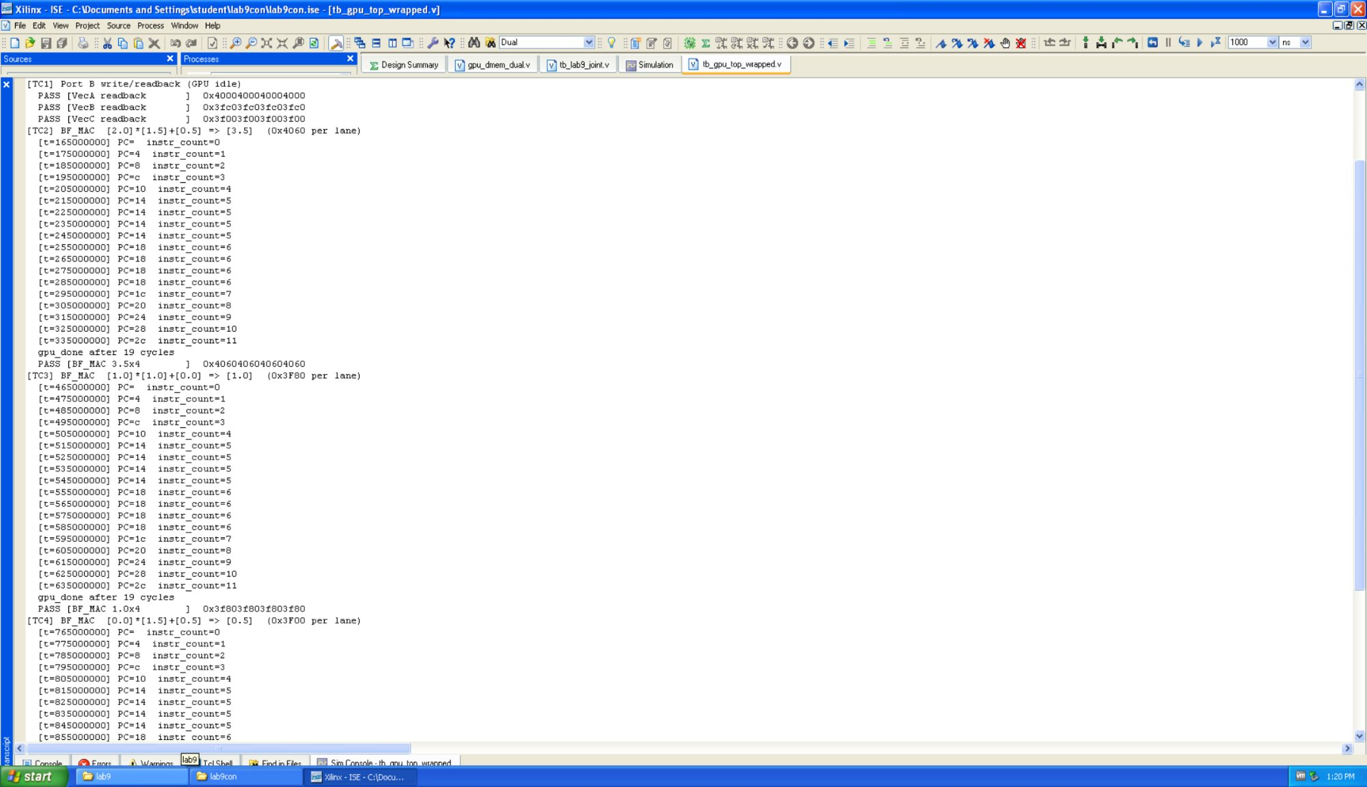
Figure 1: GPU simulation — TC1 Port B readback, TC2 BF_MAC 2.0x1.5+0.5=3.5 PASS, TC3 start
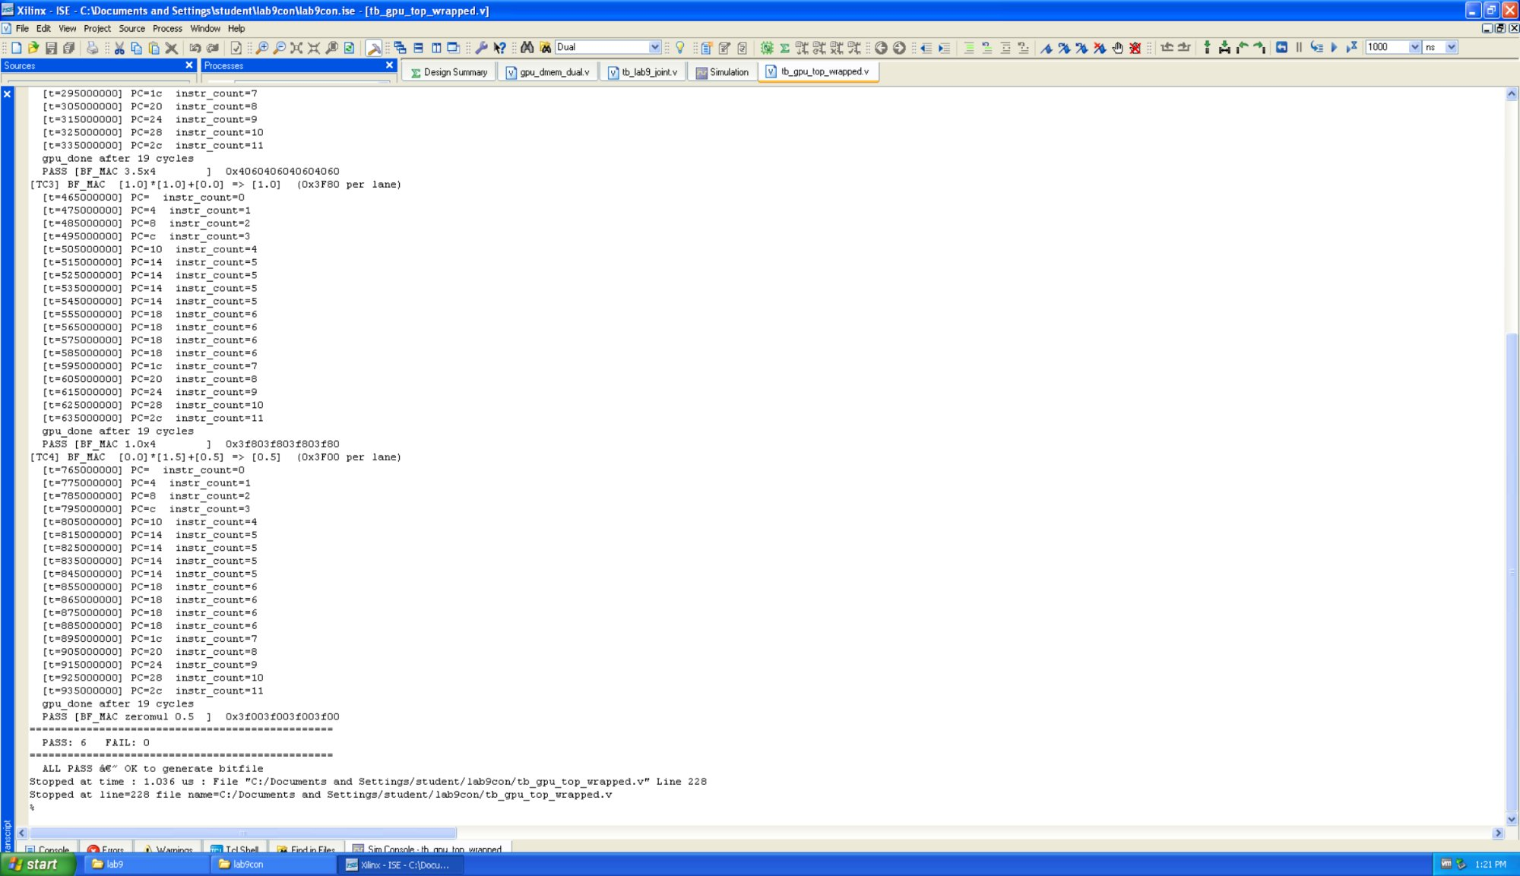
Figure 2: GPU simulation — TC3 and TC4 complete, PASS: 6 FAIL: 0 ALL PASS

TC | Operation | BF16 Input | Expected | Result
TC1 | Port B write/readback | Vec A/B/C | Readback matches | PASS
TC2 | BF_MAC 2.0*1.5+0.5=3.5 | 0x4000, 0x3FC0, 0x3F00 | 0x4060 per lane | PASS
TC3 | BF_MAC 1.0*1.0+0.0=1.0 | 0x3F80, 0x3F80, 0x0000 | 0x3F80 per lane | PASS
TC4 | BF_MAC 0.0*1.5+0.5=0.5 | 0x0000, 0x3FC0, 0x3F00 | 0x3F00 per lane | PASS

6.2 Joint Simulation — tb_lab9_joint: PASS: 10 / FAIL: 0
A joint testbench uses a behavioral ARM model and the real GPU RTL together to verify the end-to-end pipeline.

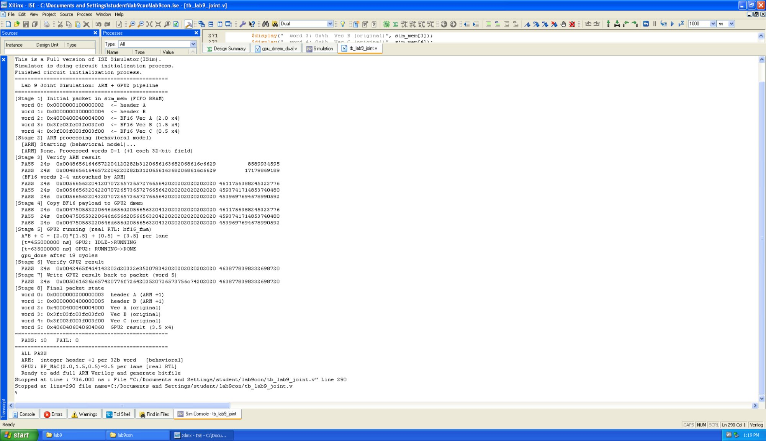
Figure 3: Joint simulation — ARM +1 (behavioral) + GPU2 BF_MAC 3.5 (real RTL), PASS: 10 FAIL: 0 ALL PASS

7. Hardware Test Results — NetFPGA nf4.usc.edu

7.1 Test Procedure
nf_download /tmp/nf2_top_par.bit
rkd &
cd /tmp && ./lab9_joint_test_final.pl

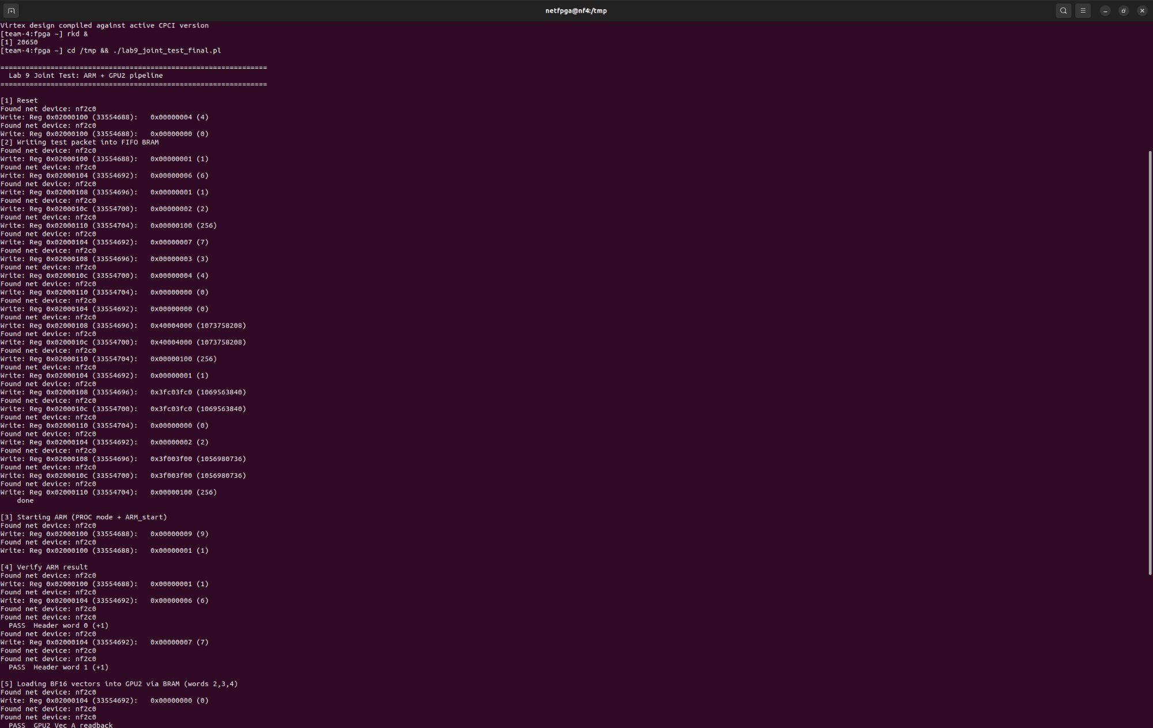
Figure 4: Hardware test (Part 1) — BRAM write, ARM start, ARM PASS (Header +1), GPU vector readback PASS

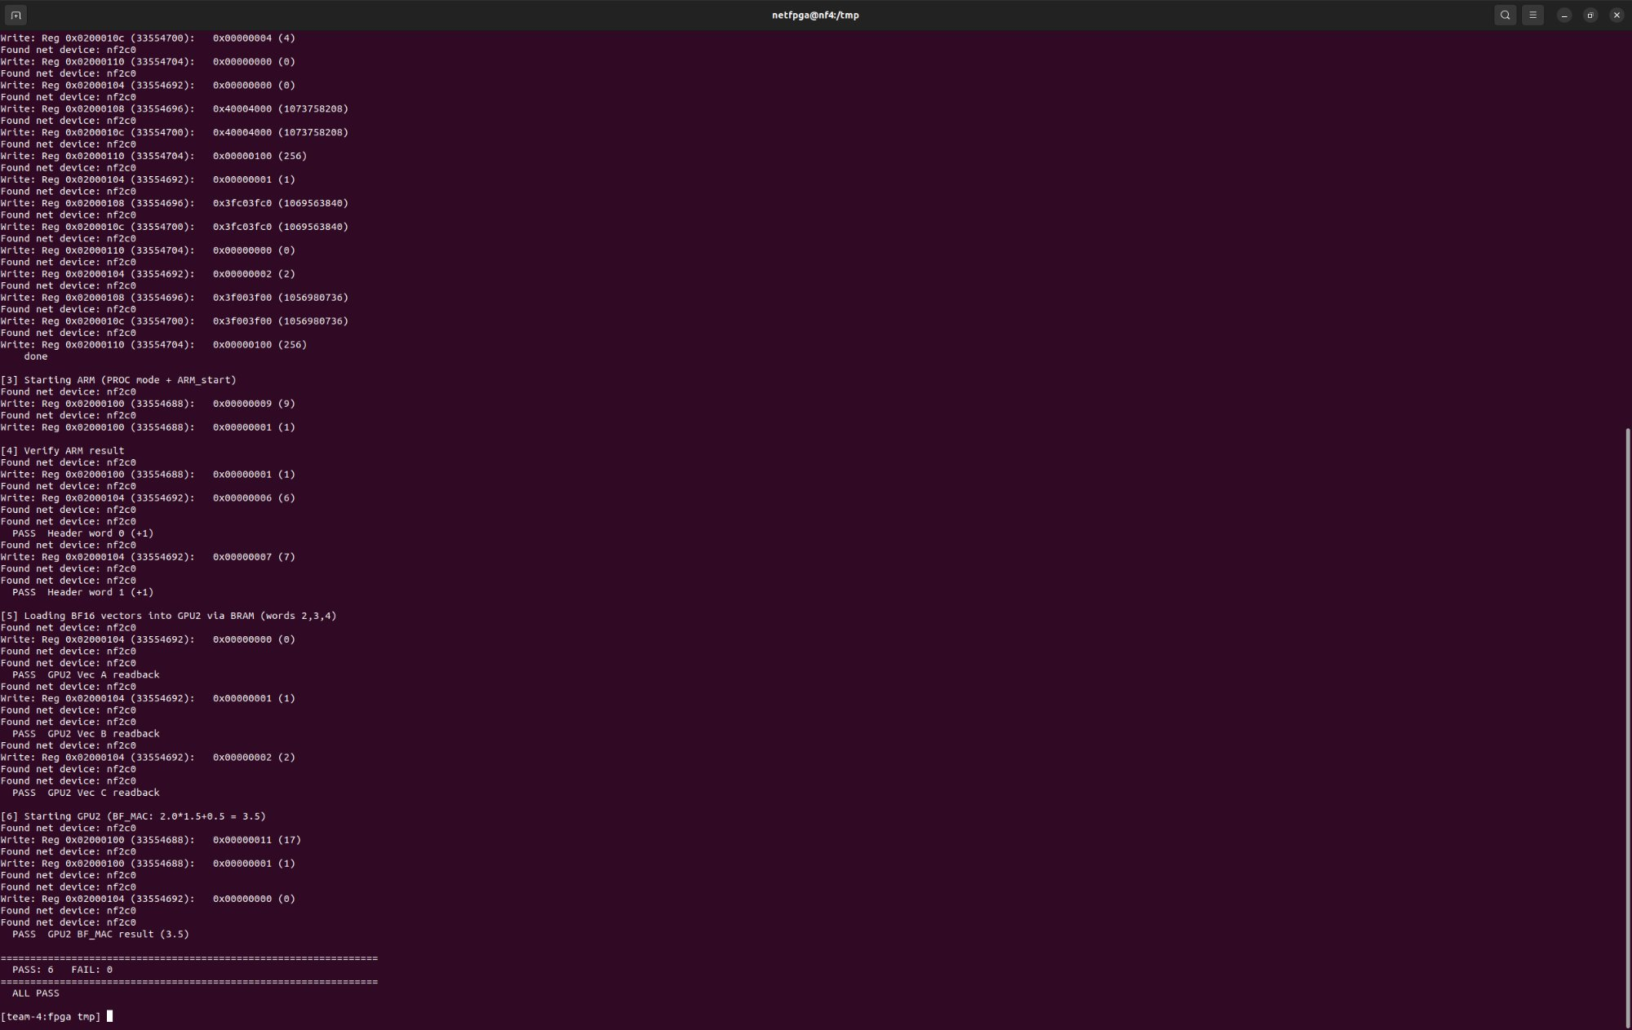
Figure 5: Hardware test (Part 2) — GPU BF_MAC result 3.5 PASS, Final: PASS: 6 FAIL: 0 ALL PASS

7.2 Hardware Test Results
Test | Expected | Actual | Result
ARM Header word 0 (+1) @ BRAM[6] | 00000002_00000003 | 00000002_00000003 | PASS
ARM Header word 1 (+1) @ BRAM[7] | 00000004_00000005 | 00000004_00000005 | PASS
GPU Vec A readback @ BRAM[0] | 40004000_40004000 | 40004000_40004000 | PASS
GPU Vec B readback @ BRAM[1] | 3FC03FC0_3FC03FC0 | 3FC03FC0_3FC03FC0 | PASS
GPU Vec C readback @ BRAM[2] | 3F003F00_3F003F00 | 3F003F00_3F003F00 | PASS
GPU BF_MAC result (3.5×4) @ BRAM[0] | 40604060_40604060 | 40604060_40604060 | PASS

PASS: 6 | FAIL: 0 | ALL PASS

8. Register Map
Register | Address | Description
CMD (SW0) | 0x2000100 | [1:0]=mode, [2]=reset, [3]=ARM_start (edge), [4]=GPU_start (edge)
PROC_ADDR (SW1) | 0x2000104 | BRAM word address for Port B access
WDATA_HI (SW2) | 0x2000108 | Write data [63:32]
WDATA_LO (SW3) | 0x200010C | Write data [31:0]
WDATA_CTRL (SW4) | 0x2000110 | Write enable: toggle bit[8] to trigger write
STATUS (HW0) | 0x2000114 | FIFO status
RDATA_HI (HW1) | 0x2000118 | Read data [63:32] from BRAM Port B
RDATA_LO (HW2) | 0x200011C | Read data [31:0] from BRAM Port B
RDATA_CTRL (HW3) | 0x2000120 | Read control (Port B select byte)
POINTERS (HW4) | 0x2000124 | [0]=arm_done, [1]=arm_running, [2]=gpu_done, [3]=gpu_running

9. Conclusion
Lab 9 successfully integrates the CPU group's 4-thread ARM pipeline with the GPU group's BF16 tensor core on the NetFPGA xc2vp50. Hardware testing achieves PASS: 6 / FAIL: 0:
- ARM pipeline correctly adds 1 to each 32-bit header field across 14 words
- GPU programmable core executes bf16_fma kernel: 2.0 × 1.5 + 0.5 = 3.5, 4 lanes, result 0x4060
- Shared dual-port BRAM correctly arbitrates between ARM, GPU, and host
- Complete NetFPGA register interface provides full observability and control
The central engineering achievement was fitting both processors into 23,616 Slices through systematic BRAM inference optimization, multi-cycle GPU architecture, pipeline pre-fetch timing analysis, and ISE 10.1 synthesis workarounds. The GPU group's core intellectual contributions — bf16_mac.v, tensor_unit.v, isa_defines.vh, and the BF16 ISA encoding — are fully preserved and demonstrated on hardware.

