Task 1

1. I see a list of directories and files. This means the ls command lists directories and files in the urrent directory.

2. I see “/home/zweli”. This means the pwd commands prints the current working directory.

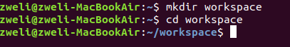
3.

4. Nothing is returned. This means the current directory workspace is empty.

5.

6.

Task 2

2.1

2.2

Task 3

1.
2.
3.
4.
5.
Task 4
The locate command

1.
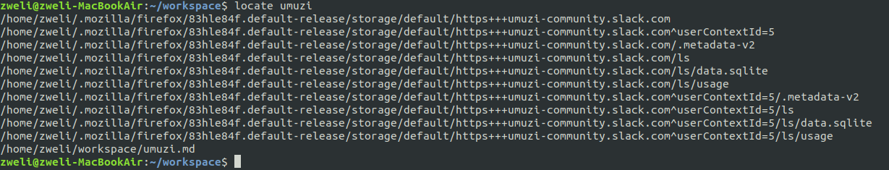
2.

Task 5 The locate command cont..
1.
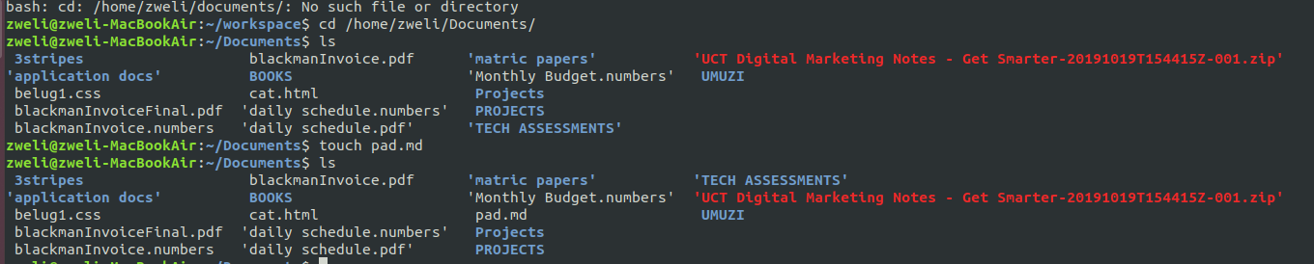
2.
3.
4.
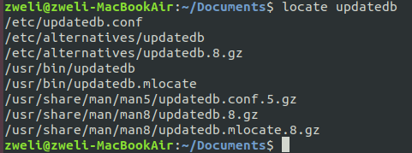

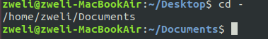

5.
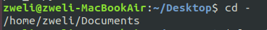

6.

Task 6 Find commands
1.
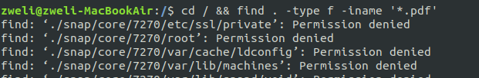
2.
3.

TASK 7

1. and 2.
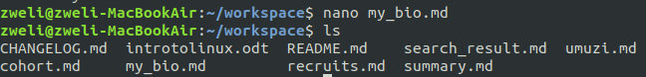
3.
