# **World Factbook**

Matriculation Number – 40437535

SSH – git@gitgud.napier.ac.uk:40437535/cw1b.git

HTTPS – https://gitgud.napier.ac.uk/40437535/cw1b.git

Server Link – <http://set09603.napier.ac.uk:5535/>

## **Introduction**

This website shows details of 195 countries such as country name, capital, population, gross domestic profit, area, top level domain and identity with 7 continents. They are Africa, Asia, Caribbean, Eurasia, Europe, North America, Oceania and South America.

## **Requirements for World Factbook**

* Internet Connection
* JavaScript supported browser
* Flask, Json, and Random modules
* Python version 3.0 or higher

## **Technologies used in World Factbook**

* HTML is used for structural layer of World Factbook
* CSS is used in design of this Website
* JavaScript is used to build function of website otherwise behavior
* JQuery is implemented for writing JavaScript, handling HTML and CSS
* Bootstrap is used to have responsiveness in Website
* Python is used in rapid development of World Factbook
* Jinja2 Template – used for template inheritance

## **Directories of World Factbook**

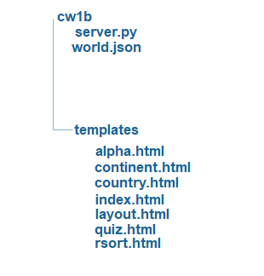

**Figure 1 Directories of World Factbook**

This website is implemented by using inline, internal, external style of CSS, and JavaScript.

## **Sitemap of World Factbook**

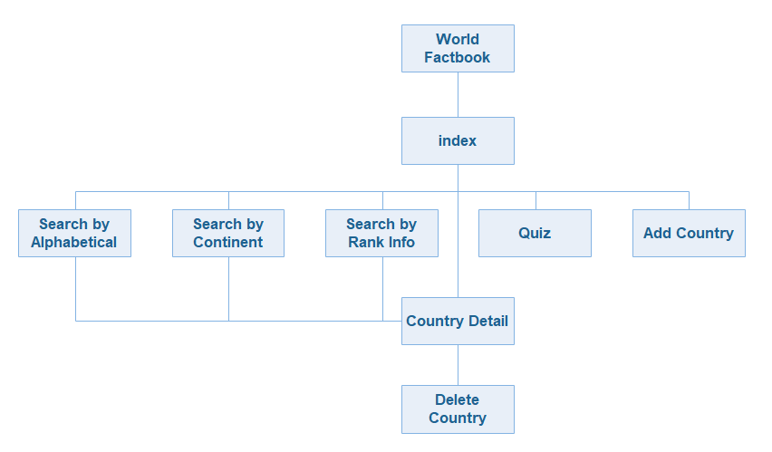

**Figure 2 Sitemap of World Factbook**

Jinja2 template inheritance is used in layout.html and index.html. Index.html inherit from layout.html.

## **Purpose of World Factbook**

* User can search country by name using search box
* User can play quiz by clicking quiz button
* User can add new country in the modal box
* User can find country by continents drop box
* User can search country by alphabetically
* User can find country by rank information such as population, gross domestic profit and area

## **Recommendation & Evaluation for Future Improvement**

The website needs to use more inheritance jinja2 templates for more saving time and memory usage. It also needs to improve in design. This website structure still needs to improv better standard. This website is compatible with any kinds of browser and also compatible with any kinds of device. Display rank information needs to show details of population, gross domestic profit and area by each country.

## **Conclusion**

In the Conclusion, this website is implemented by using high technologies and simple in design. User can search details information of the countries by rank info, population, gross domestic profit and country name. This is easy to use with simple and clear design. Website have low loading time and countries information can search and display appropriately.

## **References**

Jinja.pocoo [Online]Available From: [https://www.jinja.pocoo.org/docs/2.10/templates/](http://jinja.pocoo.org/docs/2.10/templates/) [Accessed: 2nd May 2019]

W3schools [Online]Available From: [<https://www.w3schools.com/bootstrap/bootstrap_ref_js_button.asp>](http://jinja.pocoo.org/docs/2.10/templates/) [Accessed: 2nd May 2019]

Stackoverflow [Online]Available From: <https://stackoverflow.com/questions/39555769/jinja2-include-extends-not-working-as-expected> [Accessed: 2nd May 2019]