Tipp Trainer

A Tipp Trainer program

Zwetti Patrick

3BHIF

|  |  |
| --- | --- |
| **Project title:** | Tipp trainer |
| **Project:** | IT-Project |
| **Project manager:** | Zwetti Patrick |
| **Project owner:** | DI Gernot Loibner |
| **Project duration:** | start: 29.04.2019  end: 27.05.2019 |
| **Benefit from the perspective of the user** | User learns to tip faster on keyboard. User can level up to play harder levels. Every user has his own account, where his results are saved. |
| **Targets:** | |  |  | | --- | --- | | **Partial goals:** | **Results:** | | show scores | * User knows if he gets better | | different levels | * Level for noobs and pros | | show helps | * Helps user to get better | | save account in DB | * Accounts are saved in DB | |
| **Milestones:** | |  |  | | --- | --- | | **Milestones:** | **Date:** | | Design…finished | 1. week | | Functionality…finished | 2. week | | Tests…finished | 3. week | | Project…finished | 4. week | |
| **Constraintsund** | Export/Import, Database, Additional technologies, GUI-Elements |

# Project Application

# Scrum planning

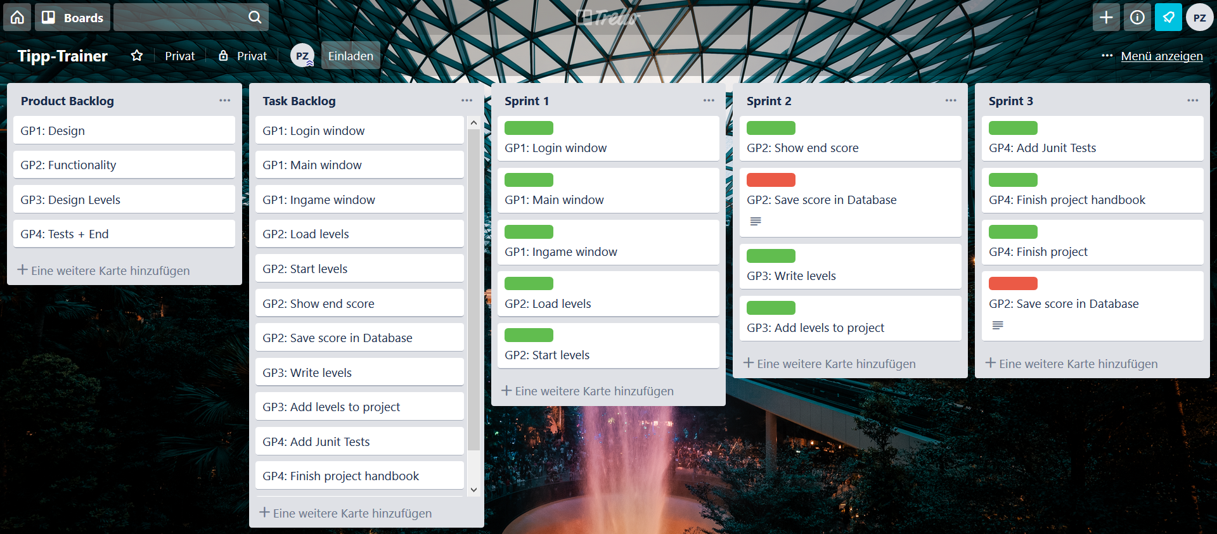

# Class Description

# Project Tests

